What makes a good surface representation?

* Concise
* Local support – moving one piece only moves that one piece
* Affine invariant – affine transformations do not fundamentally change representation
* Arbitrary topology
* Guaranteed smoothness
* Natural parameterization
* Efficient display
* Efficient intersections

What makes a good parameterization?

* Above except
* ~~Natural parameterization~~ (doesn’t necessarily have to be natural, but not sure?)
* ~~Efficient intersections~~

What is the loop subdivision scheme?

* Refinement step – add one new vertex per edge and connect them to form 4 triangles
* Smoothing step – move new vertex to location based on weighted average of old vertices and neighbors
  + Let k be the number of neighbors and b be the weight. Then position_new = (1-kb)position_original + summation(b*position_i)
  + We can get b by using the original loop equation of warren equation, as long as it guarantees smoothness properties
  + To study the limit, whether it collapses or blows up, we can encode weights into subdivision matrix, exponentiate using eigenvalue decomposition of the subdivision matrix
    - If eigenvalue < 1, then collapses
    - If eigenvalue > 1, then blows up
    - If eigenvalue == -1, then doesn’t converge
* Engineering tradeoff: sacrifice interpolation/dof for smoothness
* 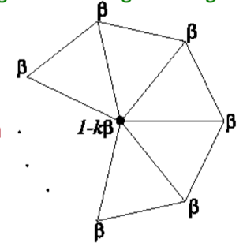

What are 3D representation schemes and their advantages/disadvantages?

* Face table – stores lists of sets of (xyz positions)
  + Pro: naïve solution
  + Con: redundant vertices so moving one vertex is tedious
  + Con: no vertex adjacency info
* Vertex and face table – stores a list of vertices (xyz positions), list of sets of vertices
  + Pro: solves redundancy issue
  + Con: no vertex adjacency info
* Adjacency list – store all vertex, edge, face adjacencies
  + Pro: efficient adjacency info
  + Con: extra storage
  + Con: variable sized arrays because we don’t know how many neighbors
  + Con: changing the connectivity (e.g. subdividing) is inefficient
* Partial adjacency list – adjacency list with limited info, you derive the rest
  + In the winged edge implementation, each edge stores [4 edges (the wing), 2 vertices, 2 faces], each face stores [1 edge], each vertex stores [1 edge]
  + 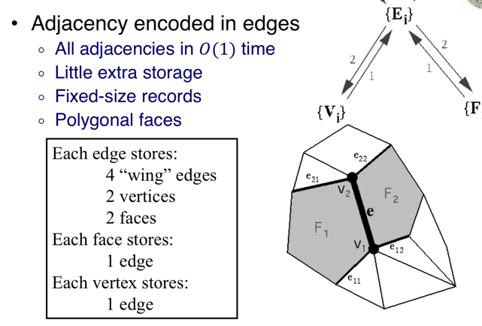
  + Algorithm: choose only edge coming out of v2, iterate counterclockwise around v2 until you cycle back to the start edge
  + Complexity: proportional to size of output

What makes a good spline?

* Local support
* Simple
* Continuous

What is a spline?

* Piecewise polynomial function whose derivative satisfy continuity constraints
* Direct parametric approach to create a curve?
  + Solve for m coefficients of a m-1 parametric function (regression)
  + Con: no local support
  + Con: as the number of points gets larger, the curve oscillates more
  + Con: complex to solve, invert a large system
* Spline approach to create a curve?
  + Rather than having one huge polynomial, piecewise polynomial function... this may not be continuous, but we can just add constraints
  + A spline is a piecewise polynomial function whose derivative satisfy continuity constraints
  + To form a continuity constraint, let the piecewise function go from 0 to 1, representing the start and end. Then C^d_i(1) = C^d_i+1(0). In other words, the derivatives at the endpoint of the previous piece should line up with the derivative of the start for the next one
* Hermite spline and advantages/disadvantages?
  + Use blending functions encoded in matrix to interpolate positions and tangents
  + Pro: C1 continuity
  + Pro: interpolating
  + Con: not C2 continuous
  + Con: requires tangents for control points
  + 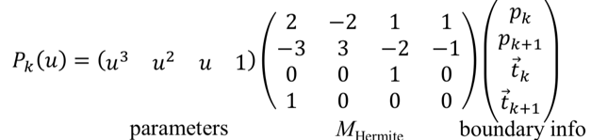
  + Parameters * hermite conversion from points/derivatives * points/derivatives
* Cardinal spline and advantages/disadvantages?
  + Gives us tangents for two points based on the surrounding points (4 control points total). Then combine with a Hermite
  + Pro: C1 continuity
  + Pro: interpolating
  + Con: not C2 continuous
  + 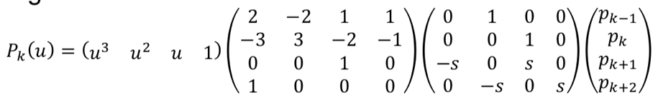
  + Parameters * hermite conversion from points/derivatives * conversion from old points to old points/new tangents * points
* Uniform Cubic B spline and advantages/disadvantages?
  + Cardinal B spline where you approximate your own points and tangents
  + Pro: C2 continuity
  + Pro: convex hull containment
  + Con: approximating, not interpolating
  + Con: missing end points
  + 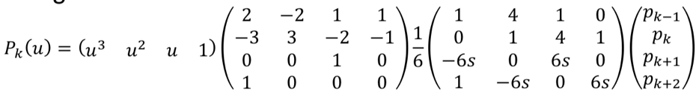
  + Parameters * hermite conversion from points/derivatives * conversion from old points to new points/new tangents * points
* 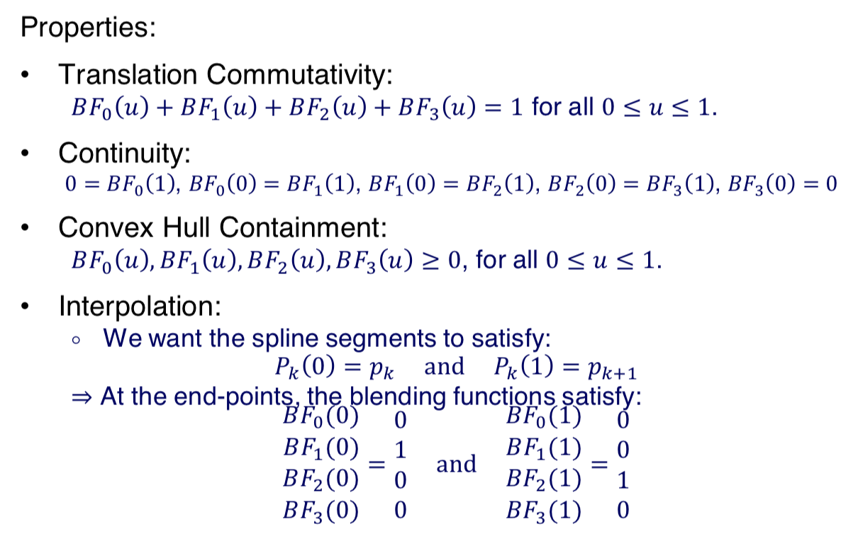

3D surface splines properties?

* Translation commutativity
* Continuity
* Convex hull containment
* Interpolation

Tensor product spline?

* Using matrices to get surface spline

Types of procedural modeling?

* Sweeps – sweep a curve about a line (which defines rotation, translation, scale)
  + 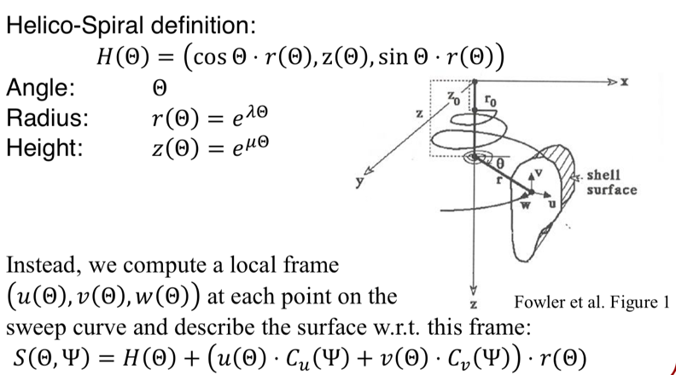
* Fractals – can either be a normal fractor, or statistically similar (initiator shape, replace subshapes with self-similar random pattern), but the idea is that you replace subshapes
* Grammars – using a grammar, replace words until there is nothing to replace

Solid modeling and advantages/disadvantages?

* Pro: easy to visualize in graphics hardware
* Con: some models cannot be represented with boundary
* Con: Difficult to intersect models

Implicit surfaces?

* Using a 3 dimensional function, good for simple shapes, e.g. quadrics, but has been shown that we can sum gaussians to create a good blobby model
* Pro: easy to test if a point is on or inside the surface
* Pro: easy to intersect surfaces
* Con: hard to describe complex shapes and functions
* Con: hard to enumerate points on surface
* Blobby model

Voxels?

* Grid representation, think Minecraft
* Can be binary model (either there is a block or not) or continuous (encode information, e.g. color)
* Voxel display – slicing, raycast for density, iso-surface extraction using marching cubes algorithm
* Pro: simple
* Pro: same complexity for all objects
* Pro: natural acquisition for some applications
* Pro: boolean operations are trivial
* Con: approximate
* Con: not affine invariant
* Con: large storage requirement
* Con: expensive to display
* Con: fixed resolution

Marching cubes algorithm?

* Creates a smoother interpretation of voxel grid
* Define 2^8 = 256 different possible cases
* Assign a rule for surface extraction in each case
* Combine the patches from the different grid cells
* 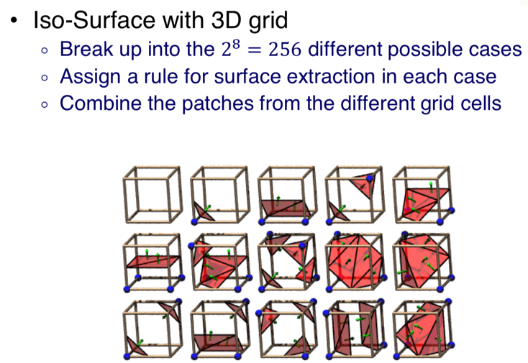
* Cons: May contain ambiguities

Quadtree/Octtree?

* Same idea as voxels, but refine resolution based on what you need
* How to handle zero-crossings? Use info from side with more information

Range processing?

* Manual initial alignment
* ICP to an existing scan
  + For each point in scan1, find the nearest point in scan2
  + Translate/rotate to minimize distance between two points
* Global relaxation
* Merging using volumetric method

Define convex, convex hull?

* Convex: line segment connecting any two points is also in the polygon
* Convex hull: smallest convex set containing set

Delaunay triangulation?

* Circumscribing circles do not contain any other points
* Compactness property – maximizes minimum angle
* 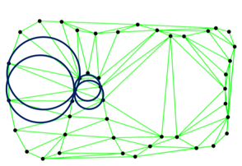

Voronoi diagram of set S?

* Partitions space into regions such that all points are closer to partition than any other point in S
* Vertices are equidistant from 3+ points in incident cells
* For a vertex, we can draw an empty circle that touches the point in 3+ incident cells
* Duality – one to one with Delaunay triangulation
* 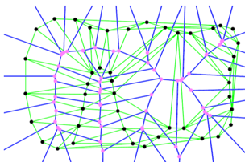

Medial axis

* Set of circles/spheres that only meet the shape tangentially at 2+ points.
* For a reasonable point sample, well sampled by Voronoi diagram

Space partitioning – you in or out?

* Spectral partitioning (organized points)
  + Assign weight to each edge indicating if two triangles are likely to have the same label (can set weights based on how much two circles overlap)
  + Find a partition into roughly even pieces minimizing sum of weights along the partition
  + 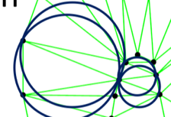
* Crust algorithm (organized points)
  + Compute Delaunay triangulation
  + Compute Voronoi vertices
  + Keep edges for which there is a circle that contains edge but not voronoi vertices (do not cross medial axis)
  + 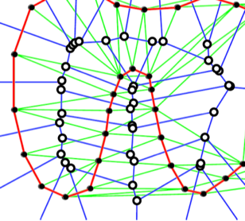
* Implicit surface reconstruction from unorganized points
  + Local signed distance function
  + Extract zero level set
  + Get normals by fitting a line to the neighbors at each point, and build a Euclidian MST and propagate orientation from root
* Poisson reconstruction
  + Transform sample into (least-squares) vector field
  + Fit scalar-field to gradients
  + Extract isosurface

In-betweening?

* Interpolate/approximate transformations rather than positions
* Can use spline
* Curve normalization
  + Con: ambiguity (line that passes through origin)
  + Con: uniform sample on original curve not necessarily uniform on new curve
  + SLERP – parameterize using angle, calculate point, blend parameters and evaluate
* SVD factorization
* Euler angles, then interpolate
* Quaternions [MAKE SURE TO STUDY THIS]
* Exponential/Logarithmic map with skew symmetric matrices

Kinematics versus dynamics?

* Kinematics considers only motion
  + Forward – given two angles of an arm, find end effector (hand)
  + Inverse – given end effector (hand), find two angles of arm. May have multiple or no solutions, so we may have to minimize energy or perform non-linear optimization aka more computation
* Dynamics considers underlying forces, physics simulation
  + Discretize time steps, minimize, solve linear or nonlinear iterative optimization technique
  + Pro: Animator doesn’t have to think about physics
  + Pro: easy to vary motions due to new parameters and/or constraints
  + Con: must specify constraints/objective functions
  + Con: need to avoid local minima during optimization

Radiosity?

* Assumes that lights are uniformly emissive, and that objects are Lambertian
* We need to account for distance and angles between surfaces
* 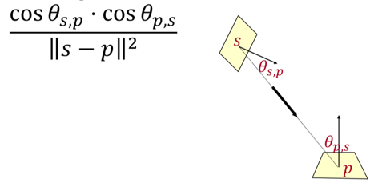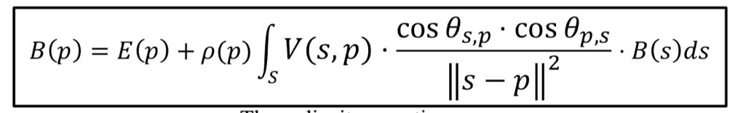
* Emissivity + material property * integral of visibility and radiosity assumptions and brightness

Gradient domain?

* Rather than representing an image, represent image as a disjoint set of pixel value differences
* E.g. in a blank image, no gradient, but in stripe.bmp, gradients going between black/white
* Good for stitching images together, HDR compression
* We would like to get pixel values from horizontal and vertical gradients, but over constrained problem, may have multiple solutions.
* However, rather than setting differences to 0, we can minimize instead.
* Gauss Seidel Iteration algorithm?
  + Runs over each pixels, calculates D^T D Lapalacian * pixels = gradients
* Multi-grid solver algorithm?
  + A few solver iterations on high-res
  + Compute residual and downsample
  + Solve low-res (recursive)
  + Upsample and add to high-res
  + A few solver iterations on high-res
  + Parallelization optimization tricks:
  + 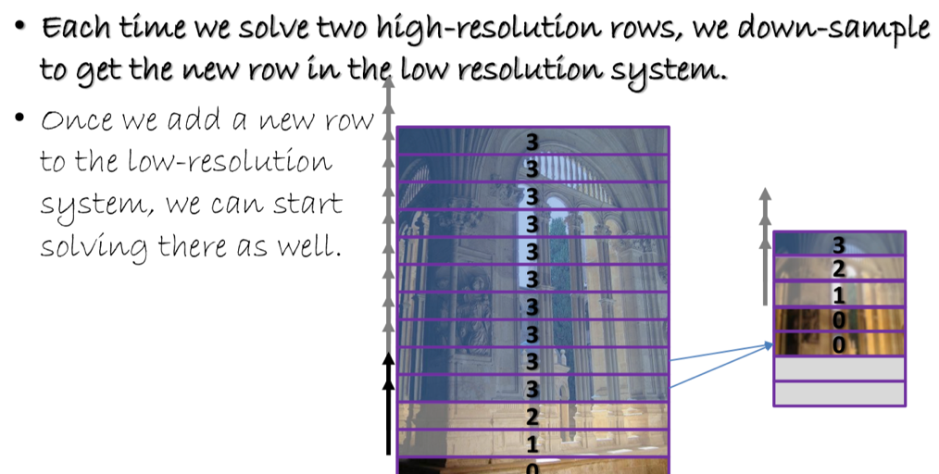

Shape matching general approach using Euclidian distance transform?

* Euclidian distance transform basically places right cones w/ apices at surface boundary, representing distance falling off linearly. Rasterizes to get a map of depth
* Compare two shapes with each others’ distance transforms with dot product
* 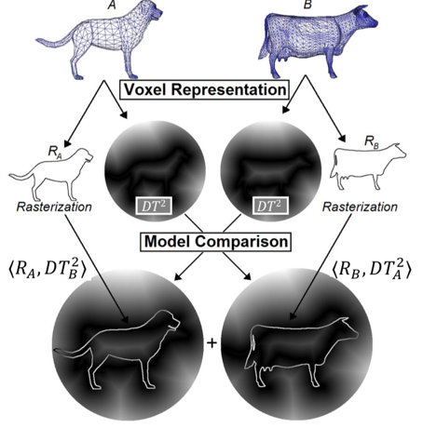
* Pro: discriminating
* Pro: quick to compute
* Pro: matching over rigid body transformations
* Con: partial object matching
* Con: difficult for articulated figures and deformable models