# Understanding Microsoft Flow Basics

Welcome to Guided Learning for Microsoft Flow. This self-paced online course explains Microsoft Flow in a sequential way so that you can build your knowledge from the ground up. The course is designed to provide guidance in understandable chunks with lots of visuals and examples, following a logical progression to help you learn principles and details.

In this course, you'll learn about Microsoft Flow and its concepts, see how to build flows, manage them, and administer them in your environment. You'll be presented with information and scenarios for a fictional company called Contoso Flooring, but you'll see how to use the same scenarios in your business or your clients' businesses.

If you're a beginner with Microsoft Flow, this course will get you going. If you already have some experience, this course will tie concepts together and fill in the gaps. This course is a work in progress, so please let us know how we're doing and what other topics you want to see in this course.

## What is Microsoft Flow?

Microsoft Flow is an online workflow service that enables you to work smarter and more efficiently by automating workflows across the most common apps and services. For example, you can create a flow that adds a lead to Dynamics 365 and a record in MailChimp whenever someone with more than 100 followers tweets about your company.

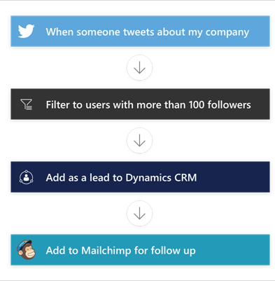

When you sign up, you can connect to more than 100 services and manage data in either the cloud or on-premises sources such as SharePoint and SQL Server. The list of applications and services that you can use with Microsoft Flow grows constantly.

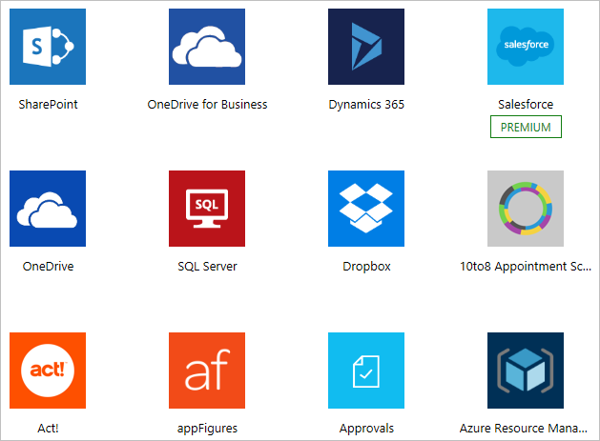

## What can you do with Microsoft Flow?

You can use Microsoft Flow to automate workflows between your favorite applications and services, synchronize files, get notifications, collect data, and more.

For example, you can automate these tasks:

* Instantly respond to high-priority notifications or emails.
* Capture, track, and follow up with new sales leads.
* Copy files from one service to another.
* Collect data about your business, and share that information with your team.
* Automate approval workflows.

A common use of Microsoft Flow is to receive notifications. For example, you can instantly receive an email or a push notification on your phone whenever a sales lead is added to Dynamics 365 or Salesforce.

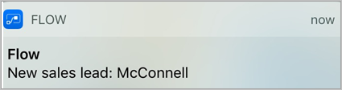

## Where can I create and administer a flow?

You can create a flow and perform administrative tasks in a browser or on your phone - if you download the mobile app for Microsoft Flow.

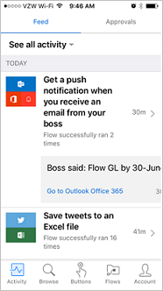

You can perform these tasks, among others:

* Turn flows on or off from wherever you are.
* See when a flow has failed.
* Review detailed run-history reports.
* View and filter runs by notification type.

## Add multiple actions and advanced options to a flow

Customize a flow by adding one or more advanced options and multiple actions for the same trigger. For example, add an advanced option that sends an email message as high priority. In addition to sending mail when an item is added to a SharePoint list, create a file in Dropbox that contains the same information.

1. In [flow.microsoft.com](https://flow.microsoft.com/), select **My flows** in the top navigation bar.
2. In the list of flows, select the flow that you want to edit.
3. Select **New step**, and then select **Add an action**.

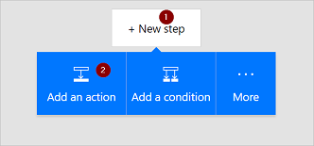

1. In the list of possible actions, search for **Create file**, and then select **Dropbox - Create file**.

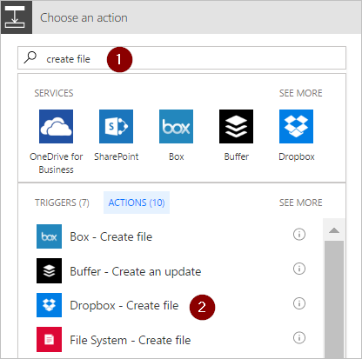

1. If prompted, provide your Dropbox credentials.
2. Select the folder icon on the right side of the **Folder path** box.

## Add conditions to a flow

Specify that a flow performs one or more tasks only if a condition is true. For example, specify that you'll get an email only if a tweet that contains a keyword is retweeted at least 10 times.

1. In [Microsoft Flow](https://flow.microsoft.com/), select **My flows** in the top navigation bar.

You might need to sign in if you're not already signed in.

1. In the list of flows, select one of the flows that you've created.

This tutorial uses an example with a Twitter trigger and a SharePoint action.

1. Select **Edit flow**.
2. Under the last action, select **New step**.
3. Select **Add a condition**.

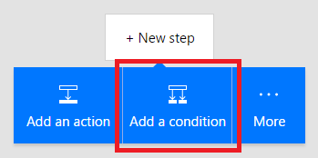

1. On the **Condition** card, select an empty area in box on the left.

The **Dynamic content** list opens.

1. Select the **Retweet count** parameter to add it to the box.
2. In the box in the middle of the **Condition** card, select **is greater than or equal to**.
3. In the box on the right, enter **10**.

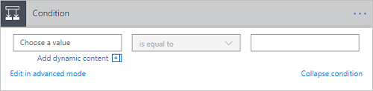

1. Select the header of the action you want to use inside the condition (such as **Create item**) and drag it underneath the text that reads **If yes**.

When you release the cursor, the action moves into that box.

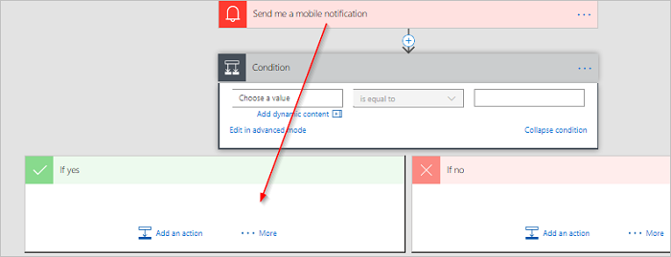

1. Configure the action as necessary.
2. Save the flow.