# Labeling Guide UW Lymphoma MTV

Version: 1.2  
Last updated: 2023/01/20  
Study Name: UW Lymphoma

# Objective:

To create a training/validation dataset for developing a convolutional neural network (CNN) to automatically quantify metabolic tumor volume (MTV) in baseline FDG PET/CT images and to automatically quantify residual tumor in follow-up FDG PET/CT images for adult patients with Hodgkin’s lymphoma (HL) or diffuse large B-cell lymphoma (DLBCL).

# Inclusion criteria:

* Baseline FDG PET/CT scan
  + Indication: initial staging
  + Acquired on one of the following UW-Madison or UWHealth PET/CT scanners: Discovery 710, Discovery MI, or Discovery IQ.
* Biopsy confirmed Hodgkin’s lymphoma (HL) or diffuse large B-cell lymphoma (DLBCL)
* No other concurrent cancers
* At least 1 follow-up scan available in UW PACS, less than 6 months from baseline
* Age ≥ 18

# General detection guidelines

* Labelers should error on the side of sensitivity over specificity in detection
* In cases of PET-CT misregistration, rely on the PET image
* Do not ignore small regions of uptake
  + While not a large contributor to MTV, ignoring small lesions can confuse a CNN, and make follow-up tracking difficult
* Lesions clusters do notneed to be separated into individual nodes
* Focus on detection rather than segmentation
* For follow-up scans, segment any disease that would qualify as Deauville 2,3,4 or 5

# Viewing settings

* SUV: 0-5 (MIM’s default)
* CT: use a soft tissue window (W/L 400/40) for soft tissue (MIM’s default, keyboard shortcut: F1); use a bone window (2500/500) for bone (keyboard shortcut: F3)

# Summary of labeling method

The workflow involves 2 stages: disease detection followed by segmentation (segmentation is implemented in a separate MIM workflow and should not be the focus during this stage of analysis). Disease detection is facilitated by the MIM *LesionID* workflow. An SUV and volume threshold are used to automatically pre-identify regions of high FDG uptake. The SUV threshold is based on the PERCIST criteria:

Volume threshold = 2 mL; and

SUV threshold = 1.5×Livermean + 2×Liverstandard_deviation; or

SUV threshold = 2×Aortamean + 2×Aortastandard_deviation

*LesionID* creates ROIs for regions that meet these criteria and the labeler then deletes any ROIs that do not contain tumor. Any tumor regions that were missed by pre-labeling (including lesions < 2 mL) should be manually added by the labeler using the PET Edge+ or PET Edge tool. Non-lymphatic disease (e.g., bone) will be tagged accordingly in the ROI name. The full labeling process is described in detail below.

# Labeling baseline images

1. **Setup**  
   Steps for configuring MIM prior to running the workflow are described below in the *Configuring MIM* section
2. **Launch workflow**  
   Select the CT and the attenuation-corrected PET image series (hold *control* to select). Select the *LesionID Lymphoma* workflow and hit Launch Workflow. Read and follow the prompts in the Notifications window
3. **Reference tissue ROI placement**

Navigate the crosshairs to the location where the reference ROI should be placed.

* + Navigate to a healthy part of the liver (3 cm in size) and hit OK.
  + If liver is overly involved, change the dropdown option to “Use the Mediastinal Blood Pool for reference placement”. Hit OK. Then navigate the crosshairs to the aortic arch and hit OK.

1. **Remove non-tumor ROIs**

Look through the list of ROIs automatically generated by the workflow. If the ROI does not contain tumor, hit “D” to delete it. Hit “A” to move to the next ROI in the list.

* + To be able to select contours *within the images* by hovering over and clicking on them, click on the  icon positioned above the contour list
  + ROIs with extra-nodal disease should have tags in the ROI name. See step 6 below for labeling details.

1. **Add any missed lesions**

Small, low uptake lesions are often missed by *LesionID*. Add these manually using PET Edge + or PET Edge:

* + PET Edge+: hover over the region until a green checkmark appears, then click with the mouse. Sometimes PET Edge+ generates different options for the ROI; these options can be explored using the  and  buttons.
  + PET Edge: click in the center of the region and drag until the tendrils reach the edge of the lesion, then release the mouse.

Clusters of lesions do not need to be individually separated.

All disease, including hepatic, splenic, marrow, osseous, and extra-nodal disease should be detected.

All equivocal lesions should also be labeled as equivocal (see step 6).

Considerations for special cases are listed below in the *Special Considerations* section.

1. **Add text labels to extra-nodal lesions**

All ROIs will be assumed to be nodal so that nodal ROIs do not need additional labels. For extra-nodal ROIs, an additional tag should be added to the ROI name.

A tag can be added manually (right click on ROI, select *Rename*, then type the label) or by hitting “L” to launch the tagging workflow. The labels are:

* + Liver
  + Spleen
  + Marrow (see definition in *Special Considerations*)
  + Osseous (see definition in *Special Considerations*)
  + Extra-nodal (extra-nodal visceral)
  + EQ (equivocal)

Lesions can have multiple tags, e.g., “Marrow, EQ”.

1. **Resume Workflow and Save**

Once all lesions have been identified and labeled, reopen the *Notifications* window (top right) and click *Resume Worfklow*

You will be asked to save the contours (DICOM RTstruct). Under *Series Description*, enter your name or initials, then hit OK.

The workflow will then show you the final “Total Tumor Burden” contour and statistics. No action is needed at this point. Close the session.

If corrections are needed after the last step, close the session, highlight the contour file together with the PET and CT series and then relaunch the *LesionID Lymphoma* workflow.

1. **Complete worksheet**

In printed worksheet, check that the patient is complete and answer any questions.

Diffuse/innumerable liver involvement

Diffuse/innumerable spleen involvement

Diffuse bone involvement

Brown adipose tissue uptake (positive/negative)

# Labeling interim or follow-up images

1. Select the baseline PET and CT images, as well as the interim/follow-up (PET2) PET and CT images. Launch the Universal PET/CT Review workflow.
2. Make sure the “Current PET” series is selected in the “Select a Series to Contour” dropdown menu
3. Use PET Edge+ or PET Edge to add residual tumors. Any tumor that is considered DS2, DS3, DS4, or DS5 should have an associated contour.
   1. If baseline and interim images are not well registered, the reader can navigate to the page that shows the CT/CT fusion images and rerun the box-based registration [TO DO: Better explanation]

Assign a text label to each contour as appropriate by hitting “L” to launch the tagging workflow. The labels are: Liver, Spleen, Marrow, Osseous, Extra-nodal (extra-nodal visceral), EQ (equivocal)

1. Assign a DS for each lesion and append it to the end of the contour name:
   1. [X]DS[1-5]. [X] is the annotator identifier (e.g., X=Muehon Shin, Y=Steve Cho, etc). [1-5] is the assigned Deauville score. For example, is Steve Cho assigned ROI-1 a Deauville score of 4, he would append “YDS4” to the ROI label: e.g., “ROI-1,YDS4”.

Save the session and the RTStruct contour set. Under *Series Description*, enter your name or initials. Associate the RTStruct with the PET image, not the CT.

**Adjudication**

1. **Select timepoints.**   
   Hold Ctrl and select both time points’ PET, CT and RTstruct files. (*note: even numbered IDs are baseline and odd-numbered IDs are follow-up*).
   1. If there are two PET images and one is described as “Corrected for SUV Calculation”, select the corrected one.
   2. If it asks you to correct the SUV image due to incorrect dates caused by the anonymization process, change the Radiopharmaceutical Start Date to match to the Scan Date
2. **Launch the workflow.**Select *Universal PET/CT Review* (*note: ignore warning about different patient names*)
3. **Check the layout**.   
   The top row is follow-up (“Current”) and bottom row is baseline (“Prior”)
   1. To zoom/size each window the same, click on the window and press “2”
4. 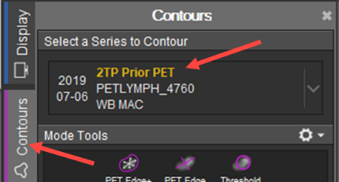**Process Prior PET**   
   Review and edit the baseline contours   
   There is a labeling system that is used to indicate which lesions should be deleted, added, or have its label changed. See the Tables at the end of this section.
   1. **Important!** In the top left dropdown menu under “Select a Series to Contour”, select “2TP Prior PET”
   2. **Review contours**. Click through each ROI.
      1. **To delete ROIs** that you don’t agree with:

Append your initial (e.g., “P” for Perlman, “Y” for Cho, etc) and “D” to the beginning of the ROI name. Do not actually delete the contour. E.g., “PD,ROI-1,EQ”

* + 1. **To add ROIs** that weren’t initially identified:

Append your initial and “A” to the beginning of the ROI name. Add an anatomy label, if needed. E.g., “PA,ROI-1,Liver”

* + 1. To change the label of an ROI:
       1. Append your initial and “L” to the beginning of the ROI name. At the end of the ROI name, add the new label. Don’t delete the original label. Examples:  
          “PL,ROI-1,Marrow,Osseous” -- indicates that labeler “P” thinks the ROI is osseous and not marrow.  
          “PL,ROI-1,EQ,NEQ” -- indicates that labeler “P” think the ROI is not equivocal but is unequivocally a lymphoma lesion
  1. Save Prior PET (PET1) contours.
     1. Click Save **→** DICOM RTstruct → **Select Prior PET** → Give it your name (“Steve”)
     2. If you made no changes, save contours anyways.

1. **Process Current PET**Review and edit the interim contours. Note: any disease that would be considered Deauville score 2,3,4, or 5 should be labeled.
   1. **Important!** In the top left dropdown menu under “Select a Series to Contour”, select “2TP Current PET”
   2. **Review Current PET contours**
      1. Follow the same steps for adding, deleting, and changing the labels for ROIs as for PET1.
      2. **Assign a lesion-level Deauville score if you don’t agree with the original.** Deauville scores are added to the end of the ROI name. Start with your initial and then add “DS1” for Deauville score 1. If you agree with the original DS, do not add anything. Otherwise, add yours after the original DS: “ROI-1,XDS2,PDS3” means that labeler “P” believes it should be a DS3 instead of a DS2 as assigned by labeler “X”.
   3. **Save Current PET (PET2) contours**.
      1. Click Save **→** DICOM RTstruct → **Select Current PET** → Give it your name (“Steve”)
      2. If you made no changes, save contours anyways.
   4. **Save final session.**
2. **Fill out worksheet**
   1. Comment generally on what you changed (“e.g., added lesions in chest”)

Table 1. Codes for adding, deleting, or changing the label of an ROI when adjudicating an exam.

|  |  |  |
| --- | --- | --- |
| **Label** | **Meaning** | **Instruction** |
| PA_* | Add new lesion | Use PETEdge+ to create ROI, add label to beginning, add anatomy label as appropriate. Example: PA_ROI-1,EQ |
| PD_* | Delete lesion | Add label to beginning (don’t actually delete ROI). Example: PD_ROI-1,Marrow |
| PL_* | Change anatomy label | Add label to beginning, append new anatomy label to the end. Example: PL_ROI-1,EQ,NEQ |

Table 2. Codes for indicating the Deauville score of an ROI when adjudicating a PET2 exam.

|  |  |  |
| --- | --- | --- |
| **Label** | **Meaning** | **Instruction** |
| *,PDS1 | Deauville score 1, from labeler P | For PET2, append DS score to end of label name. Example: PL_ROI-1,XDS2,PDS3 |

Table 3. Codes for anatomical labels.

|  |  |  |
| --- | --- | --- |
| **Anatomy Labels** | **Meaning** | **Example** |
| [none] | Default (i.e., no label) is lymphatic disease | ROI-1 |
| *,Liver | Liver lesion | ROI-1,Liver |
| *,Spleen | Spleen | ROI-1,Spleen |
| *,Marrow | Marrow involvement | ROI-1,Marrow |
| *,Osseous | Osseous involvement | ROI-1,Osseous |
| *,Extra-Nodal | Extra-nodal soft tissue involvement | ROI-1,Extra-Nodal |
| *,EQ | Equivocal findings | ROI-1,EQ |
| SPECIAL CASES | | |
| *,NEQ | Non-equivocal, only used when changing a label from EQ to NEQ | PL_ROI-1,EQ,NEQ |

# Special Considerations

* Bone disease
  + View in sagittal and transaxial planes together with MIP
    - Focal disease should be identified and segmented, even if multiple foci are present within a single bone segment (e.g., L1)
  + Diffuse skeletal uptake should not be segmented but should be indicated on the printed worksheet
  + Osseous and marrow disease should be differentiated
    - If CT findings are definitively osteolytic or sclerotic, the lesion is osseous. If there is no change in CT, it is marrow involvement.
* Liver disease
  + Focal disease should be identified and segmented
  + If liver lesions are “innumerable”, the whole organ should be segmented; PET Edge can be used to segmented the whole organ.
* Splenic disease
  + Focal disease should be identified and segmented
  + If splenic lesions are “innumerable”, the whole organ should be segmented; PET Edge can be used to segment the whole organ.
  + If the spleen is enlarged and diffuse uptake is > 1.5 above reference tissue SUV (liver or blood pool), then whole organ should be segmented; PET Edge can be used to segment the whole organ
  + If bone marrow is reactive and spleen is diffusely hot, do not segment spleen
* Brown adipose tissue
  + Indicate the presence of BAT in the printed worksheet
* Equivocal disease
  + When it is unclear whether or not a lesion is lymphoma or physiological, it must be segmented and tagged with “EQ” in the name.
* Necrotic tumors
  + Necrotic centers should be included in the ROI

# Configuring MIM 7.1

The following steps must be followed prior to running the labeling workflow.

* Import the following workflows:
  + *LesionID Lymphoma [To Do: Version control]*
  + *Apply Anatomical Labels*
  + *Universal PET/CT Review*

Workflows are imported by selecting the Workflow tab (right side of screen, yellow hardhat) → Organize → Open File (select the workflow files on your filesystem) → Import Selected Content to User Level.

* General Preferences → Imaging → Contouring → Advanced. Check the box: “Auto-localize when switching active contour”
* General Preferences → Imaging → Contouring. Check the box: Display contour list alphabetically
* General Preferences → Imaging → Contouring → Advanced. Change Default Contour Thickness to 1
* Keyboard Shortcuts. Type “Delete Contour” → Edit → Enter “D” → OK (ignore any messages)
* Keyboard Shortcuts. Type “Apply Anatomical Labels” → Edit → Enter “L” → OK (ignore any messages)
* General Preferences → Imaging → Contouring. Check the box: Deactivate current contours when hiding all contours

# References

1.

Ilyas H, Mikhaeel NG, Dunn JT, et al. Defining the optimal method for measuring baseline metabolic tumour volume in diffuse large B cell lymphoma. *Eur J Nucl Med Mol Imaging*. 2018;45:1142-1154.

1.

Barrington SF, Meignan M. Time to Prepare for Risk Adaptation in Lymphoma by Standardizing Measurement of Metabolic Tumor Burden. *J Nucl Med*. 2019;60:1096-1102.

1.

Barrington SF, Zwezerijnen BGJC, de Vet HCW, et al. Automated Segmentation of Baseline Metabolic Total Tumor Burden in Diffuse Large B-Cell Lymphoma: Which Method Is Most Successful? A Study on Behalf of the PETRA Consortium. *J Nucl Med*. 2021;62:332-337.

**To do:**

Create workheet of baseline+followup pairs, checkbox for brown fat, spleen, liver involvement, diffuse bone uptake

**Questions for MIM:**

When doing PETEdge redefine, some lesions (large ones) disappear.

Can we keep original (all in one color) and label new ones?

Adding hanging protocols we like

Register baseline to followup with contours (or just single MTV contour), show both in same window

Adjudication workflow

Add a save session with username at the end (I figured this out)

For descending aorta (mediastinal blood pool), can you change it to 1 cm?

In the tag workflow, remove the “list” option – takes an extra step.

In the tag workflow, add an EQ (equivocal) (which can be added to other labels?)

Remove the automatic bone step

Is it ordering according to Z?

To do:

Replace “Bone” with “Marrow” and add Osseous

Load labeling workflow

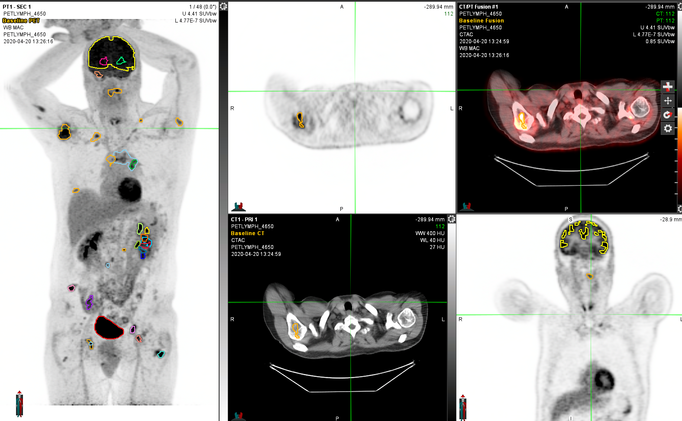

1. Highlight both time points (need to give IDs – even is baseline, odd is follow-up) together with the RTStruct
2. Launch Universal PET/CT Review (check name) (ignore error about different patient names)
3. Top is follow-up, bottom is baseline (hit “2” on each window to size them all the same)
4. First, change the contours on Prior PET (dropdown from top left)
   1. Add using PETEdge+, or delete
   2. To add tags/labels, click on the ROI, then click on the PET image, and hit “L”
   3. Save DICOM RTStruct -> Select Prior PET -> Give it your name (“Steve”)
   4. If no changes, don’t save
5. Second, change the contours on Current PET (dropdown from top left)
   1. Add using PETEdge+, or delete
   2. To add tags/labels, click on the ROI, then click on the PET image, and hit “L”
   3. Save DICOM RTStruct -> Select Current PET -> Give it your name (“Steve”)
   4. If no changes, don’t save

To do: worksheet, comment section on what they changed