Due back by Dec. 1, 2021

下面左邊的表格在應用information gain/entropy後會得到右邊的decision

tree, 請將建樹的過程一步一步show出來。

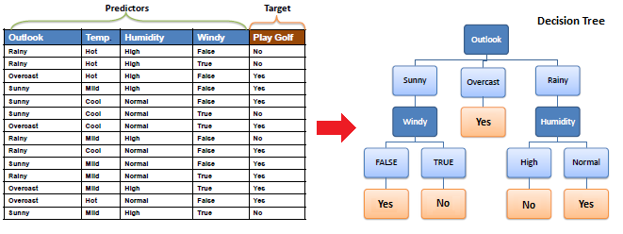

建立決策樹除了用information gain外，還有另一種方法叫做Gini. 請參考下面的document先了解Gini:

<https://www.analyticsvidhya.com/blog/2016/04/complete-tutorial-tree-based-modeling-scratch-in-python/>

然後用Gini為課本的例子建立決策樹:

