ONLINE SURVEY SYSTEM  Created by: Tyrone Chandler  Demo link: https://iu.mediaspace.kaltura.com/media/t/1_5l3acmvp  Project site: https://github.com/tychandl/OnlineSurveySystem | Collect  Feedback  Faster  Create  Respond  Review
What it does  The system lets users create surveys, collect anonymous responses, review basic results, and export data. To keep coding manageable, the project uses a simplified workflow instead of advanced account or setup features.  Best for: instructors, student groups, and small organizations. | System requirements  - Modern browser  - Internet connection  - Hosted app or local files  - Prepared demo accounts and data
Core features
Create survey  Set a title, description, and short question list. | Anonymous responses  Accept submissions with no login required.
Basic results  See totals and read short answer entries. | CSV export  Download response data for simple reporting.
Sample screens
Survey builder | Results dashboard
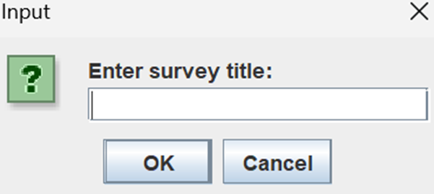 | 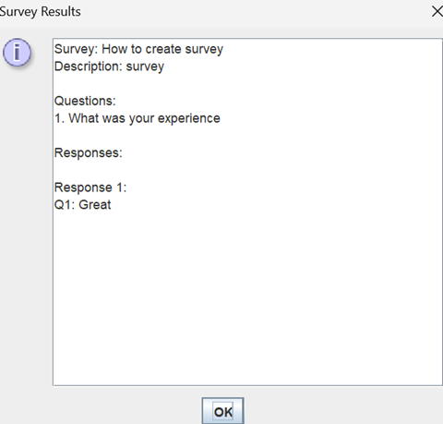
Workflow, and next steps

System workflow  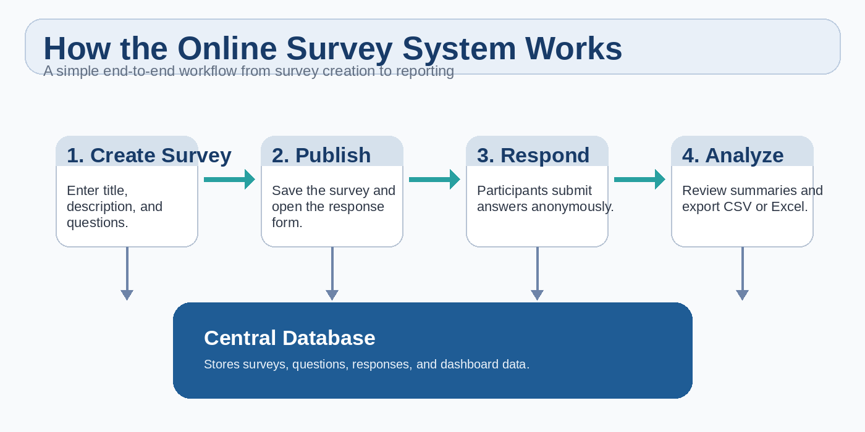 | Current status  Core workflow is implemented.  Scope is simplified to keep coding basic.  No advanced login or account management.  Focus on create, respond, review, and export.
Plan for the rest of the semester
Prioritize reliability over extra features. Keep the scope centered on survey creation, anonymous responses, basic results, and CSV export. To make development easier, remove advanced accounts, limit question types, and polish the main workflow instead.

