Instruction guide for converting MSU digitized PNE files to SAC format

**Preparing the text tile for conversion:**

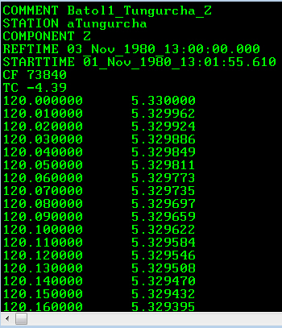MSU PNE files that are digitized at present need to be hand modified to include some supplementary information in terms of the starting time and date of each record. The python script that is used to convert the file to SAC format cannot create an appropriate time from the file without the information that you provide. The first few lines of the text file containing the digitized waveform should look like this:

COMMENT – This field is brought into SAC as comment

STATION: The first eight characters of the station name are imported.

REFTIME: This is the reference time as taken from the photographic record

STARTTIME: This is the field that must be hand calculated and placed within the text file by the user. It represents the REFTIME, plus the OFFSET (described below), plus the TC (time correction factor).

CF: Correction Factor, which converts the measured amplitude of microns into ground motion. It is derived from the photographic record and entered by the digitizer.

TC: Time correction (in seconds), which adjusts the start time forward or backward.

OFFSET is taken from the first sample and is listed in seconds. In the sample above, the first sample offset is listed as 120 seconds. Note that the sample above lists the TC as -4.39 seconds. Therefore the start time that is calculated by the user is 13:00:00.000 + 120 seconds - 4.39 seconds. This yields a start time of 13:01:55.61, where we move 115.61 seconds forward from the listed reference time of 13:00. The Reference time is the closest reference tic mark that is on the analog seismogram before onset of digitization record.

Note that there should be NO line feeds between the TC field and the first sample of the data.

**Converting the files:**

The conversion script is written in Python 2.7. Therefore the computer must have a functional Python interpreter as well as the seismic module ObSpy installed beforehand. The supported interpreter is found within the Anaconda package which should be downloaded and installed, followed by installation of ObSpy. The installation of the package is operating system dependent and is beyond the scope of this user guide.

The converter is run within the command prompt, and is designed to query a directory and convert any text files found within. Therefore, conversion of the PNE files is a batch process designed to convert multiple files. The converter will find, and attempt to convert all text files found within that directory. Go to the directory containing the converter script and run the script.

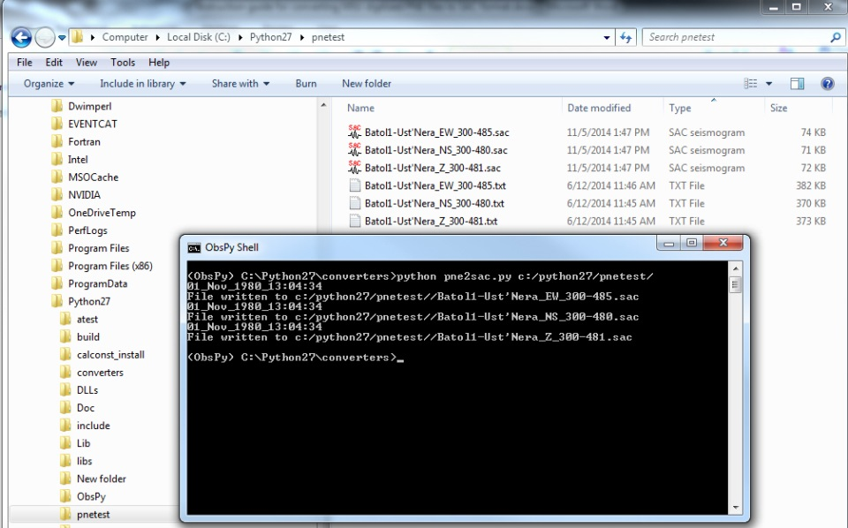The command is typed as follows: c:\> **python pne2sac.py c:/target_directory/**

Alternately, you can designate a single file thus:

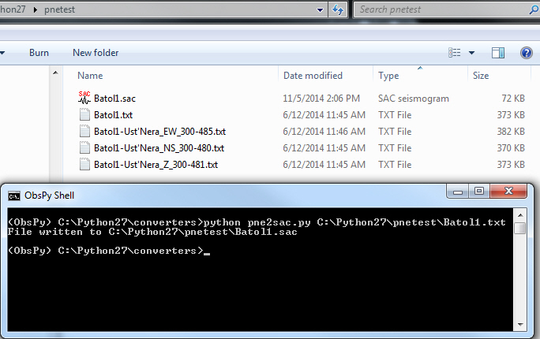c:\> **python pne2sac.py c:/target_directory/pnefile.txt**

The file format written will be the SAC-BIN format.