C:\Users\burkdani\Downloads\MSU-Wordmark-Green-CMYK.epsCTBTO-logo-Short-Engl-White.eps

How to create dataless SEED for seismic stations

1Daniel Burk

1Department of Geological Sciences, Michigan State University

**Abstract.** Once a seismic station is installed, it is critical to describe basic station parameters such as station location, digitizer sample rate, channel descriptions, gains, and instrument response. This information is stored as Metadata. One of the methods of packaging Metadata is through a Dataless Seed file. This document describes how to generate a dataless SEED using the JAVA utility PDCC, which is available for download through IRIS.

# Introduction

In order to utilize seismic data, some basic information about the station must accompany the waveforms such as station location, accurate time base, and calibration information. This Metadata is stored in various ways, from a simple table in a book, to actually embedding it within the file itself. One of the common methods of providing this data is to create a dataless SEED file. This file contains the entire record of station history, from station location changes, to amplifier gain changes, to even instrument upgrades. This guide is to be used in association with the manual from IRIS for the PDCC utility in order to help you a dataless SEED file that contains the Metadata for a basic, three-component station.

# Program setup

PDCC is available from IRIS at <http://ds.iris.edu/ds/nodes/dmc/software/downloads/pdcc/>

It is a JAVA based system, so you are required to have the latest JAVA present on the computer. Follow the instructions within the user manual that is located on the IRIS page to download and install the software.

## Downloading some sample dataless seed files:

According to the PDCC manual, you may attempt to create a dataless SEED file from scratch. However the easiest course of action is to take an existing dataless and modify it for your own needs. These sample files are located several places, including IRIS at this location: <http://ds.iris.edu/ds/nodes/dmc/data/formats/dataless-seed/>

You may also find such a file at this location: <http://www.github.com/tychoaussie/PDCC-Extras>

### What’s on the hub?

* Dataless seed file “dataless.LM_NE8K.seed” contains a single station, six channel station description with three short-period components and three broadband components. It may be edited for use with either a broadband or a short period station description by changing station name, network name, channel gains, station coordinates, and instrument response poles & zeroes.
* Channel calibration information, as generated by MDTCAL for the three short-period instruments that are described within the dataless seed file. These files enable you to cross-check the dataless seed file in order to know which fields go where.
* Station_Configuration_Worksheet.xls, which is a spreadsheet that is helpful for keeping track of the critical fields that need to be modified within your copy of the dataless SEED file.
* Supplementary texts, such as :
  + this guide book
  + Quick-start guide for requesting dataless SEED files from IRIS via email

Once you have a dataless seed file, and you have an operational PDCC Java program, you can open the file for browsing and editing.

# Dataless Seed Files

SEED is a data file format that includes not only the seismic time-history data, but also Metadata that describes the station history. Metadata includes all past calibration values, past station locations, present calibration information, and any relevant comments that the station operator wishes to include. A popular technique is to generate all seismic time-history data as a miniseed file that is stripped of metadata, and then utilize a “dataless” seed file to include the metadata. These dataless seed files are highly useful throughout the seismological community and serve as a handy packet for providing the station calibration when sharing data with analysts.

## Opening the dataless seed file:

PDCC is a Java application that is launched from a command-line prompt. IRIS has placed within the folder a batch file for Windows machines that will also open the program by piping the java code into the java interpreter. It is possible to either double-click on the batch file to launch the program, or type in the command yourself. I have generally found it easier to simply create a shortcut to the batch file and place it on my desk top.

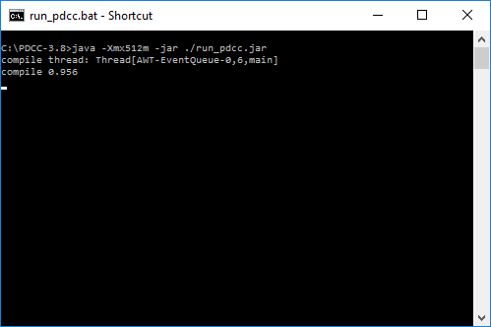

Figure Command line prompt: Execute command to start PDCC

I suggest that you copy the example file dataless.LM_NE8K.seed into the c:/PDCC-3.8 folder so that it is easy to find. Then, open the file in PDCC by pressing “Load a dataless SEED file” and browsing to the appropriate folder. Once the seed file is opened, the file will appear in the left-hand pane as a series of ‘trees’, much like what is found within the parameters registry file of any windows computer.

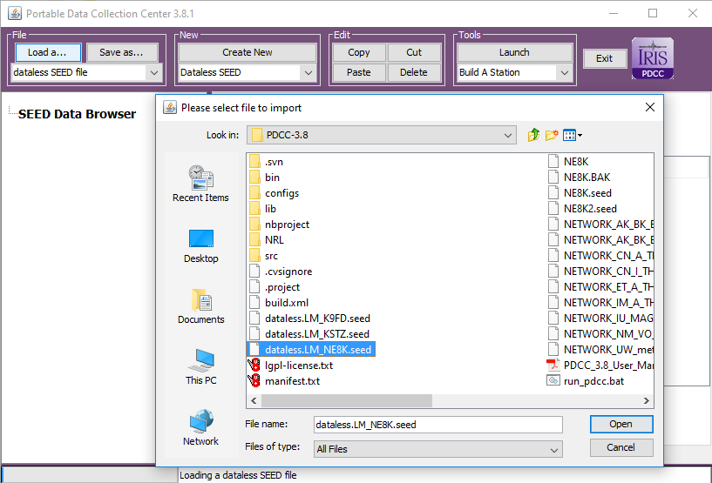

Figure Loading the dataless SEED file

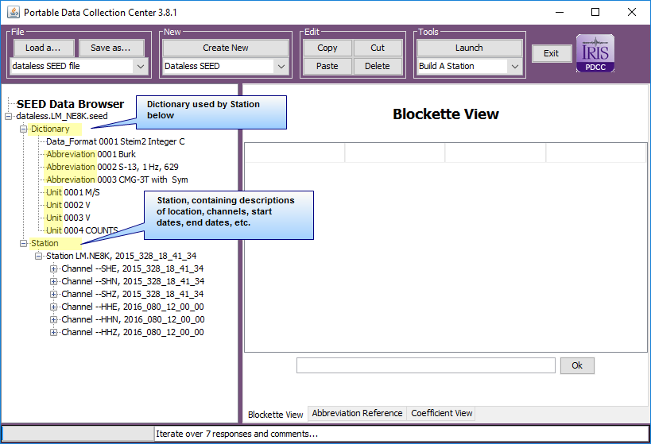

Figure PDCC Blockette arrangement in the SEED browser

Note that there are three parts of PDCC: The upper pane is the control pane where you can open files, save files, create new components within the file, and edit / delete components . These commands are covered within the PDCC manual here: <http://ds.iris.edu/pub/programs/pdcc/PDCC_3.8_User_Manual.pdf>

### Editing the dataless seed file

Note that the dataless seed is comprised of Blockettes, and they are arranged into two sections: The Dictionary and the Station.

#### The Station Configuration Worksheet

There is a worksheet that you will find on the Github page at:

<https://github.com/tychoaussie/PDCC-Guidebook/blob/master/Station_configuration_worksheet.xlsx>

This worksheet helps you keep track of the fields that must be changed within the dataless seed file in order to update it for your new station. The fields that need to be changed are highlighted in green. Fields in Orange are calculated by the work sheet. All values in green and orange must be transferred to the dataless SEED file.

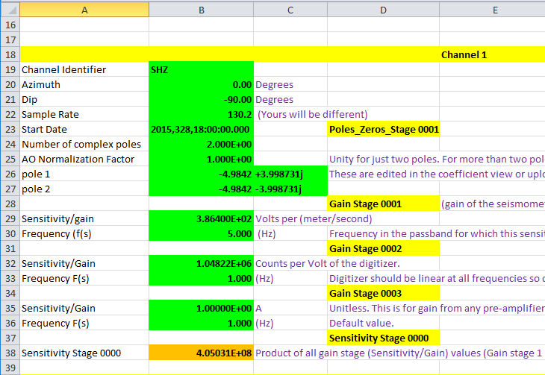

Figure Worksheet for successfully editing the dataless SEED file

#### Dictionary Blockettes

The Dictionary is a collection of blockettes that describe the system of units, seismometer descriptions, and important notes regarding the station maintenance. Abbreviations and units are numbered, and these numbered abbreviations and units are then referenced within the station blockettes. When you click on one of the abreviations on the left, you can update it within the Blockette View in the right pane.

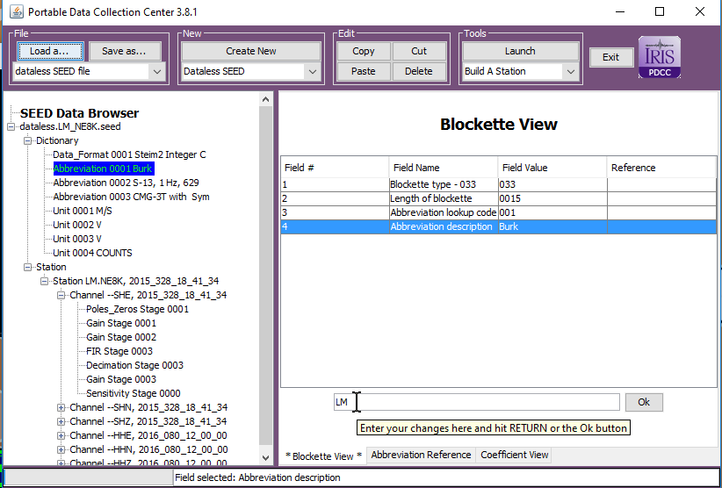

Figure Updating an abbreviation.

#### Station Blockettes

The Station blockettes contain information about the station such as its station code, network code, coordinates, and data channels. Additionally, there may be more than one station listed in the dataless miniseed: It may contain an arbitrary number of stations, perhaps even the entire network. It can also contain two stations representing the same station, but with updated critical information such as a new location, or perhaps a new type of instrument configuration. The way the two stations representing the same location are separated are by the start and ending dates that are embedded within the channel. When we set up a new seismic station, we must make sure to properly set the starting date for the channels.

### Navigating the Blockettes of the dataless seed

There are several types of blockettes:

* Data_format
* Abbreviations
* Units
* Station descriptions
* Channel descriptions.

When you click on a blockette field in the left pane of PDCC, PDCC will expand in the right-hand pane by opening the Blockette View. Each field within the Blockette can then be edited within the view. Some fields are simple text or simple numbers, whereas other fields, such as describing the poles and zeroes of an instrument, may be described as a series of coefficients. These fields can be edited within the coefficient view.

When editing an existing station for use with a new station, note that there are three levels of the Data browser which will be modified: The Station, the Channel, and the sub-components of the channel. This user guide will take you through each item.

### Station Blockette

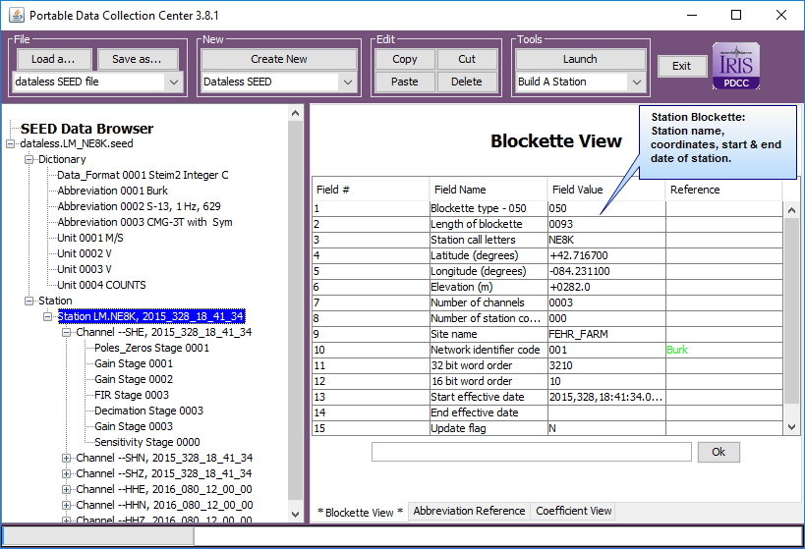

Figure Examining the Station Blockette in the Blockette View

Station Blockette is the top level of blockettes that describes each station. It is here that you will describe the location of the station, it’s call letters, the number of channels within the station, it’s elevation, and the network identifier code. It is here that some critical information must be updated for your station.

* Station call letters
* Latitude
* Longitude
* Elevation
* Site Name
* Start Effective Date

Some fields, such as Network Identifier code will use abbreviations from the Dictionary. It is in the dictionary where you must update any relevant abbreviations.

#### Channel Blockette

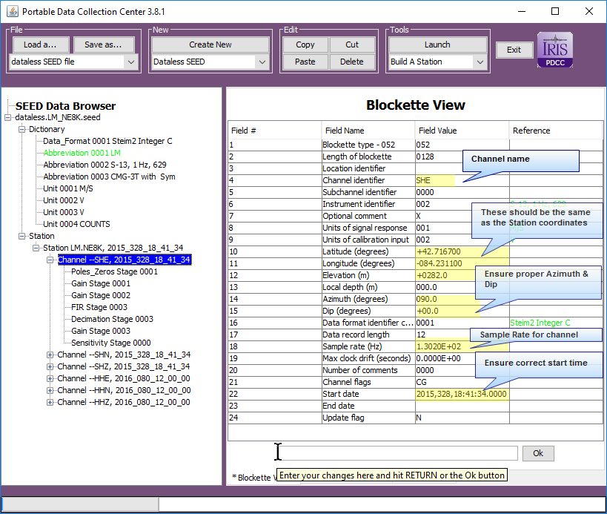

The Channel Blockette itself contains information that must be updated, as well as additional blockettes that will need to be updated. The good part is that each channel is similar to the other, but the bad part is that it is easy to overlook critical information. The fields that are highlighted above are important fields. You will find that each highlighted field is also present within a station configuration worksheet that is provided on the GITHUB page. I suggest you first fill out the worksheet for your station before you begin editing the dataless SEED file.

The important top-level fields include:

* Channel Identifier – Channel code, i.e. BHZ,SHZ,EHZ,LHZ, etc.
* Latitude
* Longitude
* Elevation – listen in meters
* Azimuth – This is the lateral orientation of the seismometer
* Dip – For vertical instruments, this is -90. For horizontals, it is commonly 0.0
* Sample Rate – The digitizer sample rate for this chanel.
* Start Date – The start date for all digital data for which this channel is valid.