The Calibration process cookbook (revision 2015-1-5)
The latest version of SIGCAL is found within the online repository: www.github.com/tychoaussie .
Access this repository and download Sigcal_V1 .
You must have a running version of Python 2.7 as well as the Obspy software plugins installed on your computer in order to use Sigcal.

STEP 1: Convert the DAT files into CSV files.
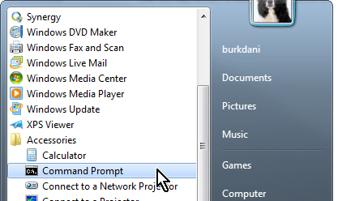
The utility called “DAT2ASC.EXE” will convert Symmetric Research files into a comma separated file format which is used for processing all of the calibration data. This is the only format currently supported by this process.
This process will be used to convert all DAT files used for calibrating all parts of the system, and is run from the command prompt. In Windows, find the command prompt window which is generally found under “accessories”:

1a) DAT2ASC.EXE is provided in the utilities from Symmetric Research. The specific version necessary is dated from 10/5/2010 and is 171,008 bytes in length. Find the program within the Sigcal repository on GITHUB and transfer it to to the directory c:/python27. Create the directory if it does not already exist. DAT2ASC.EXE will be used by the python conversion utility to automatically convert all of your data into text files.
1b) Clean your data by taking all data files that do not contain your signal files and move them to an archive directory.
1c) Move the data files that contain your freeperiod data measurements into their own subdirectory called freeperiod.
1d) Move the data files containing your damping ratio measurement data into their own subdirectory called dampingratio
1e) Make sure that all remaining .DAT files within the subdirectory represent clean sine wave signals that represent the seismometer coil signal and the laser position sensor, with no interruptions or signal frequency changes within the file. Also make sure that you have documented which channel contains the laser position sensor (usually channel 4), and which channel contains the seismometer signal under test.
1f) Open a command line window, and point the current working directory to wherever you have stored the Sigcal scripts. (I use c:/python27/sigscript for this example)
1g) Using the command line prompt, invoke Python and run the script called “dat2csv.py” on the target directory containing your data files.
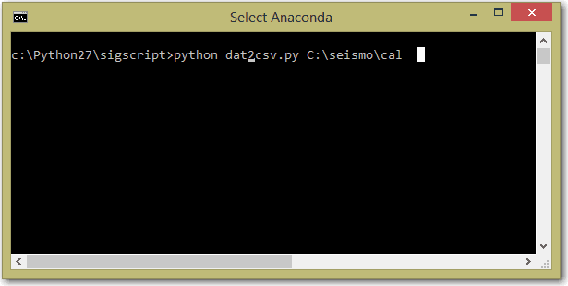
This script will batch convert all .dat files within the directory into csv files. Repeat this process by pointing it at the directories containing your free period data, and your damping ratio data.

STEP2: Measure your free period and damping ratios

2a) Measuring the Free Period
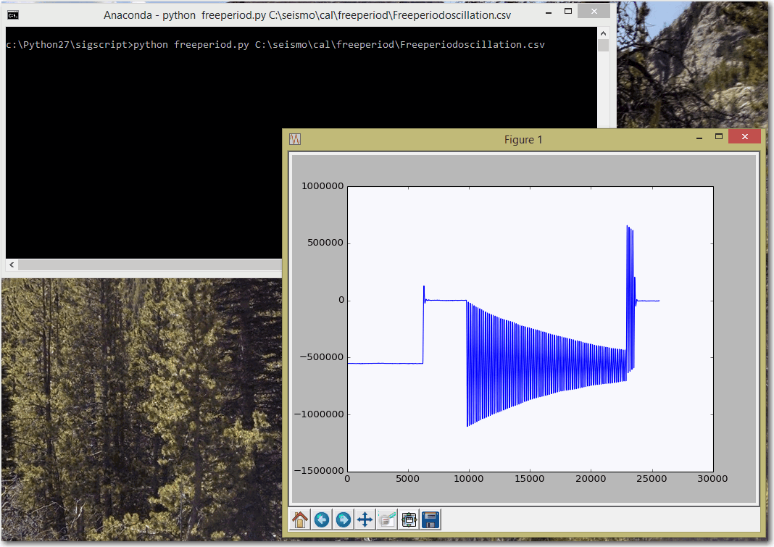
Using the command line prompt, use the script called freeperiod to analyze the period data that is represented by the converted .csv file. The script will initially display the raw waveform. Use your cursor to find the starting sample of the oscillation and record this number. The number is displayed in the lower right corner of the window as the X value. In the graphic above, X occurs about sample 10,000. Once you record the sample number for the beginning of the waveform, close the window. The command line prompt will ask for the sample number that you have selected, and will return with a new window which displays the cropped waveform, along with the free period oscillation frequency which is shown in the lower right corner of the graphic.
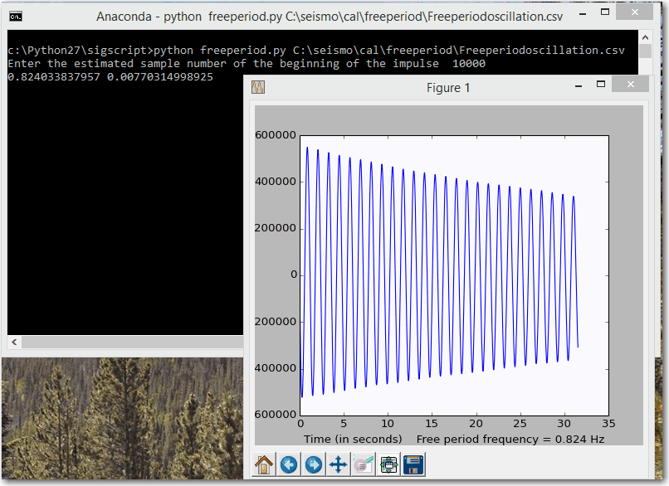
Record this value as it represents the free period oscillation frequency in Hz. This value will be used to create the calibration control file for the processing of your data.

2B) Measuring the damping ratio
Sigcal has a damping ratio measurement utility aptly named “dampingratio.py” for use in measuring with great accuracy the damping ratio of the waveform. It works in similar fashion to the freeperiod utility. It also requires a bit of manual effort in terms of recording a couple of numbers: You will need to specify the number of damping ratio events that are in your file, as well as the starting and ending sample numbers that bracket each event. To do so, find the csv file that contains your damping ratio experiments, and run the analysis utility at the command line prompt. The program will ask you to input the digitizer channel number onto which the seismic sensor is connected, as well as the channel number that is used by the laser position sensor. Channel numbers are necessary for when a system is field-deployed in which multiple seismometer axes exist. The channel number that you should input should be hooked to the axis which you are calibrating.
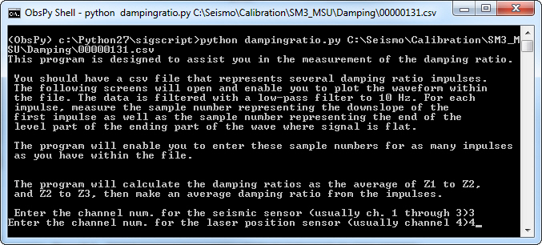
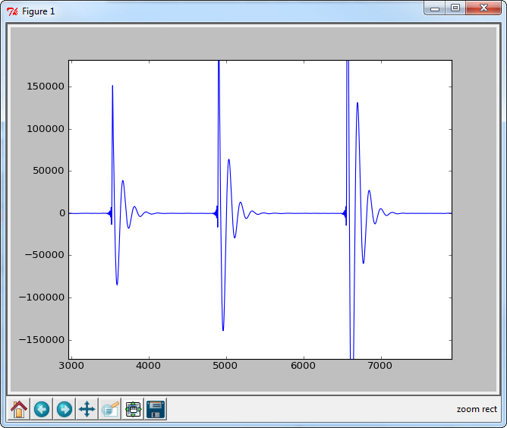
After you input the channels, a sample graphic of the channel sensor signal will appear. Several impulses should be visible within the graphic. You must decide which of the impulses to use for the calculation of the damping ratio. The utility will use these impulses to accurately calculate the damping ratio by measuring the impulses and averaging their performance to yield a mean damping ratio. Use the sample window to zoom into each impulse, and record the starting and ending sample for each impulse. The ending sample should be sufficiently far enough from the start of the impulse that it is a measure of the flat part of the signal, when all oscillation has been damped out. Count the number of impulses you have measured, and record the starting and ending sample numbers for each impulse. Once you have measured the impulses, close the window by clicking the little X in the upper-right corner. The command line window will return and ask you to input this information.
IMPULSE | START SAMPLE | END SAMPLE
1 | 3540 | 4600
2 | 4920 | 6000
3 | 6585 | 7700

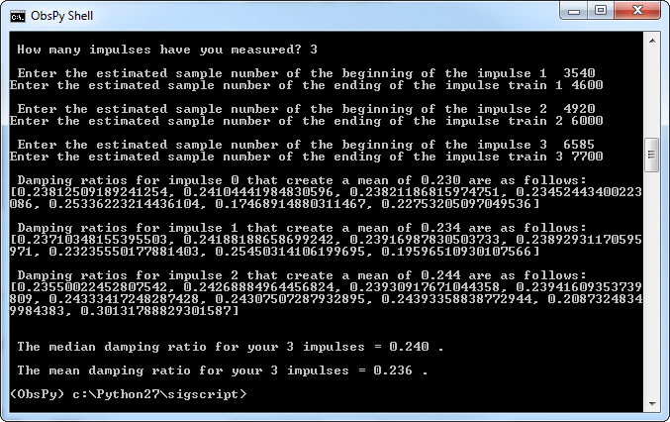
With the successful measurement of the free period and the damping ratio, it is now possible to create the calibration control file that is used for calculating the instrument response.

STEP3: Calibrate the system constants
Before Sigcal can create a calibration curve for the sensor, a few calibration constants must be defined:
- The station name
- The sensitivity of each channel of the Analog/Digital Converter in terms of microvolts per count
- The sensitivity of the laser position sensor in terms of millivolts per micron of ground motion
- The ratio of the length of fulcrum to center of mass, divided by the length from fulcrum to laser target. This is known as “lcalconst” and is required in order to resolve laser displacement with actual seismometer mass displacement.
- The total damping ratio “h” for the seismometer as a response to an impulse.
- The seismometer free-period resonance frequency.
These calibration constants must be measured and recorded accurately if we wish to reconcile the mass movement to actual ground motion and seismometer coil signal output. Therefore, be sure to accurately calibrate your digitizer by applying a set voltage step to each channel and measure the resulting change in counts . Divide the voltage by the number of counts offset, then multiply by 1,000,000 to yield a calibration constant of microvolts per count. Calibrate also your laser position sensor to determine its actual voltage output in terms of millivolts per micron. You may then generate your calibration constant file by running the python application, “calconst.py”
It is assumed that the technique for calculating the true sensitivity of the analog-digital converter has been employed to determine the exact measurement of microvolts/count. It is also assumed that the laser output has been measured by using a micrometer or some other method of determining the number of millivolts for one micron of displacement. It is also assumed that the moment arm ratio between the center of the mass and the measurement point of the laser has been calculated. (This is called the laser cal constant, typically something like 0.535 for the SM3)

Step 3.1: Generate the calcontrol file.
Gathering your constants, enter them into the program called calconst.py in order to generate the new calibration constants for processing your data.
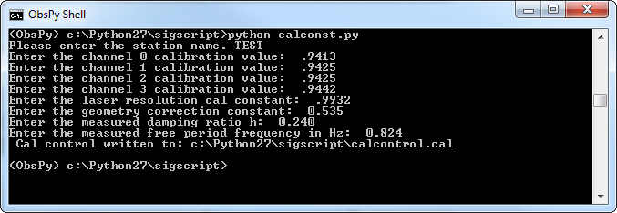
The calibration values for channels 1 through 4 represent the number of microvolts for one count of the analog-digital converter.
The laser resolution cal constant represents millivolts / micron.
The geometry correction factor represents the difference between the center of the velocity coil and the actual measurement location. This is important if the laser is mounted a significant distance from the center of the coil. It is calculated by measuring the distance from the pivot point of the seismometer pendulum and the locations to the laser as well as the center of the coil. As the system swings through its movement, the displacement of points farther away from the pivot point will be greater than points located closer to the pivot. The ratio of distances is represented by this equation:
Lcalconst = Length of moment arm to the center of mass / length of moment arm to center of laser pickup point.
The center of mass may be computed by a cal laboratory, by using a vibration table, and exciting the instrument with a sine wave that is 5 to 7 times higher than the resonance frequency. The mass at this frequency will display an amplitude that is almost identical to the movement of the vibration table, except that it will be 180 degrees out of phase. You can use the laser position sensor to measure the amplitude at your laser pickup point, then use the laser position sensor to measure the amplitude of the vibration table. The ratio of the two measurement amplitudes will also yield lcalconst. From this ratio, it is also possible to computer the exact position of the mass center. Since seismometer models will not significantly vary in terms of the center of mass, a published list of mass centers for each seismometer would be a desirable study.
The damping ratio and free period frequency have been measured in the previous paragraphs.
Once these constants have been entered into the program, the control file is ready for use in calculating the sensitivity curve for the seismometer . This is accomplished by converting the signal files into .csv ascii files, then storing them in a separate directory for processing with sigcal. Each frequency that was tested should be separated into its own ascii.csv file as the program depends on the data being stationary and clean, with no signal offsets or changes in frequency during each test.

Step 3.2: Copy the generated cal control file into the directory that contains your calibration data.
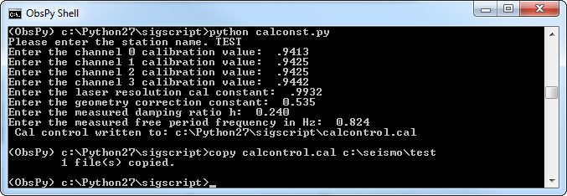

Step 4: Process your calibration data
It is important that, when collecting the calibration data, you change frequencies BETWEEN logged file runs. The digitized files which contain the frequency change should be moved OUT of the directory structure and stored within a separate “archive” directory before you run the DAT2ASC program. Once your directory has been cleaned, your .DAT structure should have only one, perhaps two files per frequency. These files should now be converted to ascii .CSV using the DAT2ASC.EXE utility. The result should be several dozen .csv files within the directory structure that represents the instrument response to frequency. NO OTHER CSV FILES should be present within the directory: Store your damping ratio and free period ascii files in a separate subdirectory. All that should be present within this directory are the .csv files that you created, and the calcontrol.cal file that you generated a few minutes ago.
Once the files are present, open the command prompt and point it to the working directory that contains the files. Then type “python sigcal.py”. If your paths are set correctly, and if you have the python script located within the working directory, the program should parse through the directory and locate all of your csv files. The result should be a series of status lines as it processes each file, followed by the construction of a calibration output file as well as a graph of the response curve.
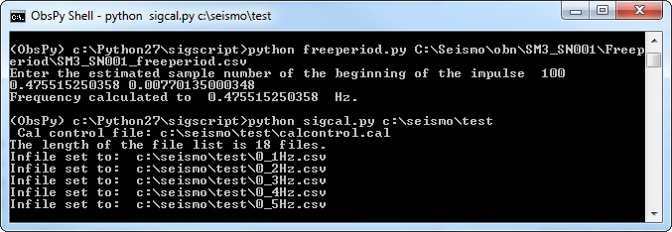
This results in both a response curve output graph, but also in the creation of a SAC poles and zeros output file.
Files output by Sigcal:
freq_v_amp.png – A graphics file that contains the plot of the response curve after optimization
calibration_output.cal – A text file that lists the calibration curve points before optimization by the grid search algorithm.
Stationname.sacpz – The sac poles & zeroes file that describes the calibration of the channel. Understand that you may need to rename this file to indicate the channel description in cases where you are calibrating more than one channel per station.
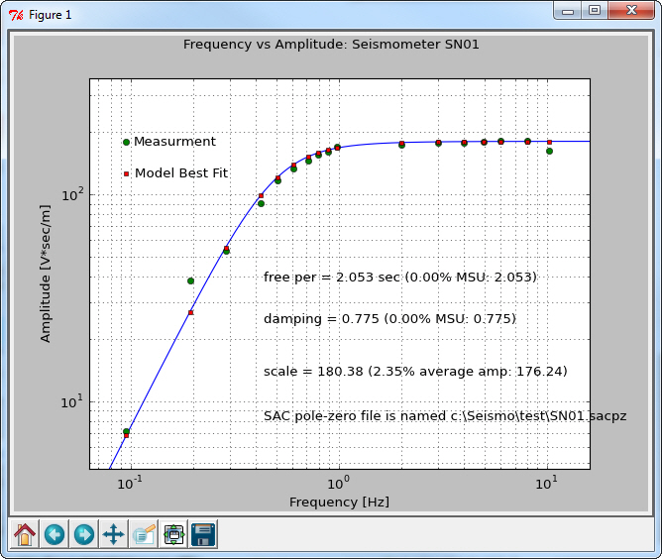
Note that the calibration display contains some essential information. The green dots show the actual, measured calibration curve. Points on the extreme ends of the curve are generally subject to issues such as reduced signal resolution as the signals and amplitudes get small and closer to the limit of measurement. The blue line and red dots represent the optimized curve as generated by a poles and zeros model for the measured data.

