20150224 - Sigcal version 2

How to calibrate with the SIGCAL software package:

1) Determine the voltage sensitivity of each channel on the digitizer in microvolts per count.

5V/2^21 = 2.38 mkv/count
Symmetric Research USB4CH: 0.95 mkv/count

2) Record the sensitivity of the laser position system in millivolts per micron.

~1.0/mV/mkm (LK-G32 / 3001)
~0.94 – 1.06 mV/mkm for (LK-031/LK2001)

3) Determine the ratio between the fulcrum of the seismometer to the center of mass, from
the fulcrum to the laser measurement point. This is known as the laser cal constant.

- For the SM3, this ratio is about 0.579, because the laser measurement point is farther away
from the fulcrum than the center of mass.
- For the SKM, this ratio is about 0.4 for the same reason.
- For the SK1-P, this ratio is 1.0, because the laser measurement point is at the center of mass.
- For the Vegik, this ratio is 1.0, because the laser measurement point is at the center of mass.

4) Determine the free-period of the sensor by disconnecting the damping resistor and exciting the
mass.
  - Analyze the free period by using the script: python freeperiod.py

5) Re-install the damping resistor and test the damping ratio by exciting the mass.
Apply four to five impulses while connected to the digitizer.
  - Analyze the damping ratio by using the script: python dampingratio.py

6) Create the calibration control file by using the script: python calcontrol.py
- This script will prompt you for the following information:
- Station Name:
- Four channels, Channels 0 through 3
- Channel name. This must be the same as is found within the digital data.
- Channel sensitivity in terms of microvolts per count.
- Laser sensitivity in terms of millivolts per micron.
- Laser geometric calibration constant. (laser cal constant). (This is a ratio and is unitless.)
- Free period of the sensor in Hz.
- Damping ratio of the sensor.
- The channel number (0 through 3) representing the sensor being calibrated
- This should correlate as one of the four channels listed above.
- The channel number (0 through 3) of representing the laser position sensor.
7) After creation of the calibration control file, place a copy within a new directory
to be used with the digitized files of the sine sweep data to be used in the calibration.

8) Now that :
- the sensitivity of the digizer is known
- the sensitivity of the laser is known
- the geometric difference between the laser measurement point and the center of mass is known
- the free period is known
- the damping ratio is known
- the channel number for the sensor under test and the laser position sensor is specified
We will be able to determine exactly:
- the millivolt output of the sensor coil that represents an unknown velocity
- the millivolt output of the laser that represents a known mass displacment.
From mass motion, we will be able to calculate ground motion using free period and damping ratio.
From ground motion, we will be able to calculate sensor velocity at each tested frequency.
By dividing the sensor voltage output by the calculated sensor velocity, we can determine
the sensor sensitivity at the tested frequency.
By performing this operation at each frequency within the sensor passband, we can construct
the frequency response curve for the sensor, taking into account all variables such as:
- seismometer
- preamplifier
- coil loading due to impedance mismatch or low amplifier input impedance.

9) Begin a sine sweep of the sensor by exciting the calibration coil with a single sine wave at
a voltage amplitude sufficient to yield good displacement for the laser position sensor.
- It is suggested that at frequencies above 3 Hz, that voltage amplitude be doubled to preserve
- sufficient ground motion for good laser resolution.
- Dwell at each frequency step for 60 seconds, or 10 periods, whichever is greater.
- minimize your movement about the sensor, for it will influence the laser as a low frequency displacement change.

10) Suggested calibration steps:
- 0.1 Hz
- 0.3 Hz
- 0.5 Hz
- 0.7 Hz
- 0.9 Hz
- 1.0 Hz
- 1.1 Hz
- 1.3 Hz
- 1.5 Hz
- 2.0 Hz
- 2.5 Hz - Double your sine wave voltage amplitude
- 5.0 Hz

Because the calibration compares sensor coil voltage output to mass displacement, it is independent of the calibration coil voltage and is unaffected by drive voltage changes. The calibration is affected, however, by insufficient ground motion for good laser resolution. The laser is accurate to about 1 micron. In general, ground motion should never be allowed to fall below +- 0.1 mm (100 micron). Otherwise, digital quantization errors in the measurement will influence the calibration accuracy.

If you are able to view your data real-time, here is the formula for calculating the approximate number of counts that will be displayed at 100 microns:

100 microns * laser_sensitivity * (1000 uV/mV) / digitizer sensitivity

For example, with 0.298 uV/micron digitizer, and a 1.0 mV/micron laser sensitivity, we get:
100u * 1000uV/u * 1/(.298 uV/CNT) = 335570 counts peak.
If the peak amplitude of the laser falls below this amplitude, turn up the signal generator voltage and repeat that frequency sweep.

11) Convert the data to a standard format.
- Sigcal version 2, supports direct import of files in :
- the Symmetric research .csv format
- data stored in .sac format.
- Miniseed data format
- css3.0 data format

- Convert your digitizer data to one of these formats, making sure that the channel names
in the data match the channel names located in the calibration control file for both the
sensor and the laser position sensor.
- csv2sac.py is one such converter. It converts Symmetric Research USBXCH .dat files into both
a csv format as well as a whole series of SAC files.

Whatever converter is used, the station name and channel name should be embedded within the file name for Sigcal to properly find the data for each channel. This requirement does not apply to css3.0 .wfd files.

12) Strip out all data files that contained mixed sine waves.
- Sigcal requires that each file in the matrix contain only one specific frequency. Sigcal
will use an FFT to calculate rms energy for both channels, and it is assumed that the data
is sinusoidal at the one frequency. The rms energy of the sensor is divided by the rms of
the laser, along with 2*pi*f, to calculate the V/m/second at that frequency.
13) Once the matrix of files (either SAC or csv) has been cleaned of all extra data, run sigcal
to process the curve and generate the sac poles and zeros file.

Install Python

Step 1: Python is best installed as part of the Anaconda software package. You must be connected to the internet for this to work properly. Navigate to this website and retrieve the appropriate download for your operating system. There is a choice of Windows for 64-bit operating systems, Windows with 32 bit operating system, and linux. Choose the correct version, download, and install.

http://continuum.io/downloads

After installing, open a command line window and use it to install Obspy software :

This uses the easy_install utility that was installed by the anaconda software package.
Navigate to the directory: c:/anaconda

easy_install lxml

easy_install sqlalchemy

easy_install suds>=0.4

easy_install obspy

Once obspy is installed, confirm the installation by attempting to activate Obspy from inside Python.
At the command line prompt, type:
../../../anaconda
c:\anaconda> python
>>> import obspy
>>>

If python is installed properly, the >>> will appear. If Obspy is present, the computer will respond by presenting another >>>. If Obspy is not installed, you will receive an error message.

Install Sigcal utilities:

Download Sigcal
Once Obspy is installed, download the latest Sigcal calibration package from:
http://www.github/tychoaussie
Install Sigcal scripts
Install the subdirectory called Sigscript within the c:/Anaconda directory. These are the “programs” that run inside Python that process the files. The actual path to the files may vary depending on where you downloaded the files.

C:/Anadonda> copy “c:/My Documents/Downloads/sigcal_v1/sigscript” c:/Anaconda

Install the Symmetric Research file converter
If you use the USB4CH digitizer, create a directory called c:/Python27 and copy the file called “DAT2ASC.EXE” from the sigcal SYMRES Utilities directory.

C:/Anadonda> copy “c:/My Documents/Downloads/sigcal_v1/SYMRES Utilities/DAT2ASC.EXE” c:/Python27/dat2asc.exe

At this point, you should have an operational Python shell, along with the Obspy seismic module, as well as the Sigcal calibration module. All calibration operations are executed from the command prompt. Sigcal is occasionally updated, and the updates are uploaded to the github link provided above. Github may be configured to let you know when new updates are available.
Tutorial: How to step through the processing of the data:
The process of analyzing data varies depending on the digitizing system. It is hoped that as time goes on and we gain experience with different digitizers, that the software will accommodate more systems. This tutorial uses data generated by the Symmetric Research USB4CH.

Gather the calibration information for the system
The first critical information that is necessary to calibrate is to know what the counts of the digitizer represents. We must understand the number of millivolts that are generated by the sensor, and the number of microns of ground motion that are generated by the laser position sensor. In the case of data used by this tutorial, the critical information is:

- Name of Channel 0: LZR .
- Sensitivity of channel 0: 0.957 microvolts per count
- Name of Channel 1: KZZ .
- Sensitivity of channel 1: 0.954 microvolts / count
- Laser sensitivity: 1.000 millivolts per micron
- Laser calibration constant: 1.00

Prepare the sample data

The sample data is found in the directory ./tutorial/sampledata. These are .dat files as generated by the Symmetric Research USBXCH. In this case, the files will be edited, then batch converted for processing. The processing will not work until a calibration control file is first created.

Move the scripts
Although it is possible to execute all Sigcal (signal calibration) scripts from their parent directory, It is generally less typing to simply move a copy of all necessary scripts to the working directory. The scripts you should copy for this tutorial are:

Sigcal.py
Csv2sac.py
Calcontrol.py
Freeperiod.py
Dampingratio.py

These scripts are found at the github location under the subdirectory called sigscript. Copy them to the working directory. They are accessible through the internet and the latest versions will always be found here at this url:

https://github.com/tychoaussie/Sigcal_v1/tree/master/sigscript

Determine the Free period of the sensor
The free period may be determined using multiple methods. The classic method is to use the stopwatch and manually count the number of rebounds of the mass when the damping coil has been disabled. A second method is to digitize the oscillation and use the python program “Freeperiod.py” to accurately determine the period using the entire waveform. This is accomplished through the use of a fast-fourier transform (FFT). It requires that the mechanical damping ratio be very low, (less than 0.1) so that there are sufficient oscillations present in the signal. Otherwise, the manual method must be used.

Convert the data to the symmetric research .csv data file format with the DAT2ASC.EXE file utility.
Example:
C:\my_working\freeperiod\> c:/python27/dat2asc.exe 00000026.dat csv

Using Free Period script:
c:\my_working> python freeperiod.py ./freeperiod/filename.csv
Point the script at the file containing the free period oscillation. It is good practice to place it within its own subdirectory called “freeperiod”.

The script will first load the csv file, and display a plot. Using the cursor, find the beginning sample number of the oscillation. Record this sample number, then close the plot. Freeperiod will ask you for this sample number in the command line window. Freeperiod will then use this sample number and will perform an FFT on the oscillation. It will then conclude by printing another plot of the waveform that includes the free period oscillation in Hz.
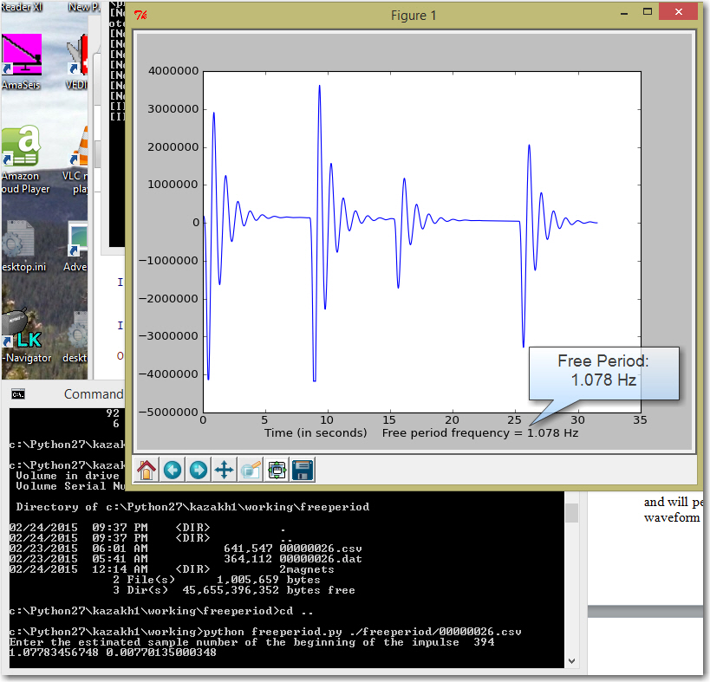

Re-connect the damping circuit and record this value. It will be used when generating the calibration control file.

Determine the damping ratio of the sensor
The damping ratio is traditionally measured by manually measuring the amplitude of the initial impulse and the second rebound, then multiplying using the formula:
h = 1 / sqrt {1 + [Pi / ln(A1 / A2)]**2}
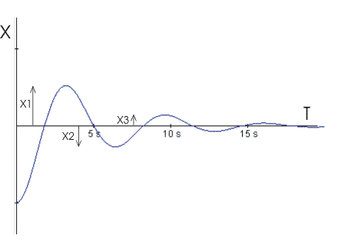
A1
A2
However, the damping ratio also applies equally to subsequent rebounds, if they are present. It is also more accurate to use multiple impulses and then average the calculated ratios. The sigcal script dampingratio.py will analyze multiple impulses and calculate an average for the whole waveform of each impulse.

First, convert the data to the symmetric research .csv data file format with the DAT2ASC.EXE file utility.
Example:
C:\my_working\freeperiod\> c:/python27/dat2asc.exe 00000026.dat csv

Next, run the script dampingratio.py on the csv file. It will first ask you to choose the channel number that represents the seismic sensor. It is a value between zero and three, and is dependent on which channel the sensor was connected at the time of data acquisition. It will next ask for the channel number that represents the laser.
Next, it will display a window with the data waveform. Use the window to pick the starting and ending sample for each impulse that you wish to include in the damping ratio calculation.

Use the “zoom” button to place a cursor onto the screen which will tell you the sample number on the X axis. Use this information to determine the approximate beginning and ending sample number for each impulse.
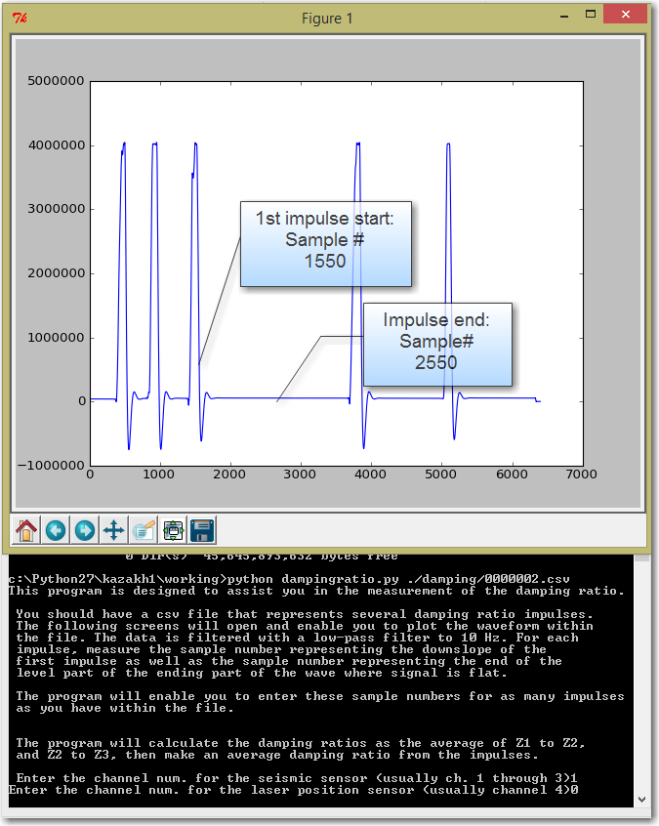

Record the starting and ending samples for the three or four best impulses. When finished, close the window and enter the sample numbers into the command line prompt:

Impulse 1: Start: 1550 Stop: 2550
Impulse 2: Start: 3850 Stop: 4850
Impulse 3: Start: 5150 Stop: 6150
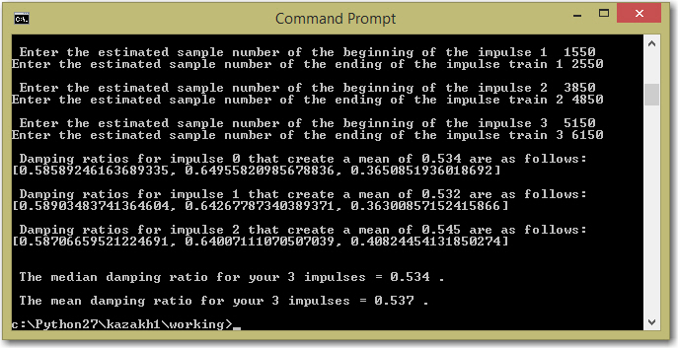

The program will analyze the first three rebounds of each impulse and report both the median and the mean impulse. In most cases, the mean damping ratio is the most representative of all amplitudes. In cases where there are only two rebounds on the impulse, such as damping ratios greater than 0.707, the program may not be able to calculate the sampling ratio and it may be necessary for you to manually calculate it. It is difficult to calculate damping ratios for over-damped systems. This is an ongoing development.
Mean damping ratio: 0.537

Create the calibration control file:
Sigcal is the processing program that will analyze the sine wave data located in the working directory. It requires a control file in order to make sense of the data. This control file designates the channel names, and the calibrations that relate the digital file to real voltages, and ground motion. The script calcontrol.py is used for the creation of the control file.

C:\my_working\>python calcontrol.py

The program will prompt you for information regarding four channels. Since only two channels are used, the remaining two channels are entered with channel names of NA1 and NA2. (This means “not applicable”.) If you choose to press enter without placing any information in the field, a default value will be chosen.

Enter the information for the four channels, as well as the following calibration information:
- Name of Channel 0: LZR .
- Sensitivity of channel 0: 0.957 microvolts per count
- Name of Channel 1: KZZ .
- Sensitivity of channel 1: 0.954 microvolts / count
- Laser sensitivity: 1.000 millivolts per micron
- Laser calibration constant: 1.00
- Channel number for the sensor under test: 1
- Channel number for the laser position sensor: 0

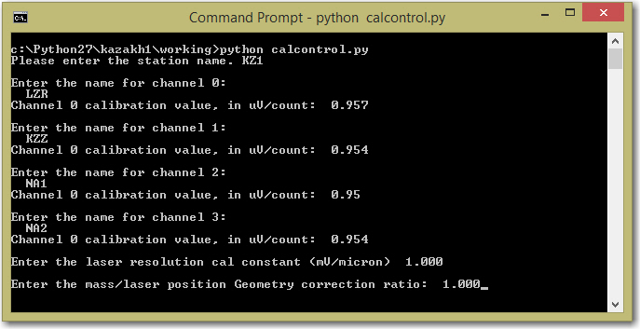

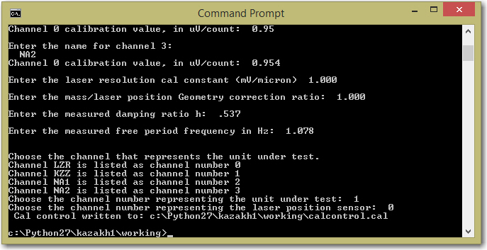

The calibration control file should be placed within the working directory in which your sine wave signal data is to be analyzed.
Collecting the data:
With the calibration control file generated, and the sensor free period and damping ratio measured, it is now possible to use a sine sweep to determine the sensitivity of the seismometer. Use the digitizer with the assigned channel names that are located within the calibration control file, and collect the sine sweep data. In the case of the tutorial, this has already been accomplished for you.

Edit the data files
The digitizer will create files continuously during the sine sweep. We ran the signal generator at multiple frequencies, and held at each single frequency for greater than one minute. Files that contain two frequencies are placed into an “archive” directory so that they are not included in the analysis.

The digitizer created files in sequential order, from 00000000.dat through 00000084.dat. Some of these files do not contain a calibration signal. Some of the files contain frequencies and amplitude shifts. These files must be moved to the archive directory. Here is our record of file names as the files were being digitized, and the frequencies contained within each file. Files that are NOT listed on this table must be removed from the working directory and placed in the archive. Files containing different frequencies must not be sequential, or else the converter DAT2ASC will combine them. We want the files to be separate. If sequential files exist, rename one of them by incrementing it’s file number by 100, 1000, etc.

00000013.dat – 0.1 Hz
00000016.dat – 0.5 Hz
00000018.dat – 0.7 Hz
00000020.dat – 0.8 Hz
00000022.dat – 0.9 Hz
00000024.dat – 1.0 Hz
00000026.dat – 1.1 Hz
00000028.dat – 1.3 Hz
00000032.dat – 1.5 Hz
00000034.dat – 1.7 Hz
00000036.dat – 2.0 Hz
00000038.dat – 2.5 Hz
00000040.dat – 3.0 Hz
00000044.dat – 4.0 Hz
00000046.dat – 5.0 Hz
Place all other remaining files into the archive directory. (except for the calibration control file.)

Convert the data into SAC
This process will be unique for each digitizer model.
The Symmetric Research USB4CH .dat file format can be converted to SAC by using the python script “CSV2SAC.py”. This script will do two things: It will generate a series of comma separated variable files by using a Symmetric Research utility called “DAT2ASC.EXE”. This file must be located in the following directory: C:/Python27. You can find this file on the github site here:
http://github.com/tychoaussie/Sigcal_v1/tree/master/SYMRES%20utilities

Place dat2asc.exe in the directory called c:/python27

Once the file has been placed, open a command prompt, navigate to the working directory and run the script csv2sac.py in order to convert the data:
C:\my_working>python csv2sac.py

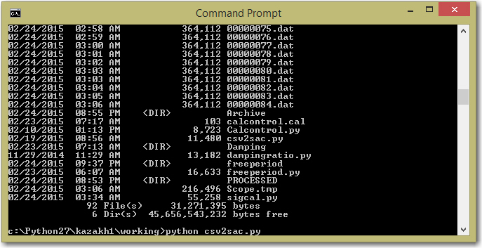

This will convert the data to both csv and SAC file format.

At this point, there should exist SAC files that represent the sensor, as well as the laser. With the creation of the cal control file, and the SAC files that represent the sine sweep data, all of the requirements are met for creating a calibration file.

Analyzing the data to create a calibration
First, make sure a copy of Sigcal.py exists within the working directory, along with the calcontrol.cal file, as well as the SAC files.

Use the command prompt and enter the working directory where the SAC files are located:
C:/cd c:\Working

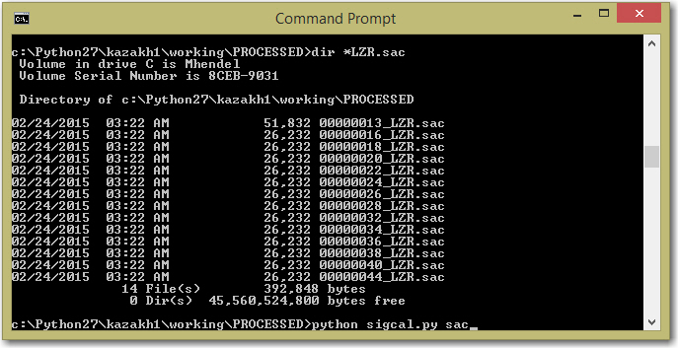
Enter the directory, and type c:\working>python sigcal.py sac
Sigcal will parse through the directory, open all SAC files, and create a series of response points for each frequency. Each coil voltage will be compared to the computed ground motion velocity, as determined by the laser position sensor. This makes it possible to calculate the sensitivity of the seismometer at that specific frequency. Once all of the points have been calibrated, a calibration curve will result. Sigcal will then “test” different damping ratios and free periods in order to best fit the calibration curve. Once the best fit has been determined, Sigcal will generate a SAC poles-and-zeros file that describes the response of the instrument.

