Field notebook

1. Preparation
Record the sample before changing the instrument.
Keep the blue marker beside the reference vessel.
Table 1. Observation register
Sample | Indicator | Result
Aster | Blue | Stable
Birch | Green | Pending
Cedar | Amber | Stable
Dahlia | Violet | Repeat

2. Observation
Repeat the observation after the indicator settles.
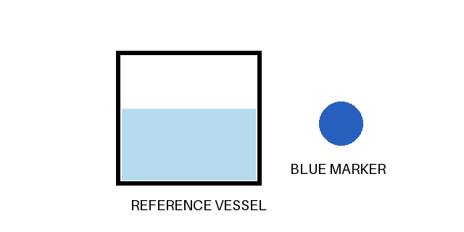
Figure 1. Reference vessel and blue marker.

