**Report from Lab nr 2 - Heat transfer**

**Author: Jan Tyc**

1. **Introduction**

Thermodynamics is a part of physics that is about heat, particle movement and it’s macro properties. With parameters such as conductivity or specific heat capacity we can calculate the tranision of heat in diffrent scenarios such as: heat transfer on a space ship, heat transfer on in a house including air conditioning or heat transfer in a nuclear power plant. Thanks to such simulations we can better predict and construct crucial parts of modern technology.

1. **Laboratory outline**
   1. **Model coding**

Physical object that is being simulated is made out of two 30x30 matrixes. First one is responsible for distribution of the temperature, whereas the second one is responsible for preserving 1st and 2nd boundary conditions.

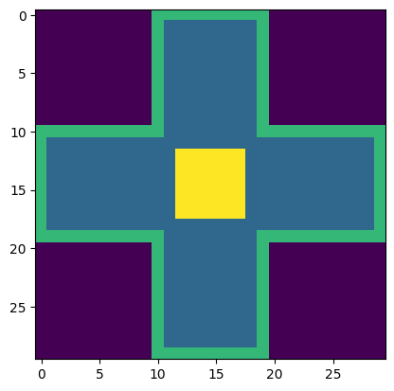

Figure 1 - Presentation of simulated object (yellow – heater, blue – object, green – Edge of object of constant temperature 10 degrees, purple – background without influence)

Above is the simplified heat transfer equation which will be used to calculate temperature in each cell in step n+1

Simplified mathematical equations describing heat transfer were implemented into python function:

def calc_temp(self, T_prev, T_left, T_right, T_top, T_down):

        dx = 3/self.resolution

        dy = dx

        p1 = T_prev

        p2 = (self.K*self.dt*(T_left-2*T_prev+T_right))/(self.cw*self.p*dx**2)

        p3 = (self.K*self.dt*(T_top-2*T_prev+T_down))/(self.cw*self.p*dy**2)

        return p1 + p2 + p3

* 1. **First simple simulation**

First simulation was made for alumina material with following parameters:

Density : ρ=2700 kg/m3

Specific heat : cw=900 J/kgK

Thermal conductivity : K=237 W/mK

Graph 1 – Outcome of heat simulation of alumina

* 1. **Testing numerical stability**

Heat transfer simulations need to be provided with extreme caution, because of the numerical errors and possibility of ustability of a conducted simulation.

Graph 2 – Simulation conducted with dt = 0.4 (numerical instability)

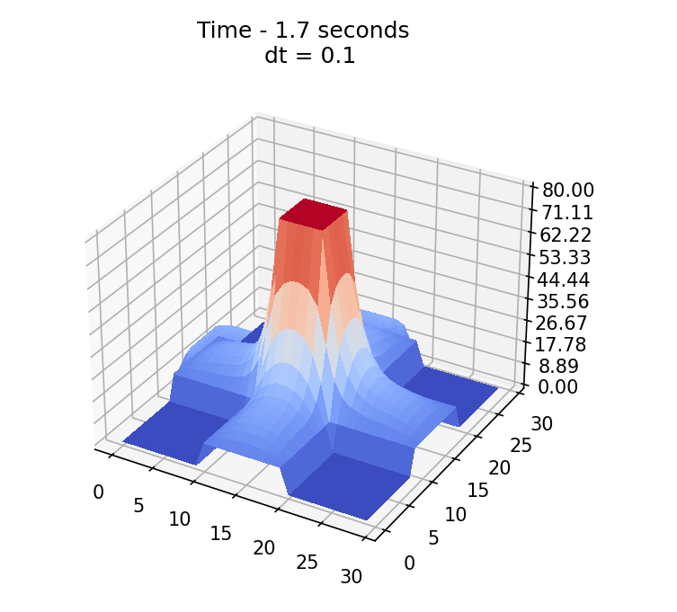

Graph 3 – Simulation conducted with dt = 0.1 (numerical stability)

From conducted experiments dt > 0.2 is considared unstable and can (and most of the time will) lead to unstability of the simulation concluding in wrong results. Hence to that, it is crucial to set at least dt = 0.1, for ensuring stable simulation work.

* 1. **Stop condition (for copper and alumina)**

Simulation for alumina and copper was conducted with 2nd boundary condition.

The initial temperature of the plate is 20 degrees Celcius.

The parameters of a simulation were:

resolution: 1px – 1cm,

power: 10W,

thickness of a plate: 2mm,

heater work time: 10s

**Evolution of heat for alumina:**

Graphs 4-8, Evolution of heat on alumina plate

Simulation is conducted until the stop condition is met. Stop condition is described as two functions:

def absolute_mean(self):

        """

        Helper function to calculate change in heat distribution after single iteration

        """

        arr = np.absolute(self.shape - self.last_shape)

        suma = np.sum(arr)

        return suma

    def stop_condition(self) -> bool:

        """

        Function depneds wheather simualtion has ended or is still running

        """

        eps = 1 * 10**(-7)    #number not significant numerically

        if self.absolute_mean() < eps:

            return True

        else:

            return False

Absolute mean diffrence of two following states is calculated to obtain the stable state. Then, if diffrence is smaller than epislon (set based on experiments on 1e-7) simulation is being stopped.

Table 1, Heat final temperature and Energy increase in the system based on dt and resolution - Alumina

|  |  |  |  |  |  |
| --- | --- | --- | --- | --- | --- |
| dt | resolution | Practical  final temperature | Theoretical final temperature | Practical Energy Increase | Theoretical Energy increase |
| 0.01 | 30 | 20,65 | 20,41 | 159,1J | 100J |
| 0.001 | 30 | 20,54 | 20,41 | 132,6J | 100J |
| 0.0001 | 30 | 20,53 | 20,41 | 130,4J | 100J |
| 0.001 | 90 | 20,53 | 20,41 | 131,1J | 100J |

Table 2, Heat final temperature and Energy increase in the system based on dt and resolution - Copper

|  |  |  |  |  |  |
| --- | --- | --- | --- | --- | --- |
| dt | resolution | Practical  final temperature | Theoretical final temperature | Practical Energy Increase | Theoretical Energy increase |
| 0.01 | 30 | 20,48 | 20,29 | 166,9J | 100J |
| 0.001 | 30 | 20,38 | 20,29 | 133,1J | 100J |
| 0.0001 | 30 | 20,37 | 20,29 | 130,5J | 100J |
| 0.001 | 90 | 20,39 | 20,29 | 137,1J | 100J |

There is about 30% change in temperature increase and Energy increase. It may be due to imperfections of the model or the small resolution or not small enough dt.

Simulation for dt = 0.0001 was running for 20 minutes so making dt smaller was computationally imposible to obtain results in reasonable time.

1. **Conclusion**

Heat transfer simulation is very important in variuos sciences and can be helpful to create and plan construction of lots of solutions. Nevertheless, it’s crucial to understand the capabilities and limitations of such simulation and to adress them properly. For example time step (dt) can’t be too big (or too small) to corectly conduct such simulation.

From the simulation we can see that choosing the right material is crucial as one can reach thermal stability almost 50x faster than the other one. It shows the magnitude of diffrence of conductivity between diffrent materials.

1. **References**

Model and whole code of the simulation is available at github:

https://github.com/tycjantyc/Modeling_of_Physical_Systems/tree/main/lab2