MAE 5803 - Homework #1 Problem #1
Tim Coon: 25, January 2017
Second-Order Nonlinear State Equation: 1
First-Order Nonlinear State Equations: 1
Draw the phase portrait 1
Plot the field of the phase portrait 2
a) ID Singular points 3
First Singular Point 3
Second Singular Point 4
b) Linearize 4
c) Linearized Phase Portraits 4
Linearized about the singular point at the origin 4
Linearized about the singular point at (-3, 0) 5
clear; close all; clc;

Second-Order Nonlinear State Equation:

First-Order Nonlinear State Equations:

Draw the phase portrait
Numerically integrate the state equation using ode45 starting at various points in the plane. The Plus (+) marks indicate starting points for each simulated trajectory.
tspan = [0 2];
figure();
hold on
for i = -5:1:5
for j = -5:1:5
T0 = [i; j];
options = odeset('RelTol',1e-4,'AbsTol',1e-7);
[t,T] = ode45(@P1stateEqn,tspan,T0,[],1);
h = plot(T(:,1),T(:,2));
c = get(h,'color');
plot(T0(1),T0(2),'+','color',c);
end
end
axis([-5 5 -5 5])
axis equal
xlabel('$\Theta$')
ylabel('$\dot{\Theta}$')
title('Nonlinear system phase portrait')
hold off
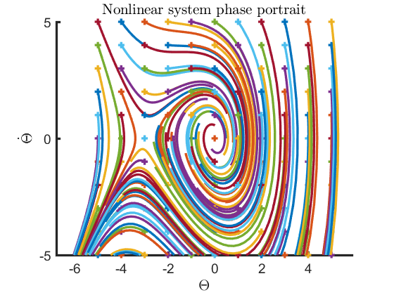

Plot the field of the phase portrait
[x1, x2] = meshgrid(-4:0.5:4, -4:0.5:4);
x1dot = x2;
x2dot = -0.6*x2 - 3.*x1 - x1.^2;
figure()
quiver(x1,x2,x1dot,x2dot,'AutoScaleFactor',5)
axis([-5 5 -5 5])
axis equal
xlabel('$\Theta$')
ylabel('$\dot{\Theta}$')
title('Phase portrait with gradients')
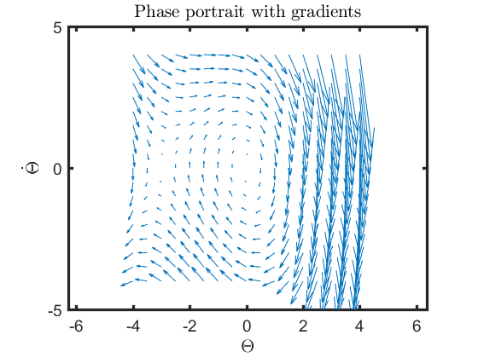

a) ID Singular points
From the phase portrait, identify the singular points of the system and determine their types (stable node, unstable focus, etc.). Reference Slotine, Section 2.5. There are two singular points.

First Singular Point
The first singular point is a stable focus at the origin. Use the Jacobian to linearize about the origin. Both eigenvalues have negative real parts, supporting the ID as a stable focus.
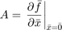
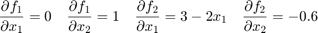
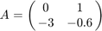
eValue1 = eig([0 1; -3 -0.6])
eValue1 =
-0.3000 + 1.7059i
-0.3000 - 1.7059i

Second Singular Point
The second singular point is a saddle point at (-3,0). Use the Jacobian to linearize about this point. One eigenvalue is positive and the other negative with no imaginary parts, supporting the ID as a saddle point.
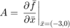
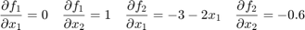
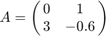
eValue2 = eig([0 1; 3 -0.6])
eValue2 =
1.4578
-2.0578

b) Linearize
Obtain the linearized equations about the singular points of the system. Then, determine the eigenvalues of each linearized equation to determine the stability of the corresponding singular point.
See part a)

c) Linearized Phase Portraits
Draw also the phase portraits of the linearized equations. Does the phase portrait of the nonlinear system in the neighborhood of the singular points compare well with the phase portraits of the linearized equations? Plot the same as nonlinear, but use linear equations in function file.

Linearized about the singular point at the origin
The phase portrait of the linearized system looks very similar to that of the nonlinear system near the -axis where the effects of the squared term are inconsequential. The linearized system is always stable, with trajectories tending toward the origin.
tspan = [0 2];
figure();
hold on
for i = -4:1:4
for j = -4:1:4
T0 = [i; j];
[t,T] = ode45(@P1stateEqn,tspan,T0,[],2);
h = plot(T(:,1),T(:,2));
c = get(h,'color');
plot(T0(1),T0(2),'+','color',c);
end
end
axis([-5 5 -5 5])
axis equal
xlabel('$\Theta$')
ylabel('$\dot{\Theta}$')
title('Linearized about the origin')
hold off
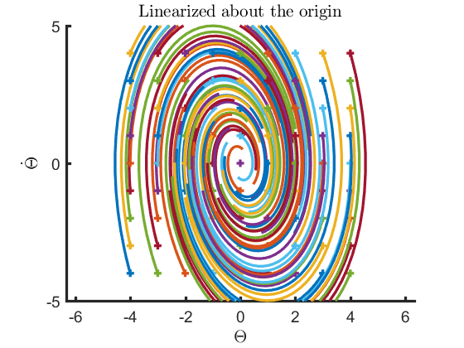

Linearized about the singular point at (-3, 0)
The phase portrait of the linearized system looks very similar to that of the nonlinear system near where the squared term is canceled by the term preceding it in the nonlinear first-order system.
tspan = [0 2];
figure();
hold on
for i = -6:1:2
for j = -4:1:4
T0 = [i; j];
[t,T] = ode45(@P1stateEqn,tspan,T0,[],3);
h = plot(T(:,1),T(:,2));
c = get(h,'color');
plot(T0(1),T0(2),'+','color',c);
end
end
axis([-5 1 -5 5])
axis equal
xlabel('$\Theta$')
ylabel('$\dot{\Theta}$')
title('Linearized about (-3,0)')
hold off
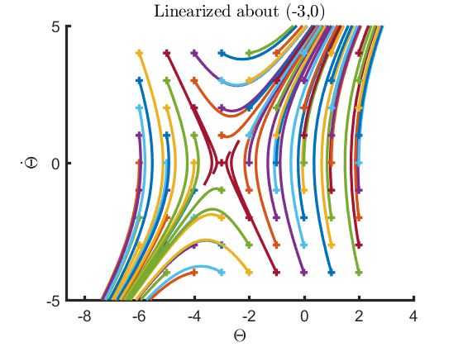
Published with MATLAB® R2016a

