MAE 5803 - Homework #1 Problem #3
Tim Coon: 25, January 2017
Consider the following second-order system 1
a) Plot Eigenvalues 1
b) Nonliear Phase Portraits 2
d) Observations 5
clear; close all; clc;

Consider the following second-order system

a) Plot Eigenvalues
Find the eigenvalues of the linearized system about the equilibrium point, (0,0). Express your answer in terms of . Sketch in the complex plane the variation of the locations of these eigenvalues as varies from -0.5 to 0.5.
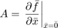
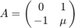
Calculate the eigenvalues for samples of the range of specified
mu = [-0.5:0.25:0.5];
eValue = zeros(2,length(mu));
figure(1)
hold on
for i = 1:length(mu)
A = [0 1; -1 mu(i)];
eValue(:,i) = eig(A);
plot(real(eValue(:,i)),imag(eValue(:,i)),'*','MarkerSize',12)
end
ax = gca;
ax.XAxisLocation = 'origin';
ax.YAxisLocation = 'origin';
ylim([-1.2 1.2]);
title('Eigenvalues of Linearized System')
xlabel('$\sigma$'); ylabel('j$\omega$');
legend(strcat('\mu = ',strread(num2str(mu),'%s')),'Location','EastOutside')
hold off
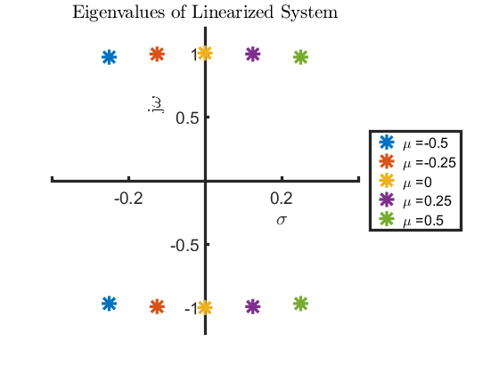

b) Nonlinear Phase Portraits
Draw the phase portraits of the system using MATLAB for , , and . Use -2 to 2 range of values for the horizontal and vertical axes.
mu = [-0.2 0 0.2];
for i = 1:length(mu)
figure()
hold on
for x1 = -1.5:.75:1.5
for x2 = -1.5:.5:1.5
tspan = [0 5];
x0 = [x1; x2];
[t,x] = ode45(@P3stateEqn,tspan,x0,[],mu(i));
h = plot(x(:,1),x(:,2));
c = get(h,'color');
plot(x0(1),x0(2),'+','color',c);
end
end
axis([-2 2 -2 2])
xlabel('$x_1$')
ylabel('$x_2$')
title(strcat('Nonlinear system phase portrait, $\mu =$ ', num2str(mu(i))))
hold off
end
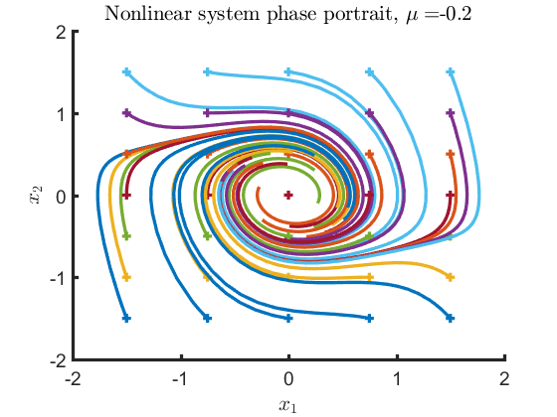
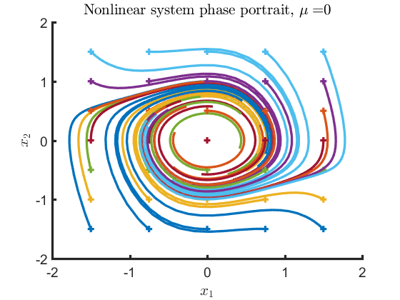
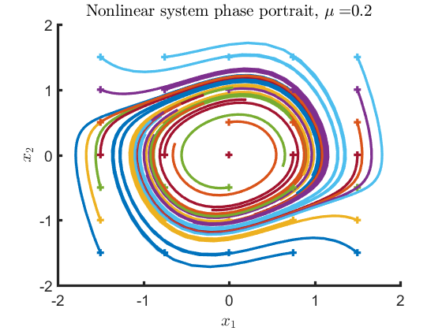

d) Observations
What phenomenon do you observe as the parameter, , varies from negative to positive? Justify your answer using Poincare-Bendixson Theorem.
- If the real parts of all eigenvalues are negative, then is locally asymptotically stable
- If the real part of at least one eigenvalue is positive, then is locally unstable
- If the real part of at least one eigenvalue is equal to zero, then the local stability of cannot be concluded
From the plot of eigenvalues, it can be seen, as goes from negative to positive, the real part of the eigenvalues moves from positive to negative. Thus, the system transitions from locally asymptotically stable to locally unstable. At , the eigenvalues have real parts equal to zero and stability is not concluded by eigenvalue analysis, but the phase portrait reveals the system is stable at this point.
Poincare-Bendixson Theorem: If a trajectory of a second-order autonomous system remains in a finite region (), then one of the following is true:
- The trajectory goes to an equilibrium point
- The trajectory tends to a stable limit cycle
- The trajectory itself is a limit cycle
Consider the region defined by the ball centered on the origin with a radius greater than the distance from the origin to the initial point. The system with negative real parts to all eigenvalues goes towards the equilibrium point at the origin. The system with zero real parts to the eigenvalues are found to act in the same way by observing the phase portrait. Both of these systems have trajectories tending toward an equilibrium point. For the system with positive eigenvalues, the radius in the phase portrait increases without bound. Thus, there is no region in which these trajectories are contained and Poincare-Bendixson Theorem does not apply.
Published with MATLAB® R2016a

