MAE 5803 - Homework #1 Problem #4
Tim Coon: 25, January 2017
Consider the following second-order system 1
a) Phase Portraits 1
b) Limit Cycle Stability Analysis 2
c) Origin Stability Analysis 2
clear; close all; clc;

Consider the following second-order system

a) Phase Portraits
Draw the phase portraits of the system about the equilibrium point . Be sure to include a sufficiently wide area of the state space to capture the possible limit cycle in the system.
tspan = [0 5];
figure();
hold on
for x1 = -5:1:5
for x2 = -5:1:5
X0 = [x1; x2];
[t,X] = ode45(@P4stateEqn,tspan,X0,[]);
h = plot(X(:,1),X(:,2));
c = get(h,'color');
plot(X0(1),X0(2),'+','color',c);
end
end
axis([-5 5 -5 5])
xlabel('$x_1$')
ylabel('$x_2$')
title('Van der Pol Phase Portrait')
hold off
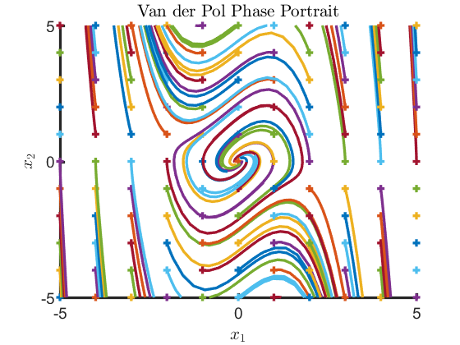

b) Limit Cycle Stability Analysis
Is the limit cycle stable? Explain your answer. The limit cycle is stable because, for any , there exists at least one point within a ball of radius about the origin where the solution tends toward the origin. Slotine, Definition 3.3

c) Origin Stability Analysis
Determine the stability of the equilibrium point at the origin (be specific on the type of stability). Determine its region of attractrion if it is asymptotically stable. Reference Slotine Definition 3.4. The equilibrium point at the origin is asymptotically stable because it is stable (see part b) and there does exist some ball of radius r (anywhere inside the limit cycle) for which any point starting inside this ball will tend toward teh equilibrium point at time increases. The domain of attraction is the ball that fits inside of the limit cycle.
Published with MATLAB® R2016a

