# 1.INTRODUCTION

* 1. Purpose

The purpose of this document is to give a description of the requirements, features for the “Appointment scheduling and reminder” software. It will provide information of the software features, process and plan for software engineer class use.

* 1. Background

There exists a need for everyone to go to the doctor, outpatient office. The Appointment scheduling applications and software will provide a tool for all the patients to look at the available time on the doctor office schedule and make the appointment by themselves.

And the receive the reminder before the appointment as confirmation.

* 1. Product Owner

Doctor office, dentist office, even for hospital

* 1. Product User

Patients

# 2. FEATURES

2.1 Patient’s information

The website app will require the patients to enter their name, email on the website to make the appointment.

2.2 Scheduler

provide an interface for users to see the available time. Users can choose a date, and the website app will display the available time on that day. Any days that are prior to the current day will be blocked.

2.3 Reminder

Users will receive a notification through email, before 24 hours of the appointment. And Users can make the confirmation after receiving the notification.

# 3. USER INTERFACE

Make Appointment

9:00

2018-05-22

Patient Name:

Email:

Choose a date:

Available time:

Nav Bar

Scheduler

9:00

10:00

11:00

12:00

…

# 4. UML

4.1

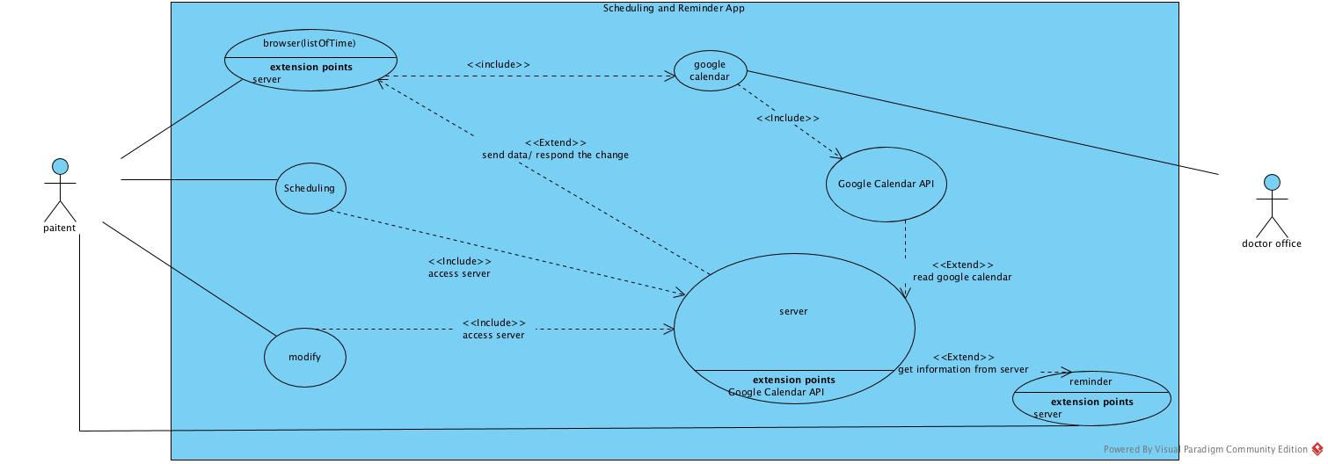

4.2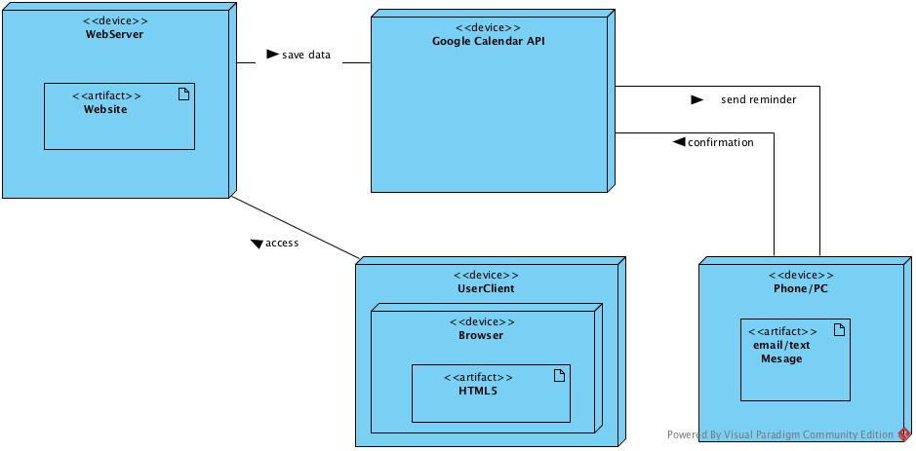

4.3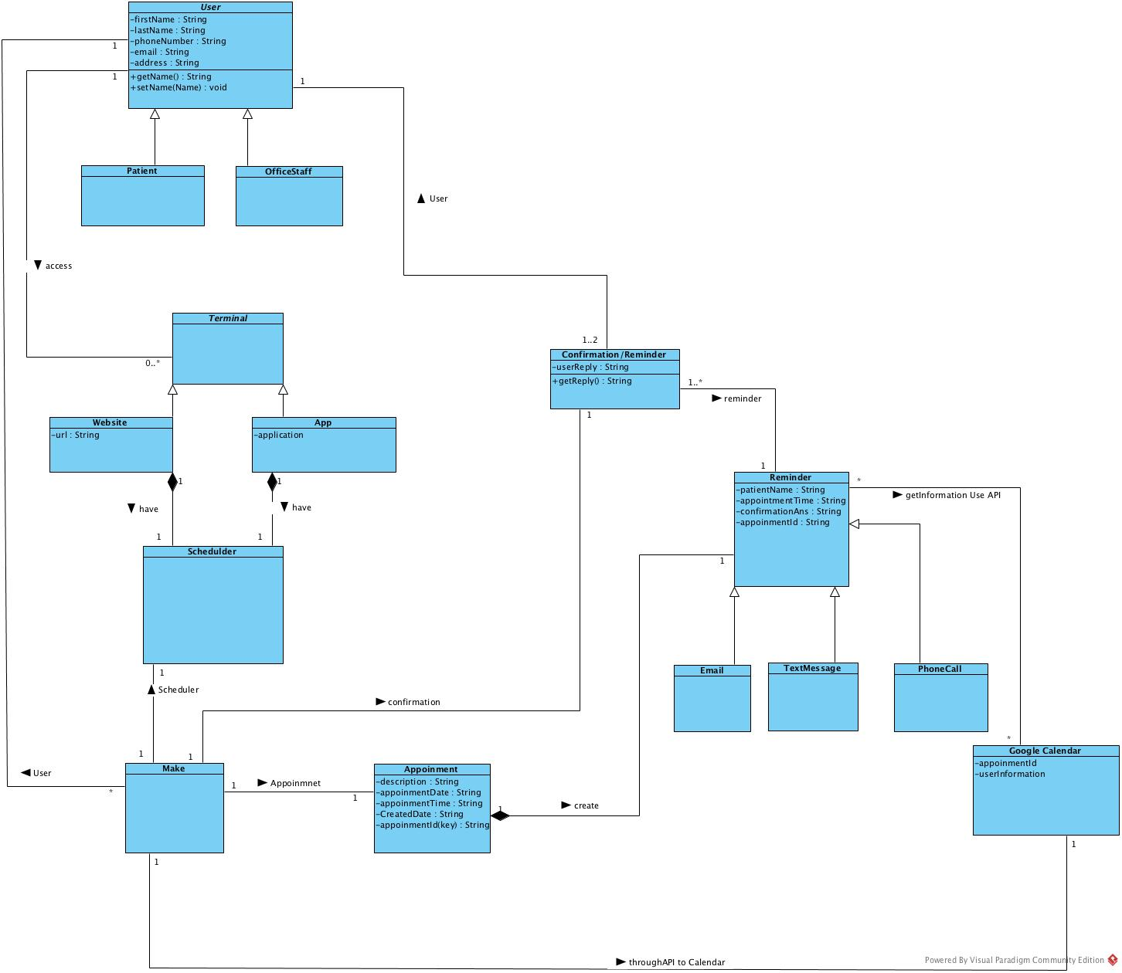

# 5. RUNNING ENVIRNMENT

The website APP is easy to updates and Users don’t have to download and update the app and Users can access the office website through any personal computers and smartphones.

# 6. LIMITATION

6.1 If there are more than one person access the website at the same time and selecting the same date and time; It may create multiple appointments at that time.

6.2 Since we don’t have Domain, the redirection isn’t working.

# 7. Techs

* HTML
* CSS
* JavaScript
* Bootstrap 3
* jquery
* PHP
* AJAX
* Google Calendar API