662 Hw2

Ty Darnell

September 6, 2018

# Problem 1

## a)

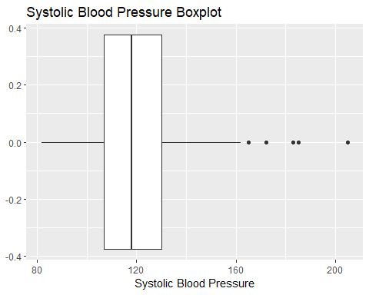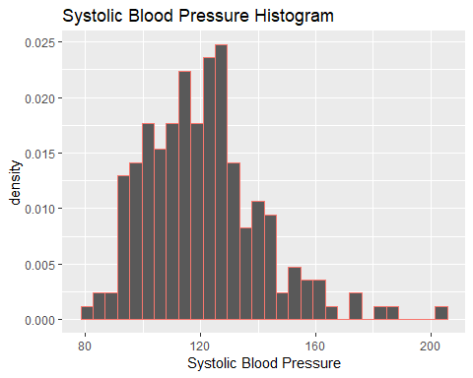

## b)

25th, 50th, 75th percentiles

25% 50% 75%   
107 118 130

## c)

IQR

[1] 23

## d)

25th - 1.5 IQR, 75th + 1.5 IQR

[1] 72.5 164.5

Smallest, Largest Nonoutliers

[1] 82 162

From the boxplot there appears to be 5 outliers. However in the dataset there are six ouliers (as shown below). However two of the values for sbp are the same so they are overlapping and thus not visually apparent. Hence the boxplot does agree with the defintion from our notes.

# A tibble: 6 x 2  
 mi sbp  
 <fct> <int>  
1 0 165  
2 0 172  
3 1 185  
4 1 205  
5 1 172  
6 1 183

## e)

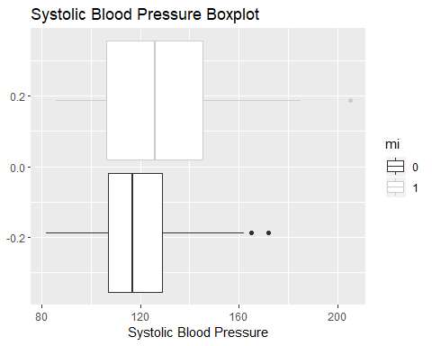

From the plot, blood pressures of the group who had an MI appears to be higher. The median of the MI group is almost equal to the 75th percentile of the group without MI.

# Problem 2

## a)

Looking at the means and standard deviations, they appear to be very different. However looking an overlaid histogram of iPGE separated by hypercalcemia we see that there are two extreme outliers that are impacting the mean of the hypercalcemia= 1 group. Based on this, I do not think that there is enough evidence to conclude that the means of the two groups differ significantly.

# A tibble: 2 x 3  
 hypercalcemia `mean(ipge)` `sd(ipge)`  
 <fct> <dbl> <dbl>  
1 0 148. 46.2  
2 1 241. 144.

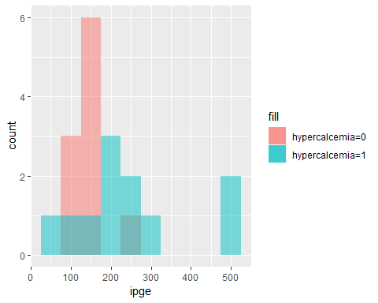

## b)

Since the correlation between iPGe and ca is .105 there does not appear to be a strong association between the two variables.

# A tibble: 1 x 1  
 correlation  
 <dbl>  
1 0.105

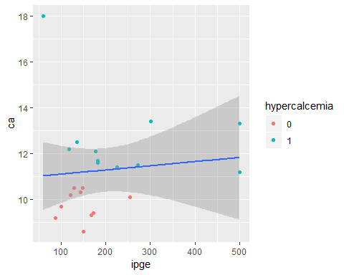

## c)

patient 11 has a ca value of 18 and an iPGE value of 60. This is the highest ca value by far and the lowest iPGE value by far. This appears to be an anomaly. After removing this point and replotting the data, there appears to be a stronger association between the two variables. The correlation between iPGE and ca become .486 which is much a stronger correlation than before but still does not suggest a strong association between the variables.

# A tibble: 1 x 4  
 patient ipge ca hypercalcemia  
 <int> <int> <dbl> <fct>   
1 11 60 18 1

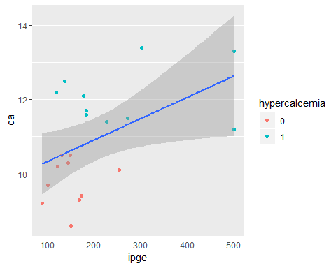

# A tibble: 1 x 1  
 correlation  
 <dbl>  
1 0.486

Call:  
lm(formula = ca ~ ipge, data = remove)  
  
Coefficients:  
(Intercept) ipge   
 9.761447 0.005765

Creating a linear model of the new data set and using the lm (shown below) to find a better ca value for patient 11, we obtain 9.761447+.005765*(60)=10.10735. Thus the new ca = 10.1

Call:  
lm(formula = ca ~ ipge, data = remove)  
  
Coefficients:  
(Intercept) ipge   
 9.761447 0.005765

## d)

The new value of ca would cause patient 11 to be part of the hypercalcemia = 0 data subset instead of the hypercalcemia = 1 subset since the new value for ca < 10.5 which is the cutoff point for hypercalcemia. This would increase the mean of iPGE and decrease the standard deviation iPGE of the hypercalcemia = 1 subset. Also for the hypercalcemia = 0 subset the mean of iPGE would increase and the standard deviation would decrease. However the effect on the hypercalcemia = 1 subset would be greater since iPGE = 60 is a much more extreme outlier in that subset.