Case Control Study Case Study Activity  
Epidemiology 600  
**ANSWER KEY**

**Case Study:**

The autism vaccine “controversy” is regularly in the news and the topic of debate in some populations. At the time of the most recent US measles outbreak, our Dean posted a Daily show clip that depicts this “controversy”. <http://mondaymorning.web.unc.edu/jon-stewart-no-denying-it-anti-vaccine-movement-is-anti-science/>

First we will review a “typical” case-control study design on mumps related vaccination and autism. We will examine how case control studies are constructed, and what makes for a good case control study. Then we will contrast this study with the retracted Lancet article by Wakefield et al. The Wakefield article uses a case series study design.

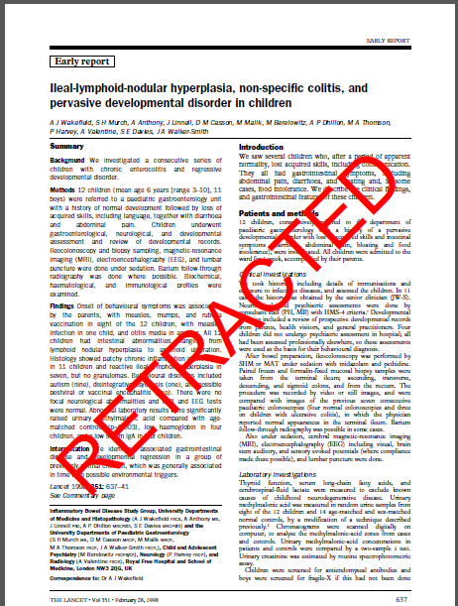

Note that the Wakefield study generated a great deal of controversy in the scientific community and sparked fear in many parents – many of whom made a decision to not have their children vaccinated as a result of the way the media ran with the story. Just because a study is published in a renowned journal (like the New England Journal of Medicine, JAMA, or the Lancet) does not mean that the study was rigorously conducted. The results of the Wakefield article were twisted by both the authors and proponents of the “anti-vax” movement as strong evidence of causation, despite the fact that one can not infer causation from a case series. This article was retracted by the Lancet, but we will include it here as a teaching example for this lab.

|  |  |
| --- | --- |
|  |  |

Let us begin with the article “Lack of association between Measles-Mumps-Rubella vaccination and Autism in children” by Mrozek-Budzyn et al (2010). Please answer the following questions related to this article.

**PRELAB work**

Please complete the following questions on your on before class as your prelab.

1. What is the study/research question?

***Is there a relationship between the MMR vaccination and autism in children?***

***Does the risk of autism differ between use of MMR and the single measles vaccine?***

1. What study design is used? Why was this study design a good design to use to answer this study question?

***It is a case control study. It is a good design because it is an efficient to method to study rare diseases/disorders and it assess whether exposure is disproportionately distributed between the cases and controls, which helps determine if the exposure is a risk factor for the outcome. Also since cases (children under study) already have autism is it makes sense to select based on the health outcome, not the exposure.***

1. What is the source population?

**The source population is children aged 2 to 15 years from Lesser Poland Voivodeship**

1. What is the sample population?

**The sample population was children aged 2 to 15 years from Lesser Poland Voivodeship, identified by general practitioner records as having a diagnosis of childhood or atypical autism. Then controls were selected from the patients of similar age who visited the same doctors office as each case.**

1. How were cases defined?

**Cases were defined as having been diagnosed with childhood or atypical autism**

1. How were controls selected (i.e. what were the matching variables)?

**The controls were individually matched to cases by year of birth, sex, and general**

**practitioners. Two controls were selected for each case. The first 2 children who visited the doctor after**

**the autistic child visited, who met the entry criteria were selected as controls for that particular case.**

1. What are the exposures? How are they defined?

**Vaccination with MMR and vaccination with single measles vaccine were the exposures.**

1. What other confounders were considered? What else would you have considered?

**Other confounders considered were: mother’s age, mother’s education, medication during pregnancy, gestation time, perinatal injury and Apgar score.**

**I would also have looked at family history of autism as well as the fathers age and his medical history around the time of conception. Also the sex of the child should be considered since males have a higher risk of autism.**

1. How was the data collected? What issues do you see with this?

***Data on autism diagnosis and vaccination history was obtained from***

***the child’s doctor. Data on the other probable autism risk factors was obtained via a questionnaire from the child’s mother. Given that the mother does not necessarily have any research experience or a depth of medical knowledge, they may not be the most reliable source for collecting data on autism risk factors. Also they would likely have an emotional bias given that the subject is their child.***

1. Review Table 3. Provide interpretations of the odd ratios and 95% confidence intervals for the single & MMR vaccination vs. non vaccinated comparisons.

* ***An odds ratio of 1 (null value) indicates no association between exposure and outcome. A 95% CI means if we sample and construct a confidence interval 100 times, 95 out of 100 confidence intervals are expected to contain the true value for the odds ratio.***

***Vaccinated before symptom onset:***

***Those exposed to the single antigen vaccine had .73 times the odds of autism diagnosis compared to those who were unvaccinated. The 95% CI was .30 to .173 This does not contain the null value (1) thus the Odds ratio is statistically significant.***

***Those exposed to the MMR vaccine had .39 times the odds of autism diagnosis compared to those who were unvaccinated. The 95% CI was .16 to .98 although the 95% CI does not contain the null value (1), .98 is close to one so we should be careful drawing conclusions in this case.***

***Vaccinated before diagnosis:***

***Those exposed to the single antigen vaccine had .29 times the odds of autism diagnosis compared to those who were unvaccinated. The 95% CI was .12 to .73 This does not contain the null value (1) thus the Odds ratio is statistically significant.***

***Those exposed to the MMR vaccine had .16 times the odds of autism diagnosis compared to those who were unvaccinated. The 95% CI was .07 to .41 This does not contain the null value (1) thus the Odds ratio is statistically significant.***



**TEAM LAB WORK.**

Please complete the follow with your team in lab.

Next, refer to the Wakefield et al (1998) article “Ileal-lymphoid-nodular hyperplasia, non-specific colitis, and pervasive developmental disorder in children”. It is unclear why the authors designed the study design as they did, other than that they thought they were observing a pattern and set out to investigate this alleged pattern. In addition there were previous studies that had implicated intestinal dysfunction in children with autistic-spectrum disorders and, therefore, it was a “hot topic”. ***Now that you have reviewed a standard case control study (Mrozek-Budzyn et al)*** ***on this topic, what flaw(s) do you find in the Wakefield et al. 1998 article?*** Please use the following information to guide your answer:

The sample population was 12 children referred to a paediatric gasteroenterology unit: 11 boys and 1 girl. Cases were defined as the following: “A History of normal development followed by a loss of acquired skills, including language, together with diarrhea and abdominal pain.” Note that physicians, but also the parents, defined this! Parents are not trained medical professionals and should not be responsible for making medical diagnoses – particularly when used as a research finding.

Here are some points to consider in your review of this flawed article:

1. How were controls selected (i.e. what were the matching variables)?

1. What study design is used?

1. Who would you say these results are generalizable to?