***Acknowledgement***

*It is great pleasure for me to undertake this project. I feel highly doing the project entitled – “Apartment Bill Management System”*

*I am highly indebted to Bangladesh Open University for their support and constant guidance, cooperation provided by Assistant Professor Md. Moshiur Rahman during the development of my project. I am deeply grateful to him, without his guideline, advice and encouragement this project would not have been successful.*

*Successfully completion of any type of project requires helps from a number of persons. I have also taken help from different people for the preparation of this project. Now, there is little effort to show gratitude to that helpful person.*

*At last but not least gratitude goes to my project supervisor who directly or indirectly helped me a lot to complete this project report.  
Sincerely,*

|  |  |  |
| --- | --- | --- |
| SL No. | Topics Name | Page no. |
| 1 | **Introduction** | **4** |
| 2 | **Objectives of Apartment Bill Management System** | **4** |
| 3 | **The Project Idea** | **4** |
| 4 | **Who can operate this system** | **5** |
| 5 | **Analysis** | **5** |
| 6 | **Methodology** | **5** |
| 7 | **Description of the project module** | **5** |
| 8 | **Requirements ( System/Hardware)** | **6** |
| 9 | **UML Diagram** | **7** |
| 10 | **Activity Diagram** | **7** |
| 11 | **DFD** | **8** |
| 12 | **Time Scheduling** | **8** |
| 13 | **Entity Relationship Diagram** | **9** |
| 14 | **Flowchart** | **9** |
| 15 | **Database** | **10** |
| 16 | **Project Timeline** | **10** |
| 17 | **Development tools** | **11** |
| 18 | **Snap shots** | **11** |
| 19 | **Future scope** | **23** |

Introduction  
  
The project “Apartment Bill Management System” is an application to automate the process of total billing or individual billing system of a whole apartment. This web based application is designed considering the chain of different billing system which is located in various house or apartment. This application also administrates its admin as well as the apartment owner.

Objectives

* Add and maintain the record of different bill
* Add and maintain of new entered bill
* Provides individual service charge report to the house tenant
* Provide a convenient solution of billing pattern
* Make a easy to calculate of apartment billing system
* Makes a portable document format (pdf) of individual bill of each apartment

Project Idea   
Apartment Bill Management System will save both time and manpower in the process of automating the regular apartment total or individual billing system. So, it’s a modern web based system to grow gradually day by day.

Who can operate this system  
 The apartment owner operates as a admin of this system.

Analysis

For this apartment bill management system, the tenant’s water bill, electricity bill or other utility bill is need to calculation. After total calculation the admin can generate the total service charge as a printable format of a flat.

Methodology

Apartment Billing Management System is a agile method system. It can be modified after the admin or renters requirements

Description of Project Module

* Managing the generated bills
* Printable format of individual service charge of each flat

System Requirements

On client side:

* Operating System(Any
* Web Browser: Chrome
* Stable Internet Connection

On Server Side:

* Web Server
* PHP
* SQL 2019
* Stable internet Connection

Hardware Requirement

On client side

* Pentium four or Above processor
* B320 motherboard
* 1gb Ram
* 160GB HDD
* LAN or WAN

On server side

* Pentium four or Above processor
* B320 motherboard
* 1gb Ram
* 160GB HDD
* LAN or WAN

UML Diagram

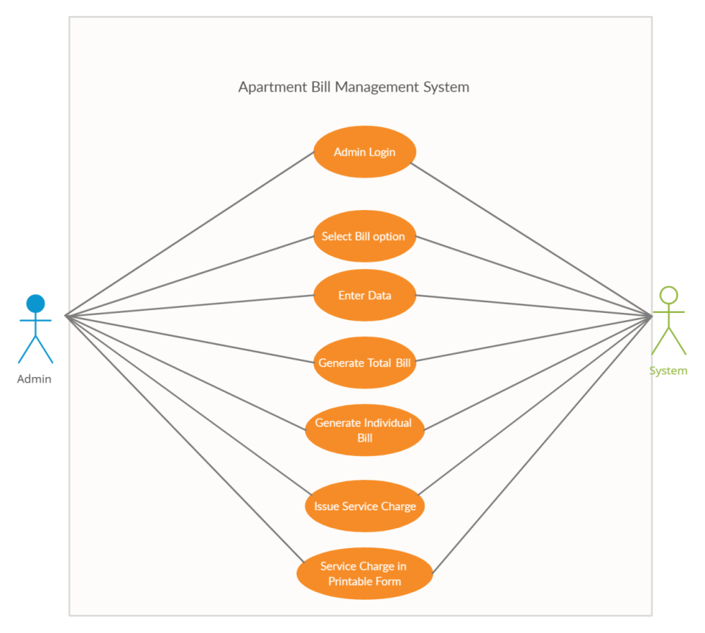

Activity Diagram

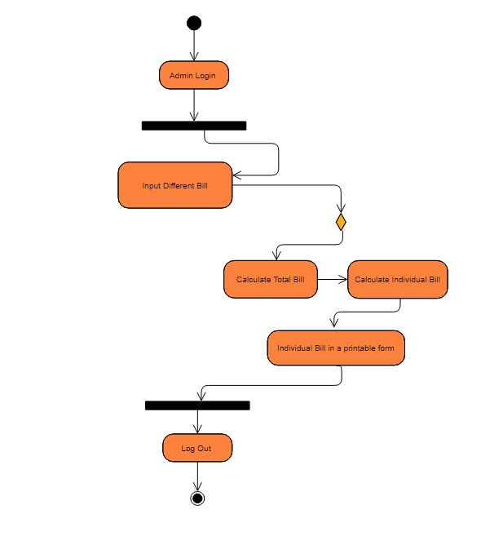

DFD  
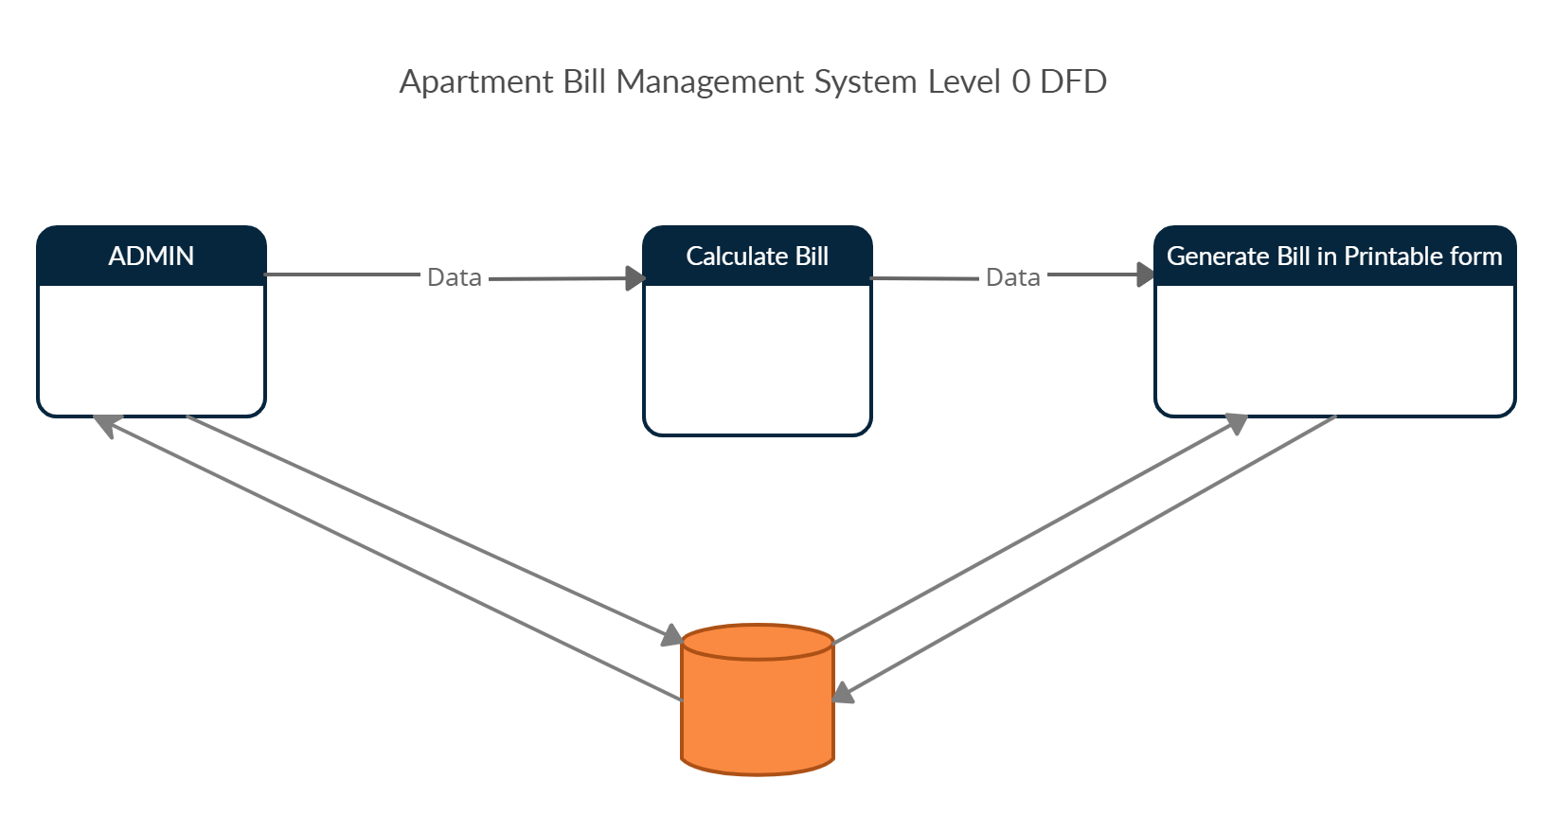

Time scheduling

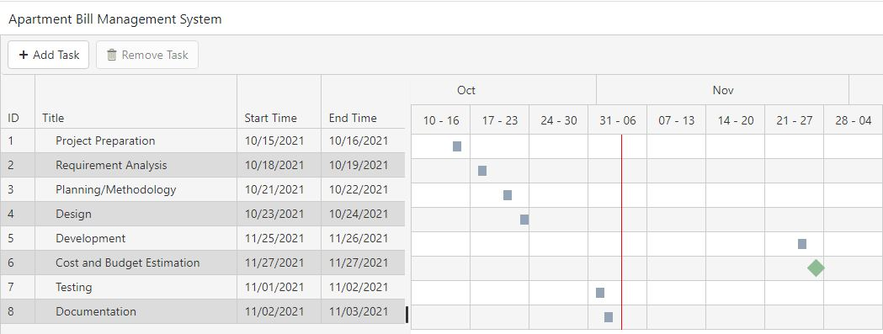

ERD

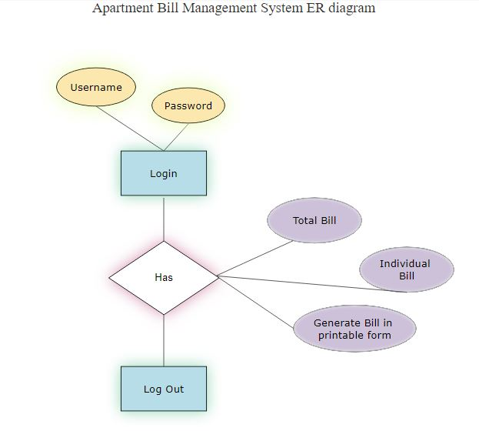

Flowchart  
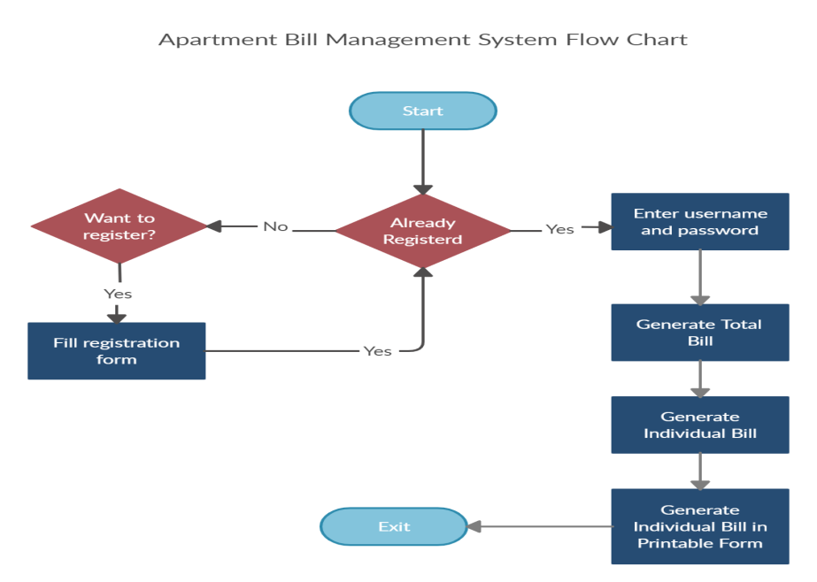

DB

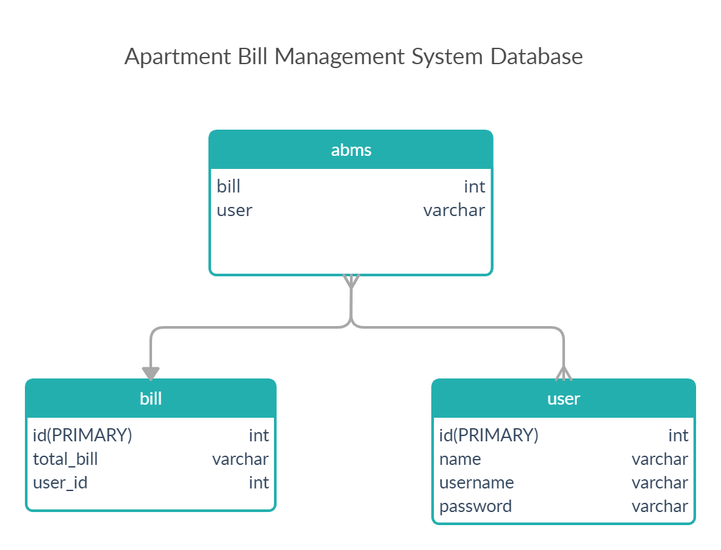

Project Timeline

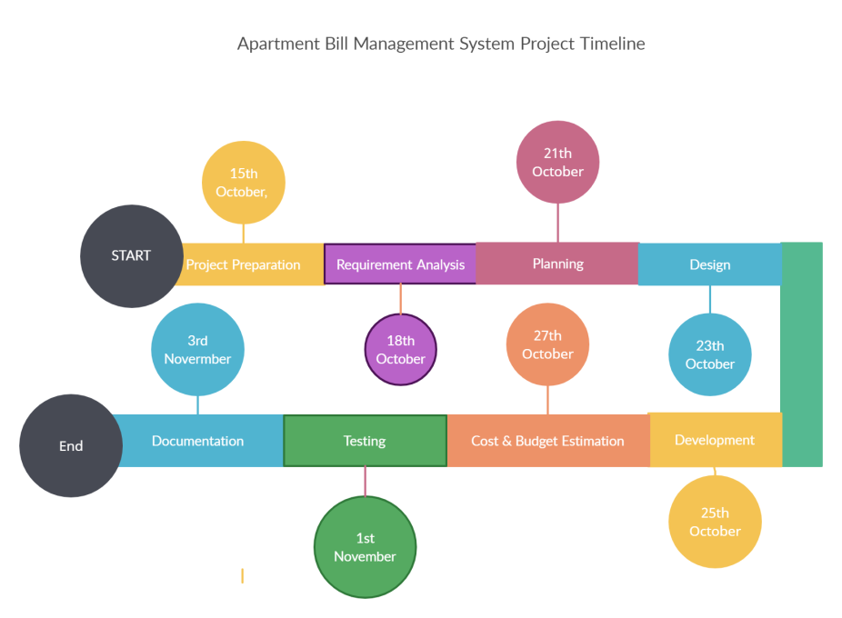

Development Tools

* I make this module with PHP with MySQL server 2019
* Language used : CSS3, HTML5, JavaScript , PHP
* Visual studio 2019
* Google Chorme browser
* Bootstrap, Jquery, notepad etc

Snap Shots:  
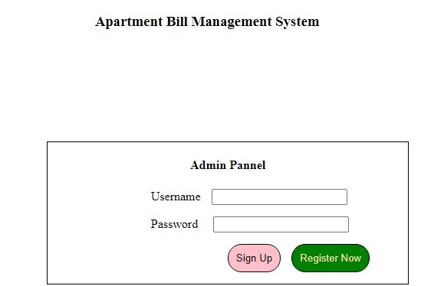

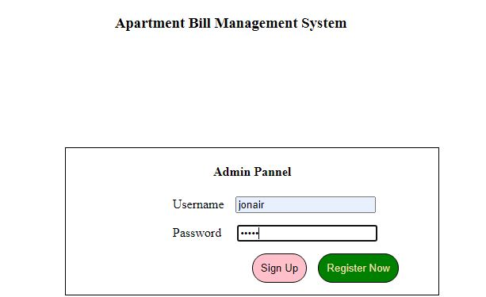

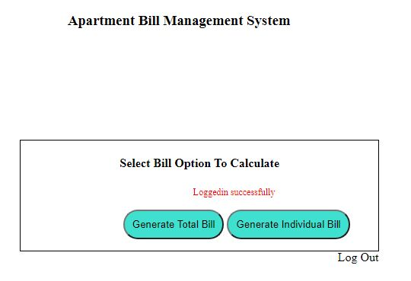

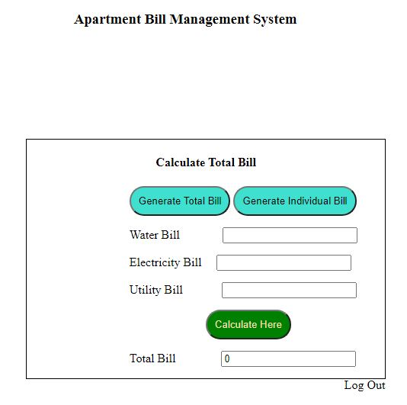

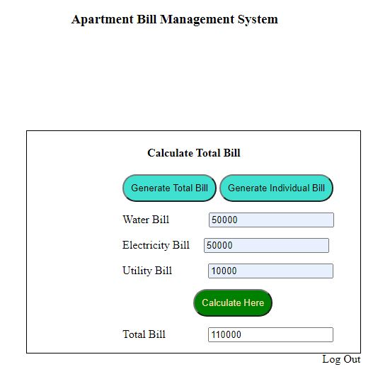

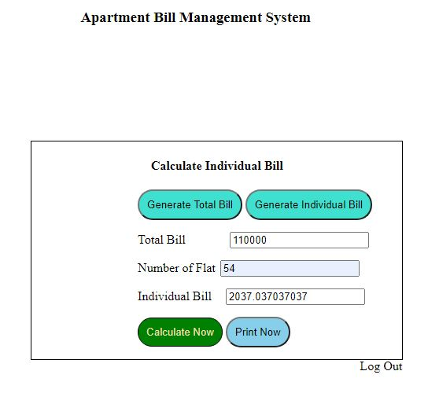

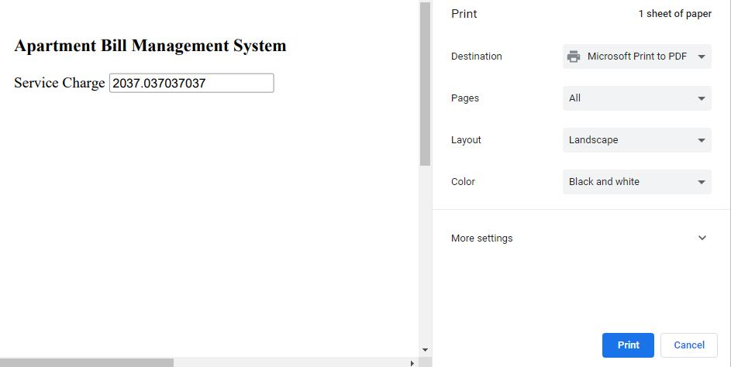

Coding part:  
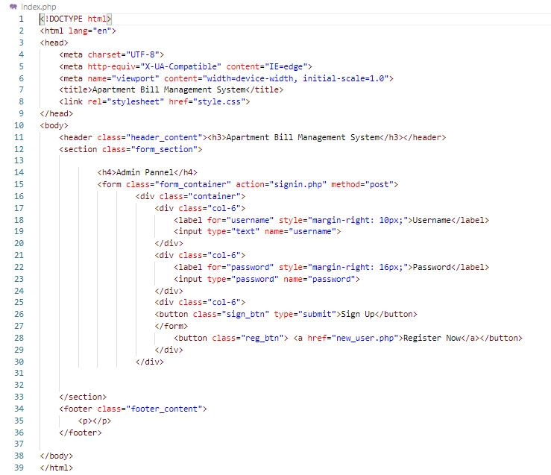

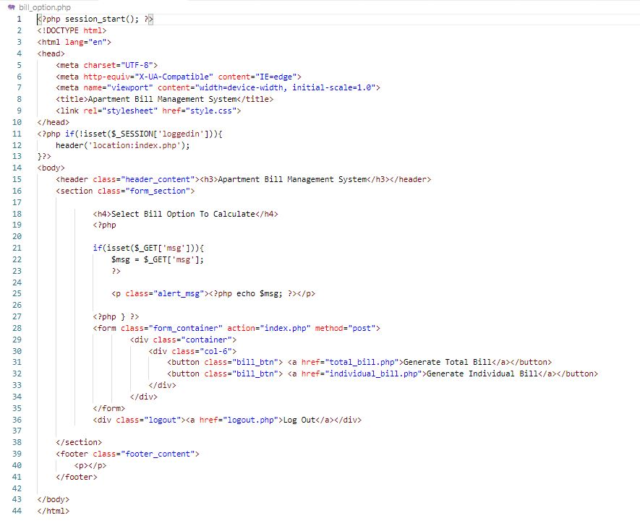

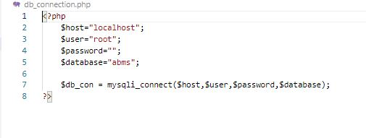

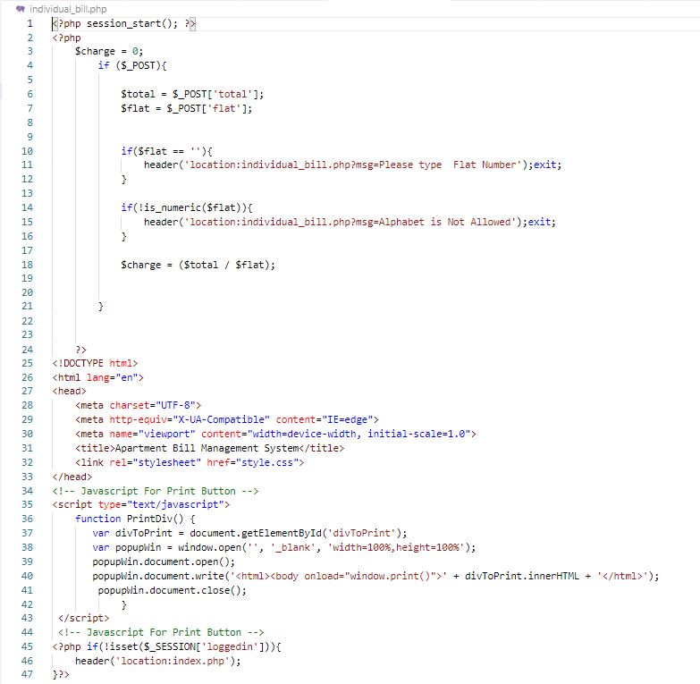

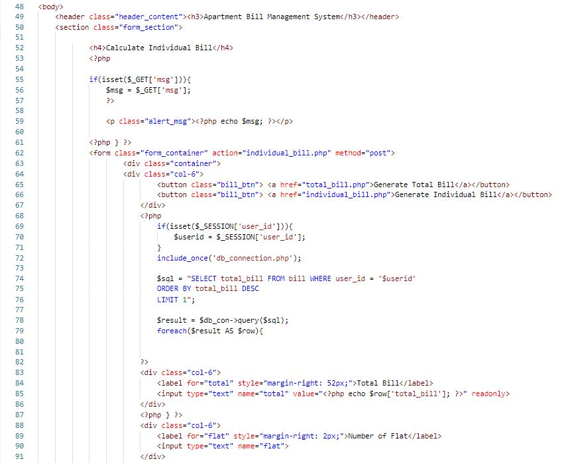

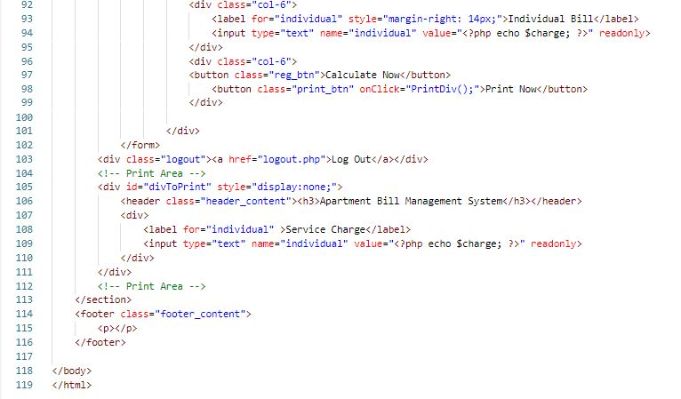

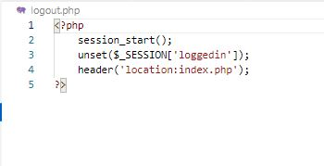

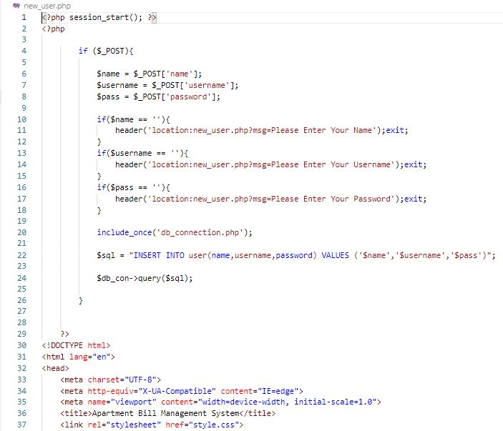

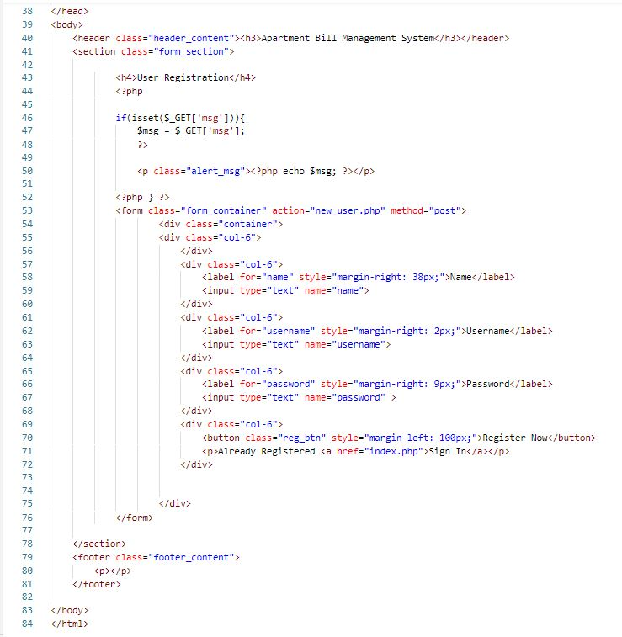

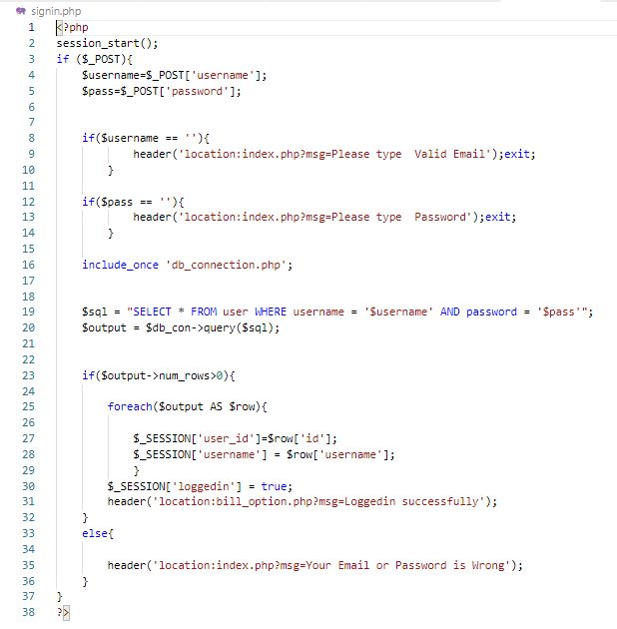

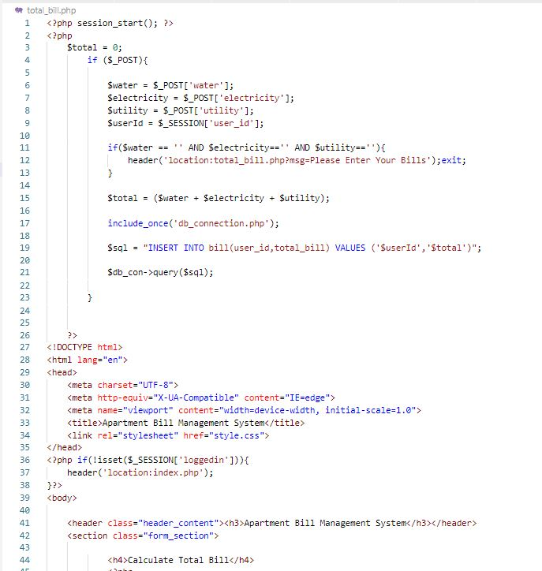

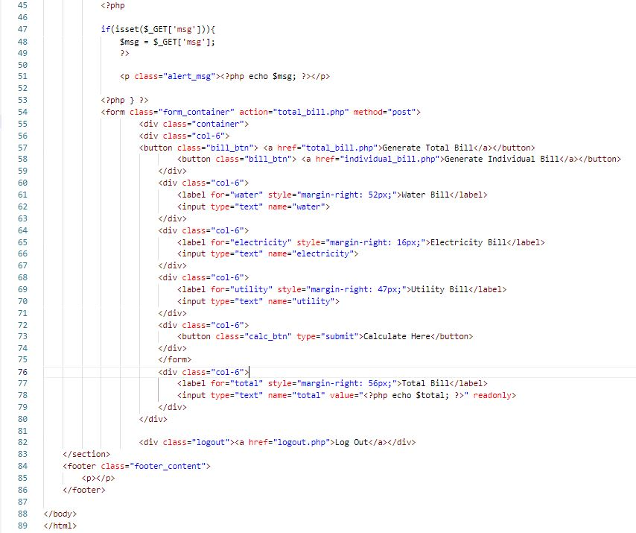

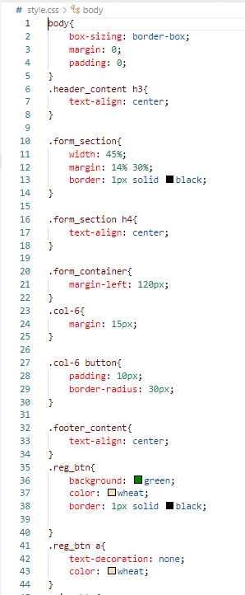

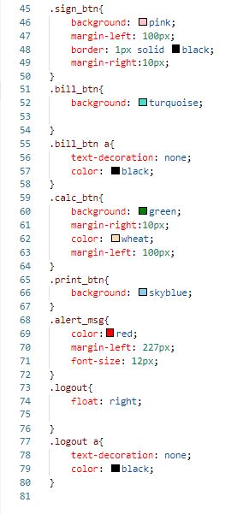

Future Scope

* Improve Security
* Attractive Interface