Threat Environment
- Risk Question: What is the risk that an unauthenticated remote code execution vulnerability in the Windows DNS Server service (CVE-2026-69730) poses to Northbridge Services’ Domain Controllers (W01) given their role in identity services, patch status, reachability, likelihood of compromise, and the vulnerability’s impact?
  - CVE JSON: https://github.com/CVEProject/cvelistV5/blob/main/cves/2026/69xxx/CVE-2026-69730.json
  - NIST NVD Entry: https://nvd.nist.gov/vuln/detail/cve-2026-69730
  - Microsoft Security Alert: https://msrc.microsoft.com/update-guide/vulnerability/CVE-2026-69730
  - Patch Information: https://support.microsoft.com/en-us/servicing/os/windows-server/2026/09/kb5122882-windows-server-2022-security-update
  - Windows_Enterprise_Environment.docx
  - CISA KEV: https://www.cisa.gov/known-exploited-vulnerabilities-catalog?search=CVE-2026-69730&field_date_added_wrapper=all&field_cve=&sort_by=field_date_added&items_per_page=20&url=
- Input Scope: One vulnerability (CVE-2026-69730) and the simulated environment snapshot. The agent assesses the W01 Domain Controllers and uses an environment lookup tool to confirm no other asset runs the DNS Server role. Saved copies of the evidence pages (e.g., CVE, MSRC) are saved in resources and act as fallbacks if live lookup fails.
- Target Environment: The Northbridge Services’ Windows Enterprise Environment. For this vulnerability specifically, four W01 Domain Controllers with Windows Server 2022, running AD DS, DNS, Kerberos and Group Policy, in the IDENTITY zone (10.20.20.0/24 at HQ and 10.40.x.0/24 at recovery-site overlay). Exact DC builds and KBs are unknown. No public DNS service is listed, and unsolicited inbound Internet traffic is denied by default
- Required Rating Output: The output will be a structured JSON that includes the following key fields:
  - Asset: The relevant asset/service ID
  - Threat: The CVE of the threat being investigated
  - Decision: High, Medium, or Low when supported; otherwise an explicit Insufficient Evidence when a key fact required for the rating is missing or Review Needed when there is a tool failure or conflict that prevents analysis.
  - Policy Rule Applied: See rule format below
  - Rationale:
    - Applicability: Does it impact Northbridge Services? Confirmed / Not Applicable / Unknown / Conflicting
    - Likelihood = Ease of exploitation, reachability, exploit activity
    - Impact = Exposed asset value, blast radius, recovery time, CIA
  - Evidence and Uncertainty: Provide source references, locators, dates, retrieval date, and live or cached status for each fact. Assumptions and unknowns should be explicitly called out. Explained confidence rating of high if all factors are cited to a source, medium if there are assumptions used in any of the scoring / applicability or any tool calls failed, and low if a decisive fact is unknown or a required lookup failed.
  - Technical Severity vs Local Risk: The recorded decision is the local risk, the technical severity is the CVSS score. Local risk can differ significantly from the actual technical severity due to environment factors like reachability.
  - Action: Recommended next step and evidence that would change or resolve the decision.
Rating Policy
- Applicability Gate 1: This assessment gate occurs first because the likelihood or impact of a vulnerability doesn’t matter if there is no component to be exploited. Further, if the applicability of a vulnerability cannot be determined then that should be flagged and an explanation given. Applicability should be evaluated against the following conditions:
  - C1: The OS is in the affected products list
  - C2: The DNS Server service is installed
  - C3: The OS build is below the patched version (Server 2022: < 10.0.20348.5622, KB5122882)
Condition | Result | Policy Rule
Vulnerability is confirmed not present in environment due to any of C1-C3 being found explicitly false | Not Applicable (Low rating) | P-NA
Any of C1-C3 have insufficient information to provide an answer | Insufficient Evidence (conditional move to gate 2 for if vulnerability was applicable) | P-IE
Any of C1-C3 have conflicting answers from checked sources | Review Needed | P-RV-C
A tool failure prevents evaluating C1-C3 with no cached fallback | Review Needed | P-RV-F
Vulnerability present in environment | Move to risk calculation
- Likelihood x Impact Gate 2:
  - Likelihood factors are summed because they each independently make the risk of compromise more likely, 0-2 = Low; 3-4 = Medium; 5-6 = High
    - Reachability: 0 = Isolated; 1 = broad internal access; 2 = Public-facing / internet-exposed
      - If reachability of vulnerable component/system is unknown then assume a base reachability score of 1 as default.
      - If reachability is 0 overall likelihood is capped at a score of 1 (low) because If the vulnerable component is not reachable by a threat actor then the other components won’t come into play.
    - Exploitability (CVSS AV/AC/PR/UI): 0 = AV:L or AV:P (local or physical); 1 = AV:N or AV:A (network or adjacent), any combination of AC, PR, and UI beside that described in 2; 2 = AV:N or AV:A, AC:L (low), PR:N (none), UI:N (none)
    - Exploit Activity: 0 = none; 1 = public proof-of-concept or vendor exploitation likely warning; 2 = CISA KEV or credible in the wild reporting
  - Impact factors are a maximum because they represent two different types of risk that both matter, 0 = Low; 1 = Medium; 2 = High
    - Asset Criticality: 0 = non-critical; 1 = business-important; 2 = critical
    - Blast Radius: 0 = single host; 1 = entire service or department; 2 = domain / organization wide
    - Adjust levels up or down one within the range based on the below conditions. These will be reported with the output whether they are binding or not
      - RTO <= 4 hours, raise impact by one level because even a short disruption can quickly cause business harm
        - If unknown make no adjustment and document it.
      - CVSS C/I/A (confidentiality, integrity, availability) all are recorded as low or none, reduce impact by one level because the actual impact on the system of exploiting the vulnerability is minimal.
- Rating Matrix: After calculating these scores the following rating matrix is applied to determine the risk rating. The policy rule reported takes the overall risk rating (Low, Medium, High) combined with the likelihood and impact scores. For example, a CVE calculated as a Likelihood of 4 and Impact of 2 would be assessed at high and report the policy rule P-H-L4I2.
Likelihood ↓ / Impact → | Low (0) | Medium (1) | High (2)
Low (0-2) | Low | Low | Medium
Medium (3-4) | Low | Medium | High
High (5-6) | Medium | High | High
Model, Code, Tool, and Human Steps
Step | Performed By | Input | Output | Decision Point
Intake | Code | CVE ID, environment file path | Validated run setup: parseable CVE ID and environment; environment_search source defined | Stop with Review Needed (P-RV-F) if the CVE ID is malformed or the environment file is missing or unparseable
Plan tool calling | Model | System prompt, tool schemas, run setup info | Planned tool call names and args. | Model decides which tools it should call and what queries to send
Tool execution | Tool | Model’s planned tool calls | Tool result returned to model | Invalid tool name or args returns error to model, allowing one correction before returning status=failed. If API calls fail one retry then attempted cached copy. Returns status=failed if unavailable
Follow up loop | Model | Tool results so far | More tool calls (e.g., tavily_search if KEV not found) or “evidence gathering complete” | Model determines if more evidence is needed for risk assessment. Loops back to step 2, capped at 5 loops and proceeding to evidence completeness step if not.
Evidence completeness check | Code | Tool call log | Pass or list of missing tool calls | This simply validates if environment_search and lookup_vulnerability were all run. If not loops to step 2 first time and returns status = failed triggers P-RV-F if check fails twice
Extract facts and assign score | Model | All tool results | Structured JSON facts from the tool calls, C1-C3 status (e.g., true, false) and impact / likelihood scores with clear source to tool log / resources for all facts | Model must decide how each fact maps to applicability, likelihood, and impact
Fact validation | Code | Tool call log + structured JSON | Error list if any validation fails | Basic code validation checks that the structured facts look correct (e.g., all scores in range, source IDs match to tool log / resources). If not returns to extractions step first time and returns P-RV-F immediately if check fails twice
Applicability gate 1 | Code | C1-C3 | Applicability status + rule ID if relevant | Any condition confirmed false then return P-NA. Tool failed status results from environment_search or lookup_vulnerability return P-RV-F. Any conflicting information on C1-C3 returns P-RV-C. Any of C1-C3 unable to be answered returns P-IE. P-NA skips to explanation step, P-RV-C or P-RV-F return failure with explanation. P-IE or C1-C3 all true moves to next step (but P-IE is conditional rating)
Likelihood x impact gate 2 | Code | Scores and adjustments | Likelihood and impact level, matrix rating, policy rule | Applies the reachability cap and impact adjustments. If P-IE caveat that rating is conditional on C1-C3 being true
Explain and recommend | Model | Rating info, validated facts | Rationale explanation including severity v local risk, recommended actions, assumptions | Only explanation, scores cannot change here
Assemble and Save | Code | Decision, facts, explanation, tool log | Assessment JSON output and log | Final schema check, if validation fails for output save it but flag as invalid
Analyst Review | Human | Assessment JSON + log | Approve or override with justification | Do the sources match to the evidence presented. Were policies applied correctly?
Workflow Diagram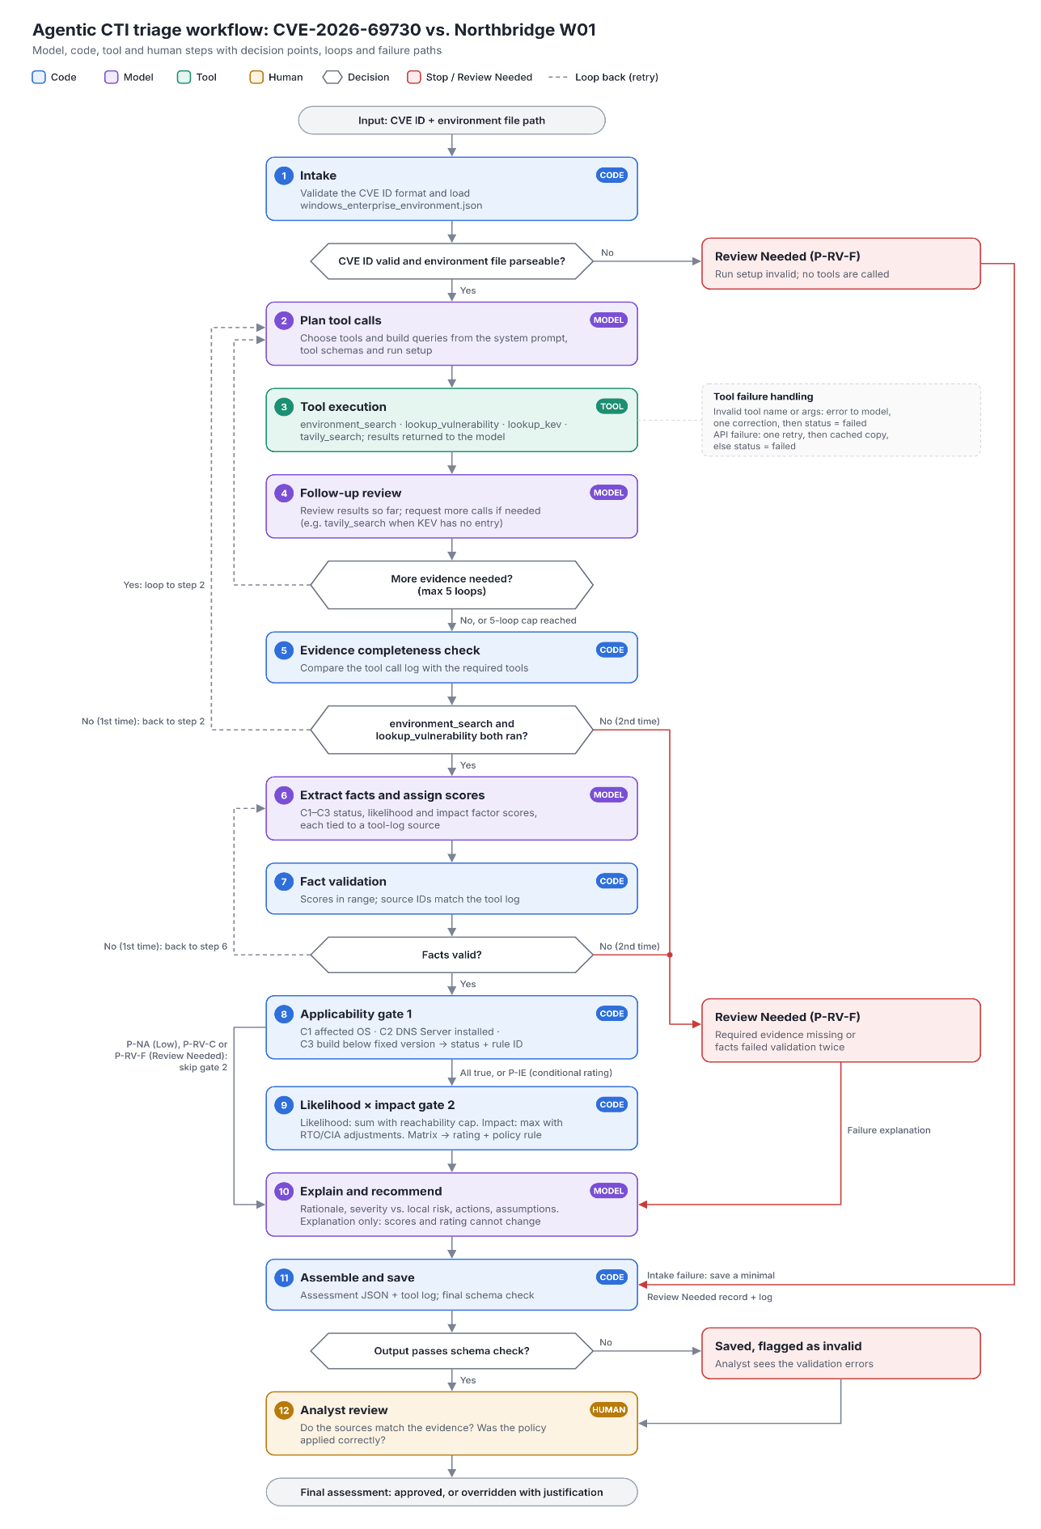
Tool Information
Tool: lookup_kev
Purpose: Check whether the CVE is known to be exploited in the wild. Fall back to cached results if the API fails.
Input: {"cve_id": str}
Output: {"status": "found|not_found|failed", "in_kev": bool|null, "date_added": str|null, "known_ransomware_use": str|null, "required_action": str|null, "due_date": str|null, "source_url": str, "retrieved_at": str, "mode": "live|cached"}
Role in rating: The vulnerability being present in KEV triggers the exploit activity score to be 2.
On failure: Retry once, then use cached feed. If no cache, return status=failed.

Tool: tavily_search
Purpose: Model-constructed web search for exploitation reports, public proof of concepts, vendor exploitability assessments, and remediation guidance.
Input: {“query” str, “allowed_domains”: [str], “max_results”: int}
Output: {"status": "found|not_found|failed", "results": [{"title": str, "url": str, "snippet": str, "published_date": str|null}], "retrieved_at": str, "mode": "live"}
Role in rating: Provides a second check on the exploit activity rating by determining if there is a credible (vendor, government, or known security vendor website) report of the vulnerability being exploited in the wild outside of KEV (exploit activity = 2) or a credible proof of concept or vendor exploitation likely advisory (exploit activity = 1). Also provides information to best guide the analyst in recommended actions based on publicly available information. The model choses whether to search and what query to search for.
On failure: return status=failed.

Tool: lookup_vulnerability
Purpose: Retrieve CVE details from the NVD and CVE APIs and return merged results (e.g., CVSS, affected products) for use in the agent’s assessment; Flag if conflicting information is given.
Input: {"cve_id": str}
Output: { "status": found|not_found|failed, "description": str, "cwe": [str], "nvd_status": str, "cvss": {"version": str, "base_score": float, "vector": str, "source": str, "metrics": {"AV":.., "AC":.., "PR":.., "UI":.., "C":.., "I":.., "A":..}}, "affected": [{"product": str, "version_start": str, "fixed_build": str}], "conflicts": [str], "sources": [{"name": NVD|CVE, "url": str, "retrieved_at": str, "mode": "live|cached"}]}
Role in rating: Provides details on what the CVE does and affected products / builds, allowing for the environment search to identify vulnerable components. This also provides the technological severity, the CVSS metrics used for assessing exploitability, and the information needed to check for the CIA adjustment.
On failure: For each source retry once then retrieve cached copy; if one source fails, use the other and note it. If both fail with no cache return status=failed.

Tool: environment_search
Purpose: Searches JSON environment file for the assets, network flow, and business impact relevant for the CVE.
Input: {"query_type”: asset|text|flows|business_service, "query": str, "max_results": int}}
Output: {“status”: found|not_found|failed, "records": [{
"record_type": asset|flow|denied_path|network_policy|public_exposure|business_service|zone|control|absence|scenario_evidence, "record_id": str, "locator": assets[asset_id=W01], "basis": stated|inferred|mixed, "evidence_ids": ["S01"], "matched_on": [services: 'DNS Server'], "unknown_fields": ["platform.os_build", "platform.installed_kbs"]
}], “source”: windows_enterprise_environment_json, “retrieved_at”: str “locator”: str, “mode”: simulated}
Role in rating: Identifies the OS, services, and build which is used to determine applicability. Flow records help determine reachability, RPO/RTO, asset importance, and dependencies fill in information for the asset criticality, blast radius, and RTO adjustment to impact. The model chooses what query to run.
On failure: File existence and validity are checked at intake where a missing or unparseable environment file stops the run there with Review Needed. When the tool is called an invalid or missing query returns an error to the model for one attempted correction, and if that fails then returns status = failed.
Expected Results
See JSON file in the repo “expected_assessment_output_CVE-2026-69730.json” for a structured assessment using the format the security agent will produce.
Failure / Error Results
The exact output from an error can vary depending on where it happens.
For every tool the default for a tool call failure is to retry after a brief sleep (with model correction for environment_search) and if that second attempt fails to turn to a cached result if available. If no cached result is available (or cached results are not relevant for that tool) then it returns status = failed. When tavily_search or lookup_kev fail the failure status is reported but the assessment will continue with lowered confidence depending on the exact missing information. If either environment_search or lookup_vulnerability return status = failed leading to applicability being unable to verified then the policy rule P-RV-F would be triggered at the first gate.
When a decisive fact is missing the policy code P-IE is triggered letting the user know that there is insufficient information to fully triage the vulnerability. However, this still provides a conditional risk assessment for if the vulnerability had been determine to be applicable allowing for quick triage when that evidence is found. For example, evaluating the applicability of this CVE is impossible without knowing the build status of the domain controllers. The policy code P-IE is returned but a conditional rating of P-H-L4I2 is still given that can be assessed if an unpatched domain controller is discovered.
Acceptance Test
The workflow passes if:
- It runs from the validated and saved inputs (CVE + environment).
- The assessment output validates against the output schema.
- Every evidence item cites to a validated source in the tool logs or resources.
- The decision and ID are approved by the analyst review.
- The following tool result criteria are met:
  - If the tools results report an unknown that leads to one of the three applicability criteria being unknown, the policy rule P-IE is returned.
  - If the tool results report conflicting information that leads to one of the three applicability criteria being unknown, the policy rule P-RV-C is returned.
  - If the tool results fail for lookup_vulnerability or environment_search or in such a way that leads to one of the three applicability criteria being unknown, the policy rule P-RV-F is returned.

