# Rally Bamboo Connector

### Introduction

The Rally Bamboo integration performs several useful functions

* It updates the Rally build indicator to show last build status, a link to the specific bamboo build page and the build message.  
    
  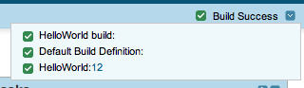
* For changesets that were built by bamboo and where those changesets were already associated with one or more Rally artifacts (tasks, defects etc.) the integration will update the build information for that changeset in Rally.  
    
  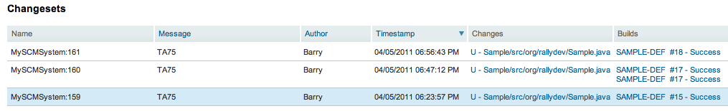  
  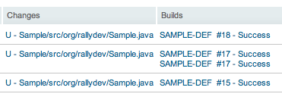

### Installation

The integration runs as a ruby process and requires a ruby installation. You can find ruby at this website.

<http://www.ruby-lang.org/en/downloads/>

Once ruby is installed you will need to install several ruby gems that are required by the integration. You can install these with the following commands. If installing on linux/unix prefix the command with ‘sudo’ to run as root.

gem install builder

gem install rally_rest_api

gem install rest-client

gem install openwferu-scheduler

### Configuration

The Rally Bamboo connector is configured using one or more xml configuration files. If you are integrating more than one bamboo server you will need additional configuration files. However multiple bamboo projects for the same server can be configured in a single file.

To configure a single Bamboo project you will need the following information.

|  |  |
| --- | --- |
| Value | Description |
| Server URL | This is a url to the REST api end point of your Bamboo server.eg. [http://**localhost:8085**/rest/api/latest/](http://localhost:8085/rest/api/latest/) [replace host and port number with your values] |
| User / Password | The username / password to access your bamboo server. |
| Bamboo Project(s) | This is the project key eg.  Screen shot 2011-04-05 at 4.09.07 PM.png |
| Bamboo Plan(s) | This is the Plan Key (see example above for project). |
| Rally Workspace | This is the name of the Rally workspace which contains the Rally project you are connecting. |
| Rally Project | The name of the Rally project to be connected to a bamboo project. |
| Last Build | This is the number of the last bamboo build. If left blank the connector will start with the latest build. After the first run of the connector this will store the last build updated in Rally. |
|  |  |

See sample-config.xml for an example of how to setup the configuration file.

### Running

To run the connector execute the following command.

Ruby rally_bamboo_notifier.rb <config file name>