🧺
KigaliCraft
An E-Commerce Marketplace for Authentic Rwandan Handcrafts
Final Examination Project Report
EWA408510 — E-Commerce and Web Application
Faculty of Computing and Information Sciences, ULK
Academic Year 2025–2026
Instructor: Eric Maniraguha
Student: Thomas S. Yekee | Reg No: 22238/2023 | GitHub: tyekee8-creator

Table of Contents
1. Introduction
2. Problem Statement
3. Project Objectives
4. System Features
5. Technologies Used
6. System Architecture
7. Database Design
8. Screenshots of the Application
9. GitHub Repository Link
10. Deployment Link
11. CI/CD Implementation
12. Docker Implementation
13. Challenges Encountered
14. Future Enhancements
15. Conclusion

1. Introduction
KigaliCraft is a full-stack e-commerce web application developed as the final project for EWA408510 – E-Commerce and Web Application. The platform provides an online marketplace for a local Rwandan business specializing in authentic handmade crafts — woven baskets, pottery, textiles, jewelry, woodwork, and traditional Imigongo paintings — connecting skilled local artisans with customers around the world.
The application was built end-to-end covering all required components: a responsive multi-page frontend, a RESTful Node.js backend API, a relational database design, automated testing, Docker containerization, and a full CI/CD pipeline using GitHub Actions. The live deployment is accessible at https://kigalicraft.onrender.com and the source code is hosted at https://github.com/tyekee8-creator/kigalicraft.

2. Problem Statement
Many small and medium Rwandan businesses, including artisan cooperatives, lack an accessible digital storefront to reach customers beyond their local market. Without an online presence, these businesses miss opportunities for wider sales, fair pricing, and global visibility. KigaliCraft addresses this gap by providing a complete, ready-to-deploy e-commerce platform tailored to the needs of a handicraft business: product browsing, cart management, secure checkout with locally relevant payment options (MTN Mobile Money, Airtel Money, and card), and full order management.

3. Project Objectives
- Design and implement a responsive, professional e-commerce UI working across mobile, tablet, and desktop.
- Build a complete product catalog with category browsing, search, filtering, and sorting.
- Implement full shopping cart functionality: add, remove, update quantities, automatic total calculation.
- Build a multi-step checkout with client- and server-side form validation and order confirmation.
- Design and implement a relational data model to store products, users, orders, and order items.
- Containerize the application using Docker for consistent, portable deployment.
- Implement a CI/CD pipeline that automatically builds, tests, and verifies the application on every push.
- Host the project on GitHub with meaningful commit history and complete documentation.
- Deploy the application to a publicly accessible URL.

4. System Features

4.1 Customer-Facing Features
- Responsive homepage with hero section, category browser, featured products, and testimonials.
- Product catalog with 24 items across 6 categories (Baskets, Pottery, Textiles, Jewelry, Woodwork, Paintings).
- Search, category filters, price-range filters, and sort options (price, rating, name) on the shop page.
- Grid and list view toggle for browsing products.
- Detailed product pages with artisan info, origin, material, stock level, and related products.
- Shopping cart with live quantity controls, free-shipping threshold indicator, and coupon field.
- Multi-step checkout (Cart → Checkout → Confirmation) with real-time field validation.
- MTN Mobile Money, Airtel Money, and card payment method support.
- Order confirmation page with printable receipt and estimated delivery info.
- User account registration and sign-in with password-strength feedback.
- About page with artisan profiles and Contact page with form validation.

4.2 Backend / API Features
- RESTful API for products (list, filter, search, single), authentication, and orders.
- Password hashing with bcrypt (cost factor 12) and JWT-based session tokens.
- Server-side input validation mirroring all client-side rules.
- Health-check endpoint (/api/health) for uptime monitoring.
- Automated API test suite with 19 test cases covering all major endpoints.

5. Technologies Used
Layer | Technology
Frontend | HTML5, CSS3 (custom responsive), Vanilla JavaScript
Backend | Node.js, Express.js
Database | JSON-file relational store (custom db.js — zero native deps)
Authentication | bcryptjs (password hashing), jsonwebtoken (JWT)
Containerization | Docker, Docker Compose
CI/CD | GitHub Actions (.github/workflows/ci-cd.yml)
Deployment | Render (https://kigalicraft.onrender.com)
Version Control | Git, GitHub (github.com/tyekee8-creator/kigalicraft)
Typography | Playfair Display & Inter — Google Fonts

6. System Architecture
KigaliCraft follows a three-tier architecture:
- Presentation Layer — Nine static HTML/CSS/JS pages served by Express, using localStorage for client-side cart state. Pages call the backend API for products, authentication, and orders.
- Application Layer — an Express.js server exposing REST endpoints with JWT authentication and bcrypt password hashing.
- Data Layer — a relational-style JSON-file database (users, products, orders, order_items) chosen specifically so the application installs and runs identically across all environments with zero native build steps.
All components are packaged into a single Docker image. The Express server serves both the REST API and the static frontend from one process, simplifying deployment to a single container on Render.

7. Database Design
The data model has four entities with relational foreign-key semantics (see database/schema.sql for the equivalent SQL DDL):
- users — id, first_name, last_name, email (unique), phone, password (bcrypt hash), role, created_at
- products — id, name, category, price, description, artisan, origin, material, stock, rating, reviews, emoji
- orders — id, order_ref (unique), customer details, shipping address, payment_method, subtotal, shipping_cost, tax, total, status
- order_items — id, order_id (→ orders), product_id (→ products), product_name, price, quantity
Relationships: orders (1) → (N) order_items; products (1) → (N) order_items. Guest checkout is supported — orders link to a customer by email without requiring a registered account.

8. Screenshots of the Application

8.1 Homepage
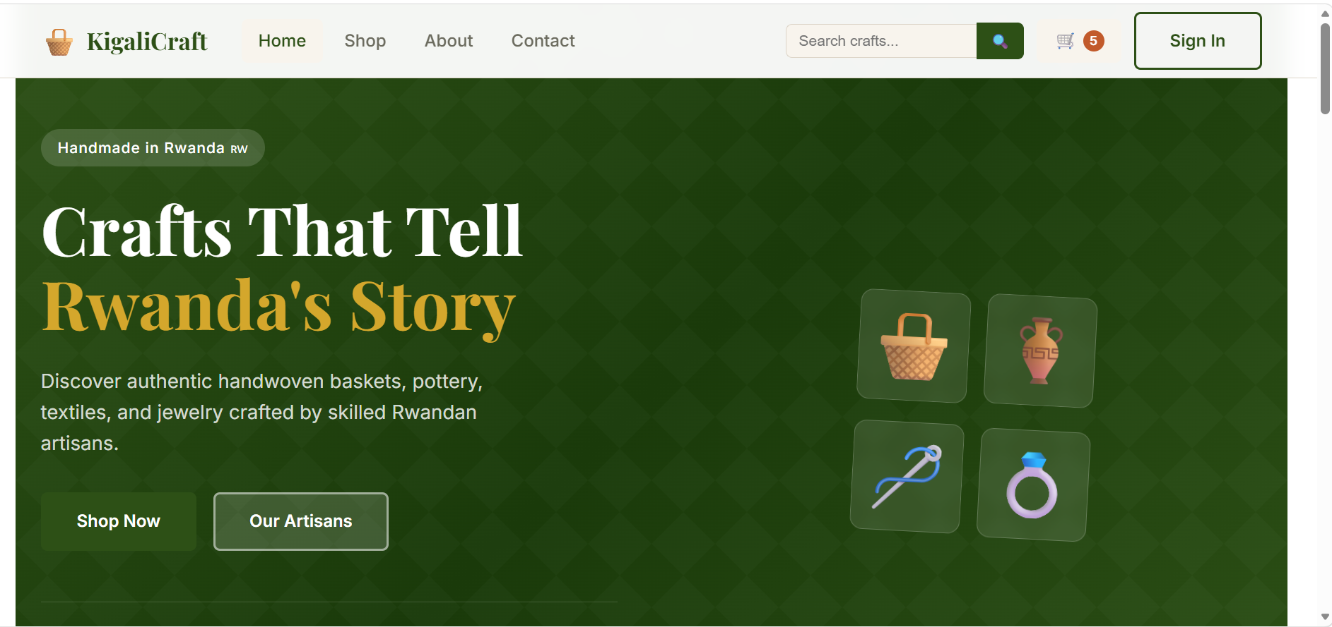
Figure 1 — Homepage: hero section with "Crafts That Tell Rwanda's Story", navigation, and search

8.2 Shop Page
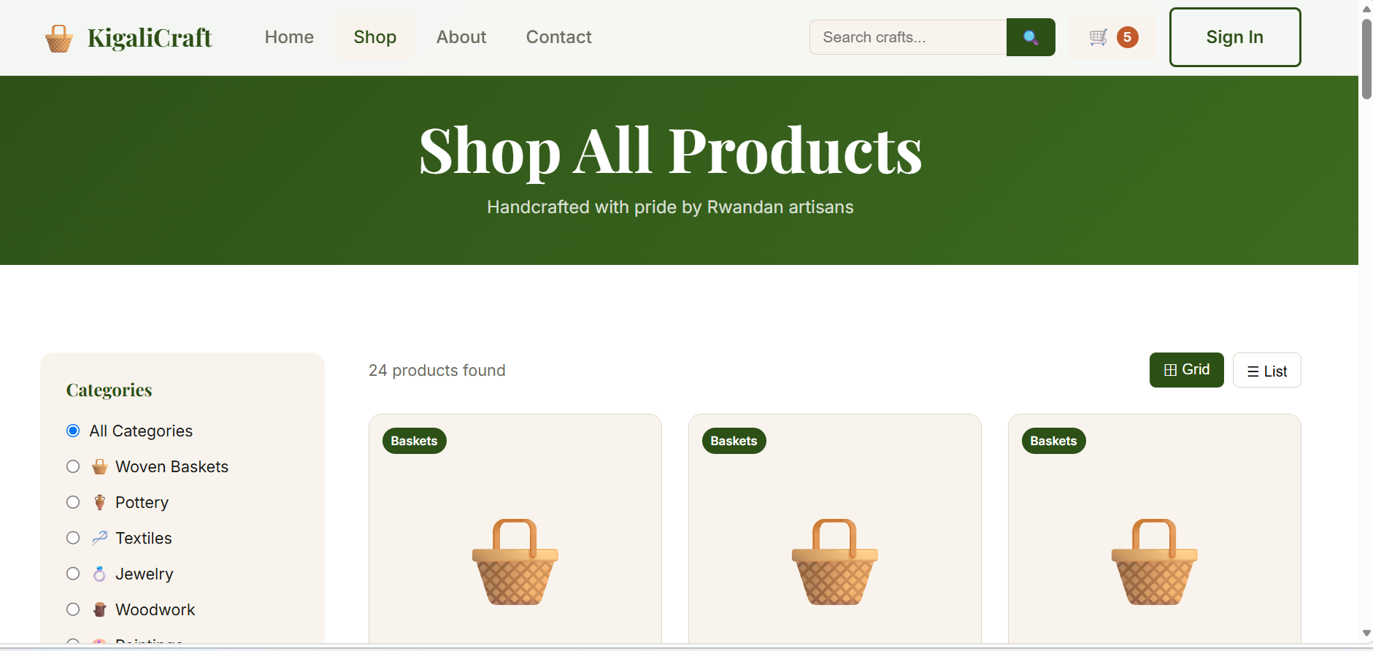
Figure 2 — Shop page: 24 products, category filters sidebar, grid/list toggle

8.3 Shopping Cart
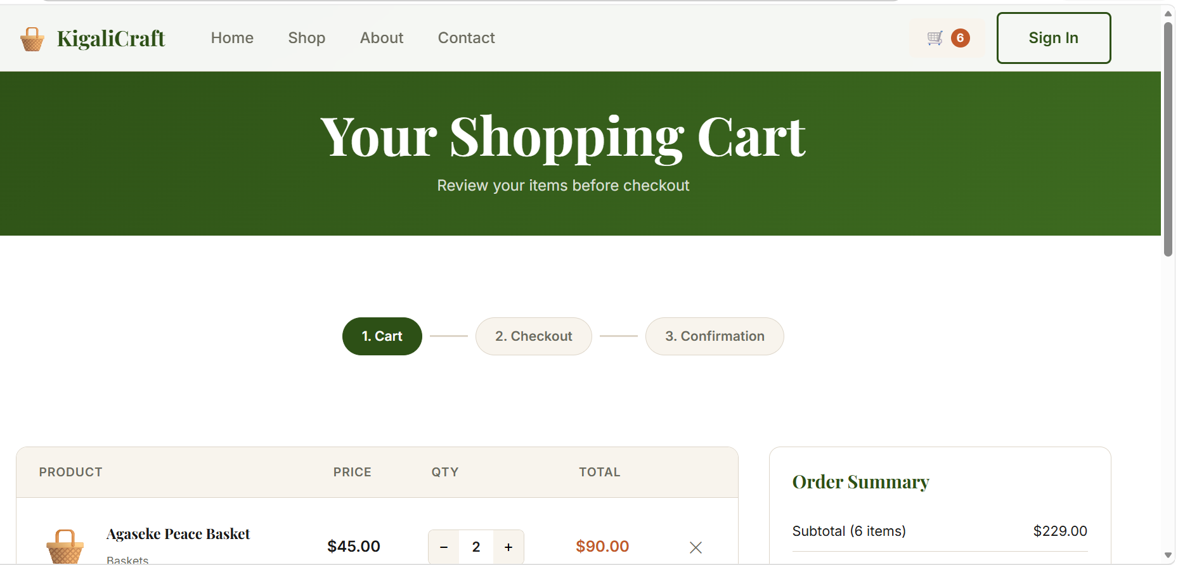
Figure 3 — Cart page: items, quantity controls, order summary with subtotal $229.00

8.4 Checkout Page
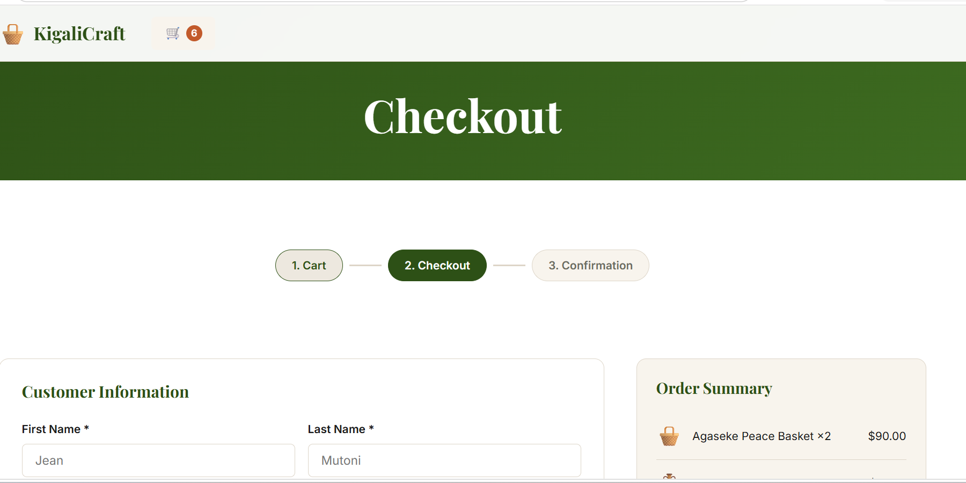
Figure 4 — Checkout: customer info form, order summary sidebar, 3-step progress indicator

8.5 Sign In / Register
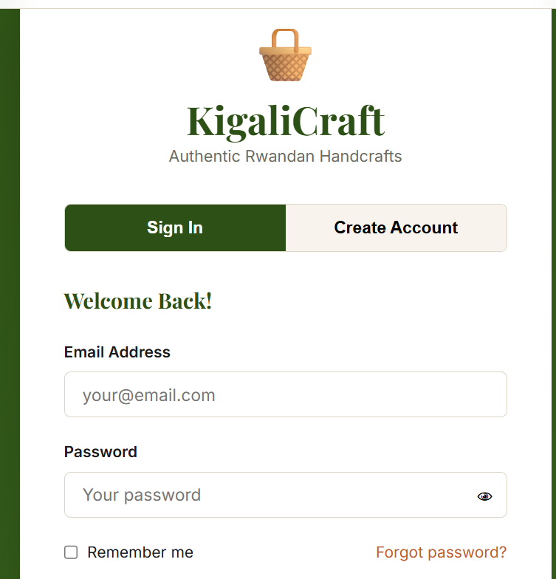
Figure 5 — Authentication: Sign In / Create Account tabs with form validation

8.6 About Page
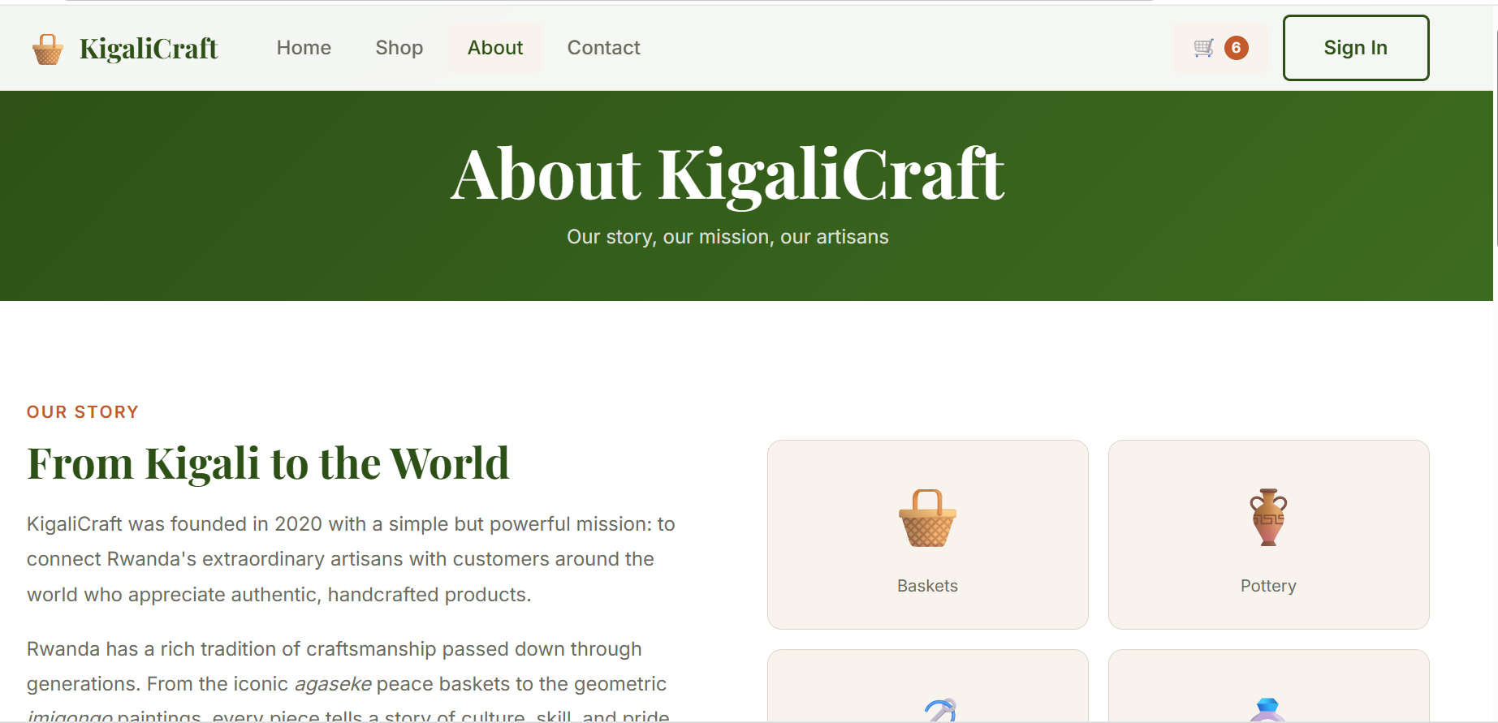
Figure 6 — About page: "From Kigali to the World" with artisan categories

9. GitHub Repository Link
The complete source code, commit history, CI/CD workflow, Dockerfile, and documentation are publicly hosted at:
https://github.com/tyekee8-creator/kigalicraft
The repository includes frontend (9 HTML pages + CSS + JS), backend (Express API + db.js + seed.js + 19-test suite), database/schema.sql, Dockerfile, docker-compose.yml, .github/workflows/ci-cd.yml, and a complete README.md.

10. Deployment Link
The application is live and publicly accessible at:
https://kigalicraft.onrender.com
Deployed on Render using the Docker image built from the project Dockerfile. The service remains accessible during the evaluation period.

11. CI/CD Implementation
A GitHub Actions workflow (.github/workflows/ci-cd.yml) runs automatically on every push or pull request to the main branch. It executes three sequential jobs:
- Build & Test (19s) — installs dependencies, seeds the database, starts the server, and runs the full automated API test suite (19 tests, passing).
- Docker Build & Verify (40s) — builds the Docker image using Buildx and starts a container to confirm the /api/health endpoint responds correctly.
- Deploy to Production (4s) — final stage gated on both prior jobs, runs only on pushes to main.
Total pipeline duration: 1 minute 13 seconds. Status: SUCCESS.

11.1 CI/CD Pipeline — All Workflows
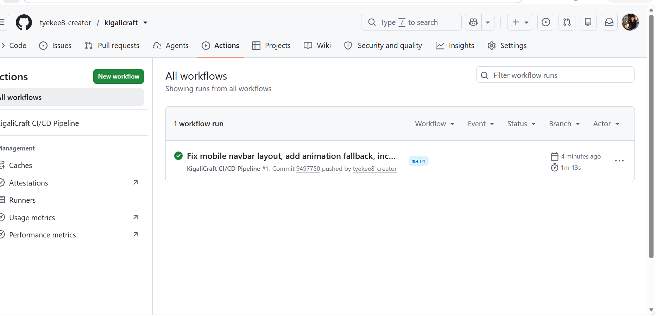
Figure 7 — GitHub Actions: KigaliCraft CI/CD Pipeline with green checkmark, 1m 13s total

11.2 CI/CD Pipeline — Detailed Job Results
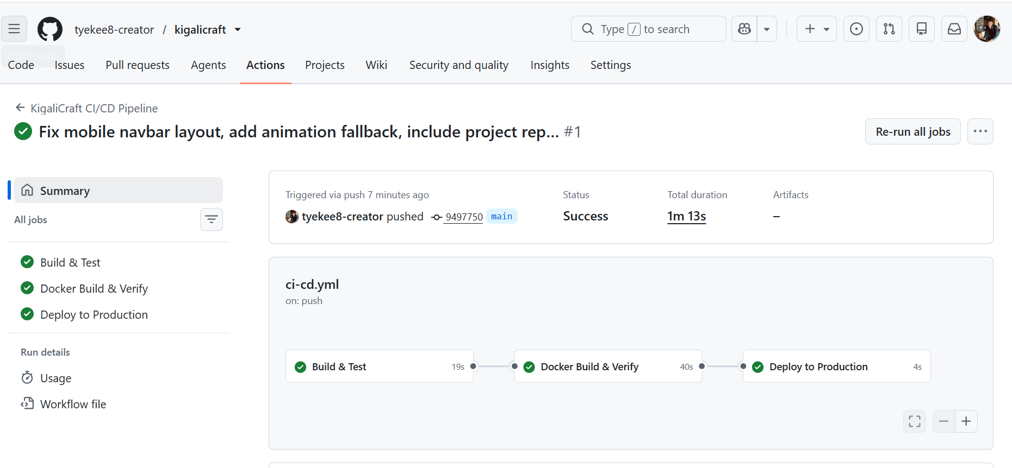
Figure 8 — All 3 jobs passed: Build & Test ✅ Docker Build & Verify ✅ Deploy to Production ✅

12. Docker Implementation
The application is fully containerized using a single Dockerfile based on node:18-alpine. The build installs production dependencies, copies frontend and backend source, seeds the database at build time, and exposes port 5000 with a HEALTHCHECK directive. A docker-compose.yml is also provided for one-command startup.

12.1 Docker Build Output
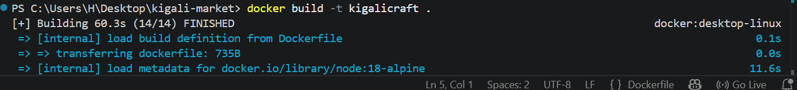
Figure 9 — docker build -t kigalicraft . completed in 60.3s (14/14 steps FINISHED)

12.2 Docker Desktop — Running Container
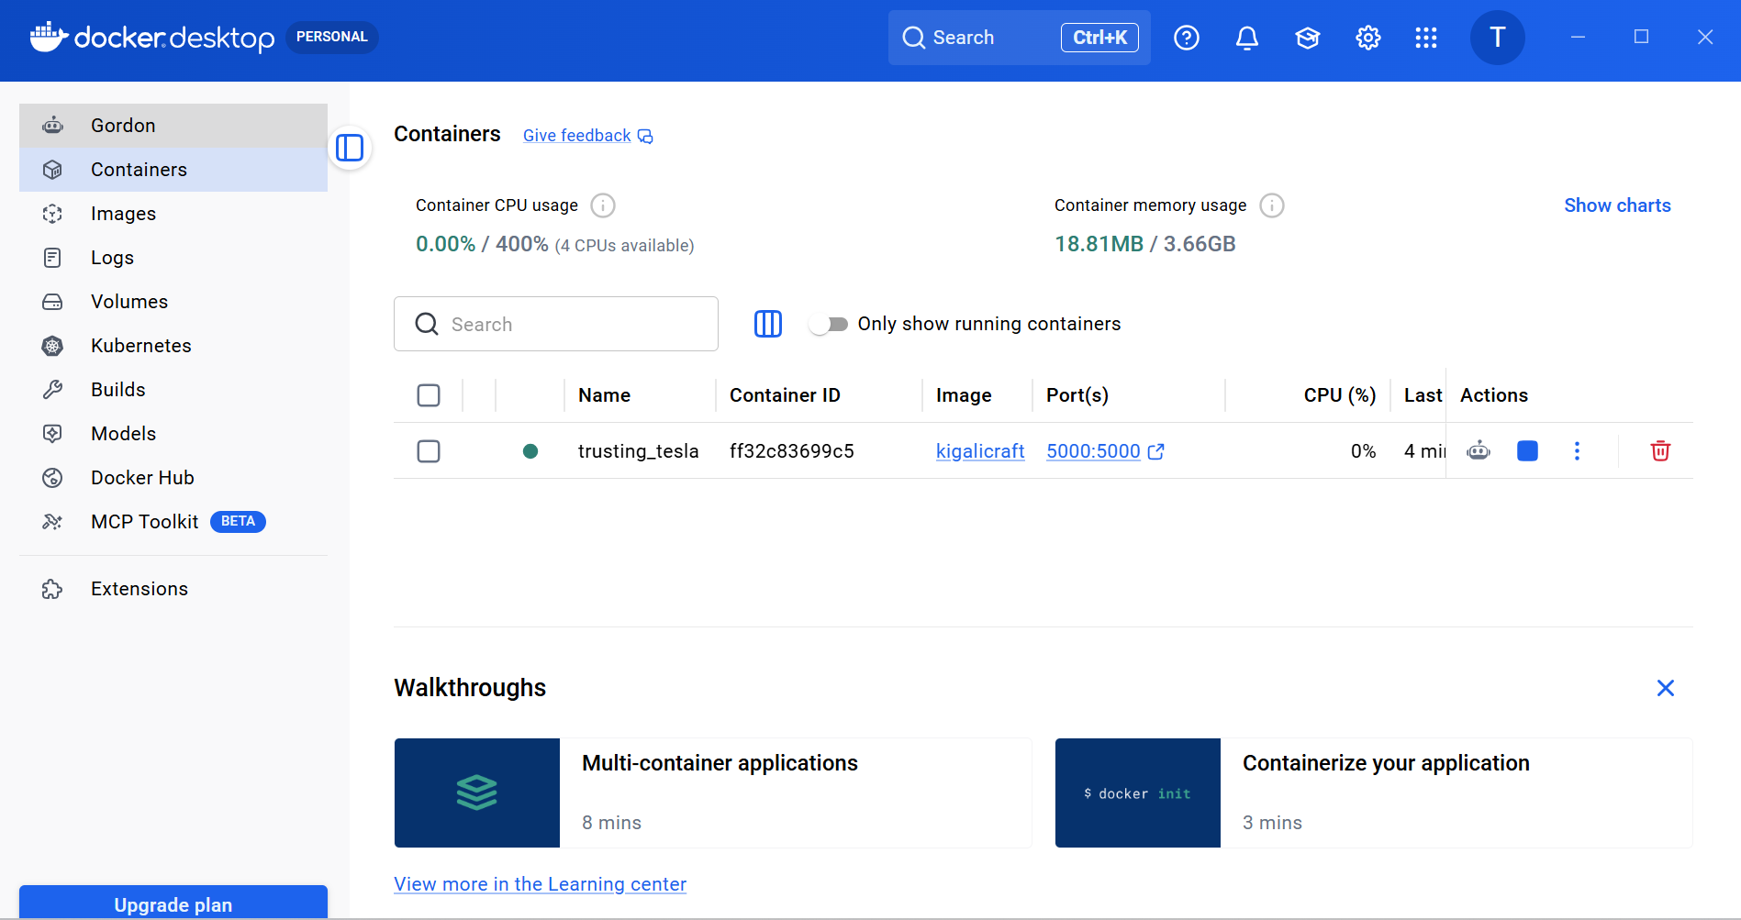
Figure 10 — Docker Desktop showing kigalicraft container running on port 5000:5000
Commands used to build and run:
- docker build -t kigalicraft .
- docker run -p 5000:5000 kigalicraft
- docker compose up --build

13. Challenges Encountered
- Native SQLite bindings (better-sqlite3) require C++ compilation toolchains not guaranteed across CI runners. This was resolved by implementing a lightweight, dependency-free JSON-file database with identical relational semantics — the application installs and runs identically everywhere with zero native build steps.
- Achieving full mobile responsiveness across nine distinct pages required careful CSS grid restructuring at each breakpoint, particularly for cart and checkout tables that needed to collapse gracefully on small screens.
- Supporting three payment methods (MTN Mobile Money, Airtel Money, card) required conditional form fields and validation logic that adapts dynamically based on the selected payment option.
- WSL2 needed to be updated before Docker Desktop could start on Windows — resolved with wsl --update in PowerShell as Administrator.

14. Future Enhancements
- Integrate a real payment gateway (Flutterwave, Paystack, or Stripe) to process live transactions.
- Build an admin dashboard for managing products, orders, and inventory.
- Add automated email notifications for order confirmations and shipping updates.
- Allow customers to submit product reviews and star ratings.
- Add multi-language support (English, Kinyarwanda, French).
- Migrate the JSON-file data store to PostgreSQL for production-scale concurrency.
- Implement real-time order tracking with WebSockets.

15. Conclusion
KigaliCraft demonstrates a complete, production-style e-commerce workflow — from a polished, responsive multi-page user interface through a secure REST API, relational data design, automated testing, containerized Docker deployment, live hosting on Render, and a fully automated CI/CD pipeline on GitHub Actions.
The project fulfils all functional requirements (product management, shopping cart, checkout, database integration) and all mandatory DevOps requirements (GitHub repository with commit history, live deployment URL, CI/CD pipeline, and Docker containerization) as specified in the course brief.
Beyond meeting the technical requirements, KigaliCraft tells a meaningful story — connecting Rwandan artisans with a global customer base through a respectful, well-designed digital storefront — reflecting the spirit of the assignment's encouragement to work with excellence, integrity, and purpose.

