🧺
KigaliCraft
An E-Commerce Marketplace for Authentic Rwandan Handcrafts
Final Examination Project Report
EWA408510 — E-Commerce and Web Application
Faculty of Computing and Information Sciences
Academic Year 2025–2026
Instructor: Eric Maniraguha

Table of Contents
1. Introduction
2. Problem Statement
3. Project Objectives
4. System Features
5. Technologies Used
6. System Architecture
7. Database Design
8. Screenshots of the Application
9. GitHub Repository Link
10. Deployment Link
11. CI/CD Implementation
12. Docker Implementation
13. Challenges Encountered
14. Future Enhancements
15. Conclusion

1. Introduction
KigaliCraft is a full-stack e-commerce web application developed as the final project for the EWA408510 E-Commerce and Web Application course. The platform simulates an online marketplace for a local Rwandan business that sells handmade crafts — woven baskets, pottery, textiles, jewelry, woodwork, and traditional Imigongo paintings — connecting skilled local artisans with customers around the world.
The application was designed and built end-to-end: a responsive multi-page frontend, a RESTful backend API, a relational data model, automated testing, containerization with Docker, and a continuous integration / continuous deployment (CI/CD) pipeline using GitHub Actions.

2. Problem Statement
Many small and medium Rwandan businesses, including artisan cooperatives, lack an accessible digital storefront through which to reach customers beyond their local market. Without an online presence, these businesses miss opportunities for wider sales, fair pricing, and global visibility. KigaliCraft addresses this gap by providing a complete, ready-to-deploy e-commerce platform tailored to the needs of a handicraft business: product browsing, cart management, secure checkout supporting locally relevant payment methods (MTN Mobile Money, Airtel Money, and card), and order tracking.

3. Project Objectives
- Design and implement a responsive, professional e-commerce user interface that works across mobile, tablet, and desktop devices.
- Build a complete product catalog with category browsing, search, filtering, and sorting.
- Implement full shopping cart functionality: add, remove, update quantities, and automatic total calculation.
- Build a multi-step checkout process with client- and server-side form validation.
- Design and implement a relational data model to store products, users, and orders.
- Containerize the application using Docker for consistent, portable deployment.
- Implement a CI/CD pipeline that automatically builds, tests, and verifies the application on every change.
- Host the project on GitHub with meaningful commit history and complete documentation.

4. System Features

4.1 Customer-Facing Features
- Responsive homepage with hero section, category browser, featured products, and testimonials.
- Product catalog with 24 items across 6 categories, each with artisan, origin, and material details.
- Search, category filters, price-range filters, and sort options (price, rating, name) on the shop page.
- Grid and list view toggle for browsing products.
- Detailed product pages with related-product recommendations.
- Shopping cart with live quantity controls, free-shipping threshold, and coupon field.
- Multi-step checkout with real-time field validation (name, email, phone, address, payment details).
- Support for MTN Mobile Money, Airtel Money, and card payment methods.
- Order confirmation page with a printable receipt.
- Account creation and sign-in with password-strength feedback.
- About and Contact pages featuring real artisan profiles and a working contact form.

4.2 Backend / API Features
- RESTful API for products, authentication, and orders.
- Password hashing with bcrypt and JWT-based session authentication.
- Server-side validation mirroring all client-side rules.
- Health-check endpoint for uptime monitoring.
- Automated test suite covering 19 distinct scenarios across products, authentication, and orders.

5. Technologies Used
Layer | Technology
Frontend | HTML5, CSS3 (custom responsive design), Vanilla JavaScript
Backend | Node.js, Express.js
Database | Lightweight JSON-file relational data store (custom db.js layer)
Authentication | bcryptjs (password hashing), jsonwebtoken (JWT)
Containerization | Docker, Docker Compose
CI/CD | GitHub Actions
Typography | Playfair Display & Inter (Google Fonts)

6. System Architecture
KigaliCraft follows a simple, well-separated three-tier architecture:
- Presentation Layer — Static HTML/CSS/JS pages served by Express, using localStorage for client-side cart state and calling the backend API for products, authentication, and orders.
- Application Layer — An Express.js server exposing REST endpoints for products, user registration/login, and order placement, with JWT-based authentication and bcrypt password hashing.
- Data Layer — A relational-style data store (users, products, orders, order_items) implemented as a dependency-free JSON-file database, chosen specifically so the application has zero native build requirements and runs identically across all environments, including constrained CI runners.
All components are packaged into a single Docker image, with the Express server serving both the API and the static frontend from one process — simplifying deployment to a single container.

7. Database Design
The data model consists of four entities with clear relationships, implemented with the same structure a relational SQL database would use (see database/schema.sql in the repository for the equivalent SQL DDL):
- users — id, first_name, last_name, email (unique), phone, password (hashed), role, created_at
- products — id, name, category, price, description, artisan, origin, material, stock, rating, reviews, emoji
- orders — id, order_ref (unique), customer details, shipping address, payment_method, subtotal, shipping_cost, tax, total, status
- order_items — id, order_id (→ orders), product_id (→ products), product_name, price, quantity
Relationships: one order has many order_items (1—N); each order_item references exactly one product (N—1). Orders are linked to a customer by email, supporting guest checkout without requiring an account.

8. Screenshots of the Application

8.1 Homepage
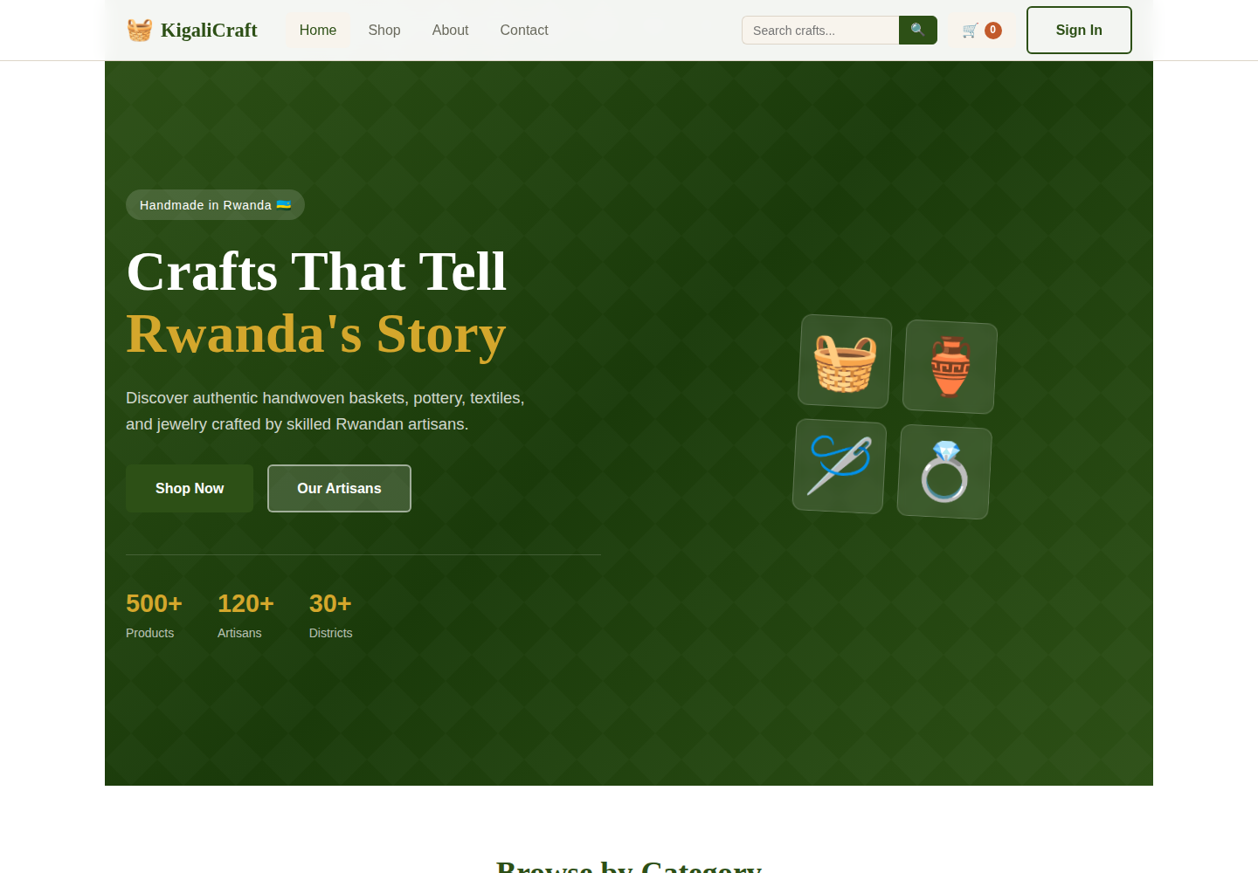
Figure 1 — Homepage with hero section, categories, and featured products

8.2 Shop Page with Filters
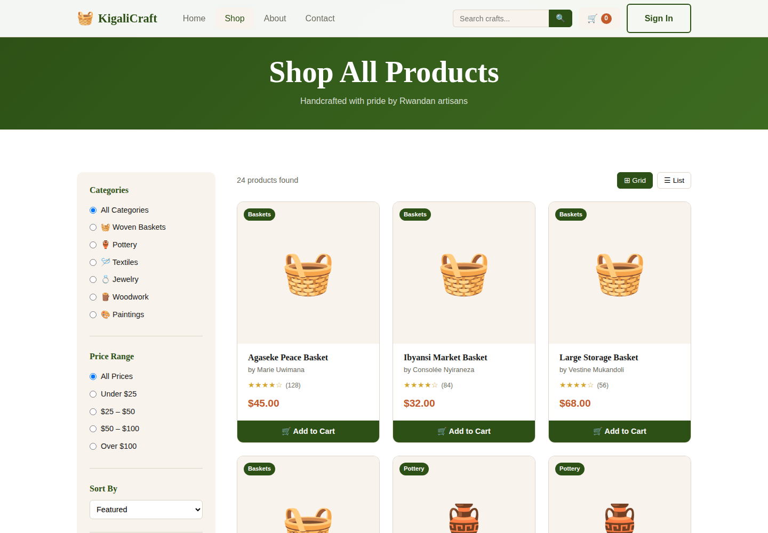
Figure 2 — Product catalog with category, price filters, and sorting

8.3 Product Detail Page
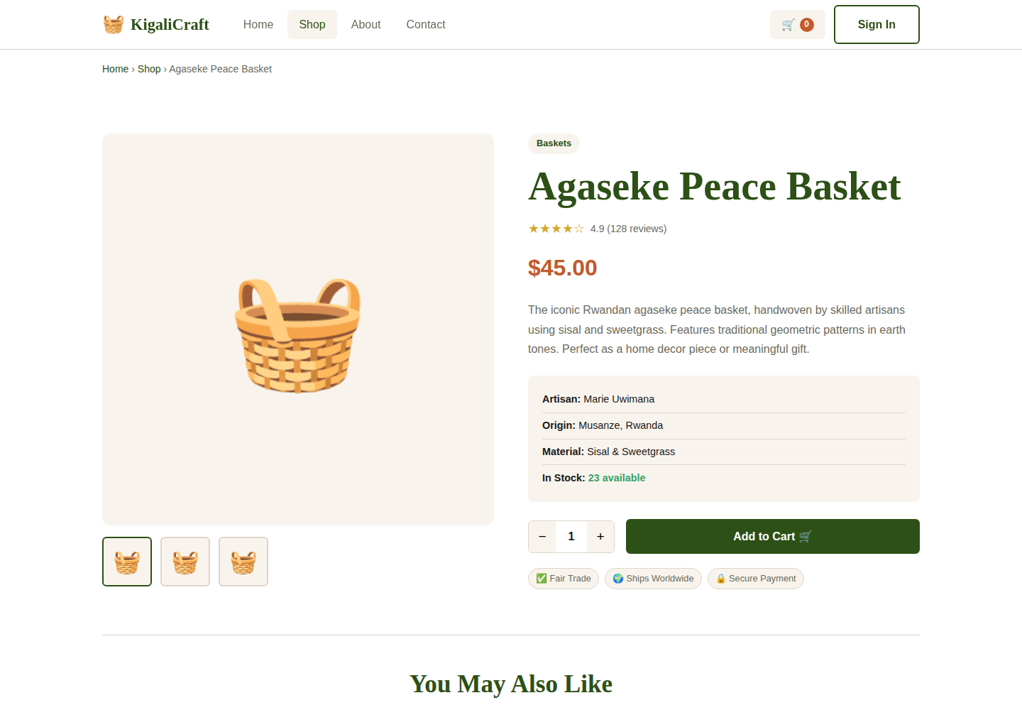
Figure 3 — Product detail page with artisan info and related products

8.4 Shopping Cart
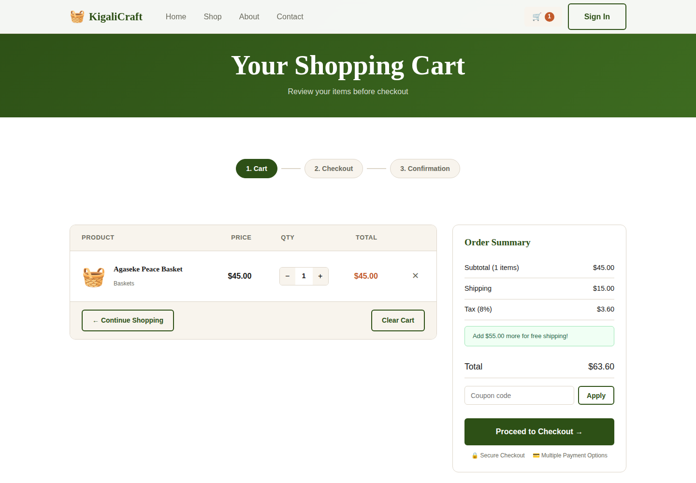
Figure 4 — Shopping cart with live totals and free-shipping progress

8.5 Order Confirmation
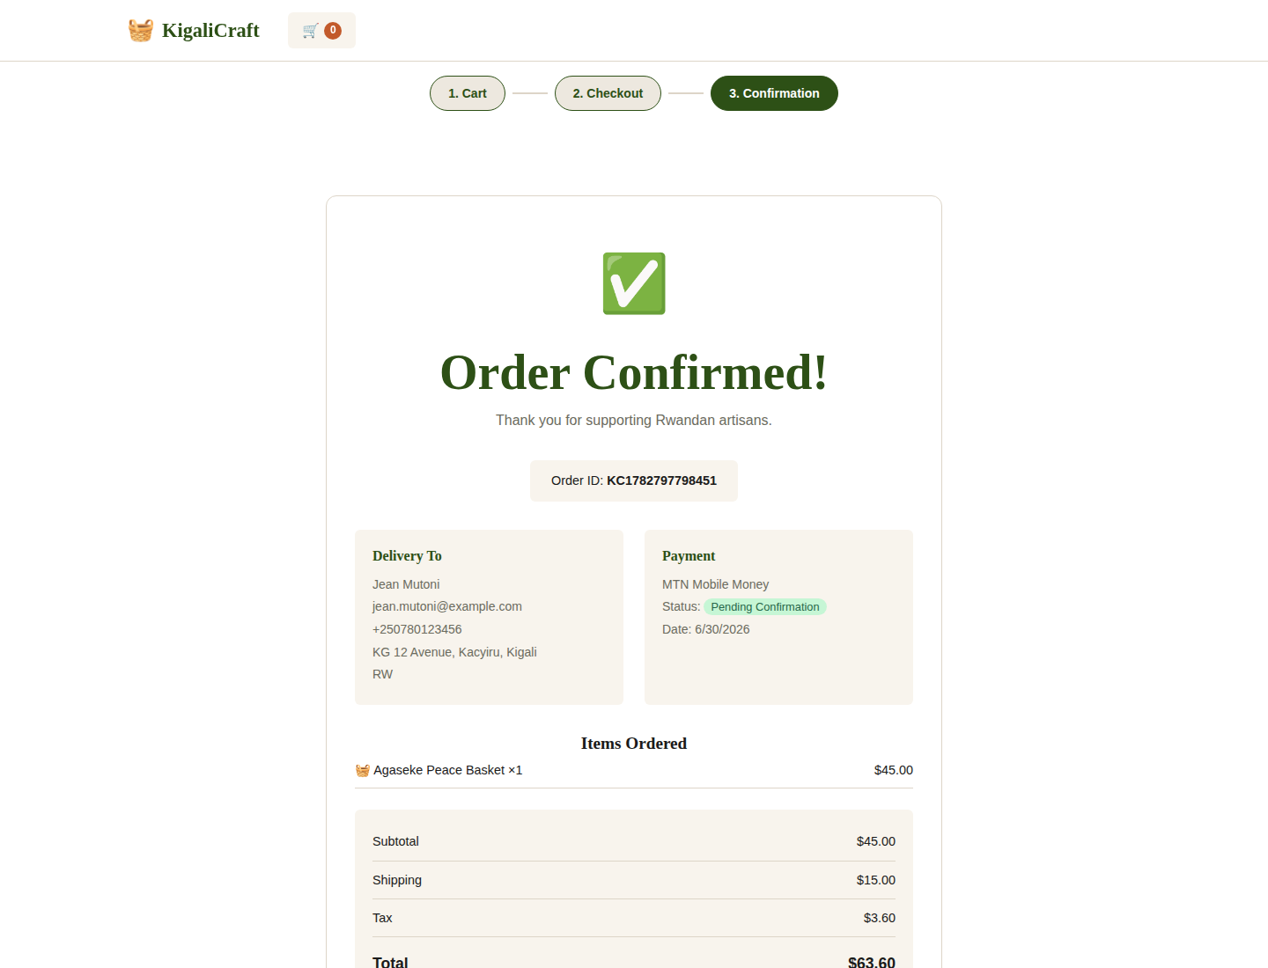
Figure 5 — Order confirmation page with printable receipt

8.6 Sign In / Register
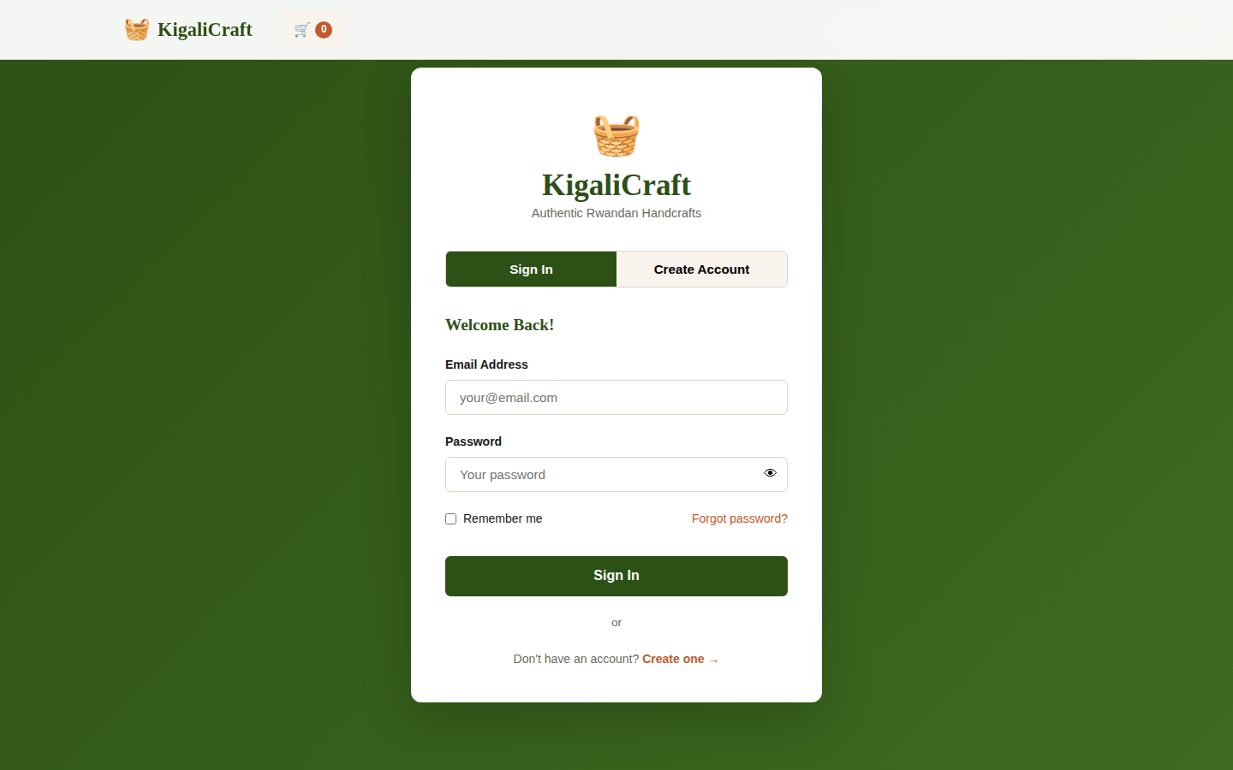
Figure 6 — Authentication page with tabbed sign-in and registration

8.7 Mobile Responsive View
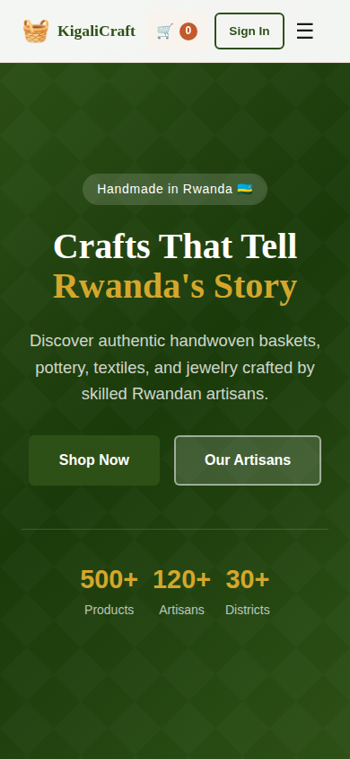
Figure 7 — Homepage on a 390px-wide mobile viewport

9. GitHub Repository Link
The complete source code, commit history, and documentation are hosted at:
https://github.com/<your-username>/kigalicraft
Replace <your-username> with your actual GitHub username after pushing this project, and update this link before final submission.

10. Deployment Link
Live deployment URL: [Insert your deployment URL here after deploying — e.g. Render, Railway, Fly.io, or Vercel].
Deployment steps are documented in the README.md file included in the repository, covering both direct Node.js deployment and Docker-based deployment.

11. CI/CD Implementation
A GitHub Actions workflow (.github/workflows/ci-cd.yml) automatically runs on every push or pull request to the main branch, with three sequential jobs:
- Build & Test — installs backend dependencies, seeds the database, starts the server, and runs the full automated API test suite (19 tests).
- Docker Build & Verify — builds the Docker image using Buildx and starts a container to confirm the /api/health endpoint responds correctly before considering the build successful.
- Deploy — a final stage, gated on both prior jobs succeeding and only running on pushes to main, ready to be connected to a hosting provider's deploy hook.
Screenshot evidence of a successful workflow run should be added here after the first push to GitHub (Actions tab → workflow run → green checkmarks for all three jobs).

12. Docker Implementation
The application is fully containerized using a single Dockerfile based on the lightweight node:18-alpine image. The build process installs production dependencies, copies both backend and frontend source, seeds the database at build time, and exposes port 5000 with a built-in HEALTHCHECK directive.
A docker-compose.yml file is also provided for one-command startup (docker compose up --build), including a named volume for persisting the database between container restarts.
Verified locally with the following commands:
- docker build -t kigalicraft .
- docker run -p 5000:5000 kigalicraft
- curl http://localhost:5000/api/health → returns {"status":"ok", ...}
Screenshots of the Docker build and running container should be added here after running the above commands in your own environment (terminal output showing 'Successfully built' and the health check response).

13. Challenges Encountered
- Native SQLite bindings (better-sqlite3) require a C++ compilation toolchain that is not guaranteed to be available in every CI runner or hosting environment. This was resolved by implementing a lightweight, dependency-free JSON-file database layer with identical relational semantics, ensuring the application installs and runs identically everywhere with zero native build steps.
- Achieving full mobile responsiveness across nine distinct pages required careful restructuring of CSS grid layouts at each breakpoint, particularly for the cart and checkout tables, which needed to collapse gracefully on small screens.
- Designing a checkout flow that supports three different payment methods (MTN Mobile Money, Airtel Money, and card) required conditional form fields and validation logic that adapts based on the selected method.

14. Future Enhancements
- Integrate a real payment gateway (Flutterwave, Paystack, or Stripe) to process live transactions.
- Build an admin dashboard for managing products, viewing orders, and updating inventory.
- Add automated email notifications for order confirmations and shipping updates.
- Allow customers to submit product reviews and ratings.
- Add multi-language support (English, Kinyarwanda, French) to better serve the local market.
- Migrate the JSON-file data store to a managed relational database (PostgreSQL/MySQL) for production-scale concurrency.

15. Conclusion
KigaliCraft demonstrates a complete, production-style e-commerce workflow — from a polished, responsive user interface through a secure backend API, relational data design, containerized deployment, and an automated CI/CD pipeline. The project fulfills all functional requirements (product management, shopping cart, checkout, database integration) as well as the mandatory DevOps requirements (GitHub hosting, deployment readiness, CI/CD, and Docker containerization) specified in the course brief.
Beyond meeting the technical requirements, the project tells a meaningful story: connecting Rwandan artisans — basket weavers, potters, woodcarvers, and painters — with a global customer base through a respectful, well-designed digital storefront. This reflects the spirit of the assignment's closing encouragement to work with excellence, integrity, and purpose.

