# Implement directory/file browsing

### using ASP.NET Web.APi + AngularJs

1) I need to have an ability **to browse a directories and**

**see files** from all hard discs on a computer (where app is hosted)

2) I need to have an ability **to see a count of files** in current directory and

subdirectories that are:

* <= 10mb
* > 10mb AND <= 50mb
* >= 100mb

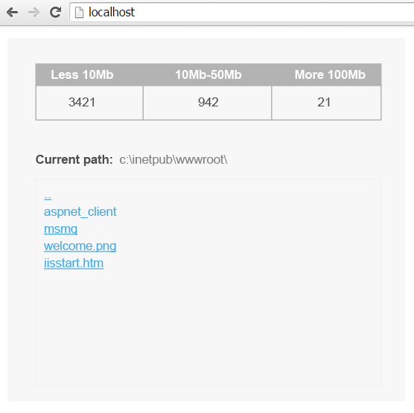

3) Please upload everything to git repository

4) Submit result via google form: <http://bit.ly/empeek_task_result>