Index
- Books.php – description
    - Books.php -source
- Db.sql – description
    - Db.sql - source
- Header.php – description
    - Header.php - source
- Footer.php – description
    - Footer.php - source
- Functions.php – description
    - Functions.php - source
- Index.php – description
    - Index.php - source
- Login.php – description
    - Login.php - source
- Logout.php
    - Logout.php - source
- Profile.php – description
    - Profile.php - source
- Register.php – description
    - Register.php - source
- Reserved.php – description
    - Reserved.php - source
- Search.php – description
    - Search.php - source
- Style.css
    - Style.css – source
- Screenshots
- Source code

Books.php – link to index on each header
PHP:
- Use functions.php.
- Connect to session if logged in, otherwise redirects to login.
- Connect to the database and retrieves all book’s categories.
- Retrieve books table from the database.
- Wait for post request with isbn value to reserve a book.
- Call reserveBook($book_isbn, $username) – functions.php

HTML:
- Include header and footer
- Output message, if set.
- Print each book and its values.
- Input through form to reserve books.

Db.sql
SQL:
- Create tables: users, categories, books, reservedBooks.
- Populate tables with given data.

Header.php
PHP:
- Start session if not started yet.

HTML:
- Output header navigation menu.
- Welcome user.

Footer.php
PHP:
- Start session if not started yet.

HTML:
- Output footer content.

Functions.php
PHP:
connectDb(): mysqli
- connect to the database
- check connection with isConnected():

isConnected($connection): bool
- if there is a connection error, die

registerUser($username, $password, $mobile): string - message
- connect to database with connectDb() func
- prepare and sanitize user input
- check if the user exists with doesUserExists($username) func
- insert sanitized data in db
- check if there is an error
- fill in session values with users data with fillInSession($ussername)
- close connection with database

loginUser($username, $password): string -message
- connect to database with connectDb() func
- prepare and sanitize user input
- check password with checkPassword($username, $password) func
- if password is right, fill in session with fillInSession($username)func
- close db connection

fillInSession($username): string – message
- connect to db with connectDb() func
- select all user data via sql query
- if there is no result, return error message
- if user was not found, return error message
- fetch result into row
- set all variables for session
- close db connection

doesUserExists($username): bool
- connect to db
- put name to lower chars
- select user from table with the given name
- if result is false, die
- close db connection

checkPassword($username, $password): string
- connect to db
- get user via sql query
- if there is no result, die
- if user is not found, return error message
- fetch result into row
- if password does not match, return error message
- close db connection

reserveBook($book_isbn, $username)
- connect to db
- sanitize user input
- check if the book is not reserved
- try to reserve the book
- update book’s status in the db
- close db connection
Index.php
PHP:
- Start session if required
- Check if user is not logged in and redirect to login page

HTML:
- Include heard and footer
- Output quick action cards menu
- Count and output total books, total categories, all reserved books by the user, all available books in database
- Output stats of the library and user

Login.php
PHP:
- Start session if required
- Check if user is not logged in and redirect to login page
- Wait for form to be filled and get values through post method
- Check that input is not empty
- Call loginUser($username, $password) – defined in functions.php
- If login successful, redirect to index.php
- Else write to error message variable

HTML:
- Output error message if it is not empty
- Print login form
- If the username was set, put it back in the form
- Print link to register

Logout.php
PHP:
- If session is not started, start it
- Destroy session
- Redirect to login page

Profile.php
PHP:
- Start session if required
- Check if user is not logged in and redirect to login page
- Wait for form to be submitted
- Connect to db
- Sanitize the user input data
- Update database values for the user with provided
- Check if the query was successful
- Update the rest of the session values for the user

HTML:
- Include header and footer
- Output error message if not empty
- Fill in the form with the sanitized values that are in session

Register.php
PHP:
- Start session if required
- Check if user is logged in and redirect to index page
- Wait for form to be submitted
- Check if the passwords match
- Call registerUser($username, $password) – defined in functions.php
- If the error message is empty, redirect to index.php

HTML:
- If error message is not empty output error
- Print form and put post elements if already set previously
- Make sure that password has at least one number, letter and capital letter
- Output hint for the password required pattern
- Print link to login page

Reserved.php
PHP:
- Start session if required
- Check if user is not logged in and redirect to login page
- Connect to db
- Select users reserved books from db
- Fetch all rows into books array
- Wait for form to be submitted, remove reservation button pressed
- Try to remove form reservedBooks table
- Try to update book reserved status
- Refresh the page

HTML:
- Include header and footer
- If error message is not empty output it
- If there any books reserved, output it

Search.php
PHP:
- Check if user is not logged in and redirect to login page
- Connect to db
- Select book’s categories
- Wait for search button to be pressed
- Sanitize user input
- Compile a sql query to select a book with user input
- If value is not empty, user it for search
- If any books are found, go through them and input into an array
- Call reserveBook($isbn, $username) – function.php

HTML:
- Output reserve message if not empty
- Output form for search
- Autofill form if was filled before
- Output drop down menu for categories
- Output search message
- If search is not empty, go through the books array and output each
- Print books values
- If the book is available, show the reserve button and hide the form

Sreenshots – link to index

Header.php

Footer.php

Index.php
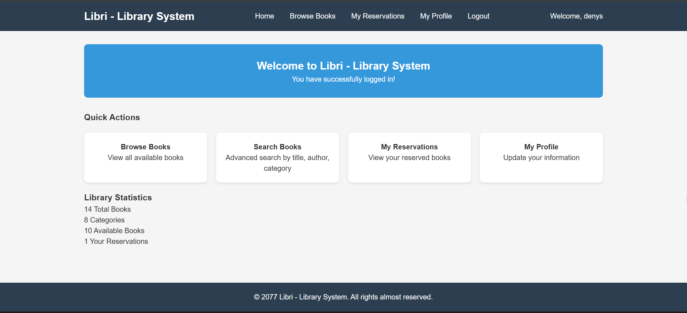

Books.php
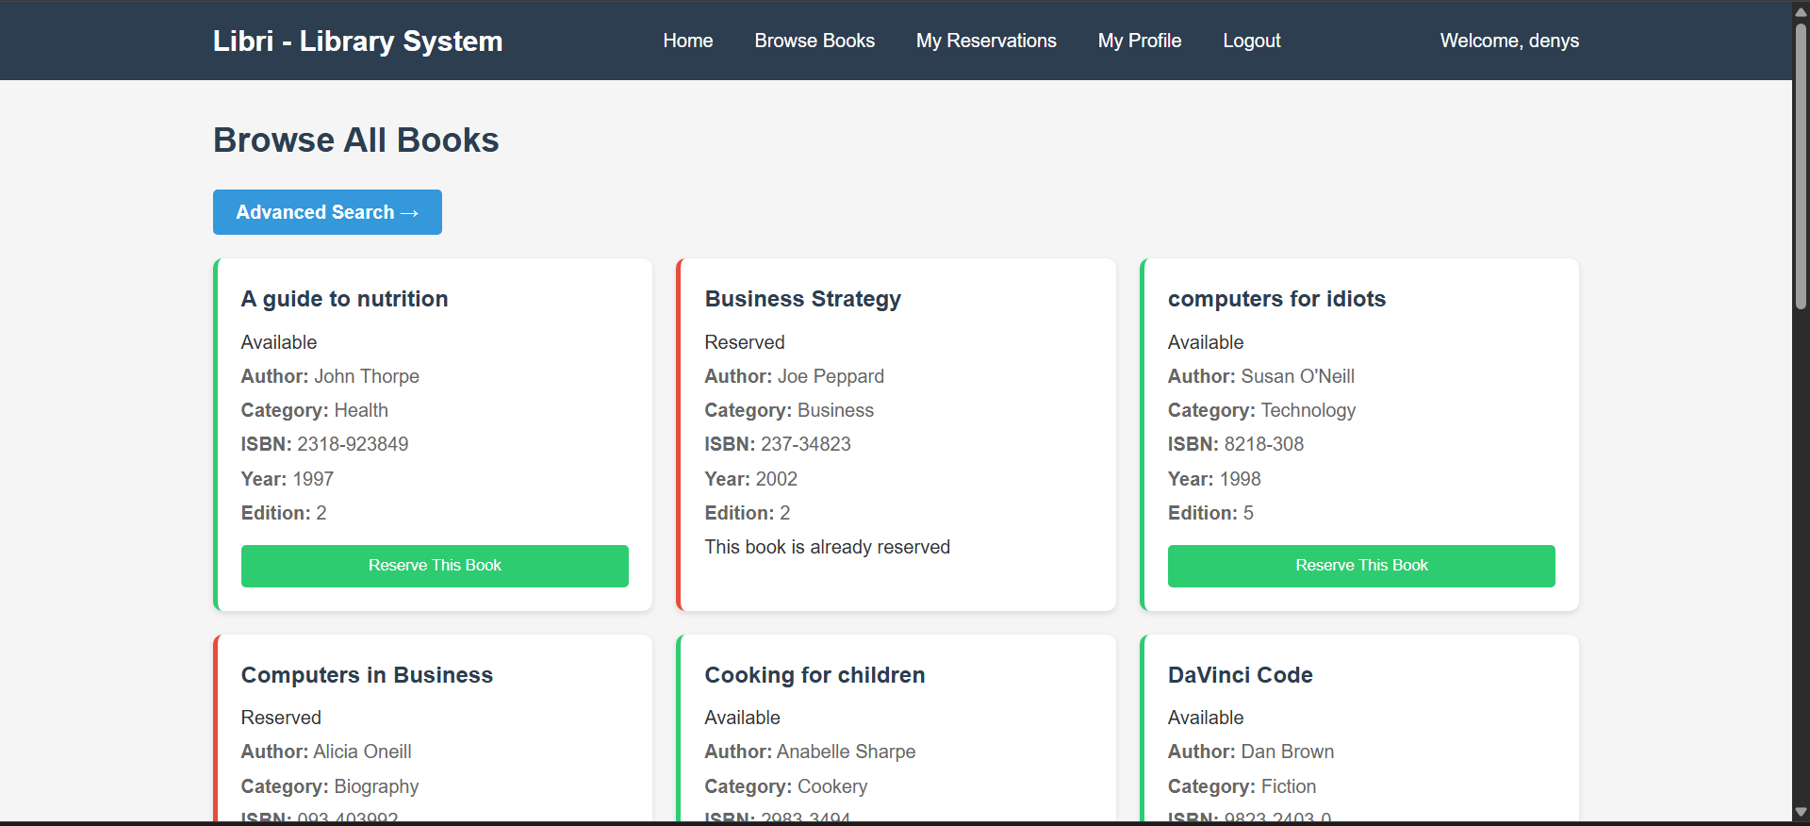

Reserved.php
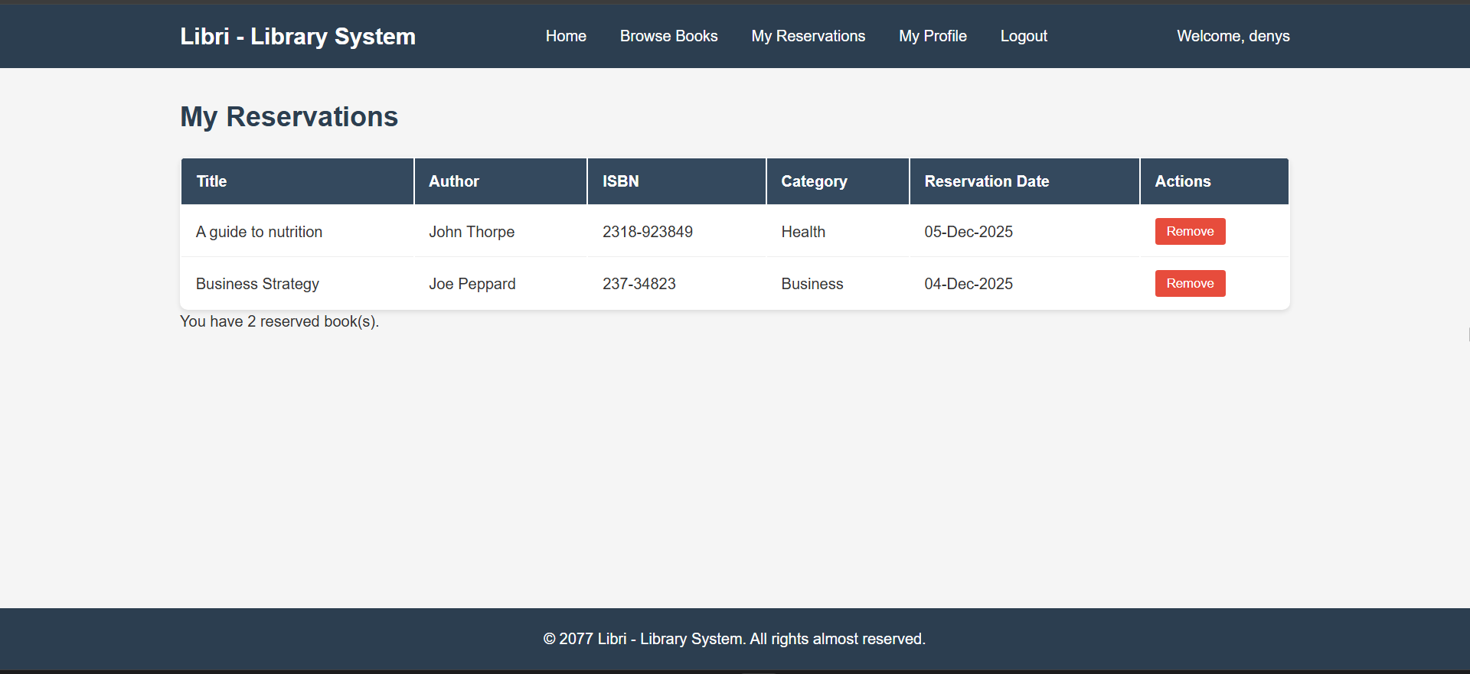

Profile.php
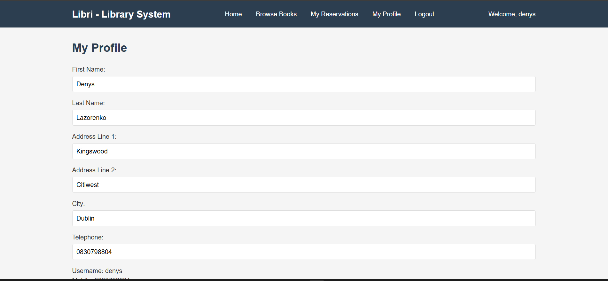

Login.php
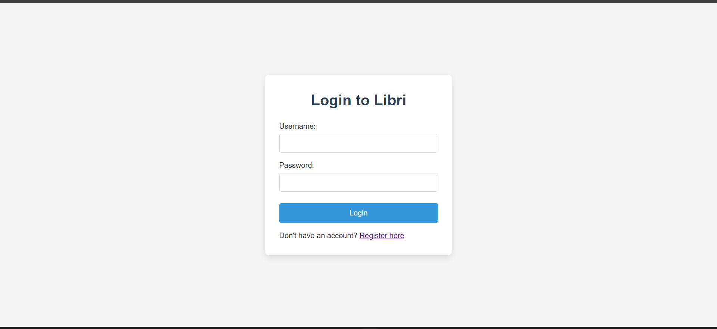

Register.php
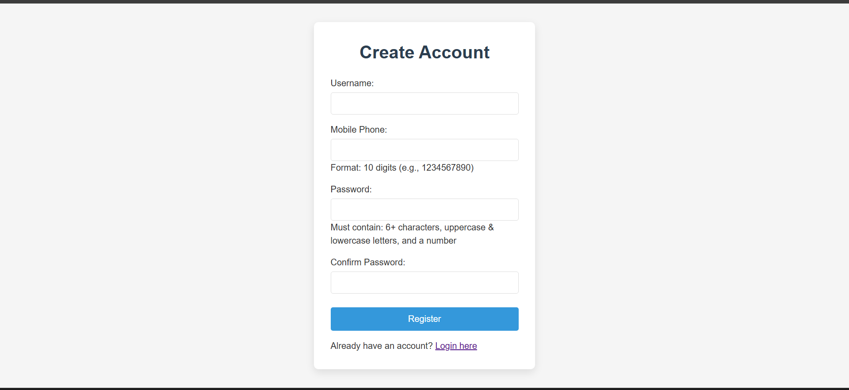

Source code – link to index
- Books.php
<?php
require_once 'functions.php';

// start session if required
if (session_status() === PHP_SESSION_NONE) {
session_start();
}

// if session is on but user is not logged_in
if(!isset($_SESSION["logged_in"]) || $_SESSION["logged_in"] === FALSE) {
// redirect to login page and exit
session_destroy();
header("Location: login.php");
exit();
}

$conn = connectDb();
$books = [];
$categories = [];

// run sql query to retrieve books categories
$category_result = $conn->query("SELECT * FROM categories ORDER BY description");
while($row = $category_result->fetch_assoc()) {
$categories[] = $row;
}

// run the sql query and retrieve books table
$sql = "SELECT b.*, c.description as category_name FROM books b
LEFT JOIN categories c ON b.category = c.id
ORDER BY b.title";
$book_result = $conn->query($sql);
while($row = $book_result->fetch_assoc()) {
$books[] = $row;
}

// handle reservation
if($_SERVER["REQUEST_METHOD"] == "POST" && isset($_POST['reserve_isbn'])) {
$message = reserveBook($_POST["reserve_isbn"], $_SESSION["username"]);
}

$conn->close();
?>

<!DOCTYPE html>
<html lang="en">
<head>
<meta charset="UTF-8">
<meta name="viewport" content="width=device-width, initial-scale=1.0">
<title>Browse Books - Libri</title>
<link rel="stylesheet" href="style.css">
</head>
<body>
<?php include 'header.php'; ?>

<main class="main-content">
<div class="content-container">
<h1 class="page-title">Browse All Books</h1>

<div class="search-container">
<button class="search-button"><a href="search.php" class="search-link">Advanced Search →</a></button>
</div>

<!-- output message -->
<?php if(isset($message)) {?>
<?php echo $message; ?>
<?php } ?>

<div class="books-section">
<div class="books-grid">
<!-- go through each book and echo it's values -->
<?php foreach($books as $book) {?>
<div class="book-card <?php echo $book['reserved'] ? 'reserved' : 'available'; ?>">
<div class="book-header">
<!-- echo header of the book -->
<h3 class="book-title"><?php echo $book['title']; ?></h3>
<div class="book-status">
<span class="status-badge <?php echo $book['reserved'] ? 'status-reserved' : 'status-available'; ?>">
<?php echo $book['reserved'] ? 'Reserved' : 'Available'; ?>
</span>
</div>
</div>

<!-- echo values -->
<div class="book-details">
<p class="book-author"><strong>Author:</strong> <?php echo $book['author']; ?></p>
<p class="book-category"><strong>Category:</strong> <?php echo $book['category_name']; ?></p>
<p class="book-isbn"><strong>ISBN:</strong> <?php echo $book['isbn']; ?></p>
<p class="book-year"><strong>Year:</strong> <?php echo $book['year']; ?></p>
<p class="book-edition"><strong>Edition:</strong> <?php echo $book['edition']; ?></p>
</div>

<!-- show form to reserve the book if available -->
<?php if(!$book['reserved']) {?>
<form method="post" class="reserve-form">
<input type="hidden" name="reserve_isbn" value="<?php echo $book['isbn']; ?>">
<button type="submit" class="reserve-btn">Reserve This Book</button>
</form>
<!-- otherwise show that the book is reserved -->
<?php } else {?>
<div class="reserved-info">
<p class="reserved-text">This book is already reserved</p>
</div>
<?php }?>
</div>
<?php }?>
</div>
</div>
</div>
</main>

<?php include 'footer.php'; ?>
</body>
</html>

- Db.sql
-- creating tables

-- users table
CREATE TABLE IF NOT EXISTS users (
username VARCHAR(30) PRIMARY KEY,
password VARCHAR(30) NOT NULL,
fname VARCHAR(50),
sname VARCHAR(50),
address1 VARCHAR(100),
address2 VARCHAR(100),
city VARCHAR(30),
tel VARCHAR(20),
mobile VARCHAR(20) NOT NULL
);

-- book's categories table
CREATE TABLE IF NOT EXISTS categories (
id VARCHAR(3) PRIMARY KEY,
description VARCHAR(50) UNIQUE NOT NULL
);

-- books table
CREATE TABLE IF NOT EXISTS books (
isbn VARCHAR(20) PRIMARY KEY,
title VARCHAR(50) NOT NULL,
author VARCHAR(100),
edition INT,
year INT,
category VARCHAR(3) REFERENCES categories(id),
resell BOOLEAN NOT NULL
);

-- reserved books table
CREATE TABLE IF NOT EXISTS reservedBooks (
isbn VARCHAR(20) REFERENCES books(isbn),
username VARCHAR(30) REFERENCES users(username),
date VARCHAR(20) NOT NULL
);

-- populating database

-- insert sample data into categories table
INSERT INTO categories (id, description) VALUES
('001', 'Health'),
('002', 'Business'),
('003', 'Biography'),
('004', 'Technology'),
('005', 'Travel'),
('006', 'Self-Help'),
('007', 'Cookery'),
('008', 'Fiction');

-- insert sample data into users table
INSERT INTO users (username, password, fname, sname, address1, address2, city, tel, mobile) VALUES
('alanjmckenna', 't1234s', 'Alan', 'McKenna', '38 Cranley Road', 'Fairview', 'Dublin', '9998377', '856625567'),
('joecrotty', 'kj7899', 'Joseph', 'Crotty', 'Apt 5 Clyde Road', 'Donnybrook', 'Dublin', '8887889', '876654456'),
('tommy100', '123456', 'Tom', 'Behan', '14 Hyde Road', 'Dalkey', 'Dublin', '9983747', '876738782');

-- insert sample data into books table
INSERT INTO books (isbn, title, author, edition, year, category, resell) VALUES
('093-403992', 'Computers in Business', 'Alicia Oneill', 3, 1997, '003', false),
('23472-8729', 'Exploring Peru', 'Stephanie Birchi', 4, 2005, '005', false),
('237-34823', 'Business Strategy', 'Joe Peppard', 2, 2002, '002', false),
('2318-923849', 'A guide to nutrition', 'John Thorpe', 2, 1997, '001', false),
('2983-3494', 'Cooking for children', 'Anabelle Sharpe', 1, 2003, '007', false),
('8218-308', 'computers for idiots', 'Susan O''Neill', 5, 1998, '004', false),
('9823-23984', 'My life in picture', 'Kevin Graham', 8, 2004, '001', false),
('9823-2403-0', 'DaVinci Code', 'Dan Brown', 1, 2003, '008', false),
('98234-029384', 'My ranch in Texas', 'George Bush', 1, 2005, '001', true),
('9823-98345', 'How to cook Italian food', 'Jamie Oliver', 2, 2005, '007', true),
('9823-98487', 'Optimising your business', 'Cleo Blair', 1, 2001, '002', false),
('988745-234', 'Tara Road', 'Maeve Binchy', 4, 2002, '008', false),
('993-004-00', 'My life in bits', 'John Smith', 1, 2001, '001', false),
('9987-0039882', 'Shooting History', 'Jon Snow', 1, 2003, '001', false);

-- insert sample data into reservations table
INSERT INTO reservedBooks (isbn, username, date) VALUES
('98234-029384', 'joecrotty', '11-Oct-2008'),
('9823-98345', 'tommy100', '11-Oct-2008');

- Header.php
<?php
// start session if required
if (session_status() === PHP_SESSION_NONE) {
session_start();
}
?>
<!DOCTYPE html>
<html lang="en">
<head>
<meta charset="UTF-8">
<meta name="viewport" content="width=device-width, initial-scale=1.0">
<title>Libri - Library System</title>
<link rel="stylesheet" href="style.css">
</head>
<body>
<header class="site-header">
<div class="header-container">
<h1 class="site-title">Libri - Library System</h1>
<nav class="main-nav">
<ul class="nav-list">
<li class="nav-item"><a href="index.php" class="nav-link">Home</a></li>
<li class="nav-item"><a href="books.php" class="nav-link">Browse Books</a></li>
<li class="nav-item"><a href="reserved.php" class="nav-link">My Reservations</a></li>
<li class="nav-item"><a href="profile.php" class="nav-link">My Profile</a></li>
<li class="nav-item"><a href="logout.php" class="nav-link">Logout</a></li>
</ul>
</nav>
<div class="user-info">
<span class="welcome-message">Welcome, <?php echo $_SESSION['username'] ?? 'Guest'; ?></span>
</div>
</div>
</header>

- Footer.php
<?php
// start session if required
if (session_status() === PHP_SESSION_NONE) {
session_start();
}
?>
<!DOCTYPE html>
<html lang="en">
<head>
<meta charset="UTF-8">
<meta name="viewport" content="width=device-width, initial-scale=1.0">
<title>Document</title>
<link rel="stylesheet" href="style.css">
</head>
<body>
<footer class="site-footer">
<div class="footer-container">
<p class="copyright">&copy; 2077 Libri - Library System. All rights almost reserved.</p>
</div>
</footer>
</body>
</html>

- Functions.php
<?php
function connectDb(): mysqli {
$servername = "localhost";
$host_name = "root";
$host_password = "";
$dbname = "libri";

// create connection to my database
$conn = new mysqli($servername, $host_name, $host_password, $dbname);
// check connection
isConnected($conn);

return $conn;
}

// check connection
function isConnected(mysqli $conn): bool {
// if connection failed, output error message and exit
if($conn->connect_error) {
die("Connection failed: " . $conn->connect_error);
}
return !$conn->connect_error;
}

// register user
function registerUser($uname, $password, $mobile): string {
$conn = connectDb();

// error message
$message = "";

// prepare sanitized input
$safe_uname = $conn->real_escape_string($uname);
$safe_password = $conn->real_escape_string($password);
$safe_mobile = $conn->real_escape_string($mobile);

// if a user with this name is already exists
if(doesUserExist($safe_uname)) {
// give error message and exit
$message = "Username is already taken";
$conn->close();
return $message;
}

// insert sanitized data
$sql = "INSERT INTO users (username, password, mobile) VALUES
('$safe_uname', '$safe_password', '$safe_mobile');";

// execute sql query
$result = $conn->query($sql);

// if there is an error
if(!$result) {
$message = "There was something wrong with your data";
$conn->close();
return $message;
}

$message = fillInSession($safe_uname);

$conn->close();

// return the message regardless of it's content
return $message;
}

function loginUser($uname, $password): string {
$conn = connectDb();

// prepare case insensitive and sanitized input
$uname_lower = strtolower($uname);
$safe_uname = $conn->real_escape_string($uname_lower);

// get message from function
$message = checkPassword($safe_uname, $password);

// if message is empty, fill in the session info on the user
if(!$message) {
$message = fillInSession($safe_uname);
}

$conn->close();

// return the message regardless of it's content
return $message;
}

function fillInSession($safe_uname): string {
$conn = connectDb();

// error message
$message = "";

// sql query to get all user data
$sql = "SELECT username, password, fname, sname, address1, address2, city, tel, mobile
FROM users WHERE username = '$safe_uname'";

// query and store in result
$result = $conn->query($sql);

// if there is no result
if(!$result) {
$message = "Failed to check if user exists: " . $conn->error;
$conn->close();
return $message;
}

// user was not found
if(!($result->num_rows > 0)) {
$message = "User not found! from session";
$conn->close();
return $message;
}

$row = $result->fetch_assoc();

// set all variables for session
$_SESSION['username'] = $row['username'];
$_SESSION['password'] = $row['password'];
$_SESSION['fname'] = $row['fname'];
$_SESSION['sname'] = $row['sname'];
$_SESSION['address1'] = $row['address1'];
$_SESSION['address2'] = $row['address2'];
$_SESSION['city'] = $row['city'];
$_SESSION['tel'] = $row['tel'];
$_SESSION['mobile'] = $row['mobile'];
$_SESSION['logged_in'] = true;

$conn->close();

return $message;
}

function doesUserExist($safe_uname): bool {
$conn = connectDb();

// prepare case insensitive and sanitized input
$uname_lower = strtolower($safe_uname);

// execute sql query
$sql = "SELECT username FROM users WHERE LOWER(username) = '$uname_lower'";
$result = $conn->query($sql);

// if result is false, die
if (!$result) {
$conn->close();
die("Failed to check if user exists: " . $conn->error);
}

$conn->close();

// return true if found user
return $result->num_rows > 0;
}

function checkPassword($safe_uname, $password): string {
$conn = connectDb();

// error message init
$message = "";

// look for provided username
$sql = "SELECT username, password FROM users WHERE LOWER(username) = '$safe_uname'";
$result = $conn->query($sql);

// if there is no result
if(!$result) {
$conn->close();
die("Failed to check if user exists: " . $conn->error);
}

// if there is no rows / aka user is not found
if(!($result->num_rows > 0)) {
$message = "User not found!";
$conn->close();
return $message;
}

// take a row
$row = $result->fetch_assoc();

// check password
if($row["password"] !== $password) {
$message = "Incorrect password!";
$conn->close();
return $message;
}

// if all was right and password matched, message should be empty
$conn->close();
return $message;
}

function reserveBook($book_isbn, $uname): string {
$conn = connectDb();
$message = "";

// sanitize input in case user could input value somehow
$isbn = $conn->real_escape_string($book_isbn);
$username = $conn->real_escape_string($uname);
$date = date('d-M-Y');

// check if the book is reserved
$check_book = $conn->query("SELECT reserved FROM books WHERE isbn = '$isbn'");
$book_data = $check_book->fetch_assoc();

// if book is not reserved
if($book_data && $book_data['reserved'] == false) {
try {
// reserve the book
$insert_sql = "INSERT INTO reservedBooks (isbn, username, date) VALUES ('$isbn', '$username', '$date')";
$conn->query($insert_sql);

// update books status in database
$update_sql = "UPDATE books SET reserved = true WHERE isbn = '$isbn'";
$conn->query($update_sql);

// output success massage
$message = '<div class="success-message">Book reserved successfully!</div>';

} catch (Exception $e) {
// if exception is caught, output error message
$message = '<div class="error-message">Failed to reserve book: ' . $e->getMessage() . '</div>';
}
} else {
// error, the book is reserved
$message = '<div class="error-message">This book is already reserved by someone else!</div>';
}

$conn->close();
return $message;
}
?>

- Index.php
<?php
require_once 'functions.php';

// start session if required
if (session_status() === PHP_SESSION_NONE) {
session_start();
}

// if session is on but user is not logged_in
if(!isset($_SESSION["logged_in"]) || $_SESSION["logged_in"] === FALSE) {
// redirect to login page and exit
session_destroy();
header("Location: login.php");
exit();
}
?>
<!DOCTYPE html>
<html lang="en">
<head>
<meta charset="UTF-8">
<meta name="viewport" content="width=device-width, initial-scale=1.0">
<title>Home - Libri</title>
<link rel="stylesheet" href="style.css">
</head>
<body>
<?php include 'header.php'; ?>

<main class="main-content">
<div class="content-container">
<section class="welcome-section">
<h2 class="section-title">Welcome to Libri - Library System</h2>
<p class="welcome-text">You have successfully logged in!</p>
</section>

<section class="quick-actions">
<h3 class="actions-title">Quick Actions</h3>
<div class="actions-grid">
<a href="books.php" class="action-card">
<h4 class="card-title">Browse Books</h4>
<p class="card-text">View all available books</p>
</a>

<a href="search.php" class="action-card">
<h4 class="card-title">Search Books</h4>
<p class="card-text">Advanced search by title, author, category</p>
</a>

<a href="reserved.php" class="action-card">
<h4 class="card-title">My Reservations</h4>
<p class="card-text">View your reserved books</p>
</a>

<a href="profile.php" class="action-card">
<h4 class="card-title">My Profile</h4>
<p class="card-text">Update your information</p>
</a>
</div>
</section>

<section class="stats-section">
<h3 class="stats-title">Library Statistics</h3>
<div class="stats-container">
<?php
$conn = connectDb();
// count total books in db
$total_books = $conn->query("SELECT COUNT(*) as total FROM books")->fetch_assoc()['total'];
// count total categories in db
$total_categories = $conn->query("SELECT COUNT(*) as total FROM categories")->fetch_assoc()['total'];
// count all reserved books by the user in db
$reserved_books = $conn->query("SELECT COUNT(*) as total FROM reservedBooks WHERE username = '".$_SESSION['username']."'")->fetch_assoc()['total'];
// count all available books in db
$available_books = $conn->query("SELECT COUNT(*) as total FROM books WHERE reserved = false")->fetch_assoc()['total'];
$conn->close();
?>
<div class="stat-item">
<span class="stat-number"><?php echo $total_books; ?></span>
<span class="stat-label">Total Books</span>
</div>
<div class="stat-item">
<span class="stat-number"><?php echo $total_categories; ?></span>
<span class="stat-label">Categories</span>
</div>
<div class="stat-item">
<span class="stat-number"><?php echo $available_books; ?></span>
<span class="stat-label">Available Books</span>
</div>
<div class="stat-item">
<span class="stat-number"><?php echo $reserved_books; ?></span>
<span class="stat-label">Your Reservations</span>
</div>
</div>
</section>
</div>
</main>

<?php include 'footer.php'; ?>
</body>
</html>
- Login.php
<?php
require_once 'functions.php';

// start session if required
if (session_status() === PHP_SESSION_NONE) {
session_start();
}

// if logged in
if(isset($_SESSION["logged_in"]) && $_SESSION["logged_in"] === TRUE) {
// redirect to main page
header("Location: index.php");
exit();
}

$message = "";

if($_SERVER["REQUEST_METHOD"] == "POST") {
$username = $_POST["username"];
$password = $_POST["password"];

if(empty($username) || empty($password)) {
$message = '<div class="error-message">Please fill in all fields</div>';
} else {
$message = loginUser($username, $password);
if(empty($message)) {
header("Location: index.php");
exit();
} else {
$message = '<div class="error-message">' . $message . '</div>';
}
}
}
?>

<!DOCTYPE html>
<html lang="en">
<head>
<meta charset="UTF-8">
<meta name="viewport" content="width=device-width, initial-scale=1.0">
<title>Login - Libri</title>
<link rel="stylesheet" href="style.css">
</head>
<body class="auth-body">
<div class="auth-form-container">
<h1 class="auth-title">Login to Libri</h1>

<?php
// if message is not empty, echo it
if($message) {
echo $message;
}
?>

<!-- login form -->
<form method="post" class="login-form">
<div class="form-group">
<label for="username" class="form-label">Username:</label>
<!-- if the username was set, put it in back -->
<input type="text" id="username" name="username" class="form-input"
value="<?php echo isset($_POST['username']) ? htmlentities($_POST['username']) : ''; ?>"
required>
</div>

<div class="form-group">
<label for="password" class="form-label">Password:</label>
<input type="password" id="password" name="password" class="form-input" required>
</div>

<div class="form-group">
<input type="submit" value="Login" class="submit-btn">
</div>
</form>

<div class="auth-link">
Don't have an account? <a href="register.php">Register here</a>
</div>
</div>
</body>
</html>

- Logout.php
<?php
// start session if required
if (session_status() === PHP_SESSION_NONE) {
session_start();
}

session_destroy();
header("Location: login.php");
exit();
?>

- Profile.php
<?php
require_once 'functions.php';

// start session if required
if (session_status() === PHP_SESSION_NONE) {
session_start();
}

// if session is on but user is not logged_in
if(!isset($_SESSION["logged_in"]) || $_SESSION["logged_in"] === FALSE) {
// redirect to login page and exit
session_destroy();
header("Location: login.php");
exit();
}

$message = '';

// if the form is submitted
if($_SERVER["REQUEST_METHOD"] == "POST") {
$conn = connectDb();

// sanitize input
$fname = $conn->real_escape_string($_POST['fname']);
$sname = $conn->real_escape_string($_POST['sname']);
$address1 = $conn->real_escape_string($_POST['address1']);
$address2 = $conn->real_escape_string($_POST['address2']);
$city = $conn->real_escape_string($_POST['city']);
$tel = $conn->real_escape_string($_POST['tel']);
$username = $_SESSION['username'];

// update database values for the user
$sql = "UPDATE users SET
fname = '$fname',
sname = '$sname',
address1 = '$address1',
address2 = '$address2',
city = '$city',
tel = '$tel'
WHERE username = '$username'";

// if the query was successful
if($conn->query(query: $sql)) {
$message = '<div class="success-message">Profile updated successfully!</div>';
// update the rest of session values for the user
$_SESSION['fname'] = $fname;
$_SESSION['sname'] = $sname;
$_SESSION['address1'] = $address1;
$_SESSION['address2'] = $address2;
$_SESSION['city'] = $city;
$_SESSION['tel'] = $tel;
} else {
$message = '<div class="error-message">Error updating profile: ' . $conn->error . '</div>';
}

$conn->close();
}
?>

<!DOCTYPE html>
<html lang="en">
<head>
<meta charset="UTF-8">
<meta name="viewport" content="width=device-width, initial-scale=1.0">
<title>My Profile - Libri</title>
<link rel="stylesheet" href="style.css">
</head>
<body>
<?php include 'header.php'; ?>

<main class="main-content">
<div class="content-container">
<h1 class="page-title">My Profile</h1>

<?php
// if the message is not empty, output it
if($message) {
echo $message;
}
?>

<!-- output form to finish registration -->
<div class="profile-section">
<form method="post" class="profile-form">
<div class="form-row">
<div class="form-group">
<label for="fname" class="form-label">First Name:</label>
<!-- if the first name is in session, sanitize it and put it in -->
<input type="text" id="fname" name="fname" class="form-input"
value="<?php echo htmlentities($_SESSION['fname'] ?? ''); ?>">
</div>

<div class="form-group">
<label for="sname" class="form-label">Last Name:</label>
<!-- if the second name is in session, sanitize it and put it in -->
<input type="text" id="sname" name="sname" class="form-input"
value="<?php echo htmlentities($_SESSION['sname'] ?? ''); ?>">
</div>
</div>

<div class="form-group">
<label for="address1" class="form-label">Address Line 1:</label>
<!-- if the address1 is in session, sanitize it and put it in -->
<input type="text" id="address1" name="address1" class="form-input"
value="<?php echo htmlentities($_SESSION['address1'] ?? ''); ?>">
</div>

<div class="form-group">
<label for="address2" class="form-label">Address Line 2:</label>
<!-- if the address2 is in session, sanitize it and put it in -->
<input type="text" id="address2" name="address2" class="form-input"
value="<?php echo htmlentities($_SESSION['address2'] ?? ''); ?>">
</div>

<div class="form-row">
<div class="form-group">
<label for="city" class="form-label">City:</label>
<!-- if the city is in session, sanitize it and put it in -->
<input type="text" id="city" name="city" class="form-input"
value="<?php echo htmlentities($_SESSION['city'] ?? ''); ?>">
</div>

<div class="form-group">
<label for="tel" class="form-label">Telephone:</label>
<!-- if the telephone is in session, sanitize it and put it in -->
<input type="text" id="tel" name="tel" class="form-input"
value="<?php echo htmlentities($_SESSION['tel'] ?? ''); ?>">
</div>
</div>

<div class="readonly-info">
<div class="info-item">
<span class="info-label">Username:</span>
<!-- sanitize before output -->
<span class="info-value"><?php echo htmlentities($_SESSION['username']); ?></span>
</div>
<div class="info-item">
<span class="info-label">Mobile:</span>
<span class="info-value"><?php echo htmlentities($_SESSION['mobile']); ?></span>
</div>
</div>

<div class="form-group">
<input type="submit" value="Update Profile" class="submit-btn">
</div>
</form>
</div>
</div>
</main>

<?php include 'footer.php'; ?>
</body>
</html>

- Register.php
<?php
// start session if required
if (session_status() === PHP_SESSION_NONE) {
session_start();
}

// if logged in
if(isset($_SESSION["logged_in"]) && $_SESSION["logged_in"] === TRUE) {
// redirect to main page
header("Location: index.php");
exit();
}

$message = "";

// if the form is submitted
if(isset($_POST["name"]) && isset($_POST["mobile"])
&& isset($_POST["pw"]) && isset($_POST["cpw"])) {
// if the passwords do not match
if($_POST["pw"] !== $_POST["cpw"]) {
$message = "<div class='error-message'>Passwords do not match!</div>";
} else {
require_once "functions.php";
$message = registerUser($_POST["name"],$_POST["pw"],$_POST["mobile"]);

// if there is no error
if(empty($message) && isset($_SESSION["logged_in"]) && $_SESSION["logged_in"] === TRUE) {
header("Location: index.php");
exit();
} else {
$message = "<div class='error-message'>$message</div>";
}
}
}
?>

<!DOCTYPE html>
<html lang="en">
<head>
<meta charset="UTF-8">
<meta name="viewport" content="width=device-width, initial-scale=1.0">
<title>Register - Libri</title>
<link rel="stylesheet" href="style.css">
</head>
<body class="auth-body">
<div class="auth-form-container">
<h1 class="auth-title">Create Account</h1>

<!-- error output -->
<?php
if($message) {
echo $message;
}
?>

<form action="register.php" method="post" autocomplete="on" id="registerForm">
<div class="form-group">
<label for="name" class="form-label">Username:</label>
<!-- input sanitized post value if set -->
<input type="text" id="name" name="name" class="form-input"
value="<?php echo isset($_POST['name']) ? htmlentities($_POST['name']) : ''; ?>"
required>
</div>

<div class="form-group">
<label for="mobile" class="form-label">Mobile Phone:</label>
<!-- input sanitized post value if set -->
<input type="tel" id="mobile" name="mobile" class="form-input"
value="<?php echo isset($_POST['mobile']) ? htmlentities($_POST['mobile']) : ''; ?>"
required pattern="[\d]{10}"
title="Must be 10 digits">
<div class="password-requirements">Format: 10 digits (e.g., 1234567890)</div>
</div>

<div class="form-group">
<label for="pw" class="form-label">Password:</label>
<input type="password" id="pw" name="pw" class="form-input"
required pattern="(?=.*\d)(?=.*[a-z])(?=.*[A-Z]).{6,}"
title="Must contain at least one number, one uppercase and lowercase letter, and at least 6 characters">
<div class="password-requirements">Must contain: 6+ characters, uppercase & lowercase letters, and a number</div>
</div>

<div class="form-group">
<label for="cpw" class="form-label">Confirm Password:</label>
<input type="password" id="cpw" name="cpw" class="form-input"
required pattern="(?=.*\d)(?=.*[a-z])(?=.*[A-Z]).{6,}">
<div id="passwordMatchMessage" class="password-mismatch"></div>
</div>

<div class="form-group">
<input type="submit" value="Register" class="submit-btn" id="submitBtn">
</div>
</form>

<div class="auth-link">
Already have an account? <a href="login.php">Login here</a>
</div>
</div>
</body>
</html>

- Reserved.php
<?php
require_once 'functions.php';

// start session if required
if (session_status() === PHP_SESSION_NONE) {
session_start();
}

// if session is on but user is not logged_in
if(!isset($_SESSION["logged_in"]) || $_SESSION["logged_in"] === FALSE) {
// redirect to login page and exit
session_destroy();
header("Location: login.php");
exit();
}

$conn = connectDb();
$reserved_books = [];

// select users reserved books from db
$sql = "SELECT b.*, rb.date as reservation_date, c.description as category_name
FROM reservedBooks rb
JOIN books b ON rb.isbn = b.isbn
LEFT JOIN categories c ON b.category = c.id
WHERE rb.username = '".$_SESSION['username']."'
ORDER BY rb.date DESC";
$result = $conn->query($sql);

// fetch all rows to books array
while($row = $result->fetch_assoc()) {
$reserved_books[] = $row;
}

// handle remove reservation
if($_SERVER["REQUEST_METHOD"] == "POST" && isset($_POST['remove_isbn'])) {
$isbn = $conn->real_escape_string($_POST['remove_isbn']);
$username = $conn->real_escape_string($_SESSION['username']);

try {
// remove from reservedBooks
$delete_sql = "DELETE FROM reservedBooks WHERE isbn = '$isbn' AND username = '$username'";
$conn->query($delete_sql);

// update book reserved status
$update_sql = "UPDATE books SET reserved = false WHERE isbn = '$isbn'";
$conn->query($update_sql);

// refresh the page
header("Location: reserved.php");
exit();

} catch (Exception $e) {
$error_message = '<div class="error-message">Failed to remove reservation: ' . $e->getMessage() . '</div>';
}
}

$conn->close();
?>

<!DOCTYPE html>
<html lang="en">
<head>
<meta charset="UTF-8">
<meta name="viewport" content="width=device-width, initial-scale=1.0">
<title>My Reservations - Libri</title>
<link rel="stylesheet" href="style.css">
</head>
<body>
<?php include 'header.php'; ?>

<main class="main-content">
<div class="content-container">
<h1 class="page-title">My Reservations</h1>

<?php if(isset($error_message)): ?>
<?php echo $error_message; ?>
<?php endif; ?>

<?php if(empty($reserved_books)): ?>
<div class="empty-state">
<p class="empty-message">You have no reserved books.</p>
<a href="books.php" class="browse-link">Browse Books</a>
<a href="search.php" class="browse-link">Search Books</a>
</div>
<?php else: ?>
<div class="reservations-table">
<table class="data-table">
<thead>
<tr class="table-header">
<th class="table-cell">Title</th>
<th class="table-cell">Author</th>
<th class="table-cell">ISBN</th>
<th class="table-cell">Category</th>
<th class="table-cell">Reservation Date</th>
<th class="table-cell">Actions</th>
</tr>
</thead>
<tbody>
<?php foreach($reserved_books as $book): ?>
<tr class="table-row">
<td class="table-cell"><?php echo htmlentities($book['title']); ?></td>
<td class="table-cell"><?php echo htmlentities($book['author']); ?></td>
<td class="table-cell"><?php echo htmlentities($book['isbn']); ?></td>
<td class="table-cell"><?php echo htmlentities($book['category_name']); ?></td>
<td class="table-cell"><?php echo htmlentities($book['reservation_date']); ?></td>
<td class="table-cell">
<form method="post" class="remove-form" onsubmit="return confirm('Are you sure you want to remove this reservation?');">
<input type="hidden" name="remove_isbn" value="<?php echo $book['isbn']; ?>">
<button type="submit" class="remove-btn">Remove</button>
</form>
</td>
</tr>
<?php endforeach; ?>
</tbody>
</table>
</div>

<div class="reservation-count">
<p class="count-text">You have <?php echo count($reserved_books); ?> reserved book(s).</p>
</div>
<?php endif; ?>
</div>
</main>

<?php include 'footer.php'; ?>
</body>
</html>

- Search.php
<?php
require_once 'functions.php';

// start session if required
if (session_status() === PHP_SESSION_NONE) {
session_start();
}

// if session is on but user is not logged_in
if(!isset($_SESSION["logged_in"]) || $_SESSION["logged_in"] === FALSE) {
// redirect to login page and exit
session_destroy();
header("Location: login.php");
exit();
}

$conn = connectDb();
$categories = [];
$search_results = [];
$search_message = '';
$reserve_message = '';

// get all categories for dropdown menu
$category_result = $conn->query("SELECT * FROM categories ORDER BY description");
while($row = $category_result->fetch_assoc()) {
$categories[] = $row;
}

// handle search
if($_SERVER["REQUEST_METHOD"] == "POST") {
// sanitize the input
$title = $conn->real_escape_string($_POST['title'] ?? '');
$author = $conn->real_escape_string($_POST['author'] ?? '');
$category = $conn->real_escape_string($_POST['category'] ?? '');

// compile a select query with user input
$sql = "SELECT b.*, c.description as category_name FROM books b
LEFT JOIN categories c ON b.category = c.id
WHERE 1=1";

// if value is not empty, include it in the search
if(!empty($title)) {
$sql .= " AND b.title LIKE '%$title%'";
}

if(!empty($author)) {
$sql .= " AND b.author LIKE '%$author%'";
}

if(!empty($category)) {
$sql .= " AND b.category = '$category'";
}

$sql .= " ORDER BY b.title";

$result = $conn->query($sql);

// if there are books found
if($result->num_rows > 0) {
// fetch them and put them into search result
while($row = $result->fetch_assoc()) {
$search_results[] = $row;
}
} else {
$search_message = '<p class="no-results">No books found matching your search criteria.</p>';
}
}

// handle reservation
if($_SERVER["REQUEST_METHOD"] == "POST" && isset($_POST['reserve_isbn'])) {
$reserve_message = reserveBook($_POST["reserve_isbn"], $_SESSION["username"]);
}

$conn->close();
?>

<!DOCTYPE html>
<html lang="en">
<head>
<meta charset="UTF-8">
<meta name="viewport" content="width=device-width, initial-scale=1.0">
<title>Search Books - Libri</title>
<link rel="stylesheet" href="style.css">
</head>
<body>
<?php include 'header.php'; ?>

<main class="main-content">
<div class="content-container">
<h1 class="page-title">Search Books</h1>

<!-- output message -->
<?php
if($reserve_message) {
echo $reserve_message;
}
?>

<div class="search-section">
<!-- search form -->
<form method="post" class="search-form">
<div class="form-group">
<label for="title" class="form-label">Book Title:</label>
<input type="text" id="title" name="title" class="form-input"
placeholder="Enter full or partial title"
value="<?php echo htmlentities($_POST['title'] ?? ''); ?>">
</div>

<div class="form-group">
<label for="author" class="form-label">Author:</label>
<input type="text" id="author" name="author" class="form-input"
placeholder="Enter full or partial author name"
value="<?php echo htmlentities($_POST['author'] ?? ''); ?>">
</div>

<!-- drop down menu for categories -->
<div class="form-group">
<label for="category" class="form-label">Category:</label>
<select id="category" name="category" class="form-select">
<option value="">All Categories</option>
<?php foreach($categories as $cat) {?>
<option value="<?php echo $cat['id']; ?>"
<?php echo (isset($_POST['category']) && $_POST['category'] == $cat['id']) ? 'selected' : ''; ?>>
<?php echo htmlentities($cat['description']); ?>
</option>
<?php }?>
</select>
</div>

<div class="form-group">
<input type="submit" value="Search" class="submit-btn">
<button type="reset" class="reset-btn">Clear</button>
</div>
</form>
</div>

<!-- search message -->
<?php echo $search_message; ?>

<!-- output books -->
<?php if(!empty($search_results)) {?>
<div class="results-section">
<h2 class="results-title">Search Results (<?php echo count($search_results); ?> found)</h2>

<div class="results-grid">
<?php foreach($search_results as $book) {?>
<div class="book-card <?php echo $book['reserved'] ? 'reserved' : 'available'; ?>">
<div class="book-header">
<h3 class="book-title"><?php echo htmlentities($book['title']); ?></h3>
<div class="book-status">
<span class="status-badge <?php echo $book['reserved'] ? 'status-reserved' : 'status-available'; ?>">
<?php echo $book['reserved'] ? 'Reserved' : 'Available'; ?>
</span>
</div>
</div>

<div class="book-details">
<p class="book-author"><strong>Author:</strong> <?php echo htmlentities($book['author']); ?></p>
<p class="book-category"><strong>Category:</strong> <?php echo htmlentities($book['category_name']); ?></p>
<p class="book-isbn"><strong>ISBN:</strong> <?php echo htmlentities($book['isbn']); ?></p>
<p class="book-year"><strong>Year:</strong> <?php echo $book['year']; ?></p>
<p class="book-edition"><strong>Edition:</strong> <?php echo $book['edition']; ?></p>
</div>

<!-- form to reserve the book if it is available -->
<?php if(!$book['reserved']) {?>
<form method="post" class="reserve-form">
<input type="hidden" name="reserve_isbn" value="<?php echo $book['isbn']; ?>">
<input type="hidden" name="title" value="<?php echo htmlentities($_POST['title'] ?? ''); ?>">
<input type="hidden" name="author" value="<?php echo htmlentities($_POST['author'] ?? ''); ?>">
<input type="hidden" name="category" value="<?php echo htmlentities($_POST['category'] ?? ''); ?>">
<button type="submit" class="reserve-btn">Reserve This Book</button>
</form>
<?php } else {?>
<div class="reserved-info">
<p class="reserved-text">This book is already reserved</p>
</div>
<?php }?>
</div>
<?php }?>
</div>
</div>
<?php } elseif($_SERVER["REQUEST_METHOD"] == "POST" && empty($search_message)) {?>
<div class="no-results-message">
<p>No books found matching your search criteria.</p>
</div>
<?php }?>
</div>
</main>

<?php include 'footer.php'; ?>
</body>
</html>

- Style.css
/* basic styling */
* {
margin: 0;
padding: 0;
box-sizing: border-box;
}

body {
font-family: Arial, sans-serif;
line-height: 1.5;
color: #333;
background: #f5f5f5;
}

button {
transition: background-color 0.3s;
}

/* header style */
.site-header {
background: #2c3e50;
color: white;
padding: 15px 0;
}

.header-container {
max-width: 1200px;
margin: 0 auto;
padding: 0 20px;
display: flex;
justify-content: space-between;
align-items: center;
}

.site-title {
font-size: 1.5rem;
}

.nav-list {
display: flex;
list-style: none;
gap: 15px;
}

.nav-link {
color: white;
text-decoration: none;
padding: 5px 10px;
}

.nav-link:hover {
background: rgba(255,255,255,0.1);
border-radius: 3px;
}

/* authorization pages style */
.auth-body {
min-height: 100vh;
display: flex;
justify-content: center;
align-items: center;
padding: 20px;
}

.auth-form-container {
background: white;
padding: 30px;
border-radius: 8px;
box-shadow: 0 5px 15px rgba(0,0,0,0.1);
width: 100%;
max-width: 400px;
}

.auth-title {
text-align: center;
margin-bottom: 20px;
color: #2c3e50;
}

/* forms styling */
.form-group {
margin-bottom: 15px;
}

.form-label {
display: block;
margin-bottom: 5px;
font-weight: 500;
}

.form-input {
width: 100%;
padding: 10px;
border: 1px solid #ddd;
border-radius: 4px;
font-size: 16px;
}

.form-input:focus {
outline: none;
border-color: #3498db;
}

.submit-btn {
width: 100%;
padding: 12px;
background: #3498db;
color: white;
border: none;
border-radius: 4px;
font-size: 16px;
cursor: pointer;
margin-top: 10px;
transition: background-color 0.3s;
}

.submit-btn:hover {
background: #2980b9;
}

/* messages */
.error-message {
background: #f8d7da;
color: #721c24;
padding: 10px;
border-radius: 4px;
margin-bottom: 15px;
}

.success-message {
background: #d4edda;
color: #155724;
padding: 10px;
border-radius: 4px;
margin-bottom: 15px;
}

/* main content on pages */
.main-content {
padding: 30px 0;
min-height: calc(100vh - 130px);
}

.content-container {
max-width: 1200px;
margin: 0 auto;
padding: 0 20px;
}

.page-title {
font-size: 1.8rem;
margin-bottom: 20px;
color: #2c3e50;
}

/* search button */
.search-button {
display: inline-block;
background-color: #3498db;
border: none;
border-radius: 4px;
padding: 10px 20px;
cursor: pointer;
transition: background-color 0.3s;
}

.search-button:hover {
background-color: #2980b9;
}

.search-link {
color: white;
text-decoration: none;
font-weight: bold;
font-size: 16px;
}

/* book cards */
.books-grid {
display: grid;
grid-template-columns: repeat(auto-fill, minmax(280px, 1fr));
gap: 20px;
margin-top: 20px;
}

.book-card {
background: white;
padding: 20px;
border-radius: 8px;
box-shadow: 0 2px 5px rgba(0,0,0,0.1);
border-left: 4px solid #3498db;
}

.book-card.reserved {
border-left-color: #e74c3c;
}

.book-card.available {
border-left-color: #2ecc71;
}

.book-title {
font-size: 1.2rem;
margin-bottom: 10px;
color: #2c3e50;
}

.book-details p {
margin: 5px 0;
color: #666;
}

.reserve-btn {
width: 100%;
padding: 10px;
background: #2ecc71;
color: white;
border: none;
border-radius: 4px;
margin-top: 10px;
cursor: pointer;
}

.reserve-btn:hover {
background: #27ae60;
}

/* tables */
.data-table {
width: 100%;
background: white;
border-radius: 8px;
overflow: hidden;
box-shadow: 0 2px 5px rgba(0,0,0,0.1);
}

.table-header {
background: #34495e;
color: white;
}

.table-cell {
padding: 12px 15px;
text-align: left;
border-bottom: 1px solid #eee;
}

.table-row:last-child .table-cell {
border-bottom: none;
}

.remove-btn {
padding: 6px 12px;
background: #e74c3c;
color: white;
border: none;
border-radius: 3px;
cursor: pointer;
}

.remove-btn:hover {
background: #c0392b;
}

/* index/home page */
.welcome-section {
background: #3498db;
color: white;
padding: 30px;
border-radius: 8px;
margin-bottom: 30px;
text-align: center;
}

.actions-grid {
display: grid;
grid-template-columns: repeat(auto-fit, minmax(250px, 1fr));
gap: 20px;
margin: 20px 0;
}

.action-card {
background: white;
padding: 20px;
border-radius: 8px;
text-decoration: none;
color: #333;
box-shadow: 0 2px 5px rgba(0,0,0,0.1);
text-align: center;
}

.action-card:hover {
transform: translateY(-2px);
box-shadow: 0 4px 10px rgba(0,0,0,0.15);
}

/* footer */
.site-footer {
background: #2c3e50;
color: white;
padding: 20px 0;
text-align: center;
}

/* responsive */
@media (max-width: 768px) {
.header-container {
flex-direction: column;
gap: 10px;
}

.nav-list {
flex-wrap: wrap;
justify-content: center;
}

.books-grid {
grid-template-columns: 1fr;
}

.actions-grid {
grid-template-columns: 1fr;
}

.data-table {
font-size: 14px;
}
}

