Machine Learning Engineer Assessment
Freight Rate Prediction
Approach, Data Preparation, Model Selection, Validation, and December Prediction

1. Objective
The objective was to develop a machine learning model for freight-rate prediction using the labeled development data, validate the modeling approach, and generate predictions for every load in the provided validation dataset. The assessment instructions require the final predictions to be saved with the columns load_id and predicted_rate.

2. Data Exploration and Key Findings
I first explored the available features and target variable to understand the structure and quality of the data. Exploratory data analysis (EDA) was used to inspect distributions, missing values, duplicate records, unusual values, and potential outliers.
- Missing values were identified during the initial data-quality checks.
- Duplicate records were checked as part of the cleaning process.
- Potential outliers and unusual observations were investigated.
- Negative weight values were identified as invalid data and addressed during preprocessing.
- The posted_rate target contained a small number of unusually high values compared with the majority of observations.

3. Data Cleaning and Preprocessing
After the exploratory analysis, the data was cleaned and preprocessed before model training. The identified invalid and problematic records were handled so that the model could be trained on more consistent data. Categorical and numerical variables were then processed using a transformer-based preprocessing pipeline, allowing both types of features to be passed into the regression models in a consistent way.

4. Train/Test Split and Validation Approach
The labeled development data was divided into a training portion and a held-out test/validation portion. The models were trained using the training data and evaluated on data that was not used to fit the model. This provided a way to compare model performance on unseen data and helped check whether the model was generalizing rather than simply fitting the training observations.
The exact split ratio should match the value used in the submitted code. For example, if the implementation uses an 80/20 split, this sentence should be updated to: "The development data was split into 80% training data and 20% held-out validation/test data."

5. Models Evaluated
Model | Purpose
Linear Regression | Simple baseline regression model and final selected model.
Random Forest Regressor | Non-linear tree-based model used for comparison.
Gradient Boosting Regressor | Boosting-based non-linear model used for comparison.

6. Model Evaluation and Final Model Selection
The models were compared using regression evaluation metrics including Mean Absolute Error (MAE), Mean Squared Error (MSE), Root Mean Squared Error (RMSE), and R².
Gradient Boosting produced the lowest MAE among the compared models. However, Linear Regression performed better on the other main comparison metrics used in the evaluation, including MSE, RMSE, and R². The performance difference between Linear Regression and Gradient Boosting was not large.
Based on the overall comparison and the relatively small performance gap, Linear Regression was selected as the final model. It was also a practical choice because it is simple, fast to train, easy to implement, and straightforward to explain.

7. Validation Predictions
After selecting the final model, it was used to generate predictions for the provided validation dataset. The prediction output was prepared using the required load_id and predicted_rate columns.

8. Fixed December Prediction Chart
The fixed December prediction chart produced using the provided scoring process is included below. The actual PNG chart should be inserted in this section before submitting the report.
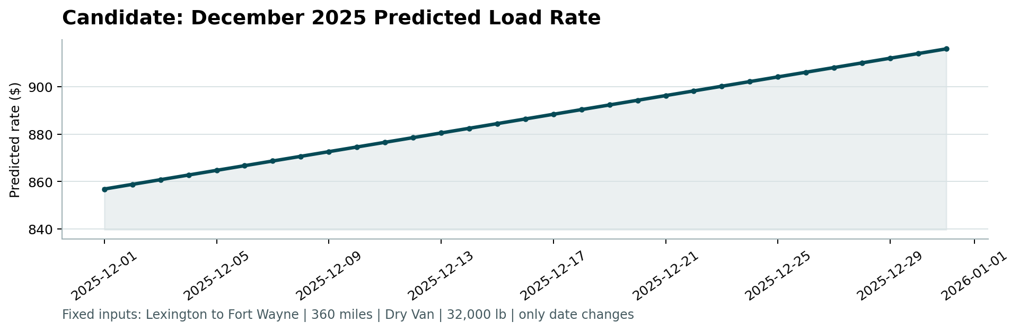

9. Conclusion
The workflow followed an end-to-end regression approach: data exploration, quality checking, cleaning, preprocessing, model comparison, validation, final model selection, and prediction on the provided validation data. The final selected model was Linear Regression, based on the overall evaluation results and its simplicity and interpretability.

10. Submission Checklist
- Accessible GitHub repository containing the solution code, dependencies, and run instructions.
- validation_predictions.csv containing exactly: load_id,predicted_rate.
- This PDF/DOCX report with the train/test validation approach and fixed December prediction chart.
- 2–3 minute Loom video covering EDA findings, data-quality issues and fixes, model reasoning, train/test validation, and key code sections.

