# Conceptual framework

Similar to [Evaluation Platform In COPD](https://doi.org/10.1177/0272989X18824098) and [Whole Diesase Modeling of Oral Cancer](http://hdl.handle.net/2429/71051), we follow the [Whole Disease Modeling framework](https://scholar.google.com/scholar?hl=en&as_sdt=0%2C5&q=Whole+Disease+Modeling+to+Inform+Resource+Allocation+Decisions+in+Cancer%3A+A+Methodological+Framework&btnG=), in which we model the **entire** course of the disease, from pre-clinical status through a variety of possible events including asthma incidence, asthma exacerbation, and death, and allow multiple decision nodes to interact with each other over time.

Furthermore, a whole-disease model can serve as a *reference* model. Customarily, a new computer model is developed to conduct the economic evaluation for each set of new health technologies or interventions. In recent years, this approach has been criticized for several reasons. First, the approach is inefficient, because sometimes different computer models are developed and used for the same disease of interest, resulting in loss of analytic resources. Next, such *de novo* models are likely to be inconsistent in terms of model structure, evidence, and underlying assumptions. There is increasing recognition that de novo models lack transparency, making them inaccessible to other researchers. At the same time, studies have shown potential sponsorship bias associated with de novo models (i.e. models are developed to produce favorable results for their sponsors). An alternative to such de novo modeling that can overcome the aforementioned issues is use of a reference model that can serve as a unified framework in which different interventions for the same disease can be evaluated. Not only does the reference model reduce the inefficiency and inconsistency problems, but it is also often developed independently of any specific evaluation question, thereby reducing the risk of sponsorship bias. The reference model must be transparent enough so that researchers can understand its model structure and assumptions and use it with confidence.

To model the entire disease pathway, we needed a concept map. A major missing gap in the literature was a concept map of the early disease course. Led by a steering committee of economic modelers, allergists, and respirologists across Canada, a concept map was developed through a modified Delphi method by closely following the guidelines set by the ISPOR-SMDM Modeling Good Research Practices Task Force. Details can be found [here](https://www.medrxiv.org/content/10.1101/2020.12.15.20248275v2), and the concept map is provided below: 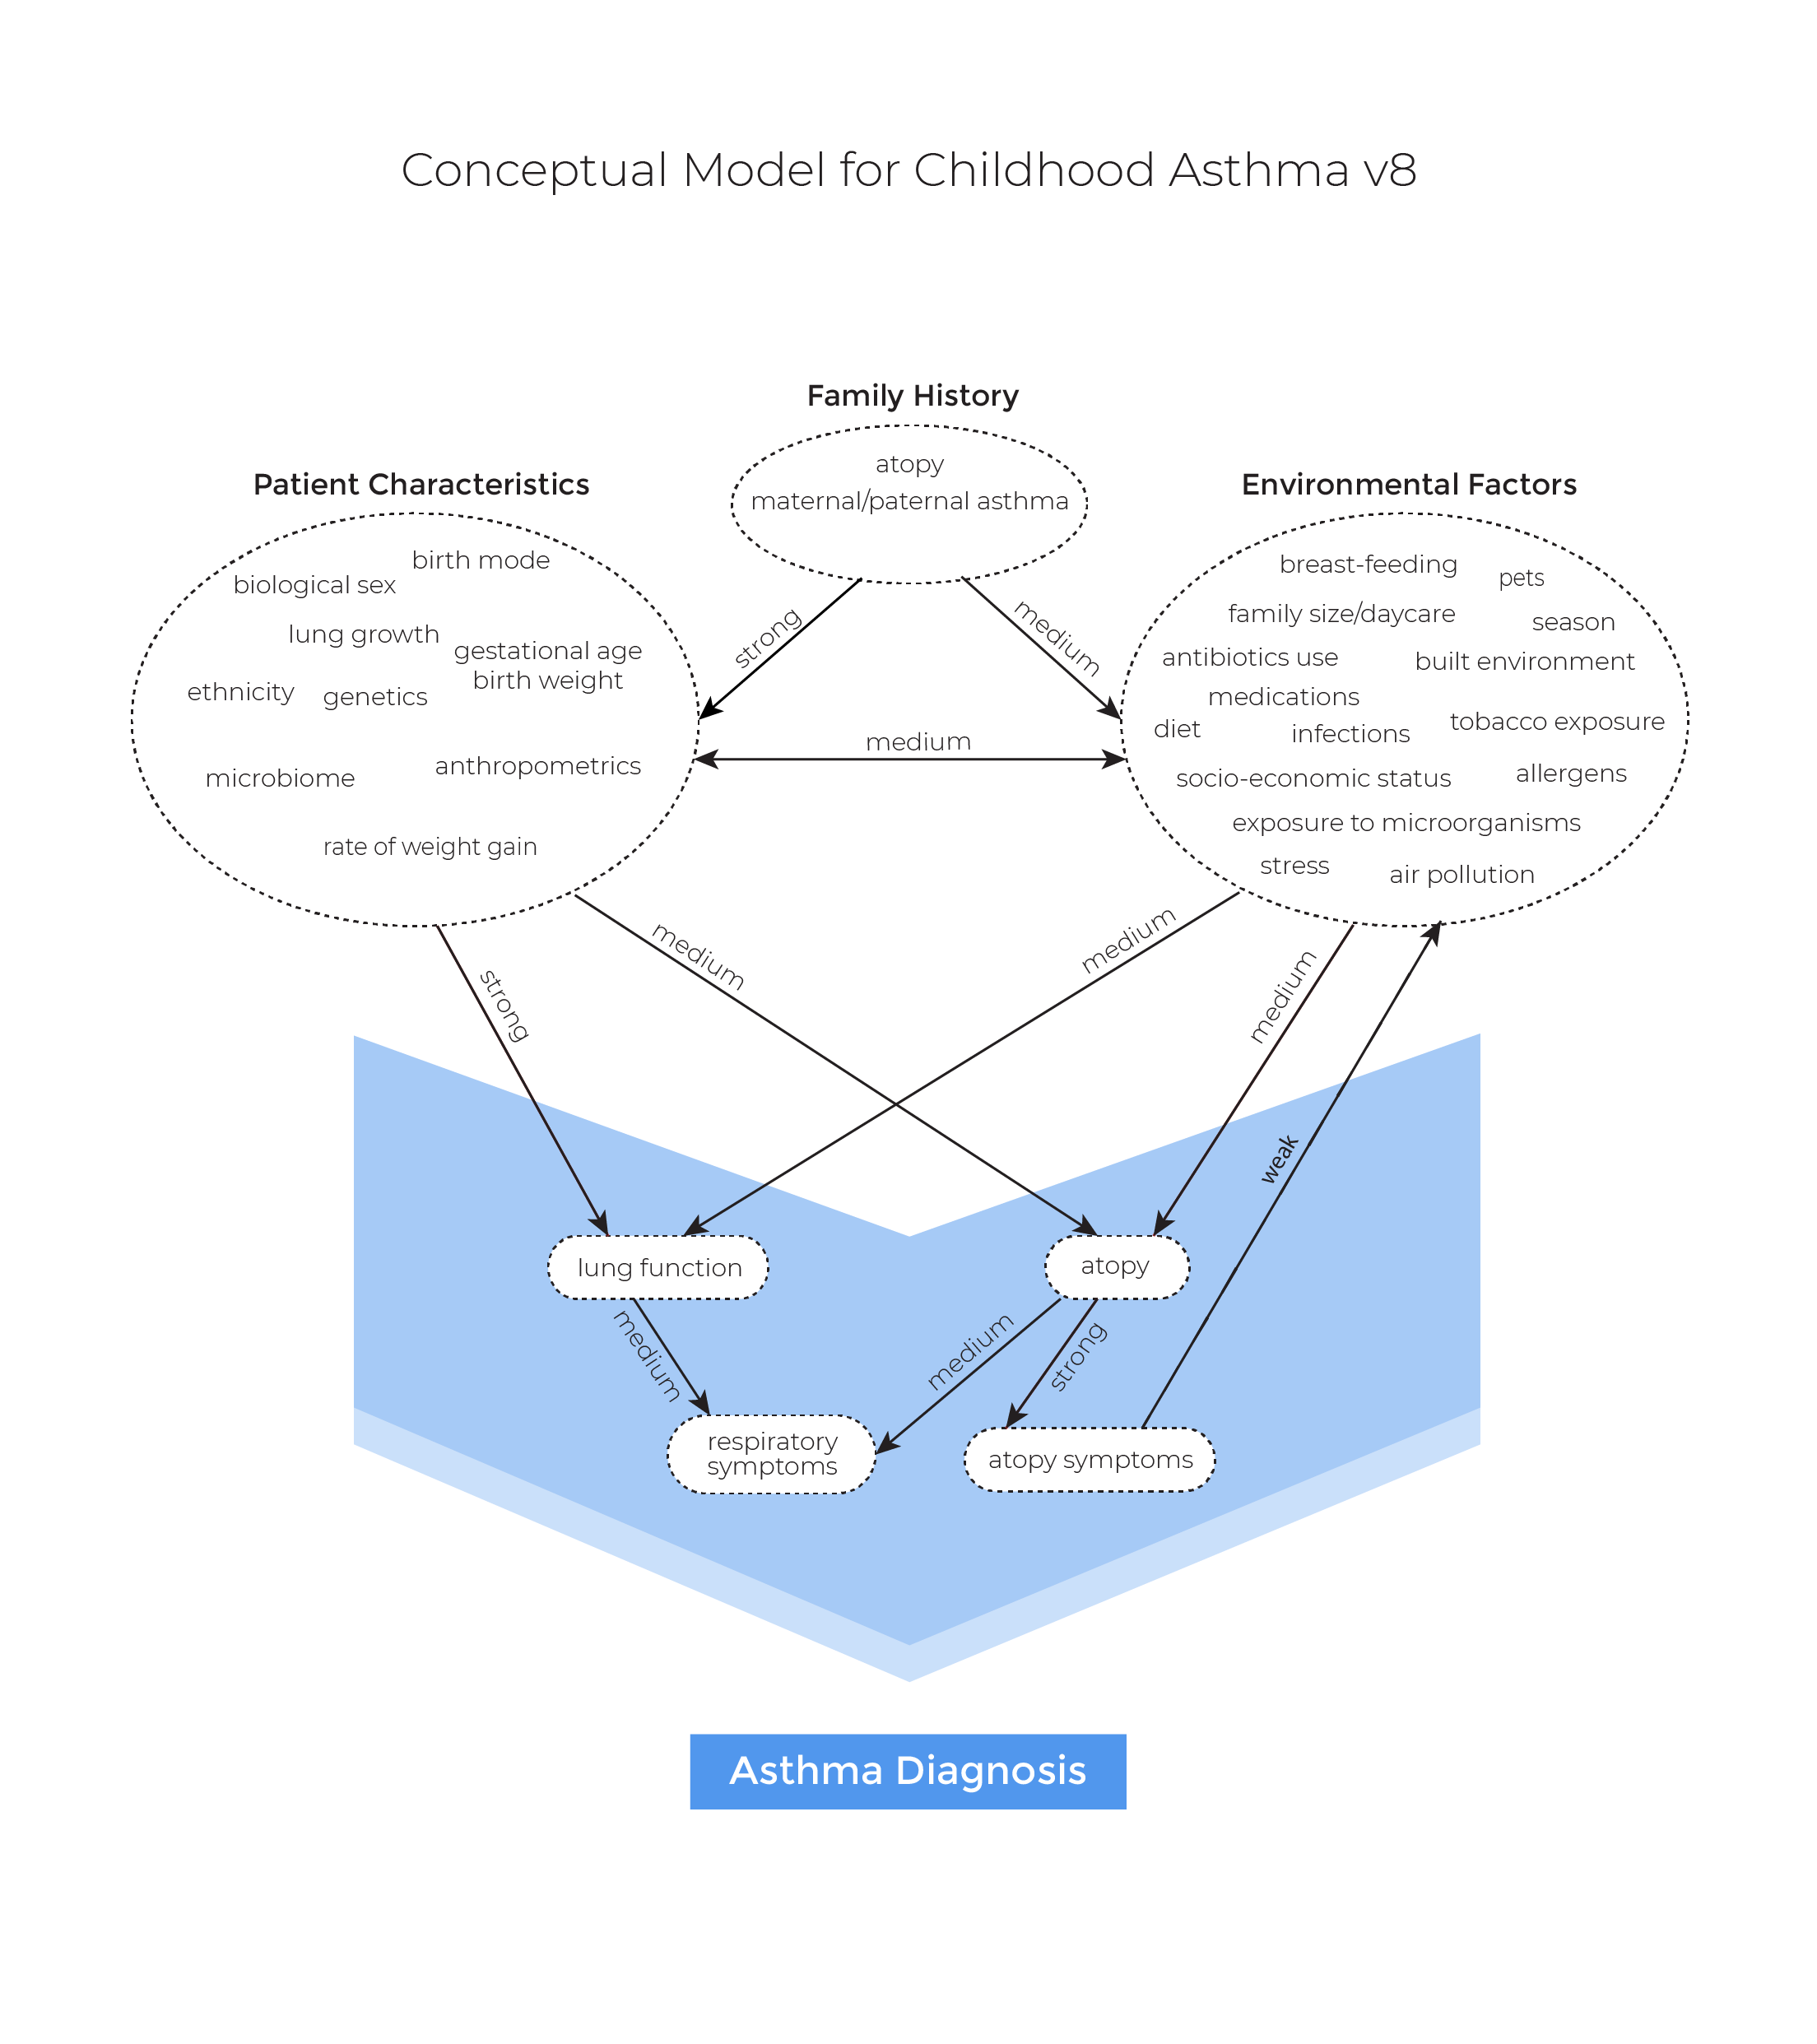

While it requires a signifcant amount of efforts and time to build a refernece model, we believe that long-term benefits are insurmountable.

# Simulation platform

We chose **Julia** as the main engine for running the model. We briefly discuss why Julia might be a better alternative than R and Python, which are the main programming languages that researchers use for health economic evaluation. Often, codes written purely in R or Python are inefficient and thus require use of C++ (via RCpp or Cython, respecitvely) or Fortran. Consequently, normal R or Python users would have difficulty with reading, interpreting, and modifying (usually very long and tedious) C or C++ codes, presenting a major obstacle towards making a reference model that can be easily understood, modified and used.

Julia is a new open-source, high-level (like R and Python) programming language for high-performance computing (like C), and thus solves the “2-langauge” paradigm. Julia codes can be often compact, quickly written (for maximal efficiency it requires experience and efforts) and easily interpretable.

For accessibility, we provided an intefrace to R by wrapping the Julia package in R.

The code is publicly available and can be downloaded and run as a Julia or an R package.

# Simulation baseline setting

Agents enter the simulation from bith, are updated annually, and live until they reach the maximum age or the end of the time horizon. We assume that the death always occurs as the last event.

There are six major input parameters: * max_age: The maximum age of the agent. * starting_year: the starting year of the simulation. * time_horizon: the time window over which the agent lives. * n: the baseline number of agents for the starting year. The subsequent number of agents depends on the population growth. * population_growth_type: the population growth trajectory type defined by Statistics Canada. * parameters: module parameters. See each of the module for details.

Note that each module contains a set of parameters and a process function that uses the parameters as the input.

Here is the current version of the schematic illustration of the disease pathway. 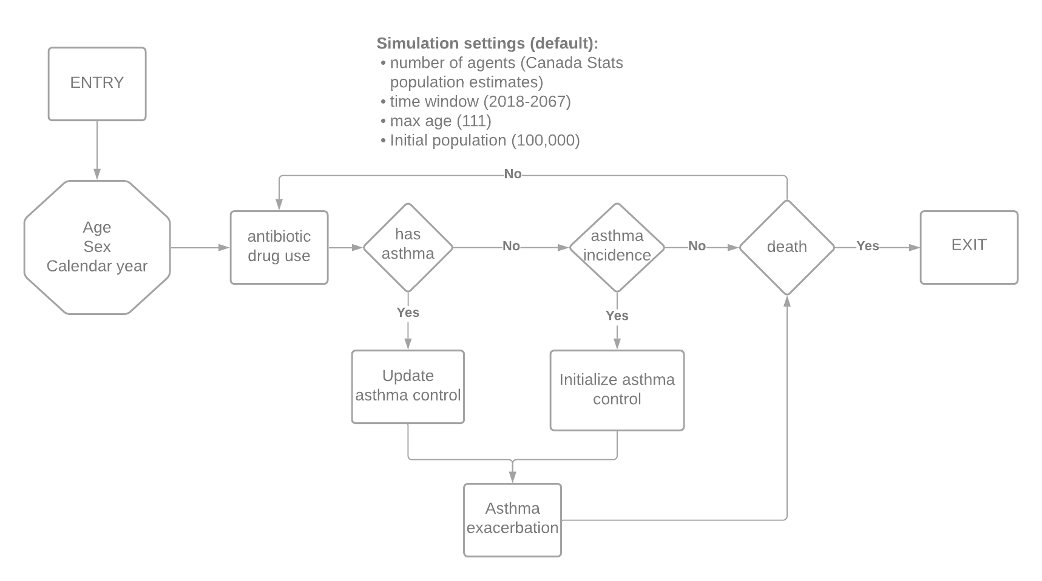

# Birth module

* Input: birth year and birth projection.
* We simply set the sex and birth year of an agent. To determine the sex, we toss a coin where the probability is given by the birth projection estimated by Statistics Canada (see the proportion of male across the years [here](../../processed_data/birth_projection_Sept2020.csv))

# Death module

* Input: age, sex, and life table.
* We used a life table provided by Statistics Canada to estimate the probability of dying given age and sex. Currently, it is independent of calendar year and disease progression.
* We assume that everyone is dead after they reach 111.

# Antibiotic drug use module

* Input: sex, age, and calendar year.
* We used a logistic regression to model whether an agent receives one dose of antibiotic drug.
* For ageint $i$,
$$logit(p_{antibiotic_drug})=β_{0,i}+β_{sex}×sex+β_{age}×age+β_{cal_year}×cal_year,$$

* where $β_{i,0}∼Normal(μ_{0},σ_{0}^{2})$.
* Parameter estimates were based on the data provided in Patrick et al., Lancet Respiratory, 2020.

# Asthma incidence module

* Input: sex, age, calendar year (cal_year), the cumulated number of antibiotic drug doses (CABE)
* We used a logistic regression model to determine whether an agent gets asthma. The parameter estimates were obtained using the asthma incidence rates provided by SickKids, Toronto, Ontario, Canada (here is the [link](https://lab.research.sickkids.ca/oasis/data-tables/)).
* An estimate of the effect of antibiotic drug use was extracted from Patrick, et al., Lancet Respiratory, 2020. We assume that the effect is only present for age < 11 years.
* Here is the equation for agent $i$:

$$logit(p_i) = \beta_{0,i} + \beta_{sex} \times sex + \beta_{age} \times age + \beta_{sex,age} \times (sex * age) +\\ \beta_{cal\_year} \times cal\_year + \beta_{sex,cal\_year} \times sex * cal\_year + \beta_{CABE} \times (CABE * \mathbf{1}[age < 11]),$$

* where $β_{0,i}∼Normal(μ_{0},σ_{0}^{2}).$

# Asthma control module

* Input: sex, age, and time since asthma diagnosis.
* We used a proportional ordinal logistic regression to estimate the proportion of time spent in each of the three control levels (set by the 2020 GINA guidelines) in a year using the Economic Burden of Asthma data.
* For deatils, see [here](../../evidence/asthmaControlLevelAnalysis_Feb16_2021.html).

# Asthma exacerbation module

* Input: sex, age, time since asthma diagnosis (Dx), asthma control, and previous asthma exacerbations
* We used a Poisson model for the number of asthma exacerbations using the Economic Burden of Asthma study and the Gaining Asthma controL (GOAL) study.
* For V1, we only incorporated the effect of asthma control.
* From the EBA study, we obtained the annnnnnnnnual exacerbation rate, which was 0.347/year. Next, from the GOAL study, we obtained the probability of exacerbation given the control levels. Combining both, we obtained the unique rate of exacerbation given the control level. For details, see [here](../../issues/3).
* For agent $i$, let $Y_{i,t}$ be the number of exacerbations in year $t$:
$$Y_{i,t}=Poisson(λ_{i,t}),$$

* where
$$λ_{i,t}=λ(X_{i,t})=exp(β_{0,i}+β_{sex}×sex+β_{age}×age+β_{Dx}×Dx+β_{prev_exac}×prev_exac+β_{control}×control)$$

* with $β_{0,i}∼Normal(μ_{0},σ_{0}^{2}).$