**10 Factual (Easy) Questions:**

1. What is the city of the warehouse with code GUT930? Explanation: Retrieves the city from the warehouses table based on warehouse_code.

Answer: Martensville

2. What is the product name for SKU with ID 1009AA? Explanation: Queries the sku_name from the skus table based on sku_id.

Answer: Product 001

3. What is the current inventory quantity for SKU 1009AA at warehouse NXH382?

Answer: 7210

4. What is the order date for order number SO - 018900?

Answer: 2021-01-01

5. What is the unit price for SKU 1163CA at warehouse NXH382?

Answer: 94.66

6. What is the order quantity for order SO - 018901?

Answer: 151

7. What is the customer type for order SO - 018926?

Answer: Distributor

8: What is the latitude and Longitude of warehouse GUT930 ?

| **latitude** | **longitude** |
| --- | --- |
| 52.29 | -106.67 |

Answer:

9. What is the vendor name for SKU 1193BA at warehouse AXW291?’

Answer: Major Corp

10. What is the country of the warehouse with code FLR025?

Answer: Canada

**10 Factual (Medium) Question**

1. Show the total inventory value (total_value) for each vendor (vendor_name) across the entire warehouse system.

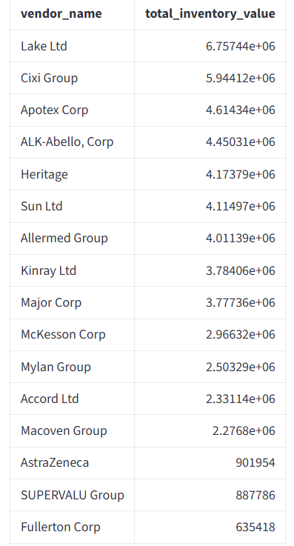

2. Display the average lead time (average_lead_time_days) of all products at each warehouse, sorted from lowest to highest.

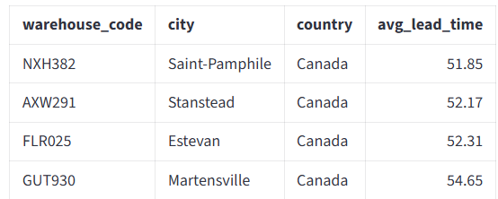

3. Calculate the total revenue for each customer type (customer_type) in 2022.

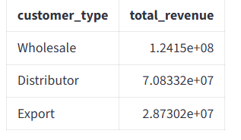

4. How many different SKUs are stored in each city? Show the city name and corresponding SKU count ?

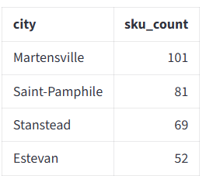

5. Display the total quantity of products sold (order_quantity) in each province from January 2023 to July 2023.

6. Find all products with inventory value (total_value) greater than 500,000, showing product name, warehouse location, and corresponding value.

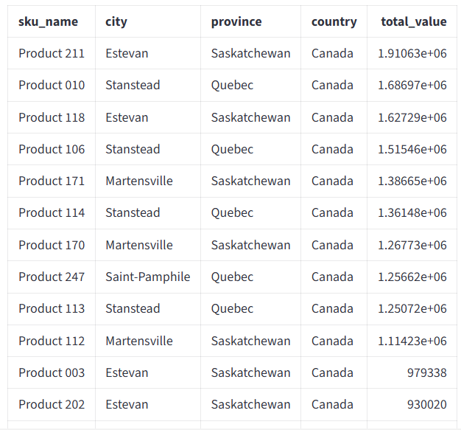

7. Show the number of different products (distinct SKUs) and total inventory quantity (sum of current_inventory_quantity) at each warehouse.

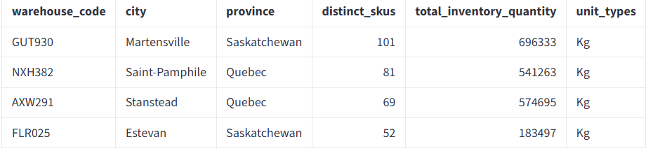

8. Calculate total revenue by month for 2022, (advance : identifying which month had the highest and lowest revenue.)

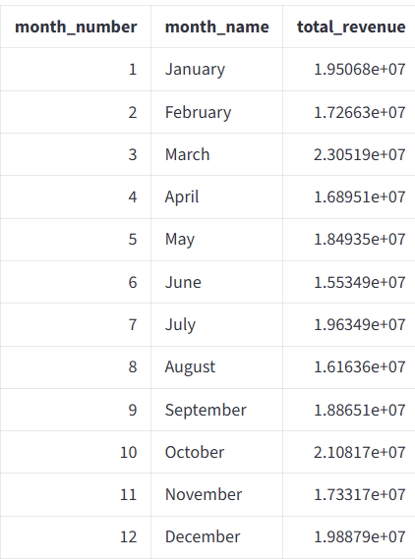

9. Find the top 5 best-selling SKUs (by quantity) for the first half of 2023 (January to June).

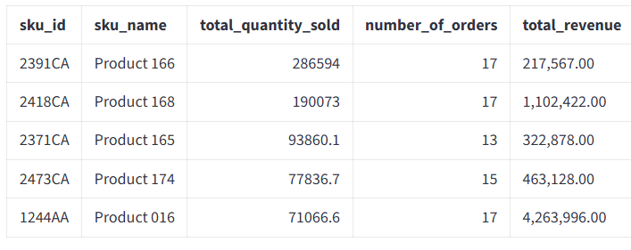

10. Show the average and maximum lead times for SKUs 1206BA, 1214CA, 1224AA, and 1234BA.

