 | SUBLIME ENTERPRISES • SMART TOOL FOR A SMART SCHOOL  EduCore™ Installation & Windows Security Guide  Step-by-Step Setup & Understanding Microsoft Defender SmartScreen

Target Operating Systems: Windows 10 & Windows 11 (64-bit) | Official Portal: https://educoreapp.in | Architecture: 100% Offline
📘 Executive Summary & Purpose of This Guide
This official handbook walks you through extracting your downloaded EduCore package, navigating the standard Microsoft Defender SmartScreen reputation prompt on Windows 10/11, and completing your offline school management installation smoothly.
EduCore is an offline-first Windows desktop ERP. It contains zero spyware, zero background telemetry, and stores 100% of your confidential school data locally inside an encrypted SQLite database on your computer.

1. Before You Begin — Official Source Verification
Ensuring Software Authenticity & Integrity
For the safety of your educational institution's data, only proceed with installation if you downloaded the software package directly from EduCore's verified official portal (https://educoreapp.in) or our official GitHub release repository (github.com/tyk786/EduCore). If you received this package from an unsolicited email, an unauthorized file-sharing site, or an unknown party, do not execute it. Contact our official team immediately.
System Prerequisites:
- Operating System: Windows 10 or Windows 11 (64-bit editions).
- Hardware: Minimum 4 GB RAM (8 GB recommended for large campuses) and 500 MB free disk space.
- No Internet Required for Daily Use: A brief 2-second connection is used solely for initial cryptographic license key activation; thereafter, all ERP modules run 100% offline.
- Antivirus Status: Do NOT disable Microsoft Defender or Windows Security. EduCore installs safely alongside standard Windows security.
2. Step-by-Step Installation Walkthrough
Extracting, Verifying & Running EduCore
STEP 1 Extract the Downloaded ZIP Package
EduCore is distributed as a compressed archive named Setup_Educore_App.zip to prevent file corruption during browser downloading. Before launching the setup wizard, you must extract all contents to a permanent folder:
1.1 Navigate to your browser's Downloads folder (or the destination folder where you saved the download).
1.2 Right-click on Setup_Educore_App.zip and select 'Extract All…' from the Windows context menu.
1.3 Choose a folder destination and click the 'Extract' button.
1.4 Open the newly extracted folder. Run the EduCore setup executable from inside the extracted folder. (Important: Do not launch the installer from inside the Windows zip preview window).
STEP 2 Navigating the Windows SmartScreen Notice
When launching the installer, Windows may display a blue dialog titled "Windows protected your PC" (Microsoft Defender SmartScreen). Understanding why this screen appears helps eliminate hesitation:
🛡️ Why does Microsoft Defender SmartScreen appear?
Microsoft Defender SmartScreen is a cloud reputation filter, not an antivirus malware detection.
When newly compiled desktop applications or regular version updates are released, Microsoft's cloud catalog has not yet accumulated thousands of telemetry download hours from users worldwide. Because the executable is newly built, Windows pauses and displays an informational prompt asking you to verify the application.
This prompt is completely normal for specialized desktop software and does NOT indicate that the file is unsafe or malicious.

Follow these three quick steps to proceed safely:
Step 2A: Click "More info" — On the initial blue screen, you will see a prominent "Don't run" button. Directly under the description text, click the underlined text link labeled "More info".
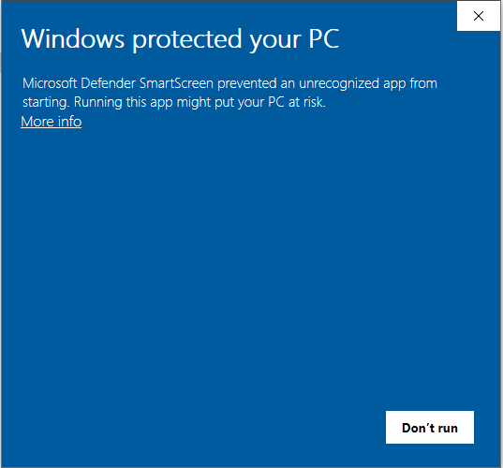
Figure: Step 2A: Click the underlined 'More info' link on the SmartScreen dialog.
Step 2B: Verify the Application Name — Once clicked, Windows expands the dialog to display the verified file name. Verify that the App field states "Setup_EduCore_App.exe" (or EduCore.exe). The Publisher field will read "Unknown publisher", which reflects our independent on-premise distribution model.
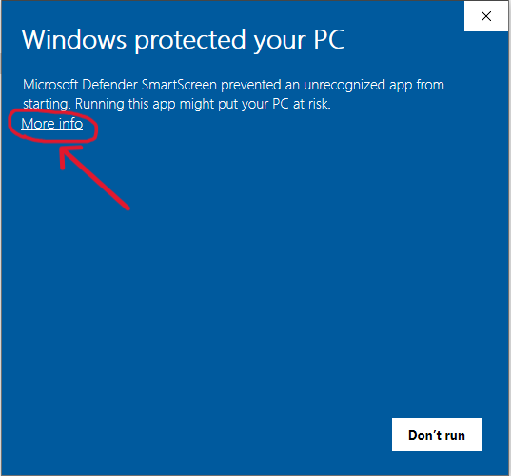
Figure: Step 2B: Inspect the expanded dialog and confirm the App name matches EduCore.
Step 2C: Click "Run anyway" — A new button labeled "Run anyway" will now appear in the bottom right corner alongside "Don't run". Click "Run anyway" to immediately launch the official EduCore setup wizard.
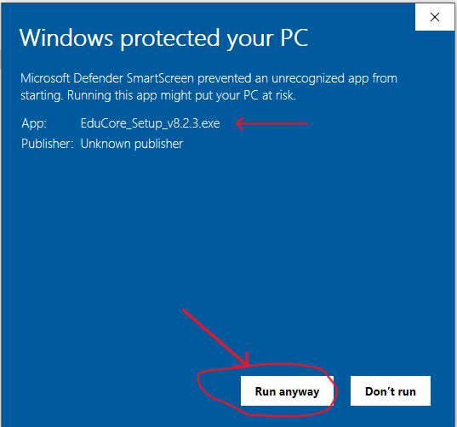
Figure: Step 2C: Click 'Run anyway' to proceed directly to the EduCore setup wizard.
STEP 3 Complete the Setup Wizard & Launch EduCore
The native Windows installation wizard will now open. Follow the on-screen prompts to finalize installation:
3.1 Review and accept the EduCore End-User License Agreement (EULA).
3.2 Select your preferred installation destination folder (default: C:\Program Files\EduCore or user directory).
3.3 Leave the 'Create Desktop Shortcut' box checked so school administrators have 1-click access from the Windows desktop.
3.4 Click 'Install' and allow the file transfer to complete (typically takes less than 15 seconds).
3.5 Click 'Finish' to launch EduCore. You are now ready to set up your school profile, academic sessions, and student records!
3. Transparent Disclosure: Code-Signing & Fair Pricing
Why We Choose Direct Value Over Expensive Corporate Certificates
At SUBLIME ENTERPRISES, we believe in complete commercial and technical transparency with educational institutions. Here is why the SmartScreen prompt appears and how our philosophy benefits your school:
Traditional Cloud Software Approach | EduCore Honest Institutional Approach
Spends ₹40,000–₹60,000 ($500+) every year on commercial EV hardware certificates solely to bypass the initial 1-time SmartScreen prompt. | Invests engineering resources directly into offline software speed, SQLite multi-threading, and automated 30-day snapshot backups.
Passes corporate overhead onto schools via recurring monthly subscription fees charged per student every month. | Passes 100% of cost savings to educational institutions with affordable one-time licensing starting at ₹4,499.
Locks your student records on third-party cloud servers; access is halted if monthly subscription payments lapse. | Guarantees 100% data sovereignty. All records remain encrypted on your school PC with perpetual offline data ownership.

✅ Independent Antivirus Verification Available Anytime
EduCore is compiled using industry-standard Python and Nuitka C-optimization. It contains zero adware, zero spyware, and zero unwanted background processes.
You are welcome to independently verify the file integrity anytime by uploading Setup_EduCore_App.zip or EduCore.exe to Google's VirusTotal (https://www.virustotal.com), where it scans clean against 70+ leading global antivirus engines.

4. Frequently Asked Questions
Common Installation Inquiries Answered
Q: Will running EduCore alter or harm my Windows operating system?
A: No. EduCore is a fully self-contained desktop software application. It operates in its own isolated application directory and uses an embedded SQLite database. It does not overwrite Windows system files or install unneeded background device drivers.
Q: What should I do if the "Run anyway" button is not visible?
A: On certain managed school administrator networks or computers running Windows in 'S-Mode', SmartScreen may require administrative privileges. If 'More info' does not display 'Run anyway', right-click Setup_EduCore_App.exe and select 'Run as Administrator', or right-click the file, select 'Properties', check the 'Unblock' box at the bottom, and click Apply.
Q: How does EduCore protect our school from future data loss?
A: Whenever you close EduCore, its automated background daemon creates a SHA-256 integrity-verified snapshot of your SQLite database and rotates a rolling 30-day backup history. If your PC ever experiences hardware failure, you can simply restore the backup file on any new PC in seconds.
5. Dedicated Institutional Support
We Are Here to Assist Your School
📞 Need Technical Setup Assistance?
If your administrative staff encounters any unexpected dialog or has questions regarding database setup, our engineering team provides direct priority assistance:
• Official Portal: https://educoreapp.in
• Direct Technical Support: tyk786@gmail.com / info@educoreapp.in
• Support Coverage: Monday – Saturday (9:00 AM – 6:00 PM IST)
• Live Walkthroughs: Available upon request via Google Meet or TeamViewer / AnyDesk.
Security Reminder: When contacting technical support, please describe the Windows message and attach a screenshot if possible. Never email passwords, financial ledgers, or sensitive student records.

EduCore™ — Smart Tool For A Smart School
Developed with passion by SUBLIME ENTERPRISES • Data Sovereignty for Educational Institutions

