The software used to draw EER/ER diagrams: *TerraER*

Homework 1A

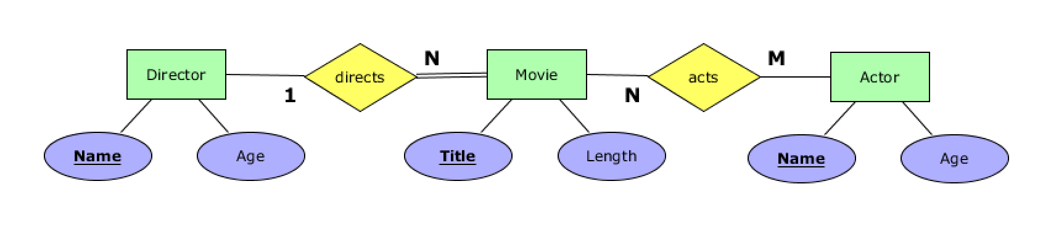

Homework 1B

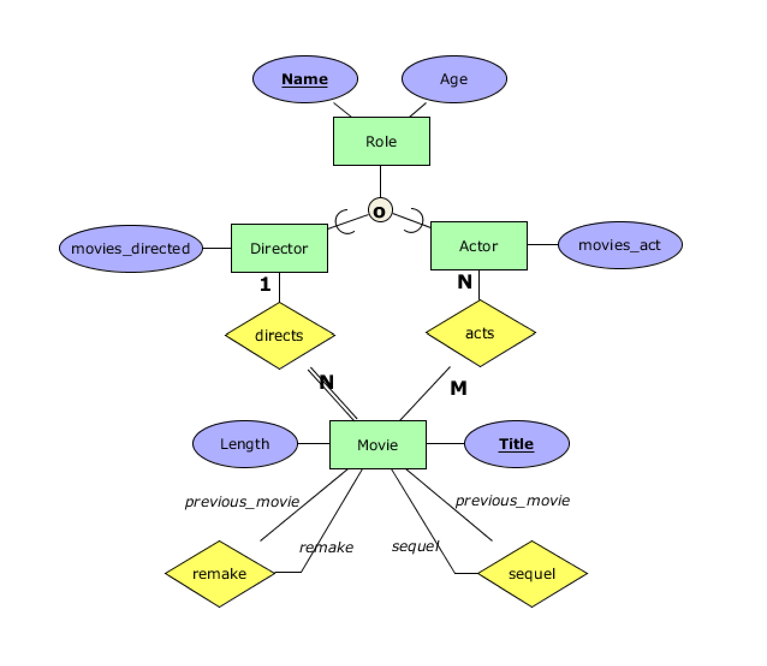

Homework 1C : Let’s Shopping Online!

1. Person has account. One person can only have one account. All accounts must be owned by one person. There can be a person that have no account.
2. Person order product. A person can order many products. There can be products that are not ordered by anyone or a person not making any orders.
3. Product has review. A product can have many reviews. There can be products have no reviews, but all reviews must be related to products.
4. Company produce product. A company can produce many products. A product can be produced by companies. All products must be made by at least one company, but there can be company not producing products.
5. Person create order list. A person can create many order lists. All order lists must be created by one person. There can be a person not creating any order list.
6. An account can follow or be followed by other account.

