**Question 1**

Given the project characteristics, I suggest using the **Agile methodology** for this situation. Agile is a flexible, iterative design and build process, which would allow the team to adapt to the changing requirements that are likely to occur given that FU has not had a similar system before and there will be a lot of user feedback to incorporate. This approach also supports high user involvement, and facilitates communication and collaboration, which is essential given the multidisciplinary nature of the team. Agile also allows for frequent testing and revision, ensuring the reliability of the system.

Here are the requirements characteristics which influenced my decision:

**Types and number of requirements**

* The set of requirements encompasses both functional and non-functional aspects.

+ For Lectures/Staffs: The system allows lecturers and staff to register bus routes, change bus routes and view currently registered bus routes.

+ For Admin Staff: The system allows administrative staff to synthesize weekly bus schedules of staffs and lectures, schedule vehicles for bus routes, record and summarize costs for bus trips.

+ For Admin Manager: The system allows managers to view bus schedules for weekly trips, approve weekly bus schedules, and view vehicle cost summary.

+ For Academic Staff: The system allows entering lecturers’ lecture schedules exported from FAP, synthesizing lecturers’ bus schedules from lecturers’ lecture schedules, transferring lecturers’ bus schedules to the administrative department.

+ The system should allow users to log in using their FU's email account on the Gmail platform.

+ The system needs to ensure high performance and reliability.

**Reliability**

* The system is expected to deliver a service of superior quality while proactively preventing any technical issues or user difficulties post-implementation..
* The project requirements have been defined with clarity, though they lack detailed specifications. Nevertheless, the project is feasible and can be initiated..

**Frequency of requests may change**

* The requirements outlined previously are subject to modifications in the future to align with evolving customer needs. These are initially proposed features for the application.
* The application is expected to expand with additional features as the project progresses..

**Development team**

The team consists of 4-6 developers with extensive experience and skills. This suggests that they are likely to be able to work effectively in a self-organizing team, which is a key aspect of Agile methodology. In addition, other department's employees will join the team to support the project, which will benefit from the collaborative nature of Agile.

**User Involvement in the Project**

The project requires high involvement from users (lecturers, staff, admin staff, admin manager, academic staff) in providing feedback and iteratively refining the system. Agile encourages regular user feedback, which can be incorporated into system development in each sprint.

**Time Constraints and Managers' Expectation**

With a goal to have the first version of the system in use within 3 months and the entire project completed within 6 months, Agile, with its emphasis on delivering working software in short sprints (typically 2-4 weeks), can help the team meet these deadlines.

**Customer/User:**

The system must cater to the needs of a variety of users (lecturers, staff, admin staff, admin manager, academic staff), and these needs may vary and evolve over time. Agile, with its focus on user stories and regular feedback, can help ensure that the system meets these diverse needs.

**Question 2**

**Here are the testing levels/stages I recommend for the Shuttle Bus Management System project:**

1. **Unit Testing - Tester role: Developers**

This is the first level of testing and it involves testing individual components of the software to ensure that they work correctly.

1. **Integration Testing - Tester role: Developers or a dedicated integration testing team**

Integration testing is the process of testing how different units of code interact with each other. This is important to ensure that the different parts of the application work together seamlessly.

1. **System Testing - Tester role: A dedicated team of testers**

This involves testing the complete system to verify that it meets the specified requirements

1. **User Acceptance Testing (UAT) - Tester role: End users in this case, it could involve lecturers, staff, admin manager, and academic staff.**

This is the final stage of testing, where actual users test the system to ensure it can handle required tasks in real-world scenarios, according to specifications

1. **Regression Testing - Tester role: A dedicated testing team or automated using software testing tools..**

Regression Testing is the process of re-testing existing functions after code changes, to ensure they still work well.

1. **Performance and Load Testing - Tester role: Specialized testers or engineers**

Given the requirement for high performance and reliability, it would be beneficial to conduct performance and load testing. This would involve testing the system's behavior under both normal and peak load conditions to ensure it can handle the expected number of users.

**Question 3**

**Four functional requirements**

+ The system allows lecturers and staff to register bus routes, change bus routes and view currently registered bus routes.

+ The system allows administrative staff to synthesize weekly bus schedules of staffs and lectures, schedule vehicles for bus routes, record and summarize costs for bus trips.

+ The system allows managers to view bus schedules for weekly trips, approve weekly bus schedules, and view vehicle cost summary.

+ The system allows entering lecturers’ lecture schedules exported from FAP, synthesizing lecturers’ bus schedules from lecturers’ lecture schedules, transferring lecturers’ bus schedules to the administrative department.

**Two non-functional requirements**

+ Authentication and Security: The system should allow users to log in using their FU's email account on the Gmail platform. This implies a necessity for secure authentication and data protection, aligning with standards for information security.

+ Performance and Reliability: The system needs to ensure high performance and reliability. This calls for the system to be robust, handle multiple users concurrently, and function effectively without crashing or causing unnecessary delays.

**Question 4**

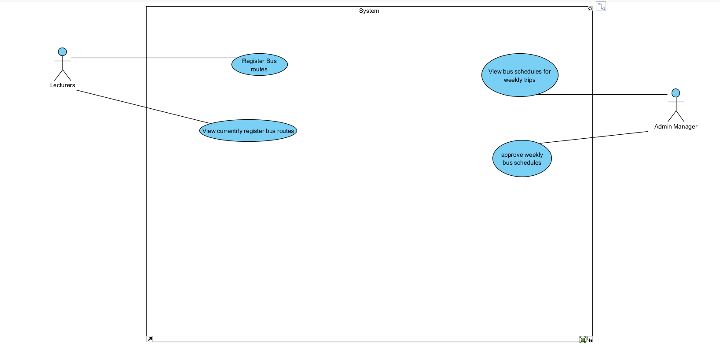

**Question 5**

**Functional test cases for each of the use-cases listed:**

1. **Use-case: Register bus routes**

**Test Case:** Verify that a lecturer can register bus routes.

**Steps:**

- Log in as a lecturer.

- Navigate to the "Register bus routes" section.

**Expected Result:** The system should successfully register bus routes.

2. **Use-case: View currently registered bus routes**

**Test Case:** Verify that a lecturer can view currently registered bus routes.

**Steps:**

- Log in as a lecturer.

- Navigate to the "Register bus routes" section.

- Select the "view currently registered bus routes" option.

**Expected Result:** The system should successfully view currently registered bus routes.

3. **Use-case: View bus schedules for weekly trips**

**Test Case:** Verify that a admin manager can view bus schedules for weekly trips.

**Steps:**

- Log in as a admin manager.

- Navigate to the "view bus schedules for weekly trips" section.

**Expected Result:** The system should successfully view bus schedules for weekly trips

4. **Use-case: Approve weekly bus schedules**

**Test Case:** Verify that a admin manager can approve weekly bus schedules.

**Steps:**

- Log in as a admin manager.

- Navigate to the "view bus schedules for weekly trips" section.

- Select the "approve weekly bus schedules" option.

**Expected Result:** The system should accept and save the admin manager response to the selected approve weekly bus schedules.

**Question 6**

Two user stories:

* As a **lecturer** (user role), I want to **view currently registered bus routes**(feature), so that I can **change my bus routes if I need**(benefit).
* As a **admin manager** (user role), I want to **approve weekly bus schedules**(feature), so that I can **approve any that need to be approved** (benefit).

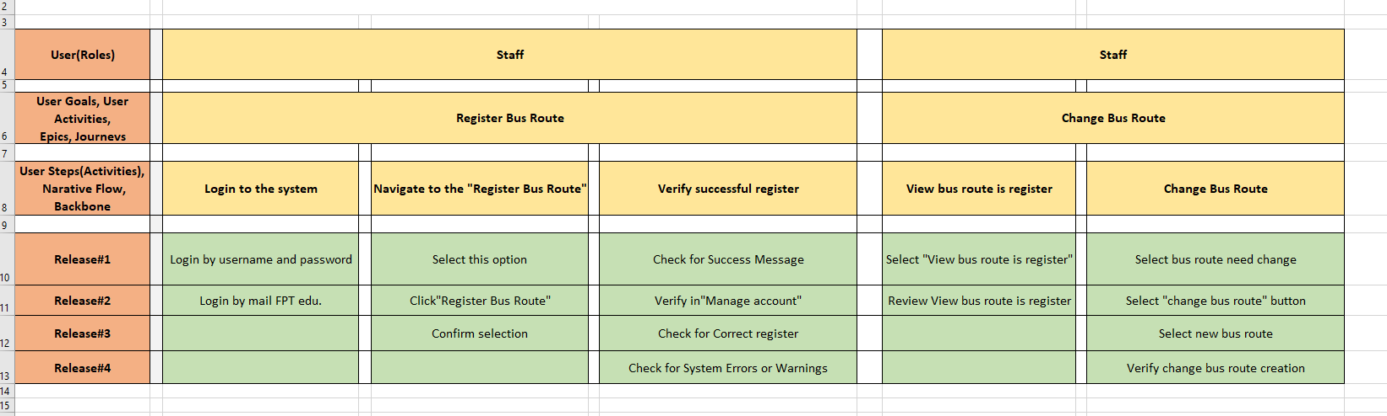**Question 7**