1.

For this situation, I suggest Agile Methodology, because

* REQUIREMENTS CHARACTERISTICS:

+ Reliability: The project is suitable for the Agile model. In addition, requirements of project are not clearly so it is hard to determine easily in early stage. Moreover, Agile model reacts quickly to change, development and continuous improvement.

+ Types and number of requirements: Any adjustments to the requirements can be made from the beginning to the end of the process. Changing conditons are adapted quickly.

+ How often the requirements can change: The flexibility of Agile model allows for fast changing needs. The Agile methodology is able to produce early iterations of working solutions. This approach is convenient for teamwork. Choosing Agile model because when dealing with situations that are dynamic and manageable.

+ Can the requirements be defined at an early stage: Agile model is easy to use, it allows to delivery and development within an overall planned context. It gives developers more freedom. There some features of ABC company are defined such as check attendent, calender view, day off of employess, reminders and some thing like that.

* DEVELOPMENT TEAM:

+ The size of the group is medium, because the team has 6 developers and 2 QA.

+ The group that has high understanding to done this project.

* USER INVOLVEMENT IN THE PROJECT:

+ As project requiremnts change frequently during development, the customer should be actively involved. The Agile team is always available to meet face-to-face if the client wants.

+ This Agile project necessitates a medium team so that having a modest project.

* In conclusion, I think Agile Methodology is the best choice for this project. Because of the need of flexibility, changes requirements at any time and regularly. So, it is not advisable to start with a phased development, but to deploy the system fist. Beside, the benefit of agile over waterfall is the ability to change dynamically to the customer's wants and needs. So Agile model is the best fit.

2.

- Functional requirements:

* + View, add, update, delete plans.
  + Check attendance of employess.
  + Employees can update their information.
  + Show employee schedules including days off and holidays.

- Non-functional requirements:

* + The language use for this application including Vietnamese and English.
  + Good security.
  + It runs fast

3.

* As a manager, I want to check employee’s attendances so that they must take responsibility for their absences.
* As an employee, I want to view my feedback, so I can improve my job.

4.

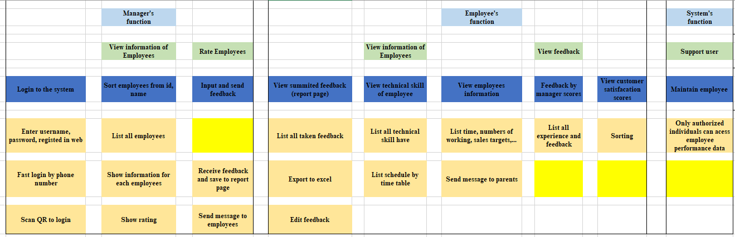

5.

* Assumption 1: Employees will accurately seft-assess their compentencies.
* Risk classification: High impact if wrong, Low probability of it being wrong
* Explantaion: This assumption is that employees will be honest and accurate when assessing their own competencies. If this assumption is wrong, it could lead to employess overestimating. But it relatively low risk as it is unlikely that many employess would intentionally misrepresent.
* Assumption 2: Managers will accurately assess employee competencies.
* Risk classification: High impact if wrong, High probability of it being wrong
* Explantation: Managers will have an accuate understanding of their emloyee’s and provide unbiased assessments. If this assumption is incorrect, it could lead to employees being unfairly evaluated, reduced productivity. Since, managers may have their own biases, there is a high probability that this assumption is false. The impact of inaccurate competency assessments by managers is also high, as it could result in employees not receiving the necessary training.
* Assumption 3: Development plans created based on competency assessments will effectively improve employee performance.
* Risk classification: Low impact if wrong, High probability of it being wrong
* Explanation: This assumption is that the development plans created based on competency assessments will lead to signigicant improvements in employedd performance. If it is not correct, it could result in wasted resources and employess turn over. However, since development plans are just one part of a comprehensive performance management system, the impact of its being wrong is low. There is a high probability being wrong since employee learning is influenced by various factors beyond the control of this app.

6.

I think we should unit testing and requirement testing in project.

* Unit testing can carry out this check in parallel with the progress of the project, so it can help us detect the error early and fix it quickly. Moreover, it is suitable for Agile methodology.
* Requirements testing can help us test the feature or functionality in the best way.