# Minecraft mod Site Plan

## Elijah Hammer

## WDD 130

## Overview

### Purpose

[To help my brother organize and display his mods]

### Audience

[My little brother]

## Branding

### Website Logo

## Style Guide

### Color Palette

|  |  |  |  |
| --- | --- | --- | --- |
| **Primary** | **Secondary** | **Accent 1** | **Accent 2** |
| #5B8C5A | #51584F | #6A9669 | #596157 |

**#EDEDED**

### Typography

#### Heading Font: [Geller]

#### Paragraph Font: [Akzidenz Grotesk next]

### Navigation

Home Display About Us

**Content**

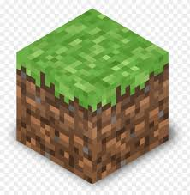

Welcome to our mod page! Here you will find all kinds of new and interesting mods for you to try out here.

Want to give feedback? Email us at [email@email.com](mailto:email@email.com)

Each of the mods displayed here was created solely by us. They are free to use.

We are a group of people who enjoy making things for others to experience. We love to make and realize new ideas. When we first started it was just simple projects but now, we have expanded our goals to create whole worlds, ecosystems, creatures and quests. We sincerely hope that you enjoy what we have in store for you.

**Wireframes**

### Home

