

XI`AN TECHNOLOGICAL UNIVERSITY

实验报告

实验课程 Android应用编程技术

专 业： 物联网工程

班 级： 16060616

姓 名： 田宇龙

学 号： 16060616107

实验学时：

指导教师：

成 绩：

2018 年 11 月 16 日

西安工业大学实验报告

|  |  |  |  |  |  |  |  |
| --- | --- | --- | --- | --- | --- | --- | --- |
| 专业 | 物联网工程 | 班级 | 16060616 | 姓名 | 田宇龙 | 学号 | 16060616107 |
| 实验课程 | Android应用编程技术 | 指导教师 |  | 实验日期 | 18.11.16 | 同实验者 |  |
| 实验项目 | 实现一个计算器 | | | | | | |
| 实验设备及器材 |  | | | | | | |

1. **实验目的：**

科学计算器的设计与实现

1. **实验内容：**

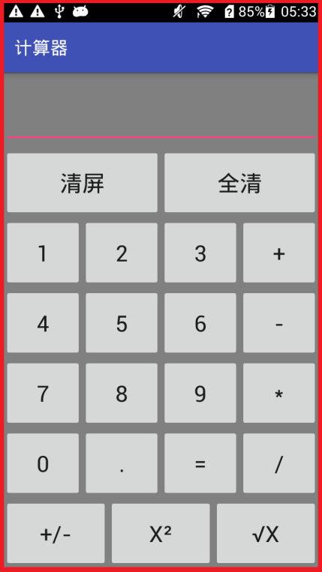 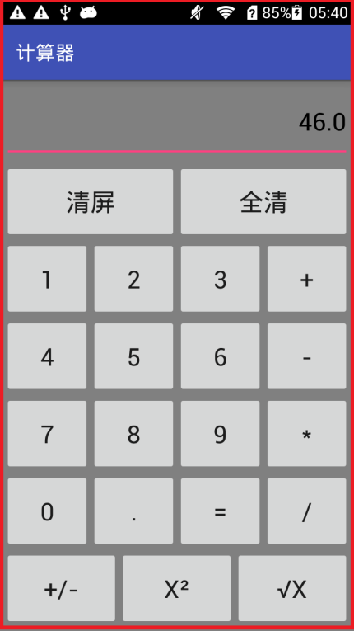  
  
**import** android.os.Bundle;  
**import** android.support.v7.app.ActionBarActivity;  
**import** android.view.Menu;  
**import** android.view.MenuItem;  
**import** android.view.View;  
**import** android.widget.Button;  
**import** android.widget.EditText;  
**public class** MainActivity **extends** ActionBarActivity {  
  
  
 **private** Button[] **btnNum** = **new** Button[11];**private** Button[] **btnCommand** = **new** Button[5];**private** EditText **editText** = **null**;**private** Button **btnClear** = **null**;**private static** String *lastCommand*; **private boolean clearFlag**;**private boolean firstFlag**; **private double result**; **public** MainActivity() {**result** = 0;**firstFlag** = **true**; **clearFlag** = **false**; *lastCommand* = **"="**;  
  
 @Override  
 **protected void** onCreate(Bundle savedInstanceState) {  
 **super**.onCreate(savedInstanceState);  
 setContentView(R.layout.***activity_main***);**btnCommand**[0] = (Button) findViewById(R.id.***add***);  
 **btnCommand**[1] = (Button) findViewById(R.id.***subtract***);  
 **btnCommand**[2] = (Button) findViewById(R.id.***multiply***);  
 **btnCommand**[3] = (Button) findViewById(R.id.***divide***);  
 **btnCommand**[4] = (Button) findViewById(R.id.***equal***);**btnNum**[0] = (Button) findViewById(R.id.***num0***);  
 **btnNum**[1] = (Button) findViewById(R.id.***num1***);  
 **btnNum**[2] = (Button) findViewById(R.id.***num2***);  
 **btnNum**[3] = (Button) findViewById(R.id.***num3***);  
 **btnNum**[4] = (Button) findViewById(R.id.***num4***);  
 **btnNum**[5] = (Button) findViewById(R.id.***num5***);  
 **btnNum**[6] = (Button) findViewById(R.id.***num6***);  
 **btnNum**[7] = (Button) findViewById(R.id.***num7***);  
 **btnNum**[8] = (Button) findViewById(R.id.***num8***);  
 **btnNum**[9] = (Button) findViewById(R.id.***num9***);  
 **btnNum**[10] = (Button) findViewById(R.id.***point***);**editText**=(EditText) findViewById(R.id.***Result***);  
 **editText**.setText(**"0.0"**);NumberAction na = **new** NumberAction();  
 CommandAction ca = **new** CommandAction();  
 **for** (Button bc : **btnCommand**) {  
 bc.setOnClickListener((View.OnClickListener) ca);  
 }  
 **for** (Button bc : **btnNum**) {  
 bc.setOnClickListener((View.OnClickListener) na);  
 }**btnClear** = (Button) findViewById(R.id.***clear***);  
 **btnClear**.setOnClickListener(**new** View.OnClickListener() {  
  
  
 @Override  
 **public void** onClick(View view) {  
 **editText**.setText(**"0.0"**);**result** = 0; **firstFlag** = **true**; **clearFlag** = **false**;  *lastCommand* = **"="**; }  
 });  
 }**private class** NumberAction **implements** View.OnClickListener {  
 @Override  
 **public void** onClick(View view) {  
 Button btn = (Button) view;  
 String input = btn.getText().toString();  
 **if** (**firstFlag**) { **if** (input.equals(**"."**)) {  
 **return**;  
 }**if** (**editText**.getText().toString().equals(**"0.0"**)) {  
 **editText**.setText(**""**);  
 }  
 **firstFlag** = **false**;} **else** {  
 String editTextStr = **editText**.getText().toString();**if** (editTextStr.indexOf(**"."**) != -1 && input.equals(**"."**)) {  
 **return**;  
 }**if** (editTextStr.equals(**"-"**) && input.equals(**"."**)) {  
 **return**;  
 }**if** (editTextStr.equals(**"0"**) && !input.equals(**"."**)) {  
 **return**;  
 }  
 }**if** (**clearFlag**) {  
 **editText**.setText(**""**);  
 **clearFlag** = **false**;}  
 **editText**.setText(**editText**.getText().toString() + input);}  
 }**private class** CommandAction **implements** View.OnClickListener {  
 @Override  
 **public void** onClick(View view) {  
 Button btn = (Button) view;  
 String inputCommand = (String) btn.getText();  
  
 **if** (**firstFlag**) {**if** (inputCommand.equals(**"-"**)) {  
 **editText**.setText(**"-"**);**firstFlag** = **false**;}  
 } **else** {  
  
 **if** (!**clearFlag**) {calculate(Double.*parseDouble*(**editText**.getText().toString()));  
  *lastCommand* = inputCommand;  
 **clearFlag** = **true**;}  
 }  
 }**public void** calculate(**double** x) {**if** (*lastCommand*.equals(**"+"**)) {  
 **result** += x;  
 } **else if** (*lastCommand*.equals(**"-"**)) {  
 **result** -= x;  
 } **else if** (*lastCommand*.equals(**"*"**)) {  
 **result** *= x;  
 } **else if** (*lastCommand*.equals(**"/"**)) {  
 **result** /= x;  
 } **else if** (*lastCommand*.equals(**"="**)) {  
 **result** = x;  
 }  
 **editText**.setText(**""** + **result**);  
  
 }  
  
 }

