Slide 1

For the next several minutes there will be instructions

and setup in preparation for the main part of today’s experiment.

After reading each slide you can press the space bar to proceed.

Slide 2

You’ll be watching a video of another person for the main part of

this experiment. This person will receive several electrical shocks,

which only occur after one of two colored squares (either red or blue).

Slide 3

Before you watch this video, you’ll be able to experience

the shock yourself, at an intensity you’re comfortable with.

To select the intensity of your shock, you’ll be able to increase

the voltage at your own rate: starting at zero volts (no pain), you

can increase the voltage, slowly, and stop whenever you’d like.

Slide 4

When you set your shock level, please follow this suggestion:

From a subjective rating of 0 (not painful at all) to 100 (unbearable),

find a shock intensity around 50—highly annoying, but not painful.

Slide 5

In the next slide, you’ll be able to increase the intensity

of the shock by changing the **“VOLTS”** dial on this machine in the

image below (circled in green). Please use your right hand.

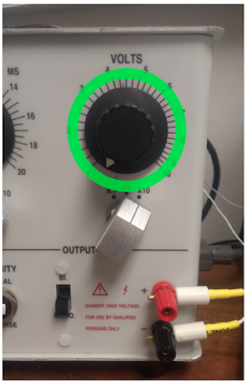

Slide 6

Shock instructions:

Press **SPACE BAR** to administer a shock while on this slide

To increase the voltage, turn the **“VOLTS”** dial, then press **SPACE BAR**.

Increase the intensity gradually, by no greater than 1 volt at a time.

When you decide on the maximum intensity you’re comfortable with,

press **ENTER** to continue to the next slide.

Slide 7

Now you’ll receive a brief shock at the same level

of intensity you chose in the previous slide.

Press any key when you’re ready to proceed.

Slide 8

How aversive would you rate that experience?

Use a scale from 0 (not at all) too 100 (unbearable).

If you make a mistake press **DELETE** to start again.

Use the numbers on the keyboard above the letters.

Press **ENTER** once your done.

Slide 9

What is the final voltage level of the shock you chose?

Look at where the arrow on the **“VOLTS”** dial is pointing,

then enter those numerical values (including decimals)

using the numbers just above the keyboard

If you make a mistake, press **DELETE** and start again.

Use the numbers on the keyboard above the letters.

Press **ENTER** once you’re done.

Slide 10

You will **not** be shocked for the remainder for the experiment.

Slide 10

For the next two minutes your task is to sit quietly, trying to stay

as still and comfortable as possible. The purpose of this period

is to allow our instruments to calibrate to your personal physiological

signal. This way we will be able to analyze your data more accurately.

Press any key when you’re ready for this period to begin.

The screen will be blank for two minutes

Slide 11

[blank]

Slide 10

Now you’ll begin the eye-tracking setup. Let the

experimenter know and they’ll get you prepared.

Slide 12

Finally, we’ll go over the gaze calibration process, which will occur throughout the video you’ll be watching. The purpose of gaze calibration is to ensure that we’re accurately measuring what you’re looking at throughout the experiment.

Slide 13:

These are your instructions:

When you hear a “beep,” the video will pause and

a black dot will appear at the center of the screen.

**Look at the black dot** **and press the space bar**

then the video will continue.

In the next slide, the screen will go blank and there will be a

practice trail, similar to what you’ll see during the video.

Press any key when you’re ready to continue.

Slide 12

You can press ‘c’ to continue, or any

other key to repeat the eye-tracking setup

Slide 13

Next is the main part of the experiment on day one. After going through a

process similar to the one you just experienced, the person in the video will

be receiving shocks at the maximum voltage they could tolerate.

Your task is to watch the person being shocked and pay attention to:

1. How they are feeling throughout the experiment—facial expressions, etc.
2. The color of the square presented just before they are shocked.

Slide 12

Please remain as still as possible throughout the experiment, which will

allow our measurements to be more accurate. Again, when you hear a “beep”, look at the dot at the center of the screen and press the space bar.

If you have any questions, now is a good time to ask the experimenter.

If not, press any button and the video will begin shortly.

Post 1

For the person you were watching, how aversive do

you think they would rate **their own** experience?

Use a scale from 0 (not at all) to 100 (unbearable).

If you make a mistake, press **DELETE** and start again.

Use the numbers above the letters on the keyboard.

Press **ENTER** once you’re done.

Post 1

In the video you just watched,

what was the color of the square that led to the shock?

Enter either “red” or “blue” with the keyboard.

If you make a mistake, press **DELETE** then start again.

Press **ENTER** once you’re finished.