Project Sprint #1

The Solitaire game is described in CS449HomeworkOverview. You should read the description very carefully.

In this assignment, you aim to specify the requirements (i.e., user stories and acceptance criteria) of the target software that allows a human player to play a Solitaire game. These requirements will be fully implemented by the end of sprint 3. The minimum features include choosing the board size and type, starting a new game, making a move, determining if a game is over. The following is a sample GUI layout.

Board size
7
Board Type  - English  - Hexagon  - Diamond | 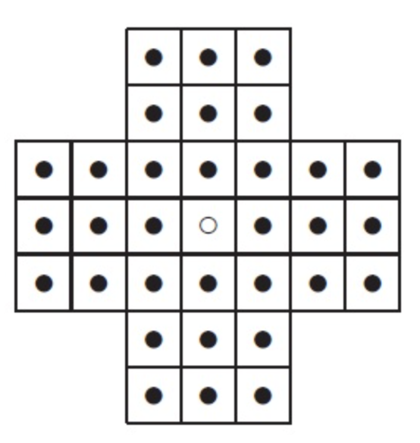 | New Game
Figure 1. Sample GUI layout of the first working program by the end of Sprint 3

Use the following tables to document your user stories and acceptance criteria.

You are required to use the free ChatGPT or another LLM to complete two user stories and two of their respective acceptance criteria. You must ensure that the generated user stories are correct and fix them if not. At the end of the submission, provide screenshots of your LLM prompts and answers, along with the description of errors the LLM made that you had to correct. Points will be deducted if no screenshots/description are provided.

For the other user stories and acceptance criteria, you are not required to use LLM.

- User Stories (3 points)

- User Story Template: As a <role>, I want <goal> [so that <benefit>]

ID | User Story Name | User Story Description | Priority | Estimated effort (hours)
1 | Choose a board size | As a player, I want to choose the board size so that I can play a game with the level of complexity I prefer | 2 | 1
2 | Choose the board type | As a player, I want to choose the board type so that I can play different variations of peg solitaire. | 3 | 1
3 | Start a new game of the chosen board size and type | As a player, I want to start a new game using my chosen board size and type so that I can play the version of peg solitaire I selected. | 4 | 2
4 | Make a move in a game | As a player, I want to make a valid move so that I can remove pegs and work toward completing the game. | 1 | 3
5 | A game is over | As a player, I want the game to recognize when it is over so that I know when I have completed or lost the game. | 5 | 2

- Acceptance Criteria (AC) (12 points): Add/delete rows as needed.

User Story ID and Name | AC  ID | Description of Acceptance Criterion | Status (completed, toDo, inPprogress)
1. Choose a board size | 1.1 | AC 1.1 A player wishes to customize board size upon loading into the application  Given the setup screen is displayed  When I view my board size options  Then I should be able too choose from multiple size options | To do
1. Choose a board size | 1.2 | AC 1.2 The player is shown multiple size boards to choose from  Given multiple board size options  When I select a new board size  Then the board displayed should take on the new size | To do
1. Choose a board size | 1.3 | AC 1.3 The player chooses a board size  Given I have selected a board size  When I change my selection  Then the new board size should replace my previous selection | To do
2. Choose the board type | 2.1 | AC 2.1 A player wishes to customize board size type upon loading into the application  Given the game setup screen is displayed  When I view the board type options  Then I should be able to choose from the available board types | To do
2. Choose the board type | 2.2 | AC 2.2 The player chooses a desired board type  Given I have selected a board type  When I change my selection  Then the new board type should replace my previous selection | To do
3.Start a new game of the chosen board size and type | 3.1 | AC 3.1 The player chooses to start the game, and we must generate their selected size and type  Given a new game has started  When the board is displayed  Then the board should match the selected size and type | To do
 | 3.2 | AC 3.2 The player chooses to start the game, and we must generate pegs in a way that satisfies the rules for starting  Given a new game has started  When I view the board  Then the board should be initialized with the correct starting arrangement of pegs and empty spaces | To do
4. Make a move in a game | 4.1 | AC 4.1 The player’s turn has come they should be able to move a peg in a way that’s in line with the rules if possible  Given it is my turn and a valid move is available  When I select a peg and move it over an adjacent peg into an empty space  Then the jumped peg should be removed and the moved peg should occupy the empty space | To do
 | 4.2 | AC 4.2 Do not allow the player to make a move that falls outside of what is allowed in the rules  Given I attempt to make a move that does not follow the rules  When I make the move  Then the board should remain unchanged | To do
 | 4.3 | AC 4.3 Reflect when the player makes a valid move by updating the board  Given I make a valid move  When the move is completed  Then the number and positions of the remaining pegs should be updated correctly | To do
5. A game is over | 5.1 | AC 5.1 The player makes a move and loses the game  Given the board has one or more pegs remaining  When there are no valid moves available  Then the game should end | To do
 | 5.2 | AC 5.2 The player makes a move and wins the game  Given the game has ended  When the player has one peg remaining  Then the game should indicate that the player has won | To do
 | 5.3 | AC 5.3 The player lost and should be notified  Given the game has ended  When the player has more than one peg remaining  Then the game should indicate that there are no more valid moves | To do
 | 5.4 | AC 5.4 Stop the game from being played after ending  Given the game has ended  When the player attempts to make another move  Then no further moves should be allowed | To do

