[Sample]

**Software Patent Maintenance Report:**

*Using Predictive Analytics to Score Patent Quality & Strategically Reduce Portfolio Maintenance Costs*

**IP Logic Systems Inc.**

**2120 University Ave.**

**Berkeley, CA 94704**

**Tyler Seymour**

**Campbell Yore**

**David Garson**

Table of Contents

Product Summary 3

Introduction 4

Legal Background 5

Figure 1. Maintenance Lifecycle of a Patent 5

Methodology: Data Collection and Processing 10

Figure 2. Process for Obtaining Maintenance Fee 11

Portfolio and Patent Analysis 12

Maintenance Rate Analysis 13

Figure 3. Maintenance Rates by Term 13

Table 1. Maintenance Rate 14

Maintenance Fee Payment Analysis 16

Figure 4. Maintenance Payment Count by Year 16

Budget Analysis 17

Maintenance Budget 2017-2020 17

Figure 5. Projected Maintenance Fees 17

Table 2. Annual Maintenance Payment Count by Period 17

Projected Budget 2021-2025 19

Figure 6. Projected Maintenance Fees 19

Table 3. Projected Maintenance Payment Count by Period 19

Maintenance by Technology Analysis 21

Art Unit Analysis 21

Figure 7. Top 10 Art Units 21

Table 4. Patent Count by Common Art Units 22

CPC Analysis 23

Figure 8. Top 10 CPC Subclasses 23

Table 5. Common CPC Subclasses 24

Figure 9. Patent Grants per Year by CPC Class 25

Table 6. Granted Patents in Top CPC Subclasses per Year 25

Claim Analysis - Validity Predictions 27

Table 7. Validity Predictions - Invalid Examples 27

US6944599 - Claim 20 27

Figure 10. Automated Claim Text Analysis - Invalid Prediction 28

Table 8. Validity Predictions Valid Examples 28

US7571195 - Claim 1 29

Figure 11. Automated Claim Text - Valid Prediction 30

Reducing Maintenance Cost Case Study 31

Figure 12. Maintenance Cost per Year by CPC Class 31

Table 9. Annual Maintenance Costs in Top CPC classes 32

Table 10. Modified Annual Maintenance Cost - CPC G06Q/F 33

Table 11. Modified Counts for Maintained Patents - CPC G06Q/F 33

Figure 13. Projected Budget and Savings for 2017-2021 34

# Product Summary

IP Logic’s Patent Maintenance Report is a tool companies can use to reduce the cost of maintaining their patent portfolios. Maintenance Reports combine high level portfolio analysis with more granular claim level analysis to provide a better understanding of which patents in a portfolio should be maintained. Portfolio Analysis augments fee payment counts and maintenance budget information with technical insights to give budget projections by technology. Claim analysis mines patent claim language to determine the risk of subject matter ineligibility using automated methods that ensure comprehensive coverage of examiner §101 rejections and very short turnaround times.

In house legal departments can use Maintenance Reports to set a Maintenance Budget using the Payment Count and Budget Projections features. They can then use Technology Groupings and Claim Analysis to keep portfolio maintenance costs within budget by distinguishing patents that should be maintained from patents that should be monetized or abandoned.

# Introduction

The *Alice vs. CLS Bank[1]* decision from Supreme Court of the United States was a watershed moment for patent law. By tightening the subject matter eligibility requirements for software, medical diagnostics, and other non-device inventions, this decision dramatically altered the landscape of patentable technology in the U.S. and abroad. Although subsequent decisions *DDR Holdings vs. Hotels.com[2]* and *Enfish, LLC vs. Microsoft Corp.*[3] have confirmed some software inventions are patent eligible subject matter, many software patents granted during the post *State Street Bank[4]* peak of “do it on a computer” patents are likely invalid. The goal of this white paper is to discern how one company with a large software patent portfolio, eBay, is adjusting to the changing landscape of software patent eligibility by studying its patent maintenance behavior.

This paper proceeds in three parts. First, the legal background of patent maintenance is presented along with costs associated with maintaining a patent for its full term. Methods used to conduct this analysis are then described including data collection and processing as well as methods of projecting maintenance fee dates and costs. Lastly, an analysis of eBay’s maintenance fee behavior is discussed along with ways to use technology tools to optimize software patent maintenance.

# Legal Background

A patent’s life is a factor of two variables: (1) the maximum term of protection afforded by law and (2) it’s owner’s willingness to comply with periodic renewal obligations. In the United States, patents receive a nominal term of protection that extends twenty years from the filing date of the earliest application to which the patent claims priority.[5] However, patent rights must be renewed three times – 3.5, 7.5, and 11.5 years after the date of issue – in order to enjoy the full term of protection afforded by statute; these renewal fees are also known as “maintenance” fee payments. Maintenance fees are set forth by the PTO’s fee Schedule.[6]

## Figure 1. Maintenance Lifecycle of a Patent

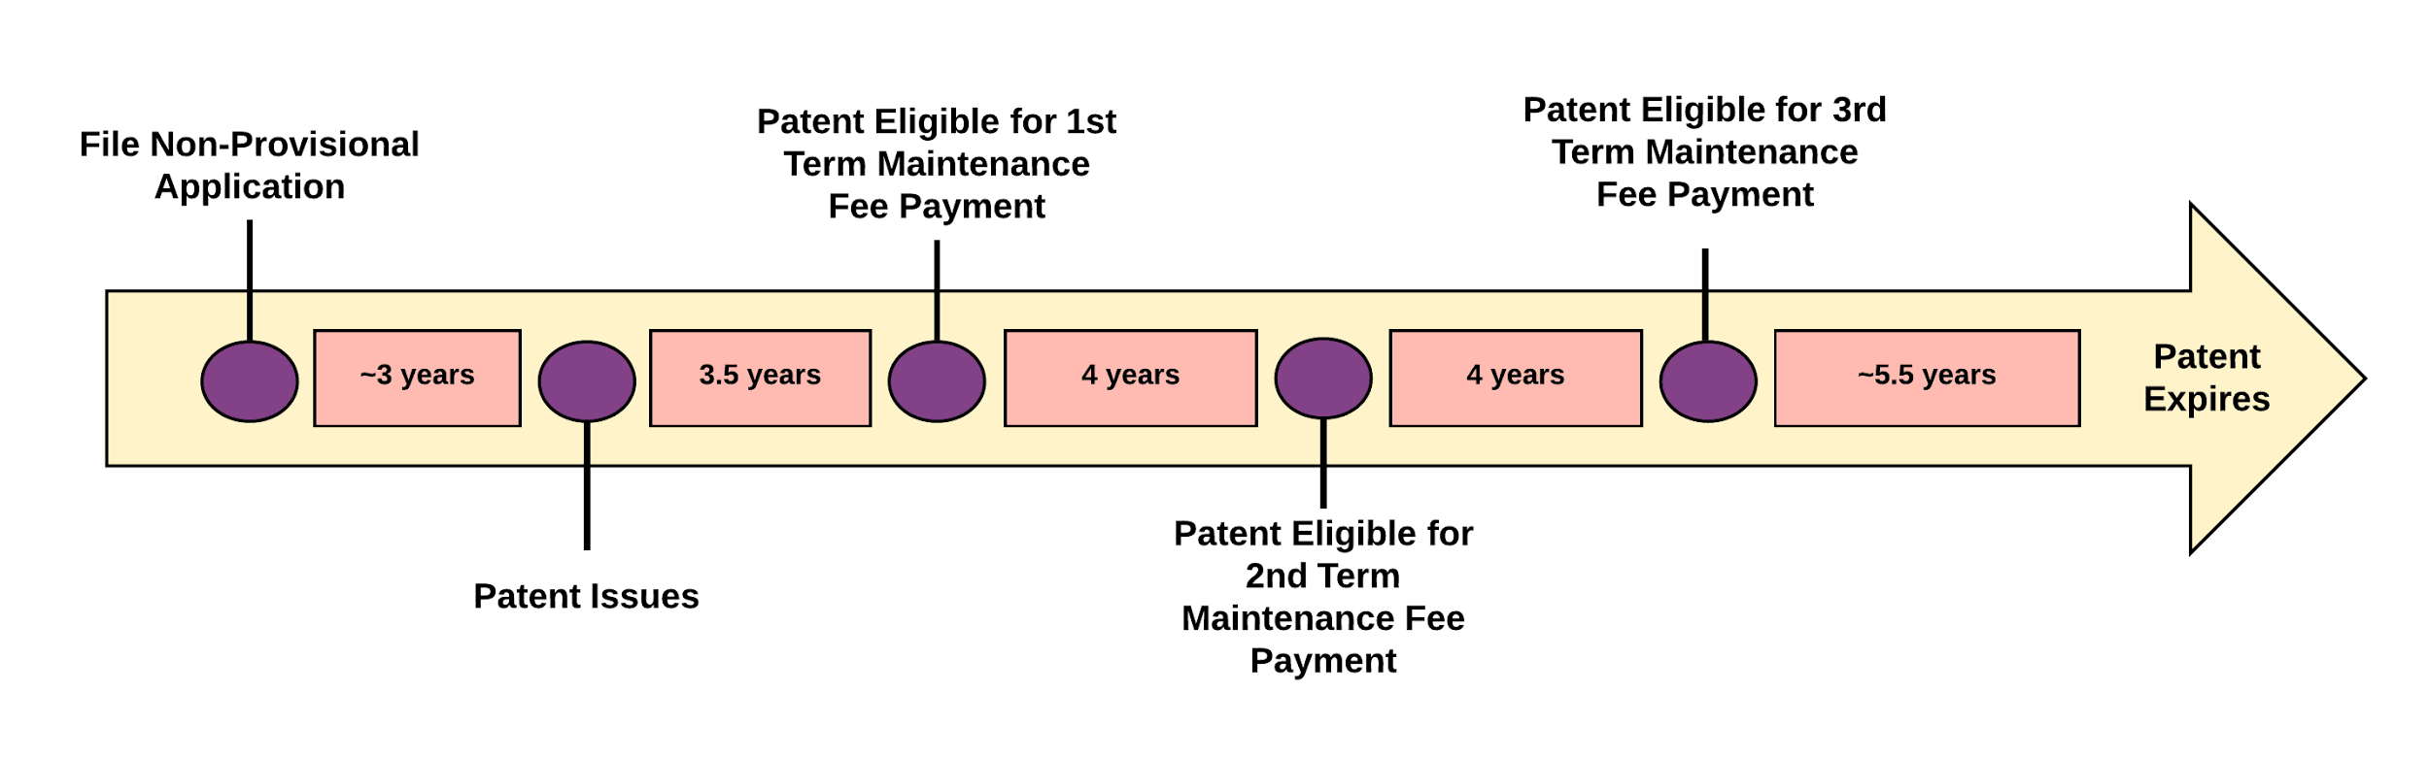

The maintenance fee lifecycle is illustrated in Figure 1 above. For fully maintained applications, it begins 3.5 years after a patent is granted and ends eight years later upon payment of the third maintenance fee.

Maintenance fee costs are a function of two variables: (1) the price charged by the USPTO for patent maintenance and (2) the risks associated with maintaining an invalid patent. Decisions to maintain or abandon are therefore based on a cost benefit analysis of these two variables. In the United States, the price for maintaining a patent is fixed with a one-time payment, for large entities, of $1,600 due for the 1st maintenance term, a second payment of $3,600 due for the second maintenance term, and a third payment of $7,400 due for the third maintenance term.[7] Accordingly, it costs $12,600 for most patent owners to maintain a patent for its full term.

On the other hand, the risks associated with maintaining an invalid patent are unfixed and in a constant state of flux. Aside from wasting money, other risks associated maintaining invalid patents include perpetuating low quality patents, relying on unenforceable assets as affirmation of freedom to operate, and losing credibility with licensing or financing partners. Patents are among a business’s most important intellectual property assets and, as such, can bring significant value as securitization collateral or licensable technology. Much, if not all, of this value vanishes if a patent is invalid and unenforceable, therefore it is important to make sure patents are valid before they are licensed, sold, or securitized.

When Google acquired Motorola Mobility in 2011 for $12.5 billion[8], it wasn’t buying a “plug and play” ready smart phone operation. Instead, it was adding 17,000 patents to its arsenal to defend against an anticompetitive campaign aimed at taking down Android organized by Apple, Microsoft, and other tech giants. By aggregating a portfolio of patents on smartphone hardware, software, and infrastructure that was on par with others in the industry, Google used the threat of mutually assured destruction to solidify its freedom to operate in the smartphone market .[9] If you sue us for patent infringement, Google warned, you better have the resources and the expertise to defend legions of counterclaims. This strategy of aggregating patents to guarantee freedom to operate, however, likely fails if the acquired patents turnout to be invalid.

Third, maintaining invalid patents exacerbates the problem of patent thickets[10], where too many low quality patents in a particular technology area crowd out new innovations in the space. If unchecked, exceedingly dense patent thickets can produce anti-commons effects[11], which suggests one risk of having a patent regime is the tendency of patent rights to, in aggregate, result in under-use of the scientific commons. Such under-use occurs when excessive patenting of a particular technology fragments the scientific commons such that no single entity has sufficient patent stock to pursue its program of research and development. Optimizing patent maintenance assures a maximum amount of the technology commons is available for new inventions, thereby keeping the incentive for new innovations high.

While the reasons for optimizing patent maintenance are well documented, the practice of determining which patents to maintain and which to abandon is difficult. Patents are complex, amorphous documents and lawyers often “abstract up” inventive concepts to increase scope. Additionally, changes to law such as the new requirements for subject matter eligibility provided in the *Alice* decision make determining the difference between enforceable and invalid patents even more challenging. Software companies, in particular, are put in a difficult position due to the high competition for software patent rights in the 2000s followed by a swift exclusion of many heavily patented categories of software subject matter in 2013. Accordingly, many e-commerce and internet service based companies face soaring maintenance budgets in the coming years with little certainty about which, if any of the assets they maintain are actually valid and enforceable.

To set the stage for the maintenance analysis that follows, a brief introduction into the current landscape of software patent eligibility is now provided. In the United States, subject matter eligibility for a subset of non-tangible inventions called abstract ideas is an evergreen topic. The *Alice* decision and other subsequent court rulings on patent eligibility of computer implemented methods provide guideposts for analyzing the subset of patent validity issues included in the subject matter eligibility requirements of U.S.C. §101. For a better idea of what a computer implemented method is a representative software patent claim, claim 33 of Patent No. 5,970,479[12], is included below:

Claim 33. A method of exchanging obligations as between parties, each party holding a credit record and a debit record for an exchange institution, the credit records and debit records for exchange of predetermined obligations, the method comprising the steps of:

1. Creating a shadow credit record and a shadow debit record for each stakeholder party to be held independently by a supervisory institution from the exchange institutions;
2. Obtaining from each exchange institution a start-of-day balance for each shadow credit record and shadow debit record;
3. For every transaction resulting in an exchange obligation, the supervisory institution adjusting each respective party’s shadow credit record of shadow debit record, allowing only these transactions that do not result in the value of the shadow debit record being less than the value of the shadow credit record at any time, each said adjustment taking place in chronological order; and
4. At the end-of-day, the supervisory institution instructing one of the exchange institutions to exchange credits or debits to the credit record and debit record of the respective parties in accordance with the adjustments of the said permitted transactions, the credits and debits being irrevocable, time invariant obligations placed on the exchange institutions.

In *Alice*, the Court distinguished patents that claim the “building blocks” of human ingenuity, which are ineligible for patent protection, from those that integrate the building blocks into something more -- “transforming” them into a patent-eligible invention. This guidance indicates inventions claimed at a high level of abstraction have a claim scope that is too broad to be proprietary. To become patent eligible, inventions including abstract ideas must be cabined to a particular application, carried out in a particular way, or otherwise meaningfully limited. This distinction makes sense in light of the potential for patents on abstract ideas to stifle innovation by foreclosing future research and invention on the entire field of study related to the idea.[13]

As guidance for separating patent ineligible claims directed to abstract ideas from patent eligible claims on applications and implementations of abstract ideas, the Supreme Court provides the following analytical framework. First, the Court must determine whether the claims at issue are directed to a patent-ineligible concept.[14] If so, the Court then asks whether the claim’s elements, considered both individually and “as an ordered combination,” “transform the nature of the claim” into a patent eligible application.[15] In Alice, the court held all claims were directed to the abstract idea of intermediated settlement because intermediated settlement is (1) an idea -- the use of a third party to mitigate settlement risk; and (2) a fundamental economic practice long prevalent in our system of commerce.

Next, the Supreme Court examined whether claiming a computer implementation of the abstract idea of intermediated settlement was enough to “transform the nature of the claim” into a patent eligible invention. The court concluded adding the words “apply with a computer” to claims directed to an abstract idea does not supply the “invented concept” needed for patent eligibility. Specifically, applying the intermediated settlement concept by creating a computerized function for creating and maintaining a shadow account, viewed as a whole, merely recite the concept of intermediated settlement as performed by a generic computer. Perceived applications of conventional steps, specified at a high level of generality, to a particular technological environment is not enough to “transform the nature of the claim” into a patent eligible invention therefore claims reciting a generic computer implementation of a long known concept like intermediated settlement are not patent eligible and are invalid.

Under this new rule thousands of patents claiming generic computer implementations of rudimentary offline concepts, for example, establishing contractual relationships, investing, wagering, diagnosing medical conditions, fixing prices, and holding public auctions,[16] are now invalid.[17] Similarly, fundamental digital data processing methods including filtering and delivering content, collecting, comparing, and organizing information, and keeping and maintaining records are also patent ineligible abstract ideas absent additional inventive elements. Despite significant changes to the landscape of patentable technology in 2013, our research suggests most patent owners, even those having portfolios with high concentrations of software patents, continue to maintain 90 to 98% of their patents.

To help patent owners adjust their maintenance strategy to account for the updated validity requirements, IP Logic developed a maintenance application. By returning an automated and instantaneous validity prediction based on a comprehensive corpus of subject matter eligibility rejections, the maintenance app allows patent owners to make more informed maintenance decisions without incurring more attorney hours. The application quickly separates patents that should be maintained from assets that should be abandoned in order to significantly reduce a company’s maintenance budget. For software companies with portfolios of hundreds or thousands of applications, IPL’s maintenance fee application can reduce maintenance fees paid to the USPTO by 25 to 50% resulting in budget savings on the order of hundreds of thousands to millions of dollars.

The remaining sections of this paper describe an example software company maintenance fee analysis generated using IPL’s maintenance fee application. First, methodology for collecting and processing patent maintenance data is presented. A maintenance fee analysis for a software company follows. The analysis comprises maintenance rate, payment counts, budget, and technical subject matter components to deliver a comprehensive understanding of company specific patent maintenance issues.

# Methodology: Data Collection and Processing

All patent and maintenance fee data is collected from the USPTO. Patent data includes the full text and corresponding bibliographic metadata for every patent and patent application issued or published between 2001 and the present.[18] Bibliographic metadata includes fields for document type, dates (*e.g.*, filing date, publication date, issue date), document identifiers (*e.g.*, application number, publication number, patent number), technical classification (*e.g.*, art unit, US patent classifications, CPC patent classifications), assignee, inventors, title, abstract, claim text, and the like. Maintenance fee events including maintenance fee payment records are available as a separate dataset and, at the time of writing, this dataset is current through July 18, 2017.[19]

From this superset of patent and maintenance data, a portfolio of patents was isolated for analysis using the following method. First, patents belonging to a single company or organization were identified by querying the above comprehensive database of patents and applications on a particular assignee name. Once the serial numbers of all patents belonging to a company of interest were extracted from the patent and applications database, the maintenance fee database was queried on this list of patent serial numbers. This second layer of filtering produced a list of all maintenance fee events for all patents belonging to a single company. From this superset of maintenance fee events, payment of first, second, and third term maintenance fees were obtained by referencing the USPTO’s system of system of codes for describing maintenance events that may occur in the life of a patent.[20] Specifically, maintenance fee code “M1551” describes first-term maintenance fee payments by large entities; “M1552” describes second-term maintenance fee payments by large entities; and “M1553” describes third-term maintenance fee payments by large entities. The superset of maintenance fee events was queried on these three codes to obtain a list of patent serial numbers having first, second, or third term maintenance fee payment maintenance events. Other important information including grant date and CPC technology classification on this subset of patent serials numbers was then obtained by querying the patent and application database on the serial numbers having maintenance fee payments.

## Figure 2. Process for Obtaining Maintenance Fee

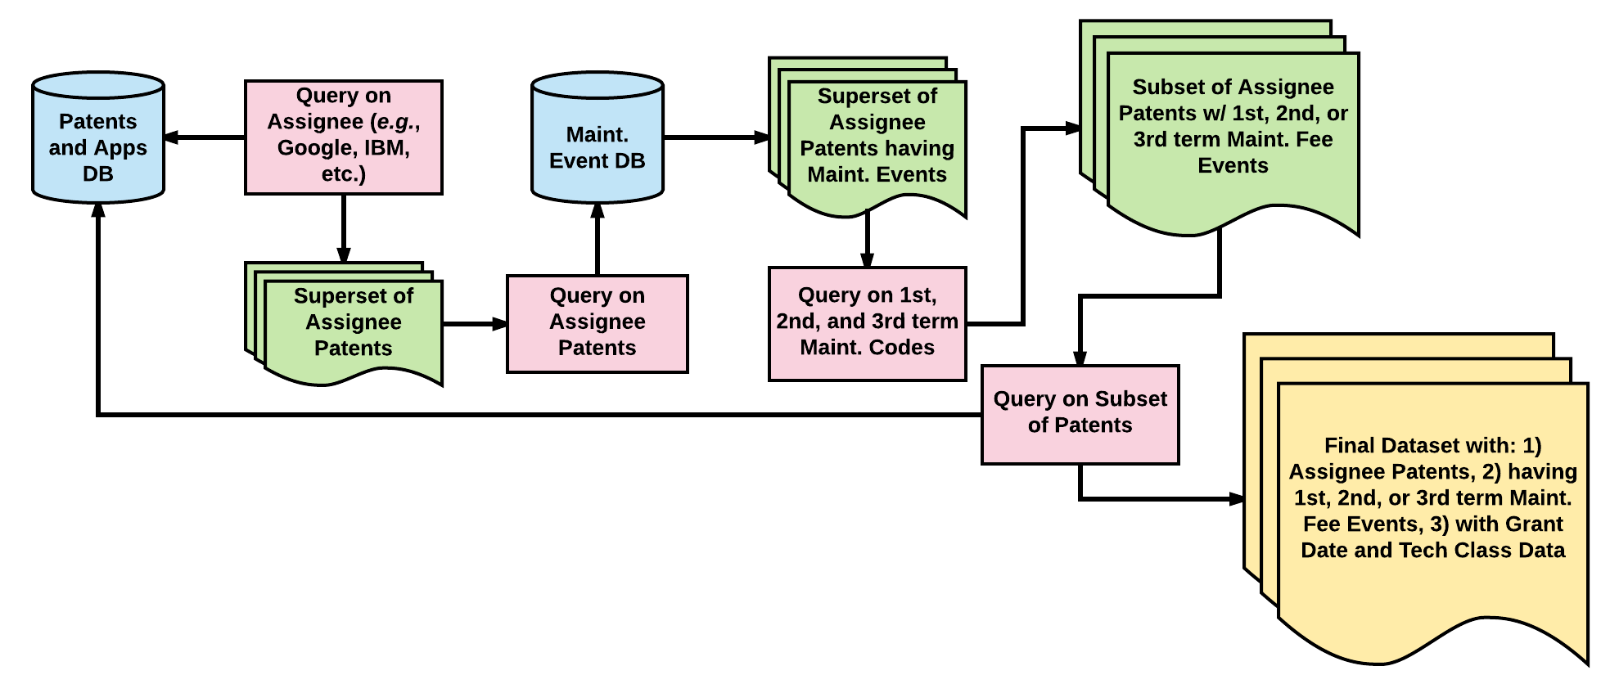

An overview of the process for obtaining the dataset used in this analysis is provided in the figure above.

Once the final dataset was collected, first, second, and third term maintenance fee due dates were calculated for all patents in the dataset by adding 3.5 years (42 months), 7.5 years (90 months), and 11.5 years (138 months) to each patent’s grant date. The number of patents with payment due dates in each year was then determined for the payments per year and budget analysis. Patents were also sorted by CPC technology classification and the number of patents in each CPC class was counted for the technology analysis. The final dataset for the analysis below includes 1,100 patents belonging to a single software company assignee. The patents have grant dates from 2001 to 2016 and are classified into twenty three distinct CPC technology classifications. A more detailed description of each maintenance analysis component is now provided below.

# Portfolio and Patent Analysis

The remainder of this white paper showcases the portfolio level and patent level analysis performed in IP Logic’s Maintenance Fee Application and Reports. Portfolio level analysis provides an overview of a portfolio’s patent maintenance matters for budgeting and strategic purposes. IPL’s baseline Patent Maintenance Portfolio Report includes Maintenance Rate Analysis summarizing a company’s historical patent maintenance tendencies, Annual Maintenance Fee Payment Counts describing the number and type of annual maintenance fee payments due, a Budget for maintaining a portfolio over the next four years, and a Projected Budget for expected future maintenance fee payments for a given filing rate. The Portfolio Level Report also includes a technology breakdown of patents in a portfolio by USPTO Art Unit and CPC class as well as the number of patents granted in a particular technology over time.

In combination with the high level Portfolio Analysis, IPL’s Maintenance Fee Application and Reports allow users to perform patent and claim level analysis to gauge §101 invalidity risk at a more granular level. To help determine whether a patent should be maintained, the likelihood a patent claim will be rejected under §101 is predicted using an ensemble of machine learning models. Rejection predictions are based on a comparison of the input claim text to a library of more than 30,000 claims receiving subject matter eligibility rejections under §101 in office actions mailed after June 19, 2014, the date the *Alice* case was decided. The greater the semantic and contextual similarity of an input text claim to the library of rejected claims the higher the machine generated §101 risk score.

In addition to claim by claim predictions, the language of the input claim text is also analyzed in IPL’s patent level analysis. IPL’s Claims Annotator extracts a given claim’s subject matter fingerprint to help visualize the words within a claim that cause it to be classified as §101 valid or invalid. From a comparison between the input claim text and millions of claims across every CPC class, the Claims Annotator the claim in a particular technology group. The model then weights each word in a claim based on it’s impact in the technology group classification. Words with the highest weights are then highlighted to reveal the claim’s technology fingerprint. Performing this analysis on §101 invalid claims can help determine specific words that cause claims to have a high risk of being subject matter ineligible.

# Maintenance Rate Analysis

A company’s patent maintenance rate is the number of patents a company pays maintenance fees on relative to the total number of patents having maintenance fees due. This ratio provides some insight into the level of review a particular patent owner gives to patents that become eligible for maintenance fee payments before deciding to maintain or abandon a patent. Companies having a lower maintenance index are presumably more discerning of the quality of the patents they maintain relative to companies that maintain pretty much all of their patents and thereby have a high maintenance rate. In addition to the level of time and energy companies invest in making maintenance decisions, maintenance rate is also determined by a variety of other factors, for example, the size of the company's patent and patent maintenance budgets, the number of patents in a company’s portfolio, the technology types covered in the portfolio, the company’s industry and the size of the company's patent portfolio relative to its closest competitors, the number of attorneys employed by the company to oversee maintenance decisions, the number of attorney hours required to make an informed maintenance fee decision, and the company's patent filing, monetization, and enforcement strategies.

## ChartFigure 3. Maintenance Rates by Term

## Table 1. Maintenance Rate

|  |  |  |  |
| --- | --- | --- | --- |
| **Maint. Period** | **Patents Eligible** | **Patents Maint.** | **Maint. Rate** |
| 1st term | 576 | 565 | 0.98 |
| 2nd term | 65 | 59 | 0.91 |
| 3rd term | 10 | 9 | 0.90 |

The graph above in Figure 3 illustrates the number of maintenance fee payments paid on a portfolio relative to the number of maintenance fee payments due. The payments are grouped by the USPTO’s three maintenance fee periods. The number of first, second, and third term eligible patents reflects the number of patents having first, second, or third term due dates in or before 2017. The number of first, second, and third term maintained patents reflects the number of patents having first, second, or third term maintenance payments that were *actually paid* in or before 2017.

Paying maintenance fees allows the patent-holder to maintain the rights granted by US patent laws for the period until the next payment is due. Deciding to forego paying maintenance fees when they become due results in the patent becoming abandoned, thereby shortening the life of the patent to less than the full term of 20 years from the date the patent is granted. Accordingly, the lifespan of patents whose maintenance fees have not become due depends on the future payment of maintenance fees.

For the 1,100 patents included in this portfolio, 565 of 576 (98%) patents that were eligible for first term maintenance fee payments were maintained; 59 of 65 (91%) patents that were eligible for second term maintenance fee payments eligibility were maintained; and 9 of 10 (90%) of patents that were eligible for third term maintenance fee payments were maintained. This data suggests, the owner of the portfolio analyzed has a clear tendency for maintaining pretty much all of its patents for the entire life of the patent.

Although only 10 of the company’s patents have become eligible for third term maintenance fee payments, this number will rise to over 200 patents by 2025. As indicated in the budget analysis below, the backloaded cost of patent maintenance fees in the US means this particular company will face significantly higher maintenance costs in the future as its patent portfolio ages. To reduce costs and minimize waste, it becomes critically important to understand the impact of the altered landscape of subject matter eligibility on the company’s software patents without adding more attorney hours. Instantaneous validity predictions delivered by applied AI can help this company readily identify patents directed to patent ineligible subject matter. Company attorneys can then use this information when making maintenance decisions to reduce legal spend on maintenance fees by 25 to 50%.

# Maintenance Fee Payment Analysis

## Chart Figure 4. Maintenance Payment Count by Year

The above figure shows the annual number of maintenance fee payments due on the portfolio analyzed from 2012 to 2028. In the US, maintenance fees are paid on a per patent basis every four years. Accordingly, the annual number of payments due depends on the amount of patents granted to the company and the amount of new applications filed by the company.

The portfolio analyzed grew significantly during the mid 2000s. This increase in applications produced an increase in granted patents between 2008 and 2009. As shown in the above figure, this increase in granted patents corresponded with an increase in maintenance fee payments from 2012 to a peak in 2017. The first maintenance fee payment is due 3.5 years after a patent’s grant date and second and third payments become due 4 and 8 years later. Accordingly, the peak in first term payments due in 2017 results in a peak in second term payments in 2021 and a peak in third year payments in 2025. Since the maintenance fee amount due increases from $1,600 in the first term to $3,600 in the second term and $7,400 in the third term, the maintenance budget required to maintain all patents in the portfolio is projected to peak in 2025. The budget analysis below provides a more detailed discussion of these projections.

# Budget Analysis

## Maintenance Budget 2017-2020

### ChartFigure 5. Projected Maintenance Fees

### Table 2. Annual Maintenance Payment Count by Period

|  |  |  |  |
| --- | --- | --- | --- |
| **Year** | **1st Term Payments** | **2nd Term Payments** | **3rd Term Payments** |
| 2017 | 203 | 48 | 4 |
| 2018 | 149 | 104 | 8 |
| 2019 | 119 | 123 | 17 |
| 2020 | 124 | 174 | 17 |

The chart shown above in Figure 5 illustrates the portfolio’s projected annual maintenance costs from 2017 to 2020. This budget accounts for only the existing granted patents in the portfolio. Patents that may be granted in 2017 and therefore have 1st term maintenance payments due in 2020 are not considered. The projections also assumes all patents in the portfolio will be maintained for their full term.

As shown in the chart, the portfolio’s maintenance cost is projected to nearly double over the next four years from $527,000 in 2017 to $950,000 in 2020. Maturation of applications filed in 2013-14, the portfolio’s two most prolific years of growth in granted patents, is the primary cause of the cost increase. As reflected in Table 2 and in the “Maintenance Payment Count by Year” line graph in Figure 4, the portfolio’s annual number of second and third term maintenance fee payments steadily increases from 2017 to 2020. In particular, the number of second term payments due annually increases by more than 260% from 48 payments due in 2017 to 174 due in 2020. Similarly, the number of third term payments due annually more than triples from 4 in 2017 to 17 in 2020. Since the fee amount for maintenance fees increases over time, this increase in second and third term payments is more than enough to offset the decrease in first term payments from 2017-2020.

## Projected Budget 2021-2025

### ChartFigure 6. Projected Maintenance Fees

### Table 3. Projected Maintenance Payment Count by Period

|  |  |  |  |
| --- | --- | --- | --- |
| **Year** | **1st Term Payments** | **2nd Term Payments** | **3rd Term Payments** |
| 2021 | *131* | 203 | 48 |
| 2022 | *131* | 149 | 104 |
| 2023 | *131* | 119 | 123 |
| 2024 | *131* | 124 | 174 |
| 2025 | *131* | *131* | 203 |

The above chart in Figure 6 displays the portfolio’s projected annual maintenance fee costs from 2021 to 2025. Italicized numbers (e.g. *131*) are projected first term payments based on the portfolio’s current patent growth rate. The projections are calculated by averaging the number of first term maintenance fee payments due over the previous nine years. As with the 2017 to 2020 projections, the 2021 to 2025 projections assume all patents in the portfolio are maintained for the full twenty year term.

Absent significant changes to maintenance or filing strategy, the example software company's maintenance budget will nearly quadruple from $527,000 in 2017 to $2,183,400 in 2025. As shown above in table 3 and Figure 4, the increase in third year maintenance fee payments is the primary cause of this increase. Most patents granted during the portfolio’s peak years of growth, 2013-14, will become eligible for third term maintenance fee payments in 2025. Due to the back-loaded nature of USPTO maintenance fees, 2025 is also the year with the highest projected maintenance fee costs. Accordingly, the increase in third term payments is enough to offset the stagnation in first term payments and decrease in second term payments anticipated in Table 3.

# Maintenance by Technology Analysis

## Art Unit Analysis

Patent examination is a highly specific process that occurs on a claim by claim basis. Patent examiners at the USPTO are technical specialists that examine patent applications containing a particular technology. To promote specialization, quality, efficiency, and customer service, the technical subject matter examined by examiners assigned to a particular Art Unit remains consistent over time. Prior to examination, patent applications are similarly classified into particular CPC classes according to the technical subject matter disclosed in the application. Art Units are then assigned applications to examine based on the results of the application CPC classifications, with each Art Unit responsible for one or more CPC classes.

As a result of examiner technology specializations, rejections given during prosecution depend heavily on the technical subject matter disclosed in an application. For example, rejections for subject matter eligibility under §101 are given almost exclusively to applications containing claims reciting software and medical diagnostic methods. Therefore, determining whether a patent is classified in an Art Unit or CPC class having a high concentration of applications containing technologies subject to heavier §101 scrutiny (e.g. software and medical diagnostic methods) provides insight into the likelihood a patent contains patent ineligible subject matter.

## ChartFigure 7. Top 10 Art Units

N = 306 of 759 or 40% of all patents with art unit data displayed in the chart

## Table 4. Patent Count by Common Art Units

|  |  |  |  |
| --- | --- | --- | --- |
| **Art Unit** | **Count** | **% of Filings** | **Art Unit Description** |
| 3625 | 107 | 14% | Data processing: financial, business practice, management, or cost/price determination |
| 3691 | 43 | 6% | Insurance, banking and finance |
| 3694 | 23 | 3% | Insurance, banking and finance |
| 3695 | 23 | 3% | Insurance, banking and finance |
| 3693 | 23 | 3% | Insurance, banking and finance |
| 2155 | 19 | 2.5% | Electrical computers and digital processing systems: multicomputer data transferring |
| 3684 | 19 | 2.5% | Operations research |
| 2163 | 19 | 2.5% | Databases and file management |
| 3687 | 17 | 2.2% | Point of sale, inventory, accounting |
| 3627 | 13 | 1.7% | Point of sale, inventory, accounting |

The above chart in Figure 7 illustrates the ten most common art units assigned to patents in the portfolio. Table 4 gives the patent count and percentage of the portfolio’s total assets in each Art Unit as well as a description of the technology examined in the Art Unit.

Table 4 indicates over 40% of the portfolio’s total patents are in Technology Center 3600. Technology centers are broader examiner classifications and contain every Art Unit that begins with the same first two numbers (e.g. “36”) TC 3600 is mostly a catch all technology center for any subject matter that does not fall nearly into another TC. Therefore, a high number of patents assigned to TC 3600 reveals little about the technical subject matter of the company’s portfolio. A closer look into the specific Art Units within TC 3600, however, suggests many if not most of the portfolio’s patents contain subject matter relating to financial, business, accounting, inventory, and management implementations of data processing methods. Other technical subject matter with good coverage in the company’s portfolio includes database management and electrical computing systems.

These business and financial implementations of data processing and management methods and computing systems is the subject matter most heavily scrutinized under the new requirements for patentable subject matter under USC §101. Accordingly, patents in the portfolio containing this subject matter are likely at risk of being held patent ineligible subject if enforced or reexamined. Such a finding of patent ineligible subject matter would invalidate the patent. Therefore, the above data suggests many patents in the portfolio carry a high invalidity risk.

## CPC Analysis

The cooperative patent classification (CPC) is a international patent technology classification schema developed by the IP5, a consortium of the world’s largest intellectual property offices (the US, Europe, China, Japan, and Korea). In use since January 1, 2013, the schema is a more detailed and updated version of the international patent classification (IPC) system. The CPC system is comprised of a five tier hierarchy ranging from nine very broad sections, for example, section “G” Physics, to many thousands of very specific subgroups, for example, subgroup “G06Q 30/0218” Commerce, e.g. shopping or e-commerce, marketing, e.g. market research and analysis, surveying, promotions, advertising, buyer profiling, customer management or rewards; price estimation or determination, specifically, discounts or incentives, e.g. coupons, rebates, offers or upsales, more specifically, giving input on a product or service or expressing a customer desire in exchange for an incentive or reward based on score. Subclass comprises the middle tier in the classification schema and strikes a good balance between having enough detail to be descriptive, while also have enough breadth to provide good portfolio coverage.

## ChartFigure 8. Top 10 CPC Subclasses

N = 1031 of 1050 or 98% of all patents with CPC data are displayed in the chart

## Table 5. Common CPC Subclasses

|  |  |  |  |
| --- | --- | --- | --- |
| **CPC Subclass** | **Count** | **% of Filings** | **CPC Subclass Description** |
| G06Q | 486 | 46% | Data processing systems or methods specifically adapted for administrative, commercial, financial, managerial, supervisory, or forecasting purposes |
| G06F | 289 | 28% | Electrical digital data processing |
| H04L | 136 | 13% | Transmission of digital information, e.g. telegraphic communication |
| Y10S | 39 | 4% | Technical subjects covered by former USPC cross-reference art collections and digests |
| H04W | 23 | 2% | Wireless communication networks |
| G06K | 23 | 2% | Recognition of data; presentation of data; record carriers; handling of record carriers |
| G06N | 16 | 1.5% | Computer systems based on specific computational models |
| G06T | 9 | <1% | Image data processing or generation, in general |
| H04N | 6 | <1% | Pictorial communication, e.g. television |
| G07F | 4 | <1% | Coin-freed or like apparatus |

The chart in Figure 8 displays the ten most common CPC subclasses assigned to patents in the portfolio. 98% of the portfolio’s patents are contained in these ten CPC subclasses. Table 5 describes the total number of patents, the percentage of all patent filings, and a description for each CPC subclass.

Over 70% of the portfolio’s patents are contained in CPC subclasses “G06Q” and “G06F”. This distribution suggests the vast majority of patents in the portfolio are directed to data processing systems specifically adapted for electrical digital data processing or administrative, commercial, financial, managerial, supervisory, or forecasting purposes. Data processing methods adapted for commercial and financial applications have consistently been among the categories of technical subject matter most heavily scrutinized by federal courts under the new subject matter eligibility guidelines promulgated by the Supreme Court in the *Alice* decision. Therefore, both the Art Unit and CPC analyses suggest the portfolio contains many patents with a high risk of containing patent ineligible subject matter. Over 100 similar patents have been held invalid under USC §101 by federal courts since June 2013. Accordingly, many patents in the portfolio are at risk of being held invalid if ever enforced.

## Figure 9. Patent Grants per Year by CPC Class

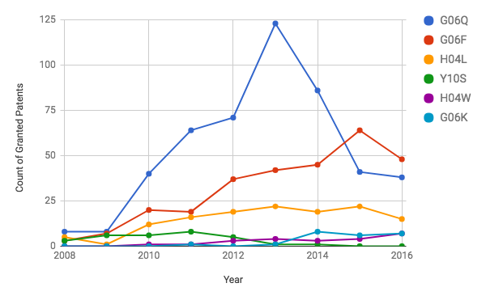

## Table 6. Granted Patents in Top CPC Subclasses per Year

|  |  |  |  |  |  |  |  |  |  |
| --- | --- | --- | --- | --- | --- | --- | --- | --- | --- |
| **CPC** | **2008** | **2009** | **2010** | **2011** | **2012** | **2013** | **2014** | **2015** | **2016** |
| G06Q | 8 | 8 | 40 | 64 | 71 | **123** | 86 | 41 | 38 |
| G06F | 3 | 7 | 20 | 19 | 37 | 42 | 45 | **64** | 48 |
| H04L | 5 | 1 | 12 | 16 | 19 | ***22*** | 19 | ***22*** | 15 |
| Y10S | 3 | 6 | 6 | **8** | 5 | 1 | 1 | 0 | 0 |
| H04W | 0 | 0 | 1 | 1 | 3 | 4 | 3 | 4 | **7** |
| G06K | 0 | 0 | 0 | 1 | 0 | 1 | **8** | 6 | 7 |

The chart in Figure 9 illustrates the number of patents granted between 2008 to 2016 that are assigned to the six most common CPC subclasses in the analyzed portfolio. Table 6 lists the number of patents granted in each of these six CPC subclass per year between 2008 and 2016. Descriptions, total counts, and the percentage of the company’s total patents assigned to each CPC subclass are listed above in Figure 9 and Table 5.

The “Patent Grants per year by CPC Class” data illustrates the portfolio’s technical areas of focus during the years between 2008 and 2016. Overall, the Figure 9 indicates an increase in granted patents from 2008 to 2013, especially in CPC subclass G06Q. After 2013, the number of granted patents in “G06Q” decreased from a peak of 123 to 38 in 2016. This decrease could be indicative of a change in filing strategy post *Alice* since subclass “G06Q” contains patents with a high risk of having patent ineligible subject matter. The decrease in granted patents in “G06Q”, however, is offset by an increase in granted patents in “G06F”. Since G06F is another subclass containing patents with a high risk of having patent ineligible subject matter, a change in filing strategy seems unlikely. On the other hand, patents are also granted 2-3 years after filing therefore the impact of any change in filing strategy would only be seen several years into the future.

# Claim Analysis - Validity Predictions

Claims for all 1,100 patents in the portfolio were analyzed using an ensemble of §101 subject matter eligibility models. The models returned an Invalidity Risk Score for each patent. Risk Scores ranged from 0 to 1 and claims receiving a risk score of 0.8 or higher were classified by the models as Invalid. Four example claims with particularly high Risk Scores are included below in Table 7. The claim text in each of these claims is semantically and contextually similar to other claims given subject matter eligibility rejections under §101 by examiners in office actions mailed after the *Alice* case was decided, June 19, 2014. Accordingly, the claims all have risk scores above 0.92 and are classified by the models as invalid.

## Table 7. Validity Predictions - Invalid Examples

|  |  |  |  |  |
| --- | --- | --- | --- | --- |
| **Patent Number** | **Claim** | **Claim Type** | **Invalidity Risk Score** | **Validity Prediction** |
| US7493281 | 1 | Independent | 0.9513 | Invalid |
| US6944599 | 20 | Independent | 0.9671 | Invalid |
| US7536402 | 11 | Independent | 0.9457 | Invalid |
| US7523114 | 10 | Independent | 0.9268 | Invalid |

As shown in Table 7, claim 20 of US Patent 6,944,599 has the highest Invalidity Risk Score of all claims in the portfolio. The full text of claim 20 is provided below along with a screenshot from IPL’s Maintenance Fee Application displaying the automated claim text analysis performed by the application.

### US6944599 - Claim 20

A system for monitoring irregular activity in network-based transaction facilities, the system including:

means for receiving item data corresponding to completed transactions within the network-based transaction facility, the item data pertaining to multiple items, each of the multiple items having a price-based value;

means for processing the item data at a server communicatively coupled to the network-based transaction facility to identify at least one of the multiple items as being an irregular item falling outside a range defined by at least one predetermined threshold price-based value, the predetermined threshold price-based value being automatically chosen from a plurality of predetermined threshold price-based values based on a category in which the irregular item was auctionedor sold within the network-based transaction facility; and

means for filtering the item data by removing irregular item data that correspond to each identified irregular item.

## Figure 10. Automated Claim Text Analysis - Invalid Prediction

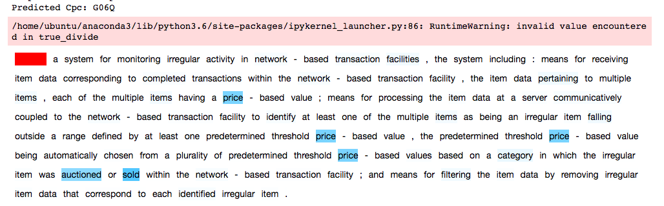

As shown in Figure 10, Claim 20 of US 6,944,599 relates to a computer system for detecting irregular online auctions. The words “price”, “auctioned”, and “sold” are all common in claims within CPC subclass G06Q that received §101 subject matter eligibility rejections. Moreover, patents containing automated systems for determining price have been invalidated post *Alice* including US Patent 6,553,350 in *Versata Development Group, Inc. v. SAP Am., Inc.[21]*  and US Patent 7,970,713 in *OIP Technologies Inc. v. Amazon.com Inc.[22]*. Accordingly, IPL’s Claim Analysis suggests Claim 20 of US 6,944,599 has a high invalidity risk under §101. These machine generated results suggested US 6,944,599 should not be maintained unless it contains claims directed to subject matter different from the system recited in claim 20.

## Table 8. Validity Predictions Valid Examples

|  |  |  |  |  |
| --- | --- | --- | --- | --- |
| **Patent Number** | **Claim** | **Claim Type** | **Invalidity Risk Score** | **Validity Prediction** |
| US7526670 | 1 | Independent | 0.7415 | Valid |
| US7571195 | 1 | Independent | 0.5148 | Valid |
| US7596510 | 24 | Independent | 0.6989 | Valid |

Three example claims with low Invalidity Risk Scores are provided in the Table 8 above. The text of these claims is semantically and contextually distinguishable from claims receiving subject matter eligibility rejections under §101 given in office actions mailed after the *Alice* decision. As shown in Table 8, claim 1 of US Patent 7,571,195 has the lowest Invalidity Risk Score of all claims in the portfolio. The full text of claim 1 is provided below along with a screenshot from IPL’s Maintenance Fee Application displaying the automated claim text analysis performed by the application.

### US7571195 - Claim 1

A method for publishing information to independent software applications operating in a computer system, the method comprising:

detecting occurrence of an event in which a persistent store of data is has been modified;

storing, in a main table of the persistent store memory of the computer system, a new record for each event, each record comprising information relating to the event and a respective next sequential identification code;

preparing a corresponding message for each record of a plurality of records, each message comprising certain information relating to a respective event that is communicated to the independent software applications;

transmitting each message to at least one independent software application of the computer system to publish information relating to corresponding events;

storing, in a shadow table separate from the main table the memory, the respective sequential identification code of the last record published by transmission of a respective corresponding message;

reading from the shadow table the respective sequential identification code of the last record published in a respective corresponding message;

reading from the shadow table a next sequential record having an identification code that is next in a sequence relative to the respective sequential identification code read from the shadow table;

preparing a next corresponding message for the next sequential record; and

transmitting the next corresponding message to at least one independent software application of the computer system to publish information relating to a corresponding event, wherein the next corresponding messages excludes any messages corresponding to any records having a sequential identification code preceding the last sequential identification code.

## Figure 11. Automated Claim Text - Valid Prediction

As shown in Figure 11, claim 1 relates to publishing sequential event information to independent software applications of a computer system. The words “publishing”, “publish”, “published”, “sequential”, “communicated”, “shadow”, “persistent”, and “messages” were all emphasized by the model in classifying claim 1 in CPC subclass G06Q. Moreover, in this context, these words are distinguishable from claims that received §101 subject matter eligibility rejections. The highlighted words suggest this claim recites methods for improving the functioning of a computer system operating multiple independent software applications. Accordingly, claim 1 of US 7,571,195 has a lower risk of being invalid under §101 and should be maintained.

# Reducing Maintenance Cost Case Study

The following section details how to use IPL’s Maintenance Report to identify a target maintenance budget and manage a portfolio to stay within that budget. In this example, in house counsel uses the budget and budget projects in Figures 5 and 6 to identify one short term and one long term maintenance budget goal. The short term goal is keeping the annual portfolio maintenance cost below $500k for the next three years (2017-19) and the long term goal is getting the annual portfolio maintenance cost below $1 million in 2021. The analysis below demonstrates how both maintenance cost reduction goals can be achieved without decreasing portfolio value.

## Figure 12. Maintenance Cost per Year by CPC Class

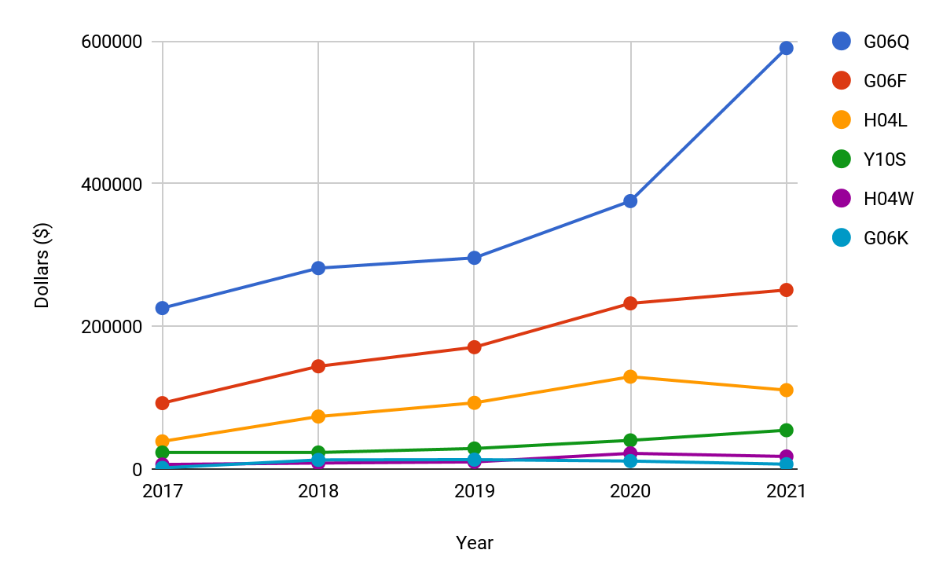

The chart shown in Figure 12 illustrates the annual maintenance costs for maintaining patents classified in the portfolio’s six most common CPC classes. As shown in the chart, most of the portfolio maintenance cost is generated from maintaining patents classified in G06Q and G06F. Both of these CPC classes contain high concentrations of software, business methods, and other subject matter with a high risk of being invalid under §101. Accordingly, the patents generating the majority of the portfolio’s maintenance costs relate to subject matter that has a good chance of being invalidated under §101 if ever litigated or enforced.

## Table 9. Annual Maintenance Costs in Top CPC classes

|  |  |  |  |  |  |
| --- | --- | --- | --- | --- | --- |
| **CPC** | **2017** | **2018** | **2019** | **2020** | **2021** |
| G06Q | $225,600 | $281,600 | $296,000 | $375,600 | $590,000 |
| G06F | $92,400 | $144,000 | $170,800 | $232,200 | $251,000 |
| H04L | $38,800 | $73,600 | $92,800 | $129,400 | $110,600 |
| Y10S | $23,200 | $23,200 | $28,800 | $40,200 | $54,400 |
| H04W | $6,400 | $8,400 | $10,000 | $22,000 | $17,600 |
| G06K | $1,600 | $12,800 | $13,200 | $11,200 | $6,800 |
| Total | $388,000 | $543,600 | $611,600 | $810,600 | $1,030,400 |

Table 9 displays the annual maintenance costs for maintaining patents in the six most common CPC classes. As shown in the table, the majority of portfolio maintenance costs are generated by patents classified in CPC classes G06Q and G06F. As shown in Figure 9 and Table 6, increases in patent filings in both of these classes during 2012- 2014 is the primary factor influencing the increase in portfolio maintenance costs from 2017 to 2021. Patent maintenance fees are backloaded so as the patents in both CPC classes mature from first maintenance fee period eligibility to second and third term eligibility the total cost of portfolio maintenance correspondingly increases.

Due to the high cost of maintaining patents in G06Q and G06F and the elevated subject matter eligibility risk associated with patent claims reciting subject matter in these two classifications, reducing maintenance costs for patents in these two CPC classes seems like the best way to meet the budget goals of bringing portfolio maintenance fees below $500k for the next three years and below $1 million in 2021. Specifically, not paying maintenance fees on half of the patents granted in G06Q and G06F during the peak *Alice* period of 2011-2015 would achieve both budget goals. The analysis below details the savings provided by reducing the the number of maintained G06Q and G06F patents.

## Table 10. Modified Annual Maintenance Cost - CPC G06Q/F

|  |  |  |  |  |  |
| --- | --- | --- | --- | --- | --- |
| **CPC** | **2017** | **2018** | **2019** | **2020** | **2021** |
| G06Q | $225,600 | $281,600 | $296,000 | $375,600 | $590,000 |
| *G06Q\** | *$128,000* | *$212,800* | *$148,800* | *$249,600* | *$370,400* |
| G06F | $92,400 | $144,000 | $170,800 | $232,200 | $251,000 |
| *G06F\** | *$58,800* | *$108,800* | *$87,200* | *$167,400* | *$175,400* |
| Total | $318,000 | $425,600 | $466,800 | $607,800 | $841,000 |
| *Total\** | *$186,000* | *$321,600* | *$236,000* | *$417,000* | *$545,800* |
| ***Savings*** | ***$131,200*** | ***$104,000*** | ***$230,800*** | ***$190,800*** | ***$295,200*** |

Table 10 illustrates the cost savings produced by reducing the number of G06Q and G06Q patents granted between 2011-15 maintained by nearly half from 592 to 299. Rows *G06Q\** and *G06F\** display the updated maintenance cost for patents in CPC classes G06Q/F. These values reflect a 50% reduction the number of maintained G06Q or G06F patents issued during 2011-15.

## Table 11. Modified Counts for Maintained Patents - CPC G06Q/F

|  |  |  |  |  |  |
| --- | --- | --- | --- | --- | --- |
| **Grant Year** | **2011** | **2012** | **2013** | **2014** | **2015** |
| G06Q | 64/32 | 71/36 | 123/62 | 86/43 | 41/21 |
| G06F | 19/10 | 37/19 | 42/21 | 45/23 | 64/32 |
| Total | 83/42 | 108/55 | 165/83 | 131/66 | 105/53 |
| ***Reductions*** | ***41*** | ***53*** | ***82*** | ***65*** | ***52*** |

Table 11 shows the total number of patents granted in CPC class G06Q and G06F every year between 2011-15 against the number of patents maintained in each CPC class under the new budget constraints. For example, in 2013, 123 G06Q patents issued and 42 G06F patents issued. Under the new budget constraints of keeping maintenance costs below $500k for the next three years and under $1 million in 2021, the number of G06Q patents issued in 2013 that can be maintained drops to 62 and the number of G06F drops to 21. In total maintaining 83 of the 165 G06Q/F patents issued in 2013 and abandoning or monetizing the remaining 82 patents keeps the portfolio maintenance costs within targeted goals. Determining which patents to maintain and which to abandon or monetizing in view of §101 subject matter eligibility is the primary goal of the claim analysis provided in the Maintenance Report.

## Figure 13. Projected Budget and Savings for 2017-2021

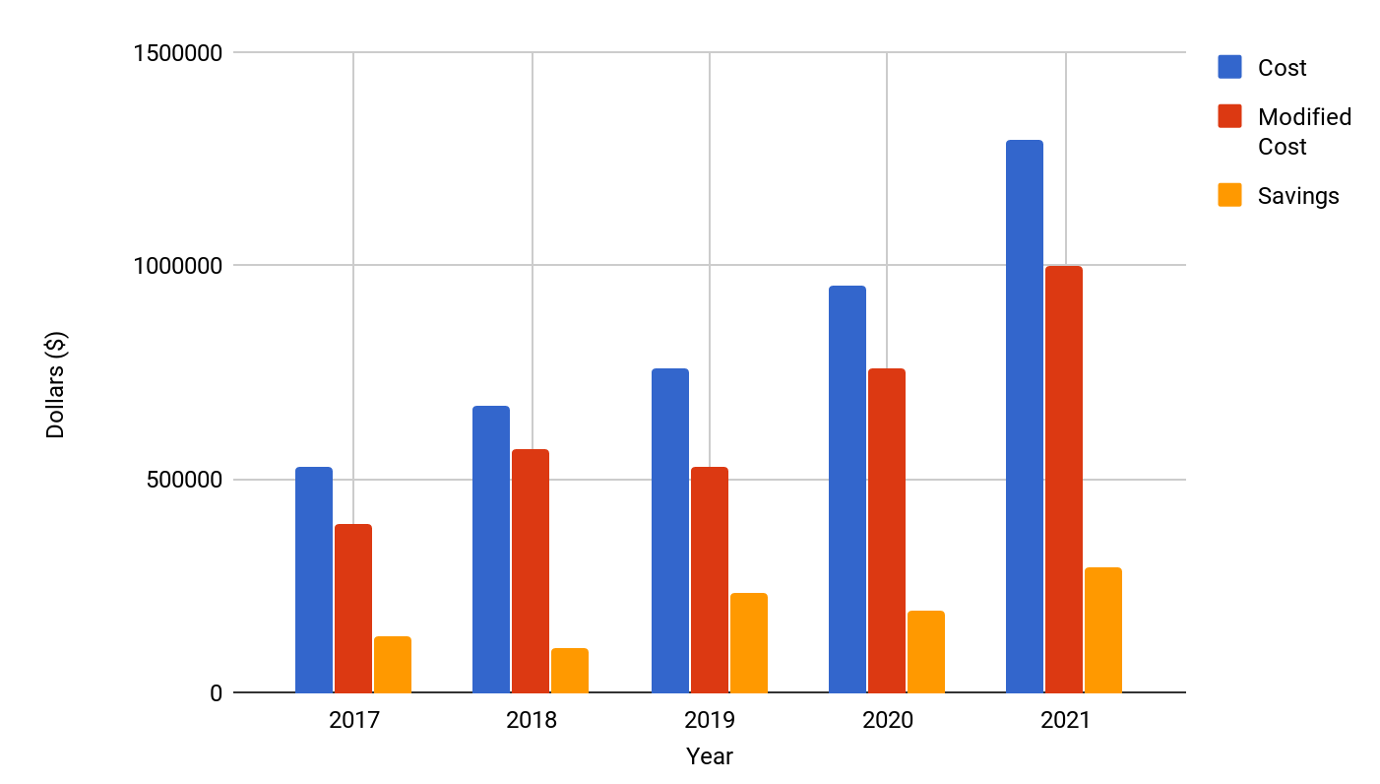

The chart shown above in Figure 13 provides a summary of the actual projected maintenance cost relative to the modified projected maintenance cost. The savings obtained by making 50% reductions in the number of maintained G06Q and G06F patents granted during 2011-15 is also displayed in the Figure.

IP Logic’s Maintenance Report is a tool, patent owners can use to reduce the cost of maintaining a patent portfolio. Portfolio Analysis provides high level annual payment and budgeting information. Combining maintenance fee payment information with technology groupings allows owners to understand the technology generating most of the maintenance costs.

From this high level information, patent owners can set budget goals and identify technical subject areas in need of further analysis. Portfolios with more restrictive budget goals can be pruned using Claim Analysis. Claim language of patents related to software, business methods, medical diagnostics, and other technologies impacted by recent limitations on patent eligible subject matter can be reviewed for risk of invalidity under §101. Patents with high invalidity risk scores and keywords relating to categories of subject matter recently identified as patent ineligible by federal courts and PTAB can be abandoned or monetized. Eliminating patents with a high risk of invalidity under §101 from a portfolio reduces maintenance costs without decreasing portfolio value.

The above example demonstrates one strategy a software company could implement to reduce portfolio maintenance costs by $1 million over the next five years. IP Logic’s Maintenance Report provides tools for developing a portfolio specific strategy that helps businesses set budget goals and achieve them without sacrificing portfolio value.

1. 134 S.Ct. 2347
2. 773 F.3d 1245
3. 822 F.3d 1327
4. 149 F.3d 1368
5. Cite URAA, see Pub. L. No. 103-465, 108 Stat. 4809 (1994).
6. The PTO Fee Schedule is available online at http://www.uspto.gov/web/offices/ac/qs/ope/fee010114.htm.
7. A complete schedule of USPTO fees, including maintenance fees, can be found at:https://www.uspto.gov/learning-and-resources/fees-and-payment/uspto-fee-schedule
8. *See* Jacob Goldstein*, Google Escalates the Patent Arms Race,* Planet Money (Aug. 15, 2011). This is still Google’s biggest ever acquisition. 
9. *See* Colleen V. Chien, *From Arms Race to Marketplace: The Complex Patent Ecosystem and Its Implications for the Patent System,* 62 HASTINGS L.J. 297, 302-03 (2010)
10. *See* Carl Shapiro*, Navigating the Patent Thicket: Cross Licenses, Patent Pools, and Standard Setting, Innovation Policy and the Economy,* Innovation Policy and the Economy, Vol. 1, pp. 119-150(2001) *(defining patent thicket as an overlapping set of patent rights requiring that those seeking to commercialize new technology obtain licenses from multiple patentees:* at 119*)*
11. *See* Michael A. Heller, Rebecca S. Eisenberg, *Can Patents Deter Innovation? The Anticommons in Biomedical Research*, Science Vol. 280, Issue 5364, pp. 698-70 1998)
12. *See https://patents.google.com/patent/US5970479A/en* for full text of patent
13. *See* Jeremy D. Roux, *The Supreme Court and §101 Jurisprudence: Reconciling Subject-Matter Patentability Standards and the Abstract Idea Exception,* U. Illinois. L. R., 629, pp. 629-662 (2014) (*describing how the inventor reeps all the reward while society does not benefit at all when patents are granted on laws of nature, natural phenomena, or abstract ideas:* at 634)
14. *See* Note 1 at pp.3
15. *Id*
16. *See* The United States Patent and Trademark Office’s *July 2017: Interim Eligibility Guidance Quick Reference Sheet Identifying Abstract Ideas* for a complete list of abstract ideas included in patents that were invalidated on subject matter eligibility grounds. Available at: https://www.uspto.gov/sites/default/files/documents/ieg-qrs.pdf
17. *See* The United States Patent and Trademark Office’s *Chart of Subject Matter Eligibility Court Decisions* for a listing of all federal court decisions on patent subject matter eligibility. Available at:https://www.uspto.gov/sites/default/files/documents/ieg-sme_crt_dec.xlsx
18. *See* Reed Tech USPTO Data Portal for bulk downloads of patents and patent applications. Available at: http://patents.reedtech.com/patent-products.php
19. *See* Reed Tech USPTO Data Portal for bulk downloads of Patent Maintenance Fee Events from September 1981 to present. Available at: http://patents.reedtech.com/maintfee.php
20. *See* Reed Tech USPTO Data Portal for bulk downloads of Maintenance Fee Event Codes and Descriptions. Available at: http://patents.reedtech.com/maintfee.php. *See Also* a complete USPTO maintenance fee schedule available at: https://www.uspto.gov/learning-and-resources/fees-and-payment/uspto-fee-schedule#Patent Maintenance Fee
21. 2015 U.S. App. LEXIS 11802
22. 788 F.3d 1359 (2015)