CS 255 System Design Document Template

This template lays out all the different sections that you need to complete for Project Two. Each section has guidance to prompt your thinking. You will need to continually reference the interview transcript as you work to make sure that you are addressing your client’s needs. There is no required length for the final document. Instead the goal is to complete each section based on what your client’s needs are. Remove this note when you are finished, and replace all bracketed text with the relevant information.

UML Diagrams

UML Use Case Diagram
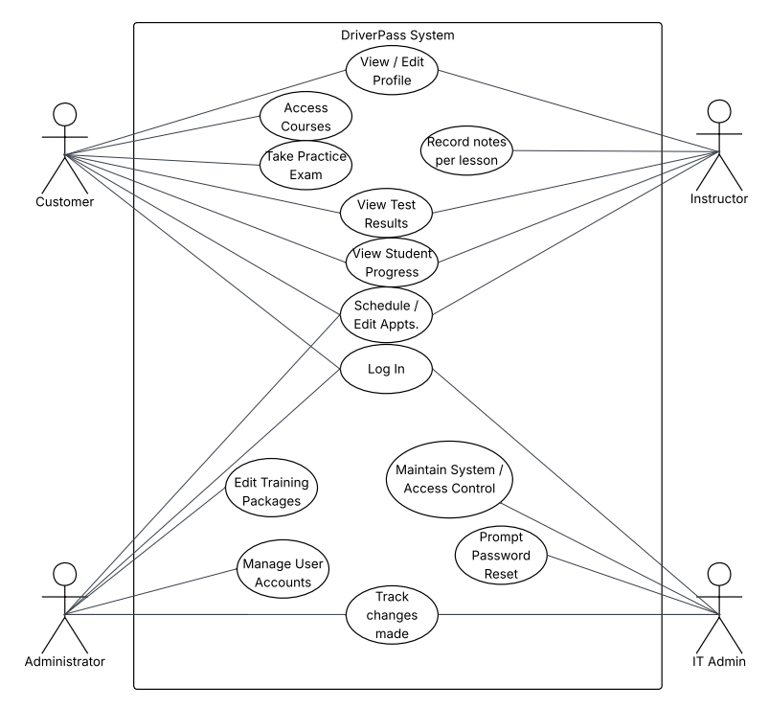

UML Activity Diagrams
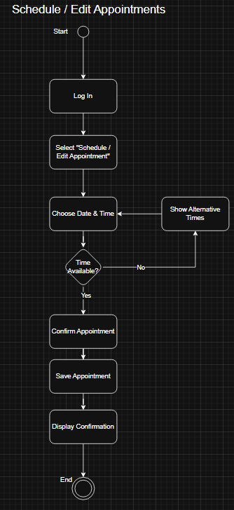

UML Sequence Diagram
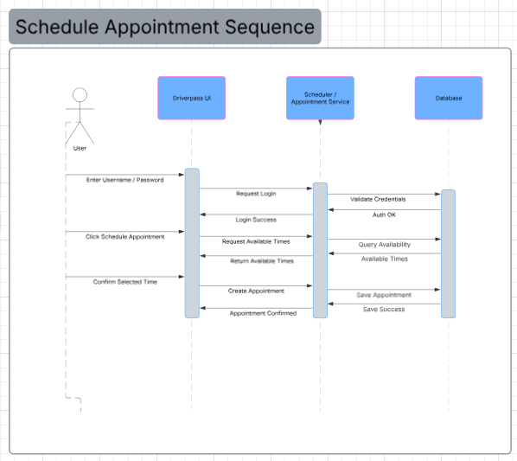

UML Class Diagram
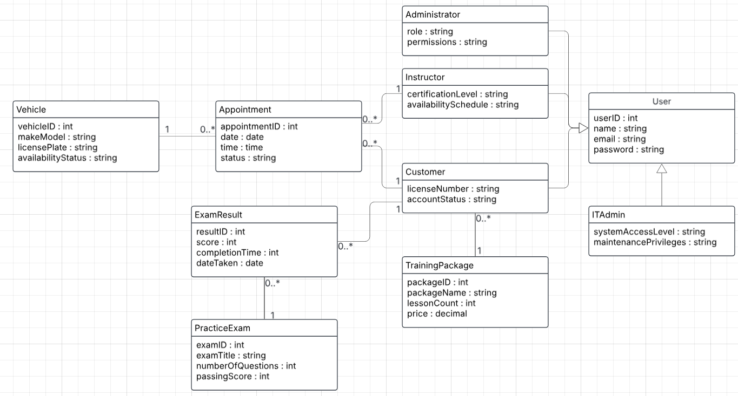

Technical Requirements
The DriverPass system will be implemented as a web-based application designed to support customers, instructors, administrators, and IT staff. The system will require a reliable internet connection and modern web browsers to ensure accessibility across desktop and mobile devices. Users will access the system through a browser-based interface, which will allow them to register accounts, schedule driving lessons, take practice exams, and manage appointments. The application should support concurrent users while maintaining acceptable performance levels.

From a hardware perspective, the system will require cloud-hosted server infrastructure capable of supporting the application server and database server. These servers will manage user authentication, scheduling operations, exam management, and data storage. Client devices such as desktop computers, laptops, tablets, or smartphones will only require internet connectivity and a supported browser to interact with the system.

The software environment will include a web application framework for building the DriverPass user interface and backend services. The system will rely on a relational database management system to store persistent data such as user accounts, appointments, training packages, exam results, and vehicle information. Secure communication protocols such as HTTPS will be required to protect data exchanged between the client and server.

Additional tools and infrastructure will include cloud hosting services for deployment, database management tools for maintaining system data, and development tools used by the software team to implement and maintain the system. Security mechanisms such as role-based access control will be implemented to ensure that different users (such as customers, instructors, administrators, and IT administrators) can only access functions permitted by their roles. Together, these technical components provide the necessary infrastructure to support the DriverPass system and ensure it operates securely, efficiently, and reliably.

