Tyler Iams

5/6/2018

**EDA Report**

Predicting Cancer Based on Mutation Profiles

**Introduction**

The data for this project has thus far been supplied by The Cancer Genome Atlas1. I have collected mutation data for four preliminary types of primary cancer cites: lung, brain, leukemia (bone marrow), and kidney. I have collected data for 400 cases total thus far, 100 cases for each type of cancer. The data collection process has once again been slower than would be preferable, but a reliable collection system has now been established. For each of the 400 cases I have three predictors:

1. gene – the name of the gene that has been mutated.
2. genomic _dna_change – the specific base-pair in the genome that was mutated.
3. chromosome – the chromosome that the mutation has occur upon.

**Exploration**

The first thing I did was explore the prevalence of mutations within each cancer type. I had an idea of the layout but felt it necessary to summarize it so it could be used to standardize the data later on:

Table 1

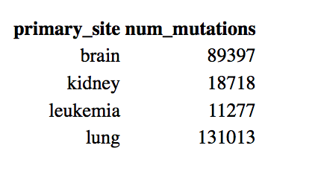

*Table 1: Lung appears to have the most mutations, while leukemia has the least.*

Plot 1

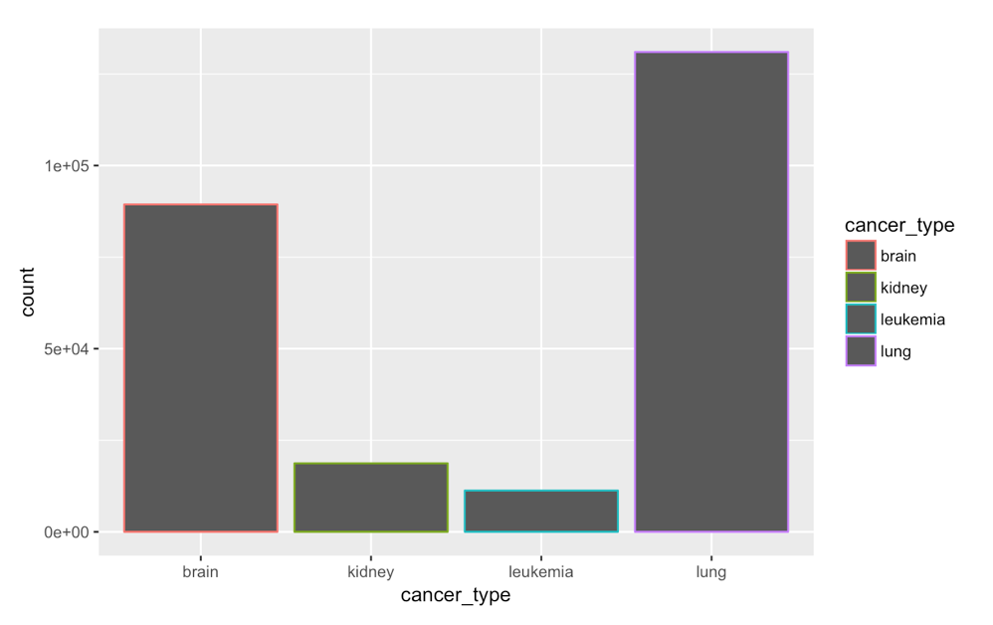

*Plot 1: Another view of the data layout, lung being the most prevalent*

Next, it was important to understand which mutations were the most prevalent while the data was grouped by cancer type. To do this, I first filtered out all of the “genomic_dna_change” data, as this caused thousands of duplicates in the “gene” field. Next, I created a field called “proportion” by calculation the prevalence of each mutation within each cancer type. This way, I was able to see that “kidney” and “leukemia” seemed to have mutations at a higher proportion than “brain” and “lung.” This is shown by Plots 2 through 5:

Plot 2

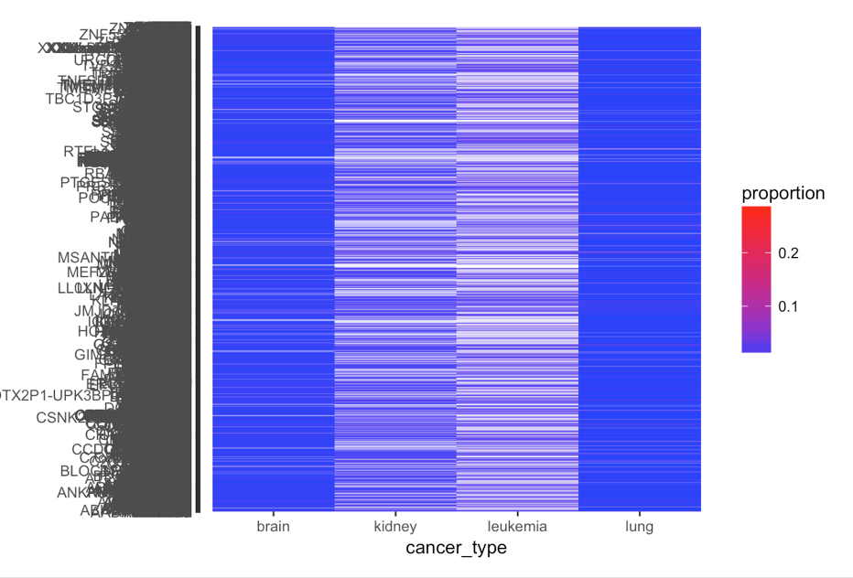

*Plot 2: The y-axis is a list of all the different mutations, and unreadable.*

Plot 2, though messy, can tell us a surprising amount of information about the dataset. The color blue indicates mutations that occur at a low rate, and the depth of the fill explains that there are a lot of mutations that occur at a low rate within patients with lung and brain cancer, while in patients with kidney cancer and leukemia it can be seen that there are fewer mutations that occur a lot within that population. This could be a key observation while modeling, as mutations for leukemia and kidney cancer may be more telling than those of lung and brain.

Zooming in a little bit on this find, I created Plot 3:

Plot 3

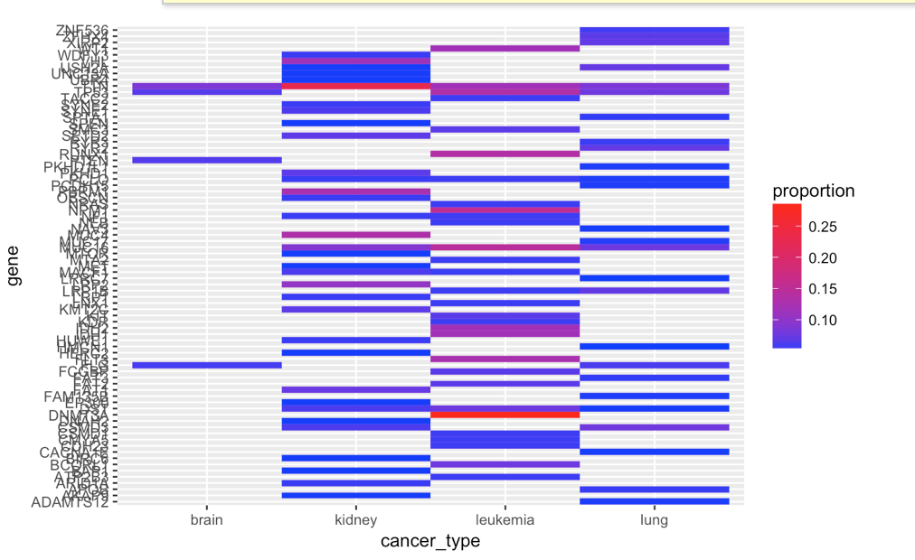

*Plot 3: The names of the mutated genes are illegible, however the plot is telling once again.*

In Plot 3 it can again be seen that mutations that occur at a high rate within patients with leukemia and kidney are more common than mutations that occur at a high rate within lung, and they are even less common in brain. One final zoom is shown by Plot 4:

Plot 4

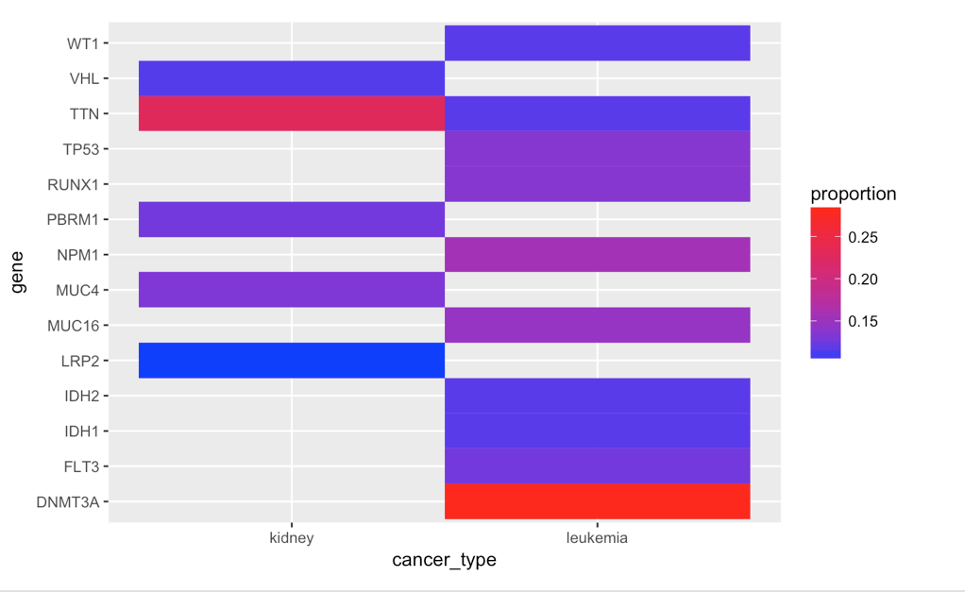

*Plot 4 shows the mutations that occurred at the highest proportions (over 10%) in patients of the various cancer types. It can be seen that patients with leukemia have the most in common in terms of their mutations*

The final step in my exploration was the final step necessary to create models, and that was to create mutation profiles. This was a much larger undertaking than expected, and required a lot more computing power than I had expected. However, I now have (saved to disk), a mutation profile for each patient that I can begin modeling with. I believe I will be able to predict certain types of cancer, possibly “leukemia” vs “not leukemia,” with some accuracy.

Citation

1. The National Cancer Institute, (2018). The Genomic Data Commons Repository. https://portal.gdc.cancer.gov/repository.