

***Poppies in the Wind*, by Artist Verodalla**

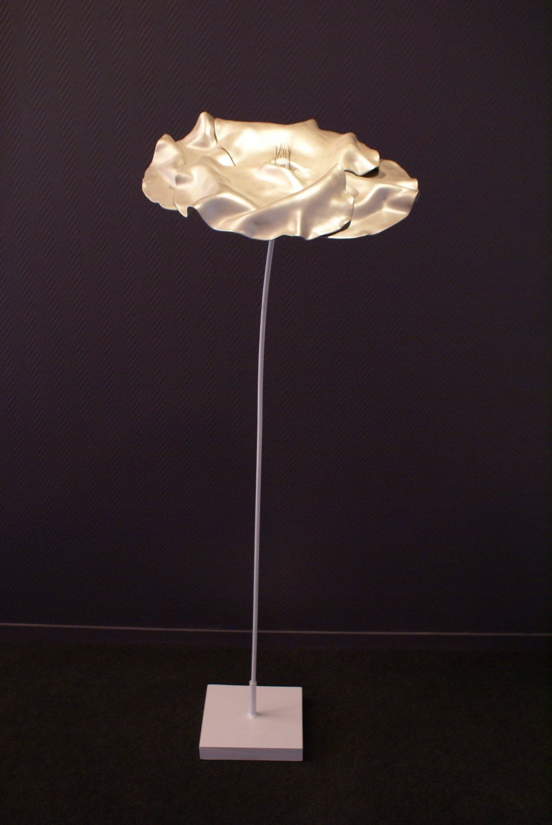

Verodalla Sculpture Silver Poppy *Poppies in the Wind* (please note: Base will be black) Technical cellulose fiber and chalk, mixed media, metal rod Color: silver flower, stem white, black base Size: approximately 17'' in diameter and 60'' high Weight: about 22 kg  Numbered with certificate of authenticity

[Verodalla's](http://verodalla.com/) world is a reflection in volume, a choice of materials, and a well thought-out color palette. Each canvas reveals a universe and reflects a sober, refined, soothing, cheerful, simple, and sometimes obvious atmosphere. Verodalla’s creations offer harmony and purity, escape and balance; a sensation of well-being predominates in the artist’s work. Verodalla’s art was triggered by a technical revelation: a mineral paste made of chalk and cellulose fibers. She recalls a personal impression or feeling fixed in her mind and couples it with an image that caught her attention. She then conceptualizes the canvas or sculpture inwardly until she feels compelled to create the material object.

**Terms:** Please note: base will be in black, not as shown in picture. Sculpture in condition as donated. **Additional shipping may apply based on winner's location**. Cannot be resold or re-auctioned.

**Shipping and Handling** The minimum shipping, handling and applicable insurance for this item is $39.95. Additional shipping charges may apply based upon the location of the winner. Hard copies of tickets, travel certificates and merchandise are shipped via FedEx or professional shipping service. Detailed redemption information for non-tangible items will be emailed to the winning bidder.

**Donated by:** Verodalla

[Learn more about Action Against Hunger 2011 Online Auction](http://www.charitybuzz.com/auctions/ACF)