**Getting up and running following one of my samples.**

**Note:** UofL students have access to VS and SSMS through DreamSpark..use that instead of following the links I provide!

**Install Visual Studio 2017**

1. Go to <http://www.visualstudio.com/downloads>
2. Select a version of Visual Studio to download **Note:** Visual Studio 2017 Community is free!
3. Download the installer
4. Launch the installer
5. Select the type of installation
6. **Select the "Web Development" option under Web & Cloud ONLY!**

[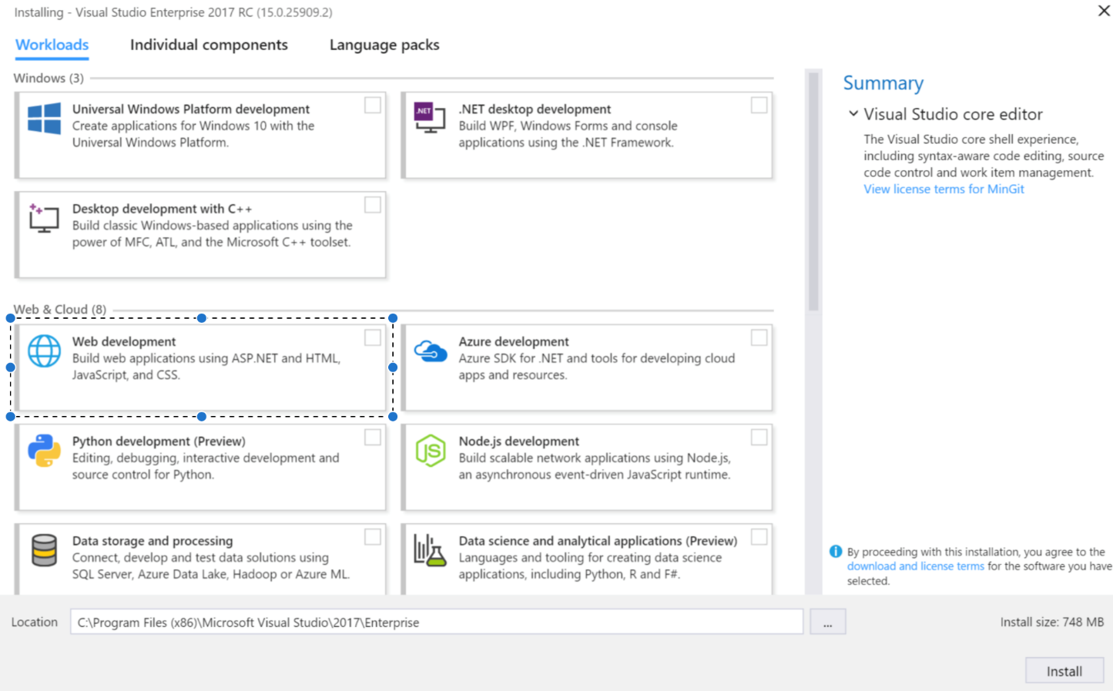](https://github.com/tylerablake/samples/blob/master/vs2017Installer.png)

1. Click Install

**Installing SQL Server Management Studio 2014**

1. Go to <http://docs.microsoft.com/en-us/sql/ssms/download-sql-server-management-studio-ssms>
2. Download the most up to date version of SQL Server Management Studio 2014
3. Run the installer
4. If the installer fails for .NET Framework 3.5 with Service Pack 1 follow steps 4a-4d:

4a. Go to <http://www.microsoft.com/en-us/download/details.aspx?id=22>

4b. Hit download

4c. Run the file to install .NET Framework 3.5 with SP 1 on your machine

4d. Hit "retry" or something like that on the installer..

1. Once the installation finishes proceed.
2. Follow the "Checking SqlLocalDb Configuration" section
3. Open SSMS 2014
4. Follow the "Connecting to LocalDB from SQL Server Management Studio" section below

**Checking SqlLocalDb Configuration**

1. Open command prompt (Hit "Windows key" then "cmd" then "enter".
2. Enter "sqllocaldb" then hit "enter"
3. If you see the following error text: "'sqllocaldb' is not recognized as an internal or external command, operable program or batch file."

You need to install SqlLocalDb on your machine, click the following link:

For Sql Express 2014 - http://www.microsoft.com/en-us/download/details.aspx?id=42299

or

Google "sql server express download" and select the version you want.

Hit the download button

Open the file

Click "yes" to allow the app to make changes to your device.

When prompted for installation type, select the "Download Media" option.

Then, Select "LocalDB"

Hit "Download"

Then browse to the folder that the installer was downloaded to.

Double click on the installer to open the installation wizard and follow the prompts.

1. After installing close open terminal windows and start back at step 1.
2. If you don't see the error text anymore, SQL Express is installed on your machine but we must verify the configuration now.
3. Run 'sqllocaldb info' in command prompt.
4. If you see the output 'MSSQLLocalDB' then SQL Express is installed and configured correctly for Entity Framework.
5. If you do not see 'MSSQLLocalDB' in command prompt then you must create an instance

Run 'sqllocaldb create MSSQLLocalDB' in command prompt, then run 'sqllocaldb info' and see that 'MSSQLLocalDB' shows up.

**Connecting to LocalDB from SQL Server Management Studio**

1. Click connect in the Object Explorer window
2. Select “Database Engine” from the drop down options
3. Make sure the data in the “Connect to Server” window matches below
4. Click “Connect”

Server Type : Database Engine

Server Name : (LocalDb)\MSSQLLocalDB

Authentication : Windows Authentication