Tyler Coppenbarger

Systems Concepts Games and Media

Old Performance Report:

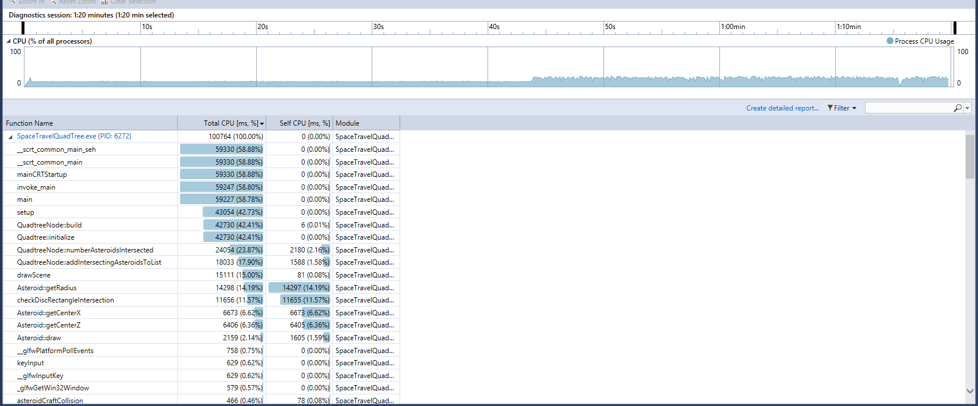

New Performance Report:

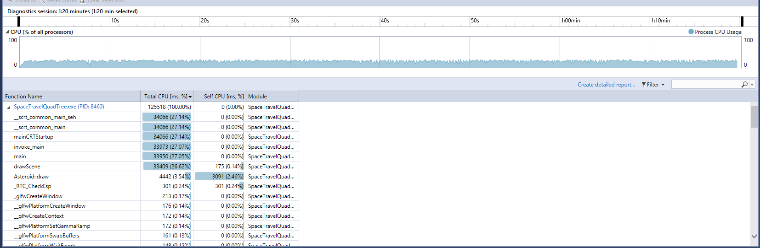

I took the liberty of making the program last the same amount of time for both times for comparison. It’s not obvious due to that but the loading time, which was originally around 45 seconds is now completely gone. However, I was not able to efficiently speed up the actual running of the program. I tried to move the two calls of asteroid.draw() to one loop instead of two, but the added cost of moving the camera for that didn’t improve anything.

I made several changes to improve the program. There were 2D loops at line 260, 340, 450, and 524 in spaceTravelFrustumCulled and lines 24 and 39 in QuadTree. I also added two instrinsics at line 339 in spaceTravelFrustumCulled. I made one more small change and that was to add memorization to the CreateSphere function by saving the sin and cos values that are consistently reused during initialization. All of these changes were very minor in terms of time and almost unnoticeable on the performance report. However, I did make one major change. Originally, two functions named numberAsteroidIntersected and addIntersectingAsteroidToList were called immediately after each other and both looped through every asteroid. I simply combined them by adding the asteroids to the list in numberAsteroidIntersected (which also returned the number of added asteroids). This made a massive improvement to the initialization time, almost entirely eliminating it.

One part of the program I didn’t change was anything around actually drawing the asteroids. I attempted to improve it, but any attempt to limit the amount of loops made no major improvement, if any.