Tyler Coppenbarger

Systems Concepts Games and Media

My name is Tyler Coppenbarger and this is my practice report. The program I chose, which is the program from class, is designed to draw asteroids, symbolized by spheres in set positions, and a spaceship, symbolized by a cone. The spaceship is moveable with the arrow keys and has collisions with the asteroids to prevent the spaceship from turning or moving in a way that would intersect with an asteroid. There is also a frustrum culling feature, where the player can press a button to enable or disable frustrum culling.

The program uses two unique structures to handle the asteroids. There is a global 2d array of asteroid objects which represent the total amount of asteroids in the scene. There is also a quadtree of asteroid objects, which represent the asteroids to be drawn using frustrum culling. The main program continuously draws the scene each frame in a loop, which then calls each asteroid object’s draw function.

According to the performance profiler, the asteroid object’s draw function seems to take up a bunch of time, as does quad tree’s draw function, at least after initialization. During initialization, the quadtree functions numberAsteroidsIntersected and addIntersectingAsteroidsToList seem to take up a good amount of time. These, along with the generic checkDiscRectangleIntersection, which is also a time-consuming function, seem to be related to getting the asteroids to draw in frustrum culling. There are also a handful of asteroid functions, getRadius, getCenterX, and getCenterY, that also take a bunch of time during initialization.

The program is tested in visual studio, using the performance profiler, to detect the time each aspect of the program takes. The program can also be tested with selective debugging, to see what removing certain lines does to the program, to reverse engineer what they do.

Performance Profiler (Initialization only):

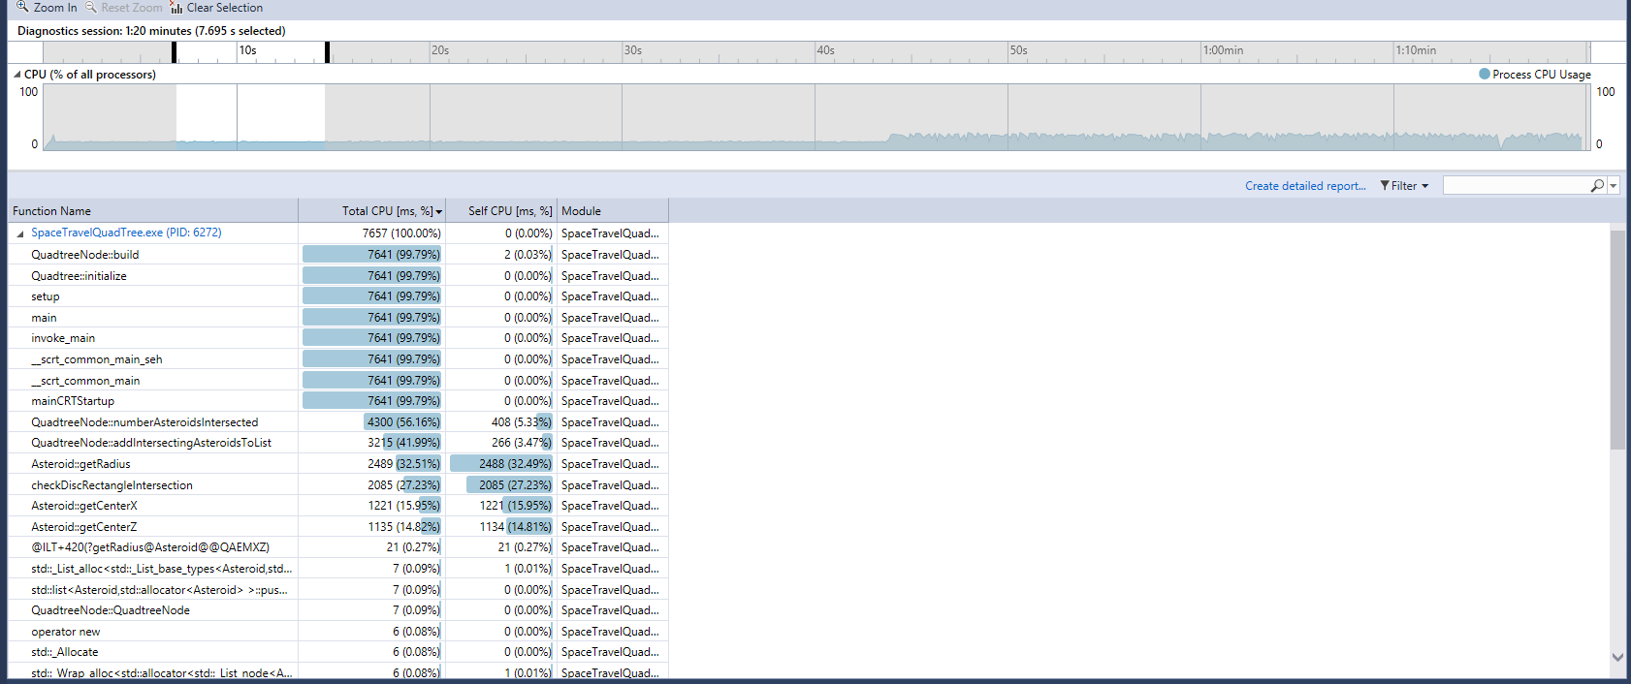

Performance Profiler (Drawing only): 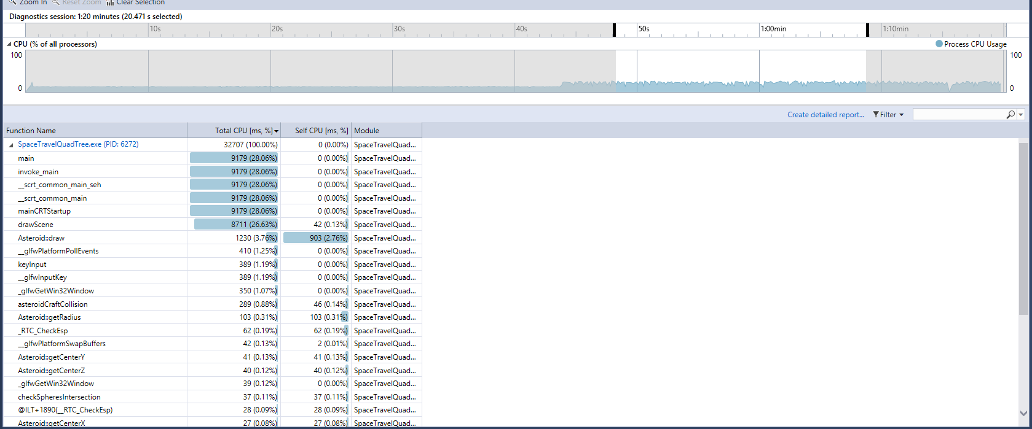

Performance Profiler (All): 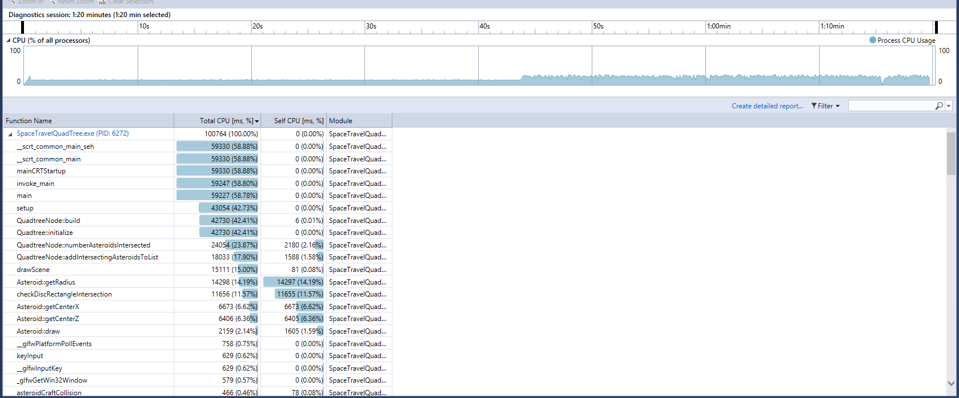

Profiling Report: