|  |  |
| --- | --- |
|  | Applications of Lidar in Tracking Glacial Processes |
|  |  |
|  | Tyler Gates  EES:3020  12/20/19 |

Table of Contents

Introduction 2

Review of Methods 4

Conclusions 9

References 10

# Introduction

Lidar, short for light detection and ranging, is a technology which can provide 3D spatial information at extremely high resolution and accuracy (*Kevin, et al., 88*). This product implements lasers which reflect off a mirror in the device. These lasers are timed from extrusion to return; the time from which laser bounces off an object and returns to the device helps determine how far away a specific point is. Along with the laser, there is usually an internal GPS system and an IMU in order to adjust measurements for movement and possible tilting of the device. This point is saved in space using a 3D coordinate system and aggregated with others in order to create a digital representation of the surrounding space (*Xiaoye, 31*).

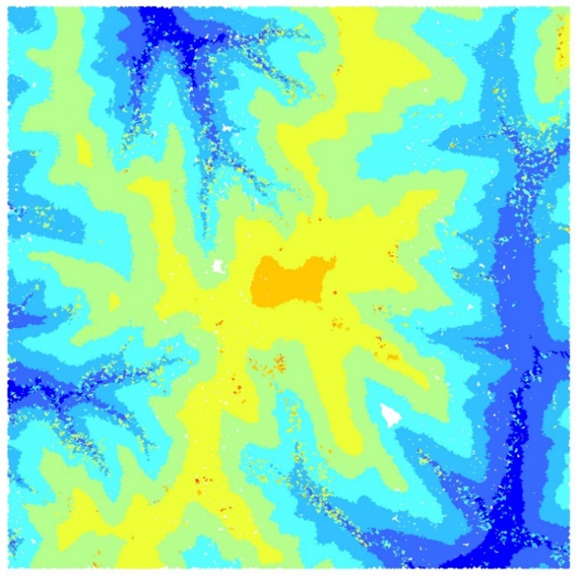This technology was first inspired by the use of echolocation in aquatic mammals and bats, and has evolved greatly over the past century. What began as shooting lights into the sky for exploring and studying the atmosphere (*Gregersen, 2016*), it has turned into a widely-used laser-based aerial and terrestrial measurement source. Its primary uses are geologic mapping (Digital Surface Models), agricultural implementations, forestry and watershed analysis (*AGI, 2018*). These measurements are typically taken from a plane or helicopter, but can also be used in terrestrial settings, such as on foot or mounted on land-based vehicles. These scanners can be used in a range of fields, including construction, historical preservation and city planning. In the past decade, the use of Lidar technology has been on the rise in the field of glacial processes as well (*Telling, 2017*).

Figure : Example of a lidar scan. This is part of Clear Creek, IA collected by the Iowa Lidar Mapping Project.

Glaciers make up about 10% of the globe’s land cover, and are one of the largest driving forces in surface changes throughout history. Glacial processes include the changes a glacier makes to the land it travels over, as well as the changes in physical properties of the glaciers themselves (*BBC Bitesize*). Erosion, deposition and sediment transport are some of the major processes in which a glacier can make changes to the Earth (*Zhu, 2018*); these landforms account for many of the grand changes found in the Earth’s geology and topology throughout history (*Karasiewicz, 2014*). Tracking and studying these Earth-changing processes allow us to understand how our planet has been changed and influenced by these features. An example of these glacial changes would be the landscape of the Midwest. There are stark differences in the landscape between different regions of this area, and almost all of them are due to glacial processes (*Nast, 2014*). The great lakes’ formation were assisted by the melting of and erosion from massive ice sheets, which define the region as we know it (*Damery, 2004*). They provide much of the northern US with fresh water, and provide a passageway for trade and commerce. Glacial processes do not only affect the landscape, but the glaciers themselves as well. They are constantly changing; as glaciers retreat and advance, they are melting and refreezing, which changes the physical landscape beneath and surrounding them at the same time. There are cracks constantly forming, internal fluvial systems, and more which change the size, shape and movement of the glacier; these changes can be tracked and investigated with the help of lidar.

The purpose of this review is to investigate the implementation of lidar in the tracking of glacial changes. The changes which can be measured by this technology can include mass balance changes, fluvial deposits, sediment distribution and seasonal surface melting. The implementation of lidar in this field is relatively new, as there have been large advances in the uses and accuracy of this as of very recently. The possible implementations of lidar are still being discovered, and this is a prime example of doing so.

# Review of Methods

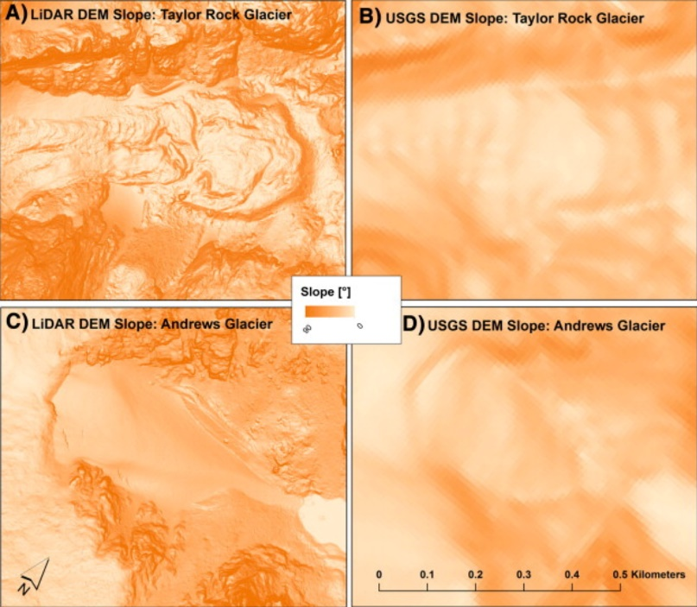The first methodology of tracking glacial changes we will be analyzing is its use in assessing the Taylor Rock Glacier ad Andrews Glacier in Rocky Mountain National Park. This study was created by Jason R. Janke of the Metropolitan State University of Denver. This study was carried out using data from an Optech Scanner in 2010, which was taken from an airplane over the park. The scans were then overlaid on top of orthophotos of the area from 1999, taken by the USGS. This study was done in order to compare the accuracies of a DEM created by data taken by a lidar machine at 1m resolution and a DEM created from the USGS aerial images. It was also done in order to compare physical features of each glacier type, according to the most accurate data type. Both DEMs were interpolated using ArcMap and compared using zonal statistics. The findings had shown that the overall surface of the glaciers were better represented by fine-resolution lidar data, rather than the interpolation based off of orthophotos. Because of this, the lidar data was used to compare the 2 glaciers. The findings had shown that the Rock Glacier had an overall “rougher” topography based on slope changes, as well as a higher range of vertical changes. This outcome changes when using the USGS data, as the DEM resolution is far lower and less meaningful than the lidar-derived data. Overall, the data seems to show that the Taylor Rock Glacier has an overall rockier, rougher and steeper shape than the Andrews Glacier which appears to be smooth and relatively flat. This conclusion would not have been able to be deduced from the USGS data, which is the most readily-available for public use. It fails to capture microtopology, which is fairly important when measuring subtle changes in glacial size and shape (*Janke, 2013*).

Figure : DEMs from both USGS and Lidar data. This highlights the stark difference in quality due to resolution differences.

This study points to a larger issue – the lack of high-resolution lidar data of important geophysical characteristics. The 1m resolution which this study was comparing USGS data against was collected by a private agency, and most likely had to be paid for. If a local agency or government needs to run terrain analyses on an area of interest, the results they would receive would be fairly inaccurate due to this issue. Many of these programs simply do not have enough money to hire an outside faculty or buy the means to get this data themselves, and need to rely on what the USGS may have for them. However, with a drop in funding all around to the USGS (*AIP, 2018*), this data would be difficult for the agency to obtain. In the future, this problem can be easily resolved by increasing funding for the USGS back to what it originally was, and make higher-resolution data available to the public on a wider scale. I believe this study was important in showing the physical differences between the 2 glaciers, as well as highlighting the differences in which the data’s resolution can make on the results of analysis. The findings of this study can lead to further developments in the preservation of glaciers, as different types have different sizes and shapes. These topics could include changing areas of interest for explorers and tourists to minimize mass loss (*Xuling et al, 2006*), predicting mass wasting events stemming from glacial melt and deposition and predicting where new glaciofluvial routes will be located on the faces of these features.

The next study we will be looking at is the use of lidar in the measuring of seasonal surface melt in a temperate Alpine glacier by Chrystelle Gabbud, Institute of Earth surface Dynamics. This study used a terrestrial lidar scanner, a RIEGL VZ-6000 mounted on a tripod. This instrument was used due to its ability to produce high-quality scans at high distances; according to the article, up to 6000m away. The area of interest was the Haut Glacier d’Arolla in Switzerland. Measurements were taken of snow cover at a distance of 3000m and 1000m from the scanner at an interval of 12 hours. The results of this study concluded that the glacial melts occurring in July and August are similar to each other, and then decrease in similarity & intensity during the seasonal transition months. The time of day did not seem to increase or decrease the melting rate over the duration of the study area – however, on the warmest day of the year, the melting rate increased slightly (*Gabbud, 2015*). It seems that the type of scanner used, which use wavelengths of lasers which are able to measure snow and ice reflection, are fairly useful when measuring snow cover and snow melt.

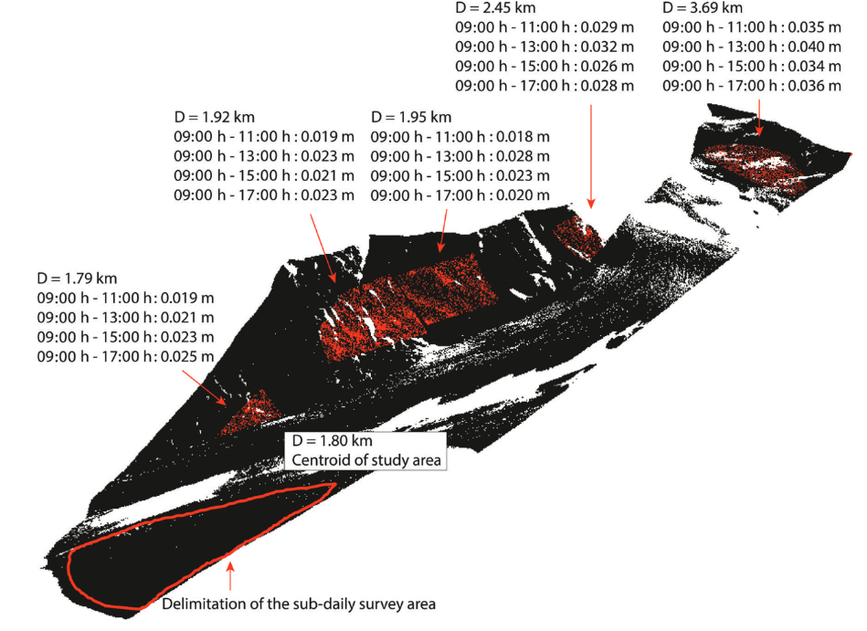I believe that the use of a terrestrial lidar is a reasonable idea, but may not be the most effective. Lidar machines have become smaller and more accurate than ever before in the recent past, such as the Velodyne Lidar Puck (*Velodyne Lidar*). These more portable designs allow for more applications, such as drones or attached to backpacks. In this case, access to one of these smaller lidar designs and a cold-weather drone may have greatly increased the accuracy of the study, as well as increase the number of study area options which would be available. These types of drone applications have been around since the time of the study (*Tang & Guofan, 2015*), however the options of lidar technology and drone options were not as cheap or readily available as they are currently. Another limitation of this study was the fact that flux effect in ice were not accounted for. This is mentioned in the discussion section, and claims to have possibly altered the correct heights of the glaciers. In future studies on similar topics, this should be addressed in order to make the accurate findings possible. Ice can fluctuate in size depending on the season, and can appear to make a sizable difference in measurement when comparing seasons such as this.

Figure : An example of lidar scans taken for this study. Values displayed are mean errors at a sub-daily time scale.

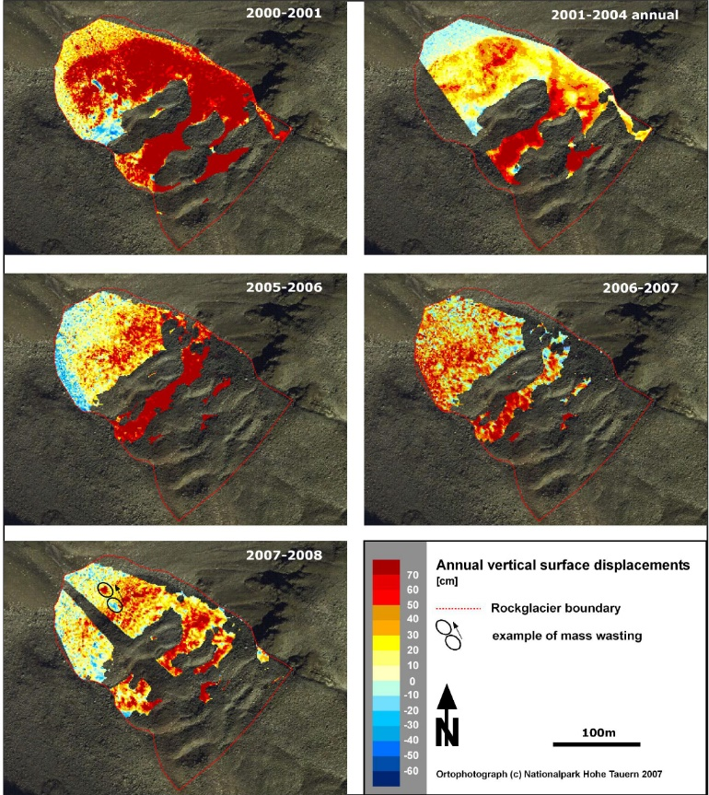Another study we will be analyzing is one concerning the use of lidar to monitor movements in permafrost environments located in Australia. The study area is the cirque Hinteres Langtal, and was preformed by M. Avian from the Graz University of Technology. This took place over the course of 8 years, between 2000 and 2008. The scanner used in the study was a RIEGL LPM-2K mounted aerially in a plane. The orientation of the sensor is recorded so that the measurements taken each year are replicable, and the same sensor is used throughout all 8 years in order to maintain consistency in accuracy and precision of the sensor. DTMs are created for each year of concern, and differences are created from each one in order to find the changes in elevation. According to the results and the example scans in Figure 4, the glacier has been shrinking at a fairly steady pace over the study period. The surface elevation change, indicated by the gradient scale, had steadily decreased every year in the northern and north-western region of the rockglacier. The only elevation increase which seemed to have occurred consistently is in the southern region of the feature (*Avian et al, 2009*).

Figure : Annual vertical surface displacement, or shifting material on a glacial face.

This study has much room for improvement if applied with modern techniques and technologies. A plane-mounted lidar scanner is still an appropriate method for collecting data over an area of this size. However, it can only be so effective due to shadowing and overlapping in surface materials. This is the reason for so many gaps in the data. After the data has been processed, areas of missing data can be identified and supplemented with a tripod-mounted terrestrial lidar scanner. This can be easily replicated by supplementing the scans from the same locations of each scan every year, as the same locations are likely to have shadowing if the plane’s route is identical every flyover. It does not seem as if the flux in glacial ice is taken into account in this study, either. Due to climate change, this may also have an effect on the accuracy in actual elevation change. For future studies with the same concentration, a drone may be more effective. There have been small 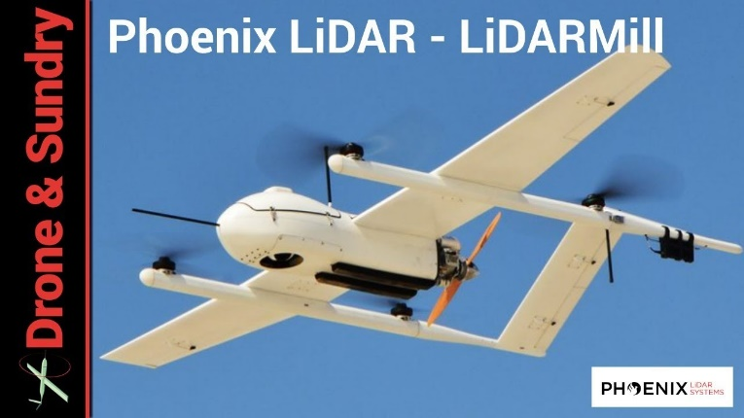aerial drones which act similarly to planes, and have lidar scanners mounted to the bottom of them. These can orient the scanner properly in an automatic fashion and have flight plans uploaded directly to their software, making replicability much easier and cheaper overall. This would also take less time to scan an entire area, as you would not have to worry about refueling the plane or setting up a complex lidar system inside of a small plane. Environmental conditions could play a bigger role in the ability to fly, however.

Figure : An example of a drone plane-mounted lidar from Pheonix Lidar Systems.

# Conclusions

There have been many applications of lidar in the field of glacial geomorphology, and there are more discoveries and methods to be found in the near future. Past studies have been limited mainly by funding and technology of the time period; there have been leaps and bounds in the advancement of lidar tech, and continues to become less expensive every year. With this new technology, such as more capable and a wider range of drones, the applications of this tech are nearly limitless in this field. Some future applications could include the mobile mapping of internal fluvial structures inside glaciers, such as eskers. These are typically dangerous to explore and can only be studied at certain times of the year in order to be as safe as possible. With mobile lidar platforms and RC vehicles, the internal structures of these glacial features can become cheaper, timely, and much safer in the long run. These are just some of the bountiful application of this technology, which will continue to improve over the years to come.

# References

* Avian, M., et al. “LiDAR for Monitoring Mass Movements in Permafrost Environments at the Cirque Hinteres Langtal, Austria, between 2000 and 2008.” *Natural Hazards and Earth System Sciences*, vol. 9, no. 4, July 2009, pp. 1087–1094., doi:10.5194/nhess-9-1087-2009.
* Damery, Krista. “Formation of the Great Lakes.” *Formation of the Great Lakes*, Emporia State University, 2004, <http://academic.emporia.edu/aberjame/student/damery1/gl_form.html>.
* “FY19 Budget Request: USGS Again Faces Double-Digit Cuts to Research.” *American Institute of Physics*, 13 June 2019, <https://www.aip.org/fyi/2018/fy19-budget-request-usgs-again-faces-double-digit-cuts-research>.
* Gabbud, Chrystelle, et al. “Lidar Measurement of Surface Melt for a Temperate Alpine Glacier at the Seasonal and Hourly Scales.” *Journal of Glaciology*, vol. 61, no. 229, 2015, pp. 963–974., doi:10.3189/2015jog14j226.
* “GeoTree.” *Iowa Lidar Mapping Project*, University of Northern Iowa, 2007, <http://www.geotree.uni.edu/lidar/>.
* “Glacial Processes - Glacial Processes and Landforms - AQA - GCSE Geography Revision - AQA - BBC Bitesize.” *BBC News*, BBC, <https://www.bbc.co.uk/bitesize/guides/zxn87hv/revision/1>.
* Gregersen, Erik. “Lidar.” *Encyclopædia Britannica*, Encyclopædia Britannica, Inc., 13 Oct. 2016, <https://www.britannica.com/technology/lidar>.
* Janke, Jason R. “Using Airborne LiDAR and USGS DEM Data for Assessing Rock Glaciers and Glaciers.” *Geomorphology*, vol. 195, 2013, pp. 118–130., doi:10.1016/j.geomorph.2013.04.036.
* Karasiewicz, Mirosław T., et al. “The Record of Hydroclimatic Changes in the Sediments of a Kettle-Hole in a Young Glacial Landscape (North-Central Poland).” *Quaternary International*, vol. 328-329, 2014, pp. 264–276., doi:10.1016/j.quaint.2013.09.045.
* “Lidar Solutions.” *Phoenix LiDAR Systems*, <https://www.phoenixlidar.com/solutions-overview/>.
* Lim, Kevin, et al. “LiDAR Remote Sensing of Forest Structure.” *Progress in Physical Geography: Earth and Environment*, vol. 27, no. 1, 2003, pp. 88–106., doi:10.1191/0309133303pp360ra.
* Liu, Xiaoye. “Airborne LiDAR for DEM Generation: Some Critical Issues.” *Progress in Physical Geography: Earth and Environment*, vol. 32, no. 1, 2008, pp. 31–49., doi:10.1177/0309133308089496.
* Liu, Xuling, et al. “Development and Conservation of Glacier Tourist Resources—A Case Study of Bogda Glacier Park.” *Chinese Geographical Science*, vol. 16, no. 4, 2006, pp. 365–370., doi:10.1007/s11769-006-0365-y.
* Nast, Phil. “The Teacher-Friendly Guides to the Earth Science of the United States.” *NEA*, Paleontological Research Institution, 2014, <http://www.nea.org/tools/lessons/66053.htm>.
* “Puck™.” *Velodyne Lidar*, <https://velodynelidar.com/products/puck/>.
* Tang, Lina, and Guofan Shao. “Drone Remote Sensing for Forestry Research and Practices.” *Journal of Forestry Research*, vol. 26, no. 4, 2015, pp. 791–797., doi:10.1007/s11676-015-0088-y.
* Telling, Jennifer, et al. “Analyzing Glacier Surface Motion Using LiDAR Data.” *Remote Sensing*, vol. 9, no. 3, 2017, p. 283., doi:10.3390/rs9030283.
* “What Is Lidar and What Is It Used for?” *American Geosciences Institute*, 13 June 2018, <https://www.americangeosciences.org/critical-issues/faq/what-lidar-and-what-it-used>.
* Zhu, Tongxin. “Glacial Processes and Landforms.” *Glacial Processes and Landforms*, University of Minnesota, 2018, http://www.d.umn.edu/~tzhu/geog1414/glacial.htm.