

**CSE 394- Spring 2016**

**In-Class: Lab 2**

**10 Points (Due: Tuesday 2nd 11:59 pm)**

**Objectives:**

1. Further enhance the knowledge about using storyboard to develop multi-view iPhone apps
2. Pass data among views.

**Lab :** During this lab, we will develop a weather forecast message propagation scenario. Once the app is completed, it will have three views as shown below. The second view gets the message from the first view and adds its own version to the message and passes the message to the third view. The third view gets the message from the second view and appends its own version to it and display.

Expected output:

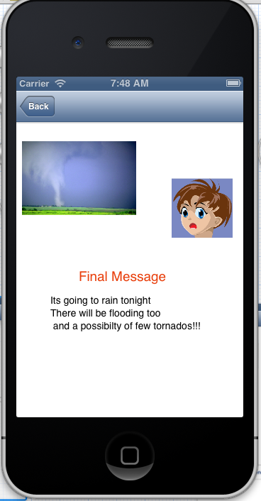

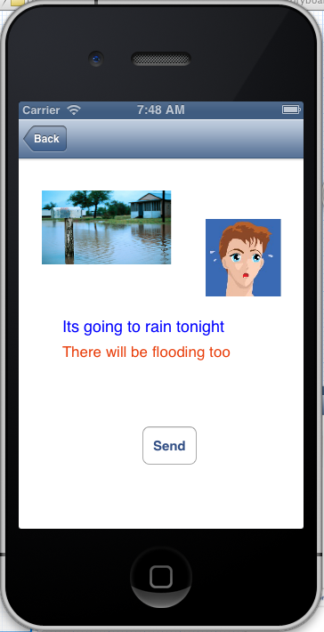

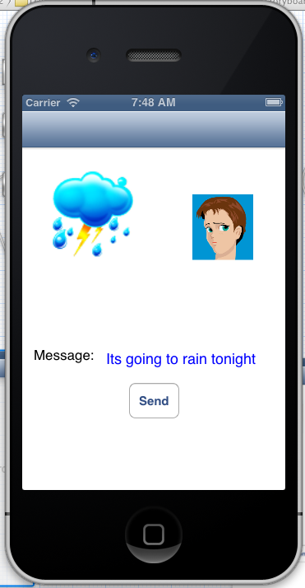

UI Design:

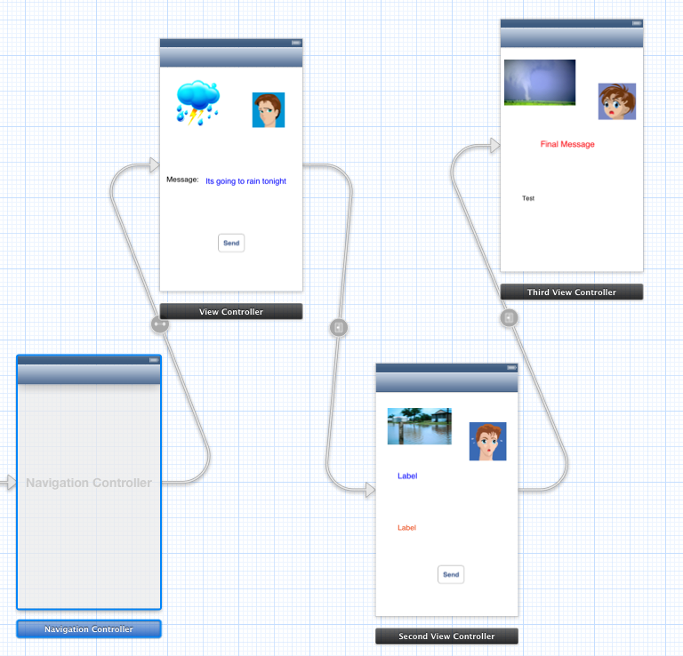

**Submission Instructions**

Submit online to the blackboard using the link given under Lab 2