CS-530 T&E

# Neapolitan Solutions testing Best Software Engineering Group (BSEG)

## Our Test Results:

* System Related Tests- FAILED
* Scheduling Tests- FAILED
* Lab & Pharmacy Order Tests- FAILED
* Insurance Billing Tests- FAILED
* Equipment and Maintenance Tests- FAILED

**NOTE**

We were unable to test their system because we were not able to get a working build to run on our machines

## Summary

After following installation instructions found in the README and multiple communications with the group, we were unable to produce a working local environment on any of our own machines. We were able to produce an interface without a backend, but on interaction with any of the site’s elements, multiple errors are produced. There was no create account button to then test a login against their login tests. Furthermore, without a login (and database to read from), we were unable to produce any working tests. The installation instructions proved to be more difficult than stated in the README and therefore we were unable to test most (if not all) of this team’s functionality. After reviewing the code, we noticed there were also several errors with NPM and Node.js when installing dependencies. The dependency folder, “node_modules” is version-controlled and therefore each change to any dependency will cause changes in the git repo. Additionally, this tracking of dependencies overloads git when attempting to remove and reinstall or update dependencies, reaching the 10k max change limit for a commit almost instantly.

## Screenshots

Below are screenshots of the web app, we were not given a login and there is not a way to create an account from their login page. We also tried their Patients page and when you click the menu button the second screenshot is what occurs. We do not know if logging in would have allowed us to witness more functionality.

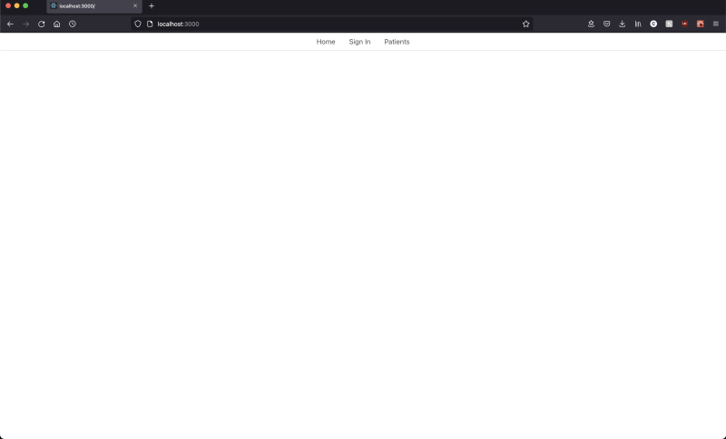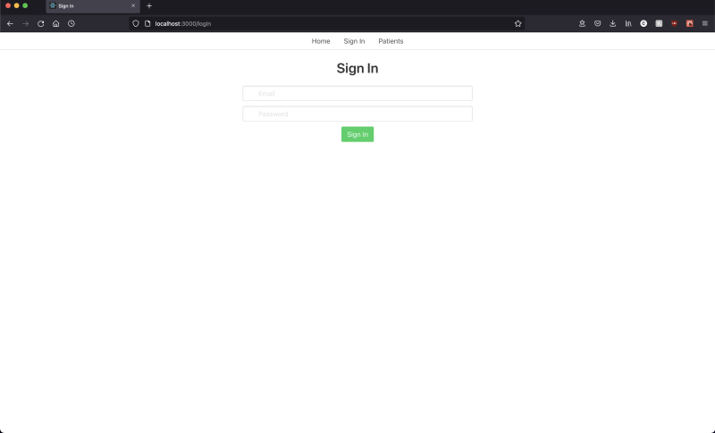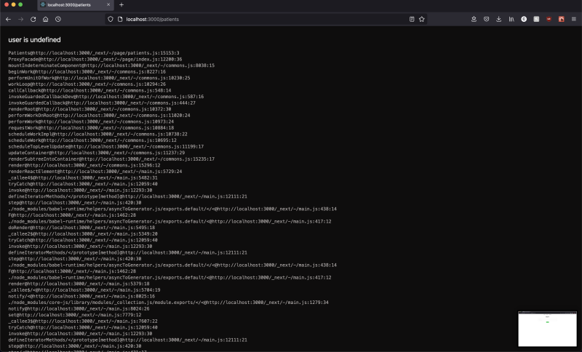

In communications with a group member as well as following the read me I was supposed to run:

“python manage.py create_db”

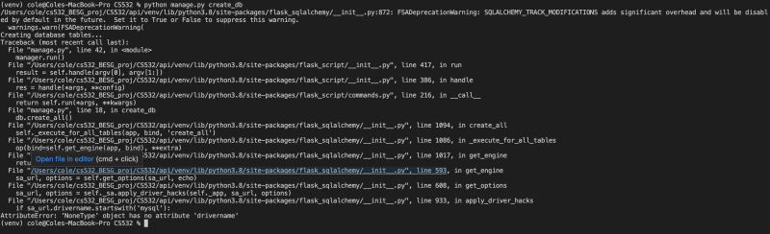

“python manage.py populate_db”

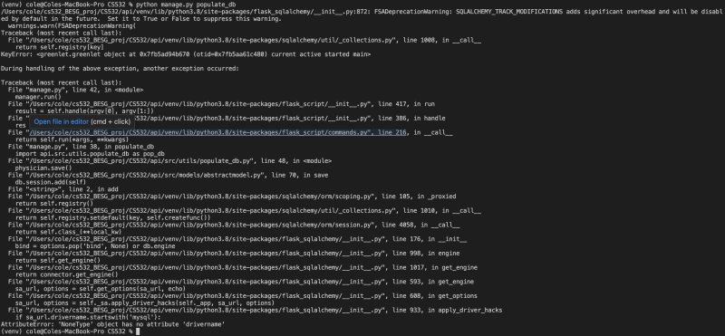

“python manage.py drop_dp”

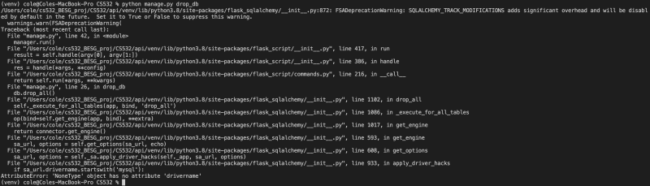

Each one of the commands gave us errors, so it was not possible to get the backend up and running on our local machines.