Bj’s cheat sheet
Brought to you by pounds transformation

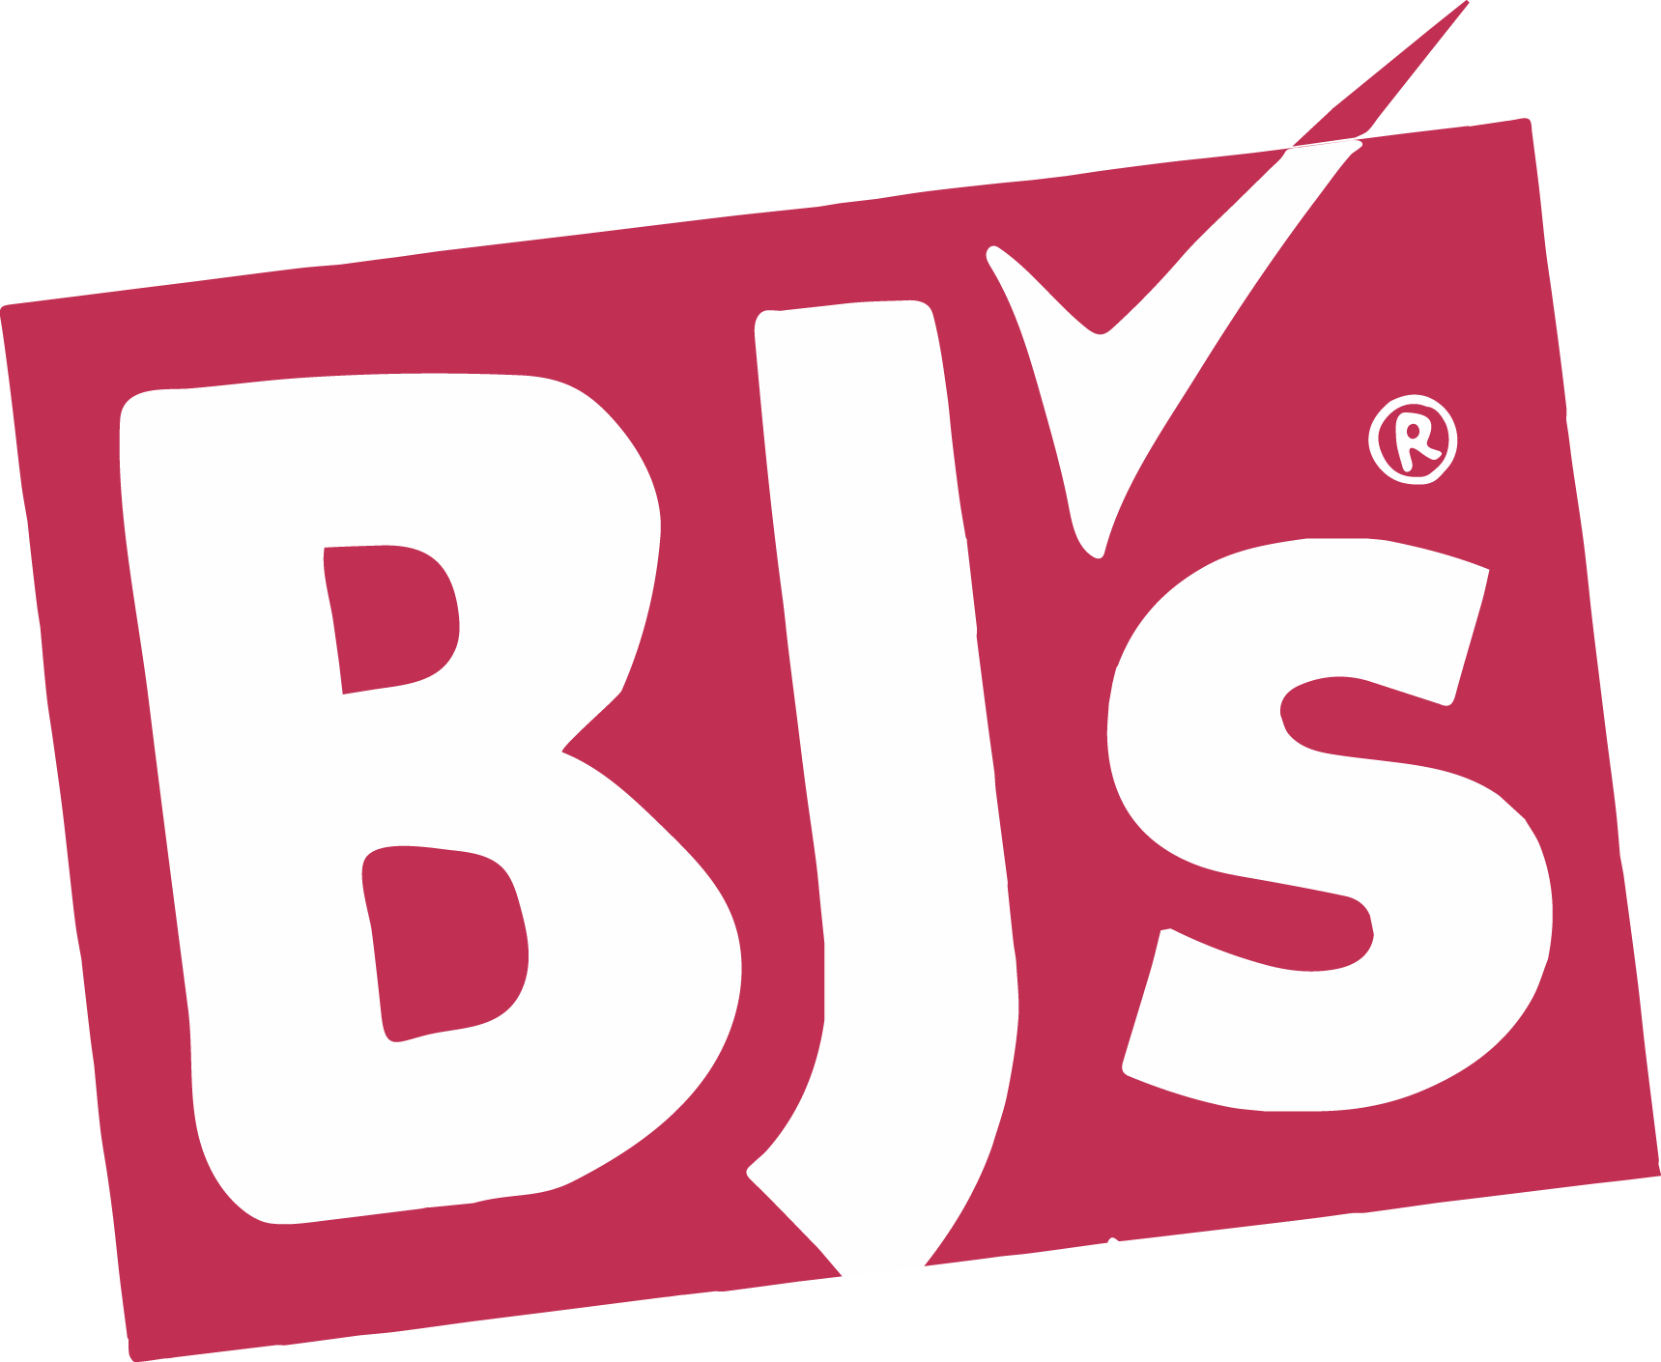

*Easy grab n’ go & precooked options!
Frozen Breakfast:
- Veggies Made Great Frozen Egg White Bites (5 g net carbs, 6 g protein)
- Butterball All Natural Sausage Links (0 g net carb, 10 g protein)
- Morningstar Veggie Sausages (3 g net carbs, 9 g protein)
- Wellsley Farms Pre-Cooked Bacon (0 g net carb, 4 g protein)
- Applegate Uncured Sunday Bacon (0 g net carb, 6 g protein)

Frozen Meat:
- Wellsley Farms Turkey Meatballs (3 g net carbs, 13 g protein)
- Wellsley Farms Swedish Meatballs (5 g net carbs, 14 g protein)
- Tyson Grilled Chicken Breast Strips (2 g net carbs, 21 g protein)
- Perdue Chicken Short Cuts (1 g net carbs, 20 g protein)
- Amylu Chicken Burgers (4 g net carbs, 16 g protein)
- Butterball Turkey Burgers (2 g net carbs, 21 g protein)
- Pound of Ground Burger Thins (0 g net carbs, 13 g protein)
- Applegate Organic Beef Hotdogs (0 g net carb, 7 g protein)
- Hillshire Farms Turkey Polska Kielbasa (3 g net carbs, 8 g protein)
- Wellsley Farms Tomato, Basil, & Mozzarella Cheese Sausage (1 g net carb, 16 g protein)
- Aidell’s Italian Style Sausage (1 g net carb, 15 g protein)
- Hormel Turkey Pepperoni (0 g net carb, 9 g protein)
- Applegate or Hillshire Farm Deli Slices (all varieties except honey/maple roasted)

Seafood/Fish:
- World Catch Salmon Burgers (1 g net carb, 18 g protein)
- Wellsley Farms Precooked Chicken Skewers (6 g net carbs, 21 g protein)
- Wellsley Farms Frozen Chicken Wings (0 g net carb, 19 g protein)
- Wellsley Farms Tilapia Loins (0 g net carbs, 34 g protein)
- Wellsley Farms Precooked Shrimp (0 g net carb, 14 g protein)
- Wellsley Farms Wild Caught Sockeye Salmon Fillets (0 g net carb, 24 g protein)
- Wellsley Farms Tuna Steaks (0 g net carb, 28 g protein)

Vegetarian:
- Morningstar Garden Veggie Burgers (8 g net carbs, 17 g protein)
- Beyond “Steak” Tips (5 g net carbs, 21 g protein)
- Nasoya Tofu (2 g net carbs, 9 g protein)

Dairy/Eggs:
- Unsweetened Almond Milk (0 g net carb, 1 g protein)
- Fairlife Milk (lactose free!) (6 g net carbs, 13 g protein)
- Nutpods Unsweetened French Vanilla Creamer (lactose free!) (0 g net carb, 0 g protein)
- Wellsley Farms Precooked Hardboiled Eggs (0 g net carbs, 6 g protein)
- Egg Life Egg White Wraps (0 g net carb, 5 g protein)
- Chobani Zero Greek Yogurt (lactose free!) (5 g net carbs, 11 g protein)
- Wellsley Farms Greek Yogurt (5 g net carbs, 18 g protein)
- Breakstone Cottage Cheese (6 g net carbs, 11 g protein)

Breads/Rice:
- Joseph’s Pita Bread (7 g net carb, 6 g protein)
- Arnold Keto Bread (3 g net carbs, 4 g protein)
- Wellsley Farms Cauliflower Rice (2 g net carbs, 2 g protein)

Protein Bars/Shake Aisle: (I recommend Pounds protein bars because they are overall cheaper in price per bar but these are some great BJ’s options!)
- Fit Crunch Bars (13 g net carbs, 16 g protein)
- Quest Bars (6 g net carb, 21 g protein)
- Premier Protein Shakes (2 g net carb, 30 g protein)
- Fairlife Protein Shakes (3 g net carbs, 30 g protein)
- OWYN Protein Shakes (vegan!) (0 g net carbs, 30 g protein)

Snacks:
- Formaggio Artisan Prosciutto Cheese Sticks (0 g net carb, 6 g protein)
- Wellsley Farms Cheese Sampler (0 g net carbs, 7 g protein)
- Whisps (great as a crouton substitute and lactose free too!) (1 g net carb, 13 g protein)
- Simply Protein Chocolate Coconut Bites (5 g net carbs, 10 g protein)
- Nature’s Garden Probiotic Keto Snack Mix (2 g net carbs, 7 g protein)
- Epic Baked Pork Rinds (0 g net carb, 11 g protein)
- Chef’s Cut Beef Sticks (2 g net carbs, 8 g protein)
- Vermont Pork/Beef Snack Sticks (0 g net carb, 6 g protein)
- Babybel Cheese Wheels (0 g net carb, 4 g protein)
- Cabot Cheddar Snack Pack (lactose free!) (0 g net carb, 5 g protein)
- Quest Chips (4 g net carbs, 19 g protein)

Condiments/Sauces:
- Simply Salad Dressings-all varieties
- Wellsley Farms Tzatziki (2 g net carbs, 2 g protein)
- Guacamole Now (1 g net carb, 1 g protein)
- Classico Tomato & Basil Pasta Sauce (5 g net carbs, 2 g protein)
- Hunt’s Tomato Sauce (2 g net carbs, 1 g protein)
- Skippy’s Natural Peanut Butter (4 g net carbs, 7 g protein)
- Teddie’s All-Natural Peanut Butter (4 g net carb, 8 g protein)

