costco cheat sheet
Brought to you by pounds transformation

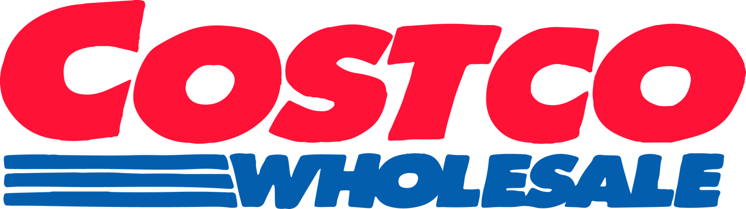

*Easy grab n’ go & precooked options!
Meat:
- Columbus Seasoned Turkey Burgers (2 net carbs, 30 g protein)
- Kirkland Pulled Pork (0 g net carbs, 16 g protein)
- Foster Farms Hot & Spicy Wings (4 g net carbs, 12 g protein)
- Wild Caught Frozen Langostino Lobster Tails (0 g net carbs, 23 g protein)
- Kevin’s Paleo Chicken Meals (3 g net carbs, 24 g protein)
- Tyson’s Blackened Unbreaded Chicken Strips (1 g net carb, 20 g protein)
- WestEnd Cuisine Chicken Skewers (3 g net carbs, 24 g protein)
- Realgood Chicken Strips (3 g net carbs, 23 g protein)

Vegetarian:
- MorningStar Sausage Patties (3 g net carbs, 9 g protein)
- LightLife Smart Dogs (3 g net carbs, 12 g protein)
- Yves Veggie Burgers (3 g net carbs, 16 g protein)

Pasta/Rice/Bread:
- Healthy Noodle (0 g net carbs, 1 g protein)
- SeaPoint Farms Edamame Spaghetti (9 g net carbs, 24 g protein)
- Frozen Riced Cauliflower (2 g net carbs, 2 g protein)
- Old Tyme Schmidt 647 Bread (6 g net carbs, 2 g protein)
- Artisan Bakers Multiseed Keto Bread (1 g net carb, 3 g protein)
- Mission Carb Balance Tortilla (3 g net carbs, 5 g protein)

Cereal/Granola: (I recommend Pounds cereal and granolas because there are less net carbs but these are also some great options!)
- Autumn’s Gold Grain-Free Granola (7 g net carbs, 4 g protein)
- Wonderworks Keto Cereal (12 g net carbs, 15 g protein)
- NuTrail Low Carb Granola (8 g net carbs, 5 g protein)

Dairy:
- Kirkland Unsweetened Almond Milk (1 g net carb, 1 g protein)
- Kirkland Plain Greek Yogurt (7 g net carbs, 18 g protein)
- Babybel Snack Cheeses (0 g net carbs, 5 g protein)
- Laughing Cow Cheese Wedges (1 g net carb, 2 g protein)
- Frigo String Cheese (1 g net carb, 6 g protein)
- Darigold Cottage Cheese (5 g net carbs, 15 g protein)
- Crepini Egg White Thins (4 g net carbs, 4 g protein)

Snacks:
- Kirkland Organic Roasted Seaweed Snacks (0 g net carb, 1 g protein)
- Frutto D’Italia Olive Pouches (0 g net carb, 0 g protein)
- Whisps (1 g net carb, 13 g protein)
- Parm Crisps Snack Mix (3 g net carbs, 10 g protein)
- Flackers (1 g net carb, 6 g protein)
- Nature’s Garden Keto Snack Mix (2 g net carbs, 7 g protein)
- Hilo Life Keto Tortilla Chips (3 g net carbs, 9 g protein)
- Green Ridge Beef Sticks (0 g net carbs, 8 g protein)
- Epic Pork Rinds (0 g net carbs, 8 g protein)
- Kirkland Protein Bars (6 g net carbs, 21 g protein)
- Pure Protein Bars (15 g net carbs, 21 g protein)
- Fit Crunch Bars (13 g net carbs, 16 g protein)

Miscellaneous:
- Vital Proteins Collagen Peptides (0 g net carbs, 18 g protein)
- Premier Protein Shakes (3 g net carbs, 30 g protein)
- IsoPure Protein Powder (0 g net carbs, 25 g protein)
- Rao’s Homemade Marinara (5 g net carbs, 2 g protein)
- Real Good Pizza Co Frozen Pizza (6 g net carbs, 17 g protein)
- PB Fit Peanut Butter Powder (2 g net carbs, 8 g protein)
- PB2 Peanut Butter Powder (4 g net carbs, 6 g protein)
- Wholly Guacamole Minis (2 g net carbs, 1 g protein)

