📚 CSE 132A Data Management Overview

Brief Overview
This note covers Data Management and was created from a PDF presentation of 19 pages on CSE 132A lecture slides. It provides an introduction to database fundamentals, including system architecture, data models, and key concepts that underpin modern data-centric applications.

Key Points
- Grasp the relational model and its importance in structuring data.
- Master SQL syntax for querying and manipulating data.
- Understand the three‑level database architecture and data independence.
- Learn how ER modeling and normal forms guide effective schema design.

📅 Logistics
- Lectures: in‑person and podcast
- Attendance: optional but strongly recommended
- Slides: posted prior to lecture
- Weekly discussion: on‑demand Zoom session
- Office hours: TA and instructor, both in‑person and via Zoom
- Discussion board: Piazza
- Exams: in‑person only
- Materials: all posted on Canvas or Piazza

📚 Data Management Overview
- Field: rapidly evolving, expanding beyond classical stand‑alone DBMS (SQL Server, Oracle, DB2)
- Trends: data‑centric computer science → data science = data management + machine learning
- Applications: scientific databases, networks, data mining, streaming sensor monitoring, social networks, bioinformatics, GIS, digital libraries, data‑driven web services, analytics
- Core: classical database concepts and algorithms remain foundational → focus of this course

🎯 Course Scope (CSE 132A)
- Core concepts: relational model, SQL, query processing, schema design, transactions, concurrency control
- Theoretical foundations: relational algebra, relational calculus, formal languages underlying SQL
- Pathways: prepares for 132B (applications), 132C (implementation), 135 (online analytics), 190 (beyond relational)

📋 Requirements

Assessment | Weight
5 homework assignments (individual) – 3 SQL programming, 2 non‑programming | —
Midterm | 30 %
Final | 30 %
Academic Integrity | – (policy posted on class website)
🗂 What Is a Database?

A database is a persistent collection of data together with a query and update language for accessing and modifying that data, supporting query optimization, and providing transaction and concurrency control.

- Typical data: many instances of similarly structured records (e.g., airline reservations, library catalogs, medication advisors)

🎈 Top‑Level Goals of a Database System
- Meaning‑based view: abstract away irrelevant details for users
- Support operations: queries and updates
- Data control: security, integrity, recovery, concurrency

🏗 Basic Architecture of a Database System

The architecture consists of three abstraction levels:
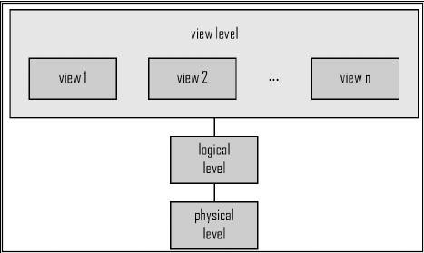

The diagram illustrates the hierarchical relationship: the view level (multiple user‑specific views) sits atop the logical level (schema description), which in turn sits above the physical level (actual storage).

- Data independence: logical and physical levels are independent, allowing changes in storage without affecting logical schema

🔍 Levels of Abstraction
- Logical level: describes data in terms close to applications (e.g., a flight reservation table)
- Physical level: specifies how data is stored and processed on disk
- View level: customized, possibly restricted, representations of data (e.g., hiding employee salaries for security)

🖥 Database System vs. DBMS

Aspect | Database System | Database Management System (DBMS)
Scope | Tailored to a specific application | Generalized, usable across many applications
Responsibilities | Application‑specific logic, data handling | Data organization, storage, access, control

Examples | A hospital’s patient‑record system | PostgreSQL, MySQL, Oracle, DB2, SQL Server
📊 Data Models
- Purpose: concepts & tools for describing relationships, semantics, constraints; includes a query/modification language
- Major models:
  - Relational model
  - Entity‑Relationship (ER) model – primarily for design
  - Object‑oriented / Object‑relational models
  - Semi‑structured (XML, graphs)
  - Older models: network, hierarchical

🧩 Example: Entity‑Relationship Model
The ER model represents an application as entities (objects) with attributes and relationships among them.
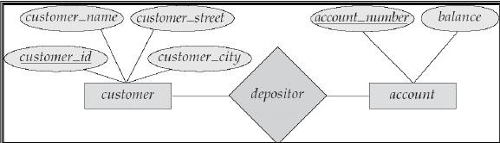

In this diagram, Customer and Account are linked by the associative entity Depositor, indicating a many‑to‑many relationship.
📐 Schemas and Instances
- Schema: logical structure of the database (analogous to a variable’s type)
- Instance: actual data at a point in time (analogous to a variable’s value)

📘 Relational Model – Schema Example

Relation | Attributes

Customer | customer_id (PK), customer_name, customer_street, customer_city
Account | account_number (PK), balance
Depositor | customer_id (FK), account_number (FK)
An instance would contain concrete rows for each relation, e.g., a specific customer “C001”, account “A123”, and a linking row in Depositor.
🛠 Data Definition Language (DDL)

DDL defines the database schema.

Example in SQL:
create table account ( account_number char(10), balance integer
);

- DDL compiler → populates the data dictionary (metadata) with:
  - schema definitions
  - integrity constraints
  - authorization information

🗂 Data Manipulation Language (DML)

DML provides a language for accessing and modifying data.

- Two query language styles:
- Declarative (non‑procedural) – specify what data is needed (e.g., SQL)
- Procedural – specify how to obtain the data
- SQL is the dominant declarative language.

📚 Core Topics Covered in This Course
- Relational model
- Standard relational query language: SQL
- Formal query languages: relational algebra & calculus
- Query processing
- Schema design: normal forms, ER model
- Concurrency control
- Additional topics as time permits

🏫 Databases at UCSD
  - Faculty: Alin Deutsch, Arun Kumar, Victor Vianu
  - Group website: https://dbucsd.github.io/ (papers, seminars, etc.)
  - Intersections with other CSE groups: storage, multimedia, machine learning, networks
  - Collaboration with SCIDS (e.g., Prof. Babak Salimi, Dr. Amarnath Gupta)

📚 Algebra & Relational Overview

Brief Overview
This note covers Algebra and was created from a 44-page PDF presentation. The notes cover algebraic structures, time-based algebras, tuples, relational algebra, JSON data.

Key Points
  - Definitions of algebras and examples (natural numbers, set, Boolean).
  - Time-based algebra operations and relations.
  - Core relational algebra operations (selection, projection, join, division).
  - JSON as semi-structured data representation.

Algebras and Data Models 🔢
What is an Algebra?
An algebra is a mathematical structure consisting of:
- A Set (A): The domain or universe of elements
- A Signature (F): A set of operations defined on the set A
- Axioms (Optional): Properties that the operations must satisfy

Formal definition: An algebra is a tuple $A = (A, {f_i}{i \in I})whereA
isthecarriersetand{f_i : A^n \to A}{i \in I}$ is a family of n-ary operations.

Examples of Algebras
Natural Numbers Algebra
The algebra of natural numbers under addition and multiplication:
- A = N (set of natural numbers)
- Operations: +, × (both binary operations: N × N → N)
Set Algebra
Formal representation: A = (P (U), ∪, ∩, ∣, ∅, U)

Components:
- Carrier Set: P (U) (power set of universe U)
- Operations:
  - Union: A ∪ B
  - Intersection: A ∩ B
  - Set Difference: A∣B (elements in A but not in B)
  - Complement: A (elements in U∣A)
- Distinguished Elements: ∅ (empty set), U (universal set)
Properties:
- Associativity: (A ∪ B) ∪ C = A ∪ (B ∪ C)
- Commutativity: A ∪ B = B ∪ A
- Distributivity: A ∩ (B ∪ C) = (A ∩ B) ∪ (A ∩ C)
- Identity: A ∪ ∅ = A, A ∩ U = A
- Complement: A ∪ A = U, A ∩ A = ∅
Boolean Algebra
Formal representation: B = (B, ∨, ∧, ¬, 0, 1)
Components:
- Carrier Set: B = 0, 1
- Operations: OR (∨), AND (∧), NOT (¬)
- Distinguished Elements: 0 (false), 1 (true)
Properties:
- Commutativity: a ∨ b = b ∨ a
- Associativity: (a ∨ b) ∨ c = a ∨ (b ∨ c)
- Distributivity: a ∧ (b ∨ c) = (a ∧ b) ∨ (a ∧ c)
- Identity: a ∨ 0 = a, a ∧ 1 = a
- Complement: a ∨ ¬a = 1, a ∧ ¬a = 0
Time-Based Algebras ⏰
Algebra of Time Points
Carrier Set (P): All possible time points (e.g., timestamps)

Operations:
- Addition: f_{add}(p, d) = p + d (add duration d to time point p)
- Subtraction: f_{sub}(p, d) = p − d (subtract duration d from time point p)
Relations:
- Before: p₁ < p₂ (true if p₁ occurs before p₂)
- After: p₁ > p₂ (true if p₁ occurs after p₂)
- Equals: p₁ = p₂ (true if p₁ equals p₂)
Algebra of Time Intervals
Carrier Set (I): I = [p₁, p₂]∣p₁, p₂ ∈ P , p₁ < p₂
Operations:
- Interval Addition: f_{add}([p₁, p₂], d) = [p₁ + d, p₂ + d]
- Interval Intersection: f_{intersect}([p₁, p₂], [q₁, q₂]) = [max(p₁, q₁), min(p₂, q₂)]
- Interval Union: Combines intervals if they overlap or are adjacent
Relations:
- Overlaps: True if intervals share common time points
- Before: True if first interval ends before second begins
- Contains: True if one interval fully contains another

Tuples and Many-Sorted Algebras 📊
Tuples
A tuple is a finite ordered collection of elements where each element can be of different type.
Definition: t = (t₁, t₂, ..., t_{n}) where:
- n: arity (length) of the tuple
- t_{i}: i-th element from domain D_{i}
Key Properties:
- Ordered: Order matters (1, 2) = (2, 1)
- Finite Length: Fixed number of elements

- Heterogeneous Types: Elements can be from different domains Operations for Atomic Tuples:
Operation | Definition | Example
Accessing Elements | Retrieves i-th element | (1, 2, 3)[2] = 2
Concatenation | Combines two tuples | (1, 2) + (3, 4) =  (1, 2, 3, 4)
Projection | Extracts specific attributes | π_{1,3}((1, 2, 3)) = (1, 3)
Slicing | Extracts contiguous subset | slice((1, 2, 3, 4, 5), 2, 4) = (2, 3, 4)
Tuple Equality | Checks equality | (1, 2, 3) = (1, 2, 3) → true

Many-Sorted Algebra
A many-sorted algebra generalizes single-sorted algebra by allowing multiple carrier sets.
Formal definition: $A = (S, {A_s}{s \in S}, {f_i}{i \in I})$ where:
- S: Finite set of sorts (types)
- A_{s}s∈S: Family of carrier sets, one per sort
- f_{i}i∈I: Family of operations between sorts
Example: 2-sorted Algebra:
- Sorts: String, Number
- Carrier Sets: A_{string} = "apple", "banana", "cherry", A_{number} = 1, 2, 3, 4, 5, 6
- Operations:
  - String concatenation within strings
  - Addition/multiplication within numbers
  - Cross-sort operations (e.g., repeat string by number)

Relational Algebra 🗄
Core Concepts

Relational algebra is a many-sorted algebra with sorts:
- Domains (D): Sets of atomic values
- Attributes (A): Names associated with domains
- Tuples (T): Ordered collections of values
- Relations (R): Sets of tuples with schema

Basic Operations
Selection
R₁ := σ_{C} (R₂)
- C: Boolean condition on attributes
- Result: Tuples from R₂ satisfying condition C
Projection
R₁ := π_{L}(R₂)
- L: List of attributes to extract
- Result: Tuples with only specified attributes, duplicates removed Extended Projection
Allows expressions in projection list:
- Arithmetic operations
- Concatenation
- Duplicate attributes
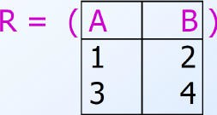
The image demonstrates how extended projection can perform calculations on attributes, transforming a simple 2×2 matrix relation into a new relation with computed values.

Product (Cartesian)
R₃ := R₁ × R₂
- Pairs each tuple from R₁ with each tuple from R₂
- Schema: Attributes of both relations (use prefixes for duplicates)
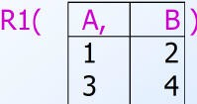
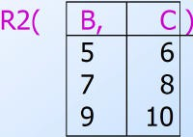

These images show the component relations used in product operations, illustrating how tuples from different relations are paired together.
Join Operations
Theta Join: R₃ := R₁ ⋈_{C} R₂
- Product followed by selection with condition C
Natural Join: R₃ := R₁ ⋈ R₂

- Equates same-named attributes
- Projects out duplicate attributes Division
R ÷ S = x ∈ π_{X}(R)∣∀y ∈ S, (x, y) ∈ R
- Finds X values associated with every y in S
- Captures "for all" queries

Query Trees and Complex Expressions
Operator Precedence:
- [σ, π, ρ] (highest)
- [×, ⋈]
- [∩]
- [∪, −] (lowest)
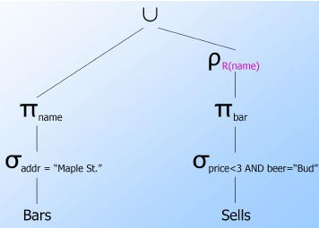
This query tree illustrates how to combine selection, projection, and union operations to find bars meeting specific criteria, demonstrating the visual representation of complex relational algebra expressions.
Self-Join Example: Finding bars selling different beers at same price using relation renaming and natural join.

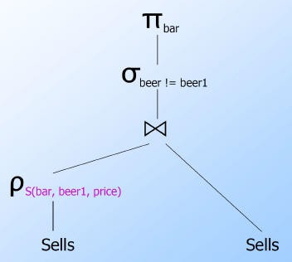
The image shows how self-join operations work by creating a copy of a relation, renaming it, and then joining to compare tuples within the same original relation.

Bag (Multiset) Operations
Bag vs Set differences:
Elements can appear multiple times
Union: Sum of occurrences
Intersection: Minimum occurrences
Difference: Subtract occurrences (minimum 0) Bag Laws:
Commutative law holds
Idempotent law fails: S ∪ S = S when S is a bag
Semi-Structured Data 📱
JSON as Semi-Structured Data
Semi-structured data lacks rigid schema but contains tags/markers to separate elements. Example JSON Structure:

Tuples: Ordered collections with different types
Lists: Ordered sequences
Atomic values: Strings, numbers, booleans
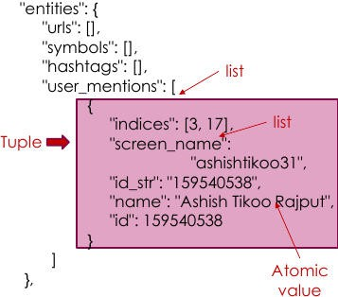
This image demonstrates the hierarchical nature of JSON data, showing how semi-structured data can nest different data types (tuples, lists, atomic values) to represent complex real-world information like social media data.

📖 ER Modeling Fundamentals

Brief Overview
This note covers entity‑relationship modeling and was created from a 36‑page PDF presentation. It provides a step‑by‑step guide through entities, attributes, and relationships, with a focus on ER diagrams, cardinality, and advanced ER concepts.

Key Points
Quick reference to entity sets, attribute types, and relationship cardinality.
Visual examples of ER diagrams for customers, orders, products, and an educational support system.
Practical guidance on handling composite, multi‑valued, derived, and weak entities.

📦 Entities
Entity: An “object” or “thing of interest” that stands alone with its own properties, is distinguishable from other objects, and has a unique name in the schema.

Examples of entity sets:
- University schema → Student, Faculty, Course, Classroom
- Shop schema → Receipt, Customer, Employee, Product
- Hospital schema → Doctor, Patient, Nurse, Disease, Procedure, Medicine
🔎 Attributes
Attribute: A property of an entity; an entity may have one or many attributes.

Attribute Types
Type | Description | Example
Single‑valued | Holds one atomic value | Name

Composite | Consists of multiple sub‑attributes | FullName (First, Middle, Last)
Multi‑valued | Can store several values for the same entity | PhoneNumbers
Nested | Attributes that themselves contain sub‑attributes (e.g., an address) | Address (StreetNumber, StreetName, AptNumber, City, State, Zip)
Derived | Computed from other attributes | Age from DateOfBirth
Sample student attributes: Name, Age, Student_Id, Year_of_study, Current_GPA, Phone_number, Email_address, Home_Address, Current_Address.

🔗 Relationships
Relationship: An association between two or more entities; may also possess its own attributes.

Captures how rows in one table relate to rows in another.
Can be binary, ternary, or n‑ary depending on the number of participating entities.

Types of Relationships – Cardinality

Cardinality | Symbol | Description | Example
One‑to‑One | 1:1 | Each entity in set A relates to at most one entity in set B | Student ↔ PID
One‑to‑Many | 1:N | One entity in A relates to many in B | Instructor → multiple email addresses
Many‑to‑One | N:1 | Many entities in A relate to one in B | Students → College
Many‑to‑Many | N:M | Entities in both sets can have multiple associations | Student ↔ Course enrollment

Types of Relationships – Entity Count
Binary – involves two entities (e.g., Student‑Course).
Ternary – involves three entities (e.g., Student‑Course‑Instructor).
N‑ary – involves more than three (e.g., Student‑Course‑Classroom‑Term).
📊 What an ER Model Looks Like
The diagram below illustrates an ER model for customers, orders, and products.
It shows entities as rectangles, attributes as ovals, and the central Order diamond linking Customer and Product.
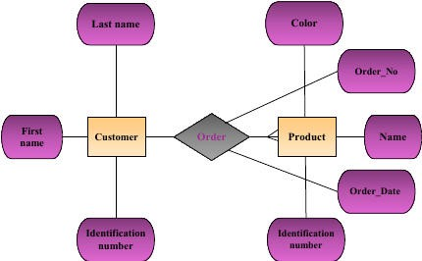
The visual helps see how an order serves as a junction (many‑to‑many) between customers and products, with attributes such as Order_No and Order_Date attached to the relationship.
❓ Example Query Questions
Identify a customer's Identification_number.
Retrieve the color of a specific product.
Find the date of a particular order.
List all products whose color is red.
Determine whether customer a bought product p and, if so, the order date.
Count how many times customer a purchased product p.
Find customers who bought products a and b in the same order.
Locate the first purchase date for customer a.
Insert a new unique customer.
Insert a new unique order linked only to known customers and products.

🏫 Creating the ER Model for EdSupp

Scenario Overview
Backend database for an educational support system (Q&A handling & grading).
Classes are instances of Courses; each class has users (students or teaching staff) who can post comments, questions, or announcements.
Assignments belong to classes; grades are recorded per assignment and per class.
Instructors need analytics (top students, grade distribution, etc.).

Detailed Entity & Attribute Specification

Entity | Primary Key | Key Attributes | Additional Attributes
User | user_id (system‑generated) | first_name, last_name, email | phone_numbers (type + number, multivalued)
Student (subclass of User) | user_id | major | —
Instructor (subclass of User) | user_id | title (Full Prof, Assoc Prof, Asst Prof, Lecturer, Guest) | —
Course | Composite key (dept, course_number) | dept, course_number | title, level (Lower/Upper Division, Graduate)
Class | Composite key (course_id, class_number) | class_number | start_date, end_date, max_students, term, year
Assignment | assignment_id | assignment_name, deadline | class_id (FK)
Grade | Composite key (student_id, assignment_id) | grade_value | —

Post (Comment/Question | post_id  /Announcement) | content, post_type | user_id (FK), class_id (FK), timestamp
Relationship Overview
User ↔ Class – Enrolls (students) or Teaches (instructors).
Class ↔ Assignment – Contains.
Student ↔ Assignment – Receives grade.
User ↔ Post – Creates.

ER Diagram for EdSupp (excerpt)
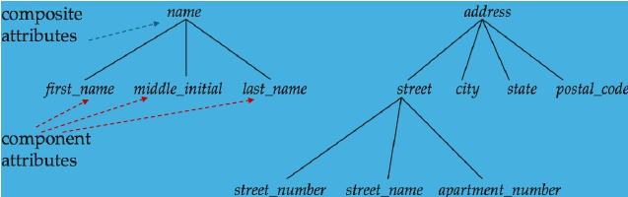
The diagram demonstrates composite attributes (e.g., name broken into first/middle/last) and multivalued attributes (multiple phone numbers). It clarifies how subclasses inherit the primary key from User while adding role‑specific attributes.
🔑 Keys in ER Design
A key is a minimal set of attributes that uniquely identifies an entity.
Example keys:
- IID → I_name for Instructor.
- SID → S_name for Student.

� Advisor Relationship Example
The schema below models an instructor advising students (one‑to‑many).

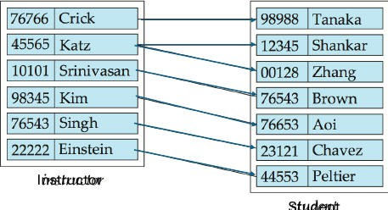
One instructor may have many advisees, while each student has exactly one advisor.

Cardinality Questions
What if an instructor has no advisee? → Allow optional participation on the instructor side.
What if a student can have multiple advisors? → Change to a many‑to‑many relationship, adding an associative entity (e.g., AdvisorAssignment).

📐 Attributes in Relationships
A relationship can own attributes (e.g., Start_Date linking instructors and students).
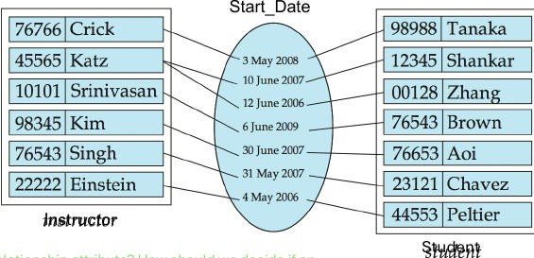
The Start_Date attribute belongs to the advisor relationship rather than either entity.

Relationship Attribute: An attribute that describes a property of the association itself, not of the participating entities.

🧩 Complex Attributes

Simple vs. Composite – Composite attributes are broken into atomic components for relational storage.
Multi‑valued – Requires a separate relation (e.g., PhoneNumber(user_id, type, number)).
Derived – Computed on demand (e.g., age() from date_of_birth).
Domain – Permitted set of values for an attribute (e.g., title ∈ {Full Professor,
…}).

🏗 Composite Attribute Example
The name attribute decomposes into first_name, middle_initial, last_name; the address attribute further splits into street details, city, state, zip.
📦 Entity Sets
Represented by rectangles; primary key attributes are underlined.
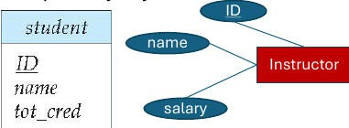
🔗 Relationship Sets
Represented by diamonds; can also carry attributes.
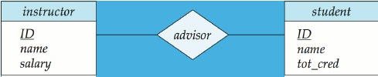

With Attributes
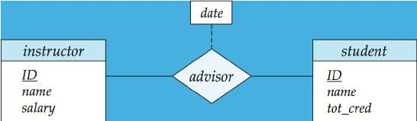
The date attribute records when an advisor relationship was established.

🎭 Roles in Relationships
An entity set can appear multiple times in a relationship, each occurrence playing a distinct role (e.g., course_id vs. prereq_id).
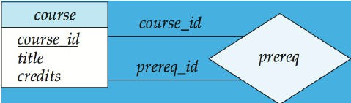
📏 Cardinality Constraints
Directed line (→) → “one”.
Undirected line (—) → “many”.

One‑to‑Many Example
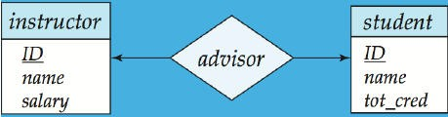

Many‑to‑One Example

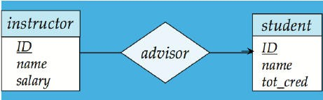

Many‑to‑Many Example
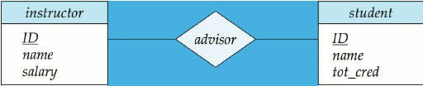
⭕ Total vs. Partial Participation
Total participation (double line) → every entity must be involved in the relationship.
Partial participation → some entities may have no related tuple.
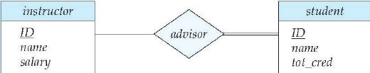
Students have total participation in the advisor relationship (each must have an advisor); instructors have partial participation (may advise none).
📏 Expressing Complex Cardinalities
Use notation l..h on relationship lines:
- l = minimum cardinality (1 → total participation).
- h = maximum cardinality (1 → at most one, * → unlimited).
Example: Instructor → 0..* students, Student → 1..1 instructor.

🗂 Notation for Complex Attributes

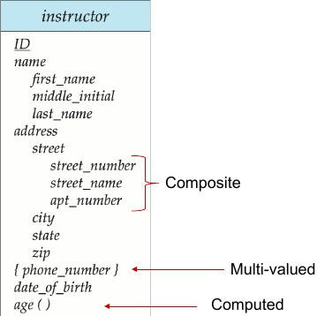
Composite attributes (address, name) are broken into components.
Multi‑valued attribute {phone_number} indicates a set of values.
Derived attribute age() is computed, not stored.

🏚 Weak Entities
A weak entity lacks its own primary key and borrows identifying attributes from a strong entity via an identifying relationship.
The weak entity’s primary key = strong entity’s key + discriminator(s).

Visual Representation
Double rectangle for the weak entity.
Dashed underline for the discriminator.
Double diamond for the identifying relationship.
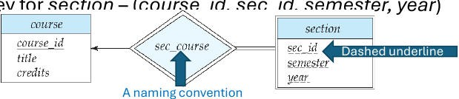
Section is weak; its key combines course_id (from Course) with sec_id, semester, year.

🏛 University Enterprise ER Diagram
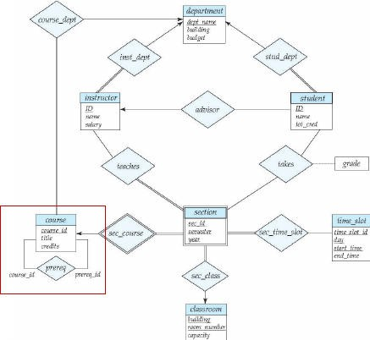
Shows entities: Course, Instructor, Department, Student, Section, Classroom, TimeSlot, etc.
Includes self‑referential prerequisite relationship (course ↔ prerequisite).

📚 Extended ER Model
Adds generalization/specialization, disjoint unions, and additional constraints (aggregations not covered).

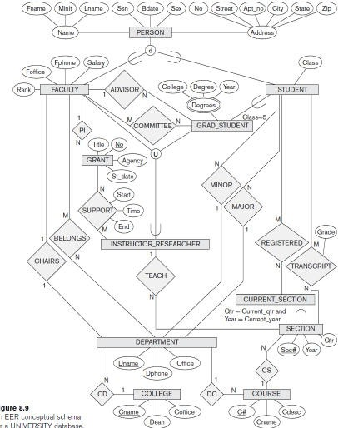
The diagram demonstrates subclass entities (e.g., GraduateStudent, InstructorResearcher) and their inheritance of attributes from Person.

🔒 Database Concurrency & Recovery
Brief Overview
This note covers Database Concurrency & Recovery and was created from a 24-page PDF presentation. The note dives into locking mechanisms, transaction isolation, recovery strategies, and practical SQL transaction examples.
Key Points
Lock types and compatibility tables
Two‑Phase Locking stages
Isolation level guarantees
WAL and checkpoint recovery

Concurrency Control 😊
Concurrency control manages simultaneous transactions so they do not interfere with one another.

Objective: allow many users to perform different operations at the same time.
Performance gain: concurrent transactions increase system throughput and reduce waiting time.
Risk without control: loss of data integrity and consistency.

Lock‑Based Protocol 🔒
A lock is a mechanism that controls concurrent access to a data item, ensuring that one process cannot retrieve or update a record that another process is updating.

Lock Modes
Shared lock (S) – item can be read but not modified.
Exclusive lock (X) – item can be read and written.

Compatibility of Lock Modes

Requested \ Existing | S | X | IS | IX
S | ✔ | ❌ | ✔ | ❌
X | ❌ | ❌ | ❌ | ❌
IS | ✔ | ❌ | ✔ | ✔

IX | ❌ | ❌ | ✔ | ❌
Any number of transactions may hold shared locks on an item.
An exclusive lock blocks all other locks on that item.

Lock Structure & Operations

Field | Description
object_id | Identifier of table, page, row, tuple, etc.
current granted mode | Current lock mode (S, X, IS, IX, …)
holders | List of (transaction_id, mode) holding the lock
wait_queue | Queue of (transaction_id, requested_mode) waiting for the lock
Intention Locks (Hierarchy)
IS (Intention‑Shared): placed on a higher‑level object (e.g., table) when a transaction intends to acquire shared locks on lower‑level items (rows).
IX (Intention‑Exclusive): placed on a higher‑level object when a transaction intends to acquire exclusive locks on lower‑level items.
Example: To update a row in table T
- Acquire IX(T).
- Acquire X(row).
The IX lock prevents another transaction from taking IS(T), which would block the row update.

Two‑Phase Locking (2PL) 🕒
Two‑Phase Locking (2PL) divides a transaction into a growing phase (acquiring locks) and a shrinking phase (releasing locks). No new locks are requested after the first release.

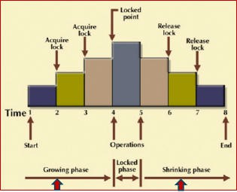

The diagram shows the timeline of a transaction: the growing phase where locks are acquired, the locked point, and the shrinking phase where locks are released. This visual reinforces the rule that a transaction must not request new locks after it starts releasing them.
- Guarantees conflict‑serializable schedules.
Timestamp‑Based Protocol ⏱
A timestamp‑based protocol assigns a unique timestamp to each transaction, establishing a serializable order for conflicting reads and writes.

- Timestamp assigned when the transaction enters the system (using system time or a logical counter).
- Notation:
Transaction timestamp: TS(T)
Read‑timestamp of data item X: R‑timestamp(X)
Write‑timestamp of data item X: W‑timestamp(X)
Transaction Isolation Levels 🔐
Isolation determines how the effects of one transaction are visible to others.

Isolation Level | Guarantees | Phenomena Prevented
Read Uncommitted | Allows reading uncommitted changes (dirty reads). | None
Read Committed | Reads only committed data; holds a lock on the current row. | Dirty read

Repeatable Read | Holds read locks on all rows read and write locks on modified rows. | Dirty read, non‑repeatable read
Serializable | Execution appears as if transactions ran serially. | All three (dirty, non‑repeatable, phantom)

PostgreSQL does not implement Read Uncommitted; it defaults to Read Committed.

Phenomena Definitions
Dirty Read: Transaction reads data written by another transaction that has not yet committed.

Non‑Repeatable Read: A transaction reads the same row twice and obtains different values because another transaction modified and committed the row in between.

Phantom Read: Re‑executing a query yields a different set of rows because another transaction inserted or deleted rows that satisfy the query’s condition.
Database Recovery 💾
Recovery restores a database to a correct state after a failure, ensuring consistency.

- Rolling Forward: Apply redo records to data blocks.
- Rolling Back: Apply undo segments to revert changes.
Log‑Based Recovery
Logs are ordered records of transaction actions stored on stable storage; they contain transaction identifiers, old and new values, and transaction states.

Example Log Sequence (transaction updating an employee address)

Modification Strategies
- Deferred Modification: All log records are written first; the database is updated after the transaction commits.

- Immediate Modification: The database is updated after each log entry; each step is logged before the change.
Write‑Ahead Log (WAL)
- Ensures that log records are written to stable storage before the corresponding data pages are flushed.

Checkpointing
A checkpoint marks a point where the database and log are synchronized: all previous logs are flushed, and a checkpoint record containing active transaction IDs is written.

- After a checkpoint, only transactions active at that point need undo/redo processing.

Recovery Process
- Read log backward from the last checkpoint.
- Undo transactions that started but did not commit.
- Redo committed transactions to reapply their effects.
  - Undo: Use a log record to restore the old value.
  - Redo: Use a log record to apply the new value.

Recovery Using Log Records & Checkpoints
  - Transaction Ti is undone if appears without a matching or .
  - Transaction Ti is redone if appears with a matching or .
  - A checkpoint record lists active transactions L at checkpoint time; only those transactions (and any started afterward) require undo/redo.

SQL Transaction Examples 📋
Updating a User’s Nickname (with diagram)
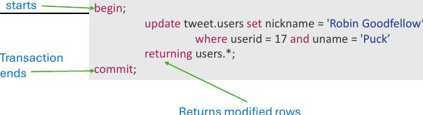

The image illustrates a simple transaction: BEGIN; → UPDATE …; → COMMIT;, highlighting the start and end of the transaction.
BEGIN;
UPDATE tweet.users

SET nickname = 'Robin Goodfellow' WHERE userid = 17 AND uname = 'Puck' RETURNING *;
COMMIT;
Deleting a User Record
BEGIN;
DELETE FROM tweet.users
WHERE userid = 22 AND uname = 'CLAUDIUS' RETURNING *;
COMMIT;
  - Records are not physically removed until the VACUUM process runs automatically.

Truncate with Rollback
SELECT count(*) FROM foo; BEGIN;
TRUNCATE foo; ROLLBACK;
SELECT count(*) FROM foo;
  - TRUNCATE efficiently purges all rows from a table in a single operation.
Concurrency Situation (Read‑Committed effect)
- Console 1: BEGIN; UPDATE tweet.message SET rts = rts + 1 WHERE messageid = 1 RETURNING messageid, rts; (no commit yet)
- Console 2: Executes the same statement and receives no rows because the first transaction holds a lock.
- After Console 1 issues COMMIT;, Console 2 proceeds and sees the updated row.

Isolation Level Demonstration (Repeatable Read)
\set ON_ERROR_ROLLBACK on
BEGIN TRANSACTION ISOLATION LEVEL REPEATABLE READ;
UPDATE tweet.message SET rts = rts + 1 WHERE messageid = 1 RETURNING messageid, rts;
-- In a second session run the same statement
-- The second transaction will wait until the first commits COMMIT;
If the first transaction commits, the second receives an error:
ERROR: could not serialize access due to concurrent update → transaction rolls back.

📚 Database Indexes Overview
Brief Overview
This note covering Database Indexes was created from a 29‑page PDF presentation. It provides a clear walkthrough of indexing concepts, practical examples, and algorithmic details to help you grasp how databases efficiently locate and manage records.

Key Points
- Understand dense vs. sparse index structures.
- Learn how primary, clustering, and secondary indexes differ.
- Apply B‑Tree insertion and deletion algorithms.
- Evaluate multi‑level index advantages for large datasets.

📚 Single‑Level Indexes
Definition

An index is an auxiliary file that makes searching for a record in a data file more efficient.
It usually consists of ordered entries and is built on one or more fields.

Dense vs. Sparse (Nondense) Indexes
- Dense index – an entry for every search‑key value (i.e., for every record).
- Sparse (nondense) index – entries only for some search values, typically one per disk block.

Math Example
Assume a data file EMPLOYEE with the following parameters:

Parameter | Value
Record size $R$ | 150 bytes
Block size $B$ | 512 bytes

Number of records $r$ | 30 000
Field size (SSN) $V_{ssn}$ | 9 bytes
Record‑pointer size $P_R$ | 7 bytes
Calculations
- Blocking factor $B_{fr}= \frac{B}{R}= \frac{512}{150}=3$ records/block
- Number of data‑file blocks $b= \frac{r}{B_{fr}}= \frac{30 000}{3}=10 000$ blocks
Index entry size $R_i = V_{ssn}+P_R = 9+7 = 16$ bytes
- Index blocking factor $B_{fr}^{(i)} = \frac{B}{R_i}= \frac{512}{16}=32$ entries/block
- Number of index blocks $b_i = \frac{r}{B_{fr}^{(i)}}= \frac{30 000}{32}\approx 938$ blocks
Binary search on the index needs
$\log_2 b_i \approx \log_2 938 \approx 10$ block accesses,
versus an average linear search cost of $\frac{b}{2}=5 000$ block accesses.
If the data file were ordered, binary search on the data would need
$\log_2 b = \log_2 10 000 \approx 14$ block accesses, but ordering 30 000 records is far more costly than ordering < 1 000 index blocks.

Primary Index 📂

A primary index is built on an ordered data file. It stores one entry per data block, using the key of the first (or last) record in the block as the block anchor. This makes it a sparse index.

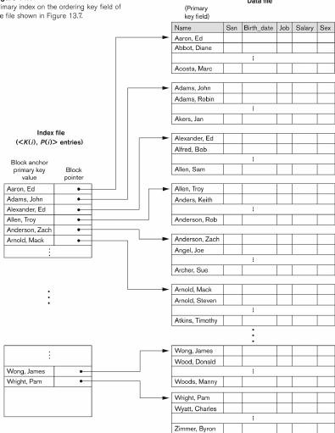

The diagram shows the index file on the left with entries mapping primary keys to block pointers in the data file.

Clustering Index 🌐
A clustering index is defined on a non‑key ordering field. It contains one entry for each distinct value of that field, pointing to the first block that holds records with that value. Like the primary index, it is also sparse, but insertion and deletion are simpler because the ordering field need not be unique.

Example 1 – Clustering index on DEPTNUMBER

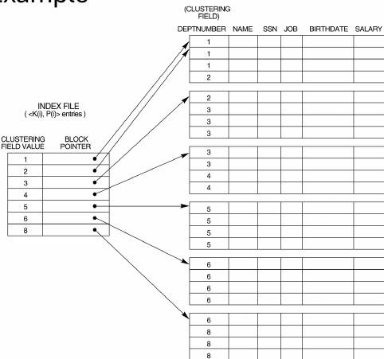

The left side lists clustering field values (1‑8) with block pointers; the right side shows the data blocks grouped by those values.
Example 2 – Separate block clusters for each clustering value

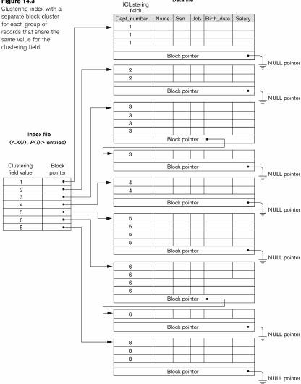

Each index entry points to a block cluster containing all records sharing the same department number.

Secondary Index 🔎

A secondary index offers an additional access path to a file that already has a primary access method. It may be built on a candidate key (unique) or a non‑key (duplicates). The index file is ordered and typically dense, containing one entry for each record.

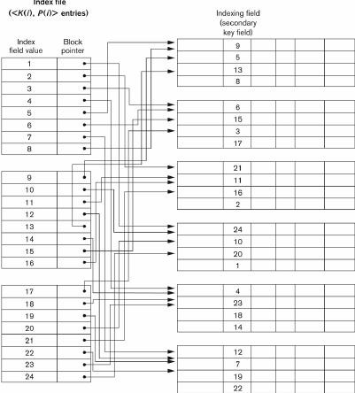

Shows an index file with field values, block pointers, and the secondary key.
Secondary index with indirection – the index points to blocks of record pointers rather than directly to records.

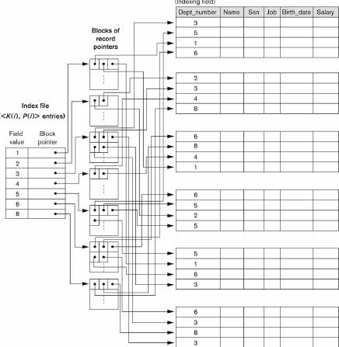

Illustrates how entries map to blocks that contain the actual record pointers.

📊 Properties of Index Types

Index Type | First‑Level Entries | Dense? | Anchor on Data File? | Nondense?
Primary | One per block | No | Yes (key of first/last record) | Yes
Clustering | One per distinct ordering‑field value | No | Yes (non‑key ordering) | Yes

Secondary | One per record | Yes | No (independent of data‑file order) | No
Every distinct value of the ordering field starts a new block in primary and clustering indexes; secondary indexes are dense, covering every record.

🏗 Multi‑Level Indexes
When a single‑level index spans many blocks, it can be indexed itself:
- First‑level index – the original index file.
- Second‑level index – an index on the first‑level index.
- Additional levels can be added until the topmost index fits in a single disk
block.
Two‑Level Primary Index Example

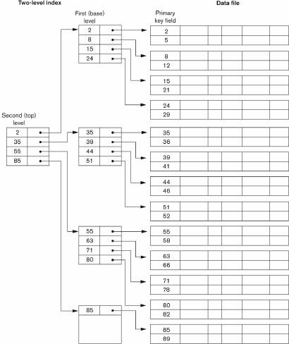

The lower level contains block anchors (2, 8, 15, 24) pointing to data; the upper level points to those anchors, reducing the number of disk I/O operations.

🌳 B‑Tree and B⁺‑Tree Indexes
Why B‑Tree / B⁺‑Tree?
- Provide dynamic multi‑level indexing.
- Support efficient insertion and deletion while keeping nodes between half‑full and completely full.
- Each node corresponds to a disk block.
B⁺‑Tree Characteristics
- Balanced: all root‑to‑leaf paths have equal length.

- Non‑leaf nodes have between $\lceil n/2\rceil$ and $n$ children (where $n$ is the order).
- Leaf nodes store actual data pointers and are linked via a doubly‑linked list for fast range queries.
- Leaf occupancy ≥ 50 % of the maximum.
B‑Tree Example (order $n=4$)

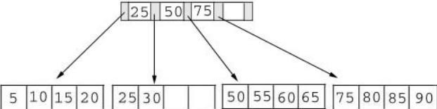

Root contains keys 25, 50, 75; each child covers a numeric range. Searching for 45 or 55 follows the appropriate branch.

Insertion Process
- Locate the appropriate leaf.
- Insert the key in sorted order.
- If the leaf exceeds capacity, split it and promote the middle key to the parent.
- Propagate splits upward as needed.

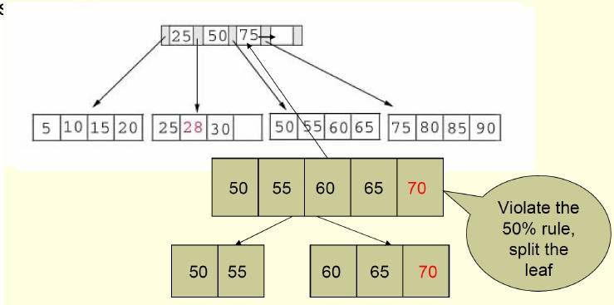

The leaf node (50 55 60 65 70) violates the 50 % rule, so it splits into two leaves (50 55) and (60 65 70).
Insertion Algorithm Summary

Situation | Action
Leaf page not full | Insert key in sorted position.
Leaf page full | Split leaf; promote middle key to index page.
Index page full after promotion | Split index page and continue upward.
Deletion Process
- Remove the key from the leaf.
- If the leaf falls below the minimum fill, borrow from a sibling or merge with a sibling, updating the parent accordingly.
- Propagate merges upward if necessary.

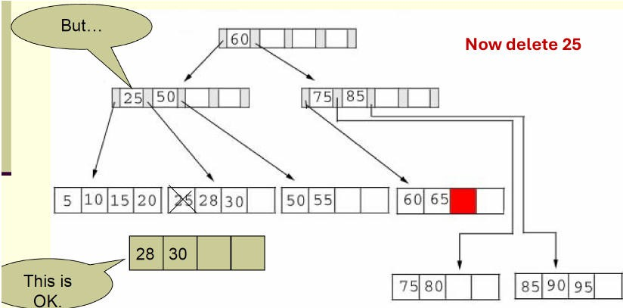

The node containing 25 is deleted; its sibling (28 30) absorbs the gap, maintaining the tree balance.
Deletion Algorithm Summary

Situation | Action
Leaf page still ≥ minimum fill | Delete key; re‑order remaining keys.
Leaf underfull | Combine with sibling; adjust parent index entries.
Parent underfull after combine | Recursively combine or redistribute upward.

📐 Designing B / B⁺ Trees
Maximum keys per node: $n h$ (where $h$ = height, $n$ = order).
Minimum keys per node: $2\bigl(\frac{n}{2}\bigr)^{h-1}$ . Example order $n = 200$
Each leaf can hold up to 199 keys.
Assuming the root has at least 100 children:
- 2‑level B⁺ tree → ≥ 100 leaves × ≥ 99 keys ≈ 9 900 records.
- 3‑level B⁺ tree → about 1 million keys.
- 4‑level B⁺ tree → up to 100 million keys.
These capacities illustrate how B⁺‑trees scale efficiently with modest growth in height.

📚 Recursive Queries in SQL
Brief Overview
This note covers recursive relational queries and was created from a 24‑page PDF presentation. It covers SQL expressiveness for flight paths, recursive CTEs in PostgreSQL, Datalog basics, and fixpoint evaluation methods.

Key Points
Understanding how SQL limits stopovers versus using recursion for unbounded paths
Implementing reachability with recursive CTEs in PostgreSQL
Comparing naive and semi‑naive fixpoint evaluation strategies
Grasping Datalog’s least fixpoint semantics for family‑tree examples

Expressiveness of SQL 🚀
Direct flight

Definition: Checks whether there is a flight from City1 to City2 without any stopovers.
SELECT *
FROM flight
WHERE from = 'City1' AND to = 'City2';

At most one stopover

Definition: Determines if a route exists with either a direct flight or exactly one intermediate city.
SELECT *
FROM flight
WHERE (from = 'City1' AND to = 'City2') OR EXISTS (
SELECT 1
FROM flight f1
JOIN flight f2 ON f1.to = f2.from
WHERE f1.from = 'City1' AND f2.to = 'City2'
);

At most two stopovers

Definition: Extends the previous idea to allow two intermediate cities.
SELECT *
FROM flight
WHERE (from = 'City1' AND to = 'City2') OR EXISTS (
SELECT 1
FROM flight f1
JOIN flight f2 ON f1.to = f2.from
WHERE f1.from = 'City1' AND f2.to = 'City2'
)
OR EXISTS (
SELECT 1
FROM flight f1
JOIN flight f2 ON f1.to = f2.from JOIN flight f3 ON f2.to = f3.from
WHERE f1.from = 'City1' AND f3.to = 'City2'
);
General k stopovers

Observation: Requires k + 1 tuple variables; the query size grows linearly with k.

Unbounded stopovers

Result: Cannot be expressed in basic SQL; needs recursion.

Recursive Relational Queries 🔁
Definition: A recursive query computes the transitive closure of a relation, i.e., all pairs of nodes reachable via any length of directed path.

Graph Example
The diagram below illustrates a simple directed graph used to explain reachability.

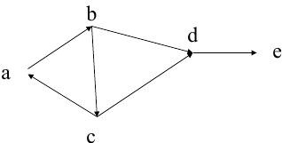

The image shows five nodes (a‑e) connected by directed edges, forming a path that can be traversed to demonstrate recursive reachability.

Edge (from → to)
a → b
a → d
a → e
b → d
b → e
…
The task is to find all ordered pairs ⟨x, y⟩ such that a directed path exists from x to y.

Datalog Foundations 📚
Definition: Datalog expresses inference declaratively via rules; evaluation follows the least fixpoint semantics.

Family Relation Example
% Base facts
person('Alice', 'Bob', 'Carol').
person('Bob', 'David', 'Emma' ).
person('Carol', 'Frank', 'Grace').
person('Henry', 'Bob', 'Carol').

% Parent relation derived from family facts parent(C, P) :- person(C, P, _).
parent(C, P) :- person(C, _, P).

% Recursive ancestor definition

ancestor(C, A) :- parent(C, A).
ancestor(C, A) :- parent(C, X), ancestor(X, A).

Definition: A least fixpoint (LFP) is the smallest set of facts that satisfies all Datalog rules. It is reached by repeatedly applying the immediate consequence operator until no new facts appear.

Fixpoint Evaluation 🛠
Naïve Evaluation
R = BaseFacts; REPEAT
New = ApplyRules(R); R = R UNION New;
UNTIL New IS EMPTY;

Recomputes joins over the entire relation each iteration.
Leads to many redundant matches, especially on large graphs.
Semi‑Naïve Evaluation (Δ‑based)
Δ0 = BaseFacts; R = Δ0;
REPEAT
Δnext = ApplyRules(Δ, R) MINUS R; R = R UNION Δnext;
Δ = Δnext; UNTIL Δ IS EMPTY;

Uses only newly derived tuples (Δ) from the previous iteration.
Guarantees each tuple participates in a join exactly once.
Δ‑Table Example (Family Tree)

Iteration | Δ contents (new pairs)
0 | (Alice, Bob), (Alice, Carol)
1 | (Bob, David), (Bob, Emma)
2 | (Alice, David), (Alice, Emma)
3 | (Alice, Frank), (Alice, Grace)
… | …

final | ∅ (no new tuples)
The fixpoint is the union of all Δ tables.

Recursive Queries in PostgreSQL 🐘
Schema & Data
CREATE TABLE family ( person TEXT, father TEXT, mother TEXT
);

INSERT INTO family VALUES
('Alice','Bob','Carol'),
('Bob','David','Emma'),
('Carol','Frank','Grace'),
('Henry','Bob','Carol');

Binary parent Relation (CTE)
WITH parent AS (
SELECT person AS child, father AS parent FROM family WHERE father IS NOT NULL UNION ALL
SELECT person AS child, mother AS parent FROM family WHERE mother IS NOT NULL
)
SELECT * FROM parent;

child | parent
Alice | Bob
Alice | Carol
Bob | David
Bob | Emma
Carol | Frank
Carol | Grace
Henry | Bob
Henry | Carol
Ancestor Query (Depth‑agnostic)

WITH RECURSIVE
parent(child, parent) AS (
SELECT person, father FROM family WHERE father IS NOT NULL UNION ALL
SELECT person, mother FROM family WHERE mother IS NOT NULL
),
ancestor(child, ancestor) AS (
SELECT child, parent FROM parent UNION
SELECT p.child, a.ancestor FROM parent p
JOIN ancestor a ON p.parent = a.child
WHERE p.child <> a.ancestor
-- base case
-- recursive step
-- avoid cycles
)
SELECT DISTINCT child, ancestor FROM ancestor
ORDER BY child, ancestor;

Ancestor Query with Depth
WITH RECURSIVE
parent(child, parent) AS ( …same as above… ), ancestors(child, ancestor, depth) AS (
SELECT child, parent, 1 FROM parent UNION
SELECT p.child, a.ancestor, a.depth + 1 FROM parent p
JOIN ancestors a ON p.parent = a.child WHERE p.child <> a.ancestor
)
SELECT DISTINCT child, ancestor, depth FROM ancestors
ORDER BY child, depth;
-- base depth = 1

Graph Reachability (Any Number of Stopovers)
WITH RECURSIVE reachable(origin, destination, stops) AS ( SELECT origin, destination, 0 FROM flights
UNION
SELECT r.origin, f.destination, r.stops + 1 FROM reachable r
JOIN flights f ON r.destination = f.origin WHERE r.origin <> f.destination
)
SELECT DISTINCT origin, destination, stops FROM reachable
ORDER BY origin, destination, stops;
-- direct flights
-- avoid self‑loops

Origin | Destination | Stops
San Diego | Los Angeles | 0
San Diego | Denver | 1
San Diego | Chicago | 2
San Diego | New York | 3
Los Angeles | Denver | 0
Los Angeles | Chicago | 1
Los Angeles | New York | 2
Denver | Chicago | 0
Denver | New York | 1

Existence Check for a Specific Route
WITH RECURSIVE reachable AS (
SELECT origin, destination FROM flights UNION
SELECT r.origin, f.destination FROM reachable r
JOIN flights f ON r.destination = f.origin
)
SELECT EXISTS (
SELECT 1 FROM reachable
WHERE origin = 'San Diego' AND destination = 'New York'
) AS flight_exists;

Avoiding Cycles (Path Enumeration)
WITH RECURSIVE reachable(origin, destination, path) AS (
-- Anchor: direct flights
SELECT origin, destination, ARRAY[origin, destination] FROM flights
UNION ALL
-- Recursive step: extend path by one flight, prevent revisiting cities SELECT r.origin, f.destination, path || f.destination
FROM reachable r
JOIN flights f ON r.destination = f.origin WHERE NOT f.destination = ANY(r.path)
)
SELECT origin, destination, path FROM reachable;

Origin | Destination | Path
San Diego | Los Angeles | {San Diego, Los Angeles}
San Diego | Denver | {San Diego, Los Angeles, Denver}
San Diego | Chicago | {San Diego, Los Angeles, Denver, Chicago}
San Diego | New York | {San Diego, Los Angeles, Denver, Chicago, New York}
Los Angeles | Denver | {Los Angeles, Denver}
… | … | …

📚 🔍 Relational Calculus Primer

Brief Overview
This note covers relational calculus and was created from a 28‑page PDF presentation. It includes historical background, translation to SQL, example queries, and variable scoping in tuple calculus.

Key Points
- The evolution from Frege, Tarski, to Codd and the algebraic foundation of relational databases.
- Predicate logic definitions and concrete examples such as even and prime numbers.
- Syntax and semantics of tuple relational calculus, including atomic conditions and quantifiers.
- Techniques for translating universal quantification into SQL using NOT EXISTS and NOT IN.

📚 Origins of Relational Calculus
- Frege – developed first‑order (FO) logic.
- Tarski – provided an algebraic foundation for FO logic.
- Codd – introduced relational databases, using FO logic as the theoretical core.

🔍 Relational Calculus Overview
Definition: A logic‑based query language that specifies what data to retrieve rather than how to retrieve it. It models data manipulation at the heart of SQL.

- General form:
${,t \mid \text{property}(t),}$
where property(t) is expressed in predicate calculus (first‑order logic).
📐 Predicate Calculus Examples

- Even numbers:
${,x \mid \exists y;(x = 2 \times y),}$
- Prime numbers:
${,x \mid x \neq 1 ;\wedge; \forall y,\forall z,[,x = y \times z ;\Rightarrow; (y =
1 \vee z = 1),],}$ Symbols:
- $\exists$ – “there exists” (existential quantifier)
- $\forall$ – “for all” (universal quantifier)

🗂 Tuples in Relational Calculus
- Tuple membership is written $m \in R$ (“tuple m is in relation R”).
- Example table movie:
SQL: SELECT * FROM movie
Tuple view: “The answer consists of tuples m such that m ∈ movie.”

📋 Example Queries

Directors & Actors of Currently Playing Movies
Tuple calculus expression
$ {,t : \text{Director}, \text{Actor} \mid \exists m \in \text{movie};\exists s \in
\text{schedule}; [, t(\text{Director}) = m(\text{Director}) ,\wedge, t(\text{Actor}) = m(\text{Actor}) ,\wedge, m(\text{Title}) = s(\text{Title}) ,] ,} $

Universal Quantification Example
“Every director is also an actor”
$ \forall m \in \text{movie};\exists t \in \text{movie}; [, m(\text{Director}) = t(\text{Actor}) ,] $
The query evaluates to true or false.

✏ Tuple Relational Calculus Syntax

- Tuple variables: $t, s, \dots$
- Atomic conditions (atoms):
  - $t(A) = \text{constant}$, $t(A) \neq \text{constant}$, $t(A) \ge
\text{constant}$
  - $t(A) = s(B)$, $t(A) \neq s(B)$
- Boolean operators: $\land$, $\lor$, $\lnot$ (with abbreviation $p \rightarrow q \equiv \lnot p \lor q$)
- Quantifiers:
  - Existential: $\exists t \in R; \phi(t)$
  - Universal: $\forall t \in R; \phi(t)$

📊 Free and Bound Variables
- Scope of a quantifier is the formula that follows it.
- A free variable is not bound by any quantifier; it acts as a parameter of the formula.
Example
$ {,t : \text{Director}, \text{Actor} \mid \exists m \in \text{movie};\exists s \in
\text{schedule}; [,\dots,] ,} $
- Free variables: $t$ (the answer tuple).
- Bound variables: $m$, $s$ (introduced by $\exists$).

📑 Tuple Calculus Query Form
$ {,t : \langle\text{attributes}\rangle \mid \phi(t) ,} $
- $\phi(t)$ contains only one free variable ($t$).
- The result is a table with the listed attributes, containing all tuples $v$ for which
$\phi(v)$ evaluates to true.
- If the range of $t$ isn’t explicitly given, it defaults to the active domain (all values present in the database or mentioned in the query).

🎬 Movie Database Example Queries

Query | Tuple Calculus
Titles of currently playing movies | ${,t:\text{title} \mid \exists s \in  \text{schedule};[,s(\text{title}) = t(\text{title}),] ,}$

Titles of movies directed by Berto | ${,t:\text{title} \mid \exists m \in  \text{movie};[,m(\text{director}) =  \text{“Berto”} ,\wedge, t(\text{title}) = m(\text{title}),] ,}$
Title & director of currently playing movies | ${,t:\text{title},\text{director} \mid  \exists s \in \text{schedule};\exists m \in  \text{movie};[,s(\text{title}) = m(\text{title}) ,\wedge, t(\text{title}) = m(\text{title}) ,\wedge, t(\text{director})  = m(\text{director}),] ,}$
Employees with the highest salary | ${,x:\text{name} \mid \exists y \in  \text{employee};[,x(\text{name}) = y(\text{name}) ,\wedge, \forall z \in  \text{employee};(y(\text{salary}) \ge z(\text{salary})),] ,}$
Actors appearing in every movie by Berto | ${,a:\text{actor} \mid \exists y \in  \text{movie};[,a(\text{actor}) = y(\text{actor}) ,\wedge, \forall m \in  \text{movie};(m(\text{director}) =  \text{“Berto”} \rightarrow \exists t \in  \text{movie};(m(\text{title}) = t(\text{title}) ,\wedge, t(\text{actor}) = y(\text{actor}))),] ,}$

Visualizing Universal Quantification
The following diagram illustrates the typical pattern ∀ m ∈ R [ filter(m) → property(m) ]:

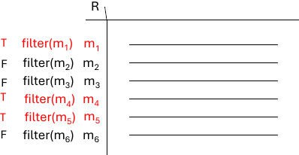

Rows marked T satisfy the filter; the corresponding property(m) column shows the evaluated condition. Rows marked F are irrelevant (“don’t care”).

🔄 Translating to SQL

Basic SQL Template
SELECT A1, …, An FROM R1, …, Rk
WHERE cond(R1, …, Rk);
- Each tuple combination $(r_1,\dots,r_k)$ that satisfies cond yields a result row.
- The SQL form implicitly uses only existential quantification; there is no direct
∀ construct.
Example: Theaters Showing Movies by Bertolucci
- SQL
SELECT s.theater
FROM schedule s, movie m WHERE s.title = m.title
AND m.director = 'Bertolucci';
- Tuple calculus
$ {,t:\text{theater} \mid \exists s \in \text{schedule};\exists m \in
\text{movie}; [,t(\text{theater}) = s(\text{theater}) ,\wedge, s(\text{title}) = m(\text{title}) ,\wedge, m(\text{director}) = \text{“Bertolucci”},] ,} $

Eliminating Universal Quantifiers
Logical equivalence:
$ \forall x \in R;\phi(x) ;\equiv; \lnot\exists x \in R;\lnot\phi(x) $
Image illustrating the equivalence:

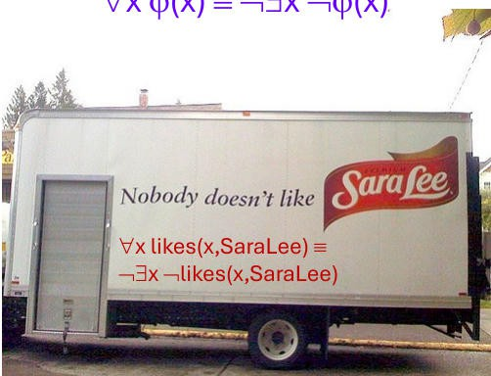

The diagram shows how a universal statement can be rewritten as the negation of an existential violation.

Converting the “Actors in Every Berto Movie” Query
Tuple calculus (with ∀)
$ {,a:\text{actor} \mid \exists y \in \text{movie}; [,a(\text{actor}) = y(\text{actor})
,\wedge, \forall m \in \text{movie};(m(\text{director}) = \text{“Berto”} \rightarrow
\exists t \in \text{movie};(m(\text{title}) = t(\text{title}) ,\wedge, t(\text{actor}) = y(\text{actor}))) ] ,} $
After eliminating ∀
$ {,a:\text{actor} \mid \exists y \in \text{movie}; [,a(\text{actor}) = y(\text{actor})
,\wedge, \lnot\exists m \in \text{movie};(m(\text{director}) = \text{“Berto”} ,\wedge,
\lnot\exists t \in \text{movie};(m(\text{title}) = t(\text{title}) ,\wedge, t(\text{actor}) = y(\text{actor}))) ] ,} $
Corresponding SQL (using NOT EXISTS)
SELECT y.actor FROM movie y
WHERE NOT EXISTS ( SELECT *
FROM movie m

WHERE m.director = 'Berto' AND NOT EXISTS (
SELECT *
FROM movie t
WHERE t.title = m.title AND t.actor = y.actor
)
);
Alternative SQL (using NOT IN)
SELECT actor FROM movie
WHERE actor NOT IN ( SELECT s.actor
FROM movie s, movie m WHERE s.title = m.title
AND m.director = 'Berto' AND s.actor NOT IN (
SELECT t.actor FROM movie t
WHERE t.title = m.title
)
);
- The ability to mix ∃ and ∀ in tuple calculus provides greater expressive flexibility than standard SQL, which must simulate universal quantification via negated existential subqueries.

📊 Database Normalization Overview

Brief Overview
This note covers Database Design and was created from a PDF presentation.
It focuses on Universal schema, anomaly identification, functional dependencies, and design guidelines for lossless joins.

Key Points
- Identify insertion, deletion, and update anomalies.
- Decompose the universal relation into Supplier, Part, and Shipment tables.
- Apply Armstrong’s axioms to determine keys and dependencies.
- Verify lossless‑join properties and key minimality.

📦 Universal Schema & Data

Universal schema – a single relation that attempts to store all information about suppliers, parts, and shipments in one table.

Attribute | Meaning
S# | Supplier number
SNAME | Supplier name
SCITY | Supplier city
P# | Part number
PNAME | Part name
PCITY | City where part is stored
QTY | Quantity of shipment
Example tuples

S# | SNAME | SCITY | P# | PNAME | PCITY | QTY
S1 | Smith | London | P1 | Nut | London | 100

S1 | Smith | London | P2 | Bolt | Paris | 150
S2 | Adams | Paris | P1 | Nut | London | 200
S3 | Blake | Rome | P3 | Screw | Rome | 250
S4 | Clark | Paris | P2 | Bolt | Paris | 300

⚠ Anomalies in the Universal Relation
🚩 Insertion Anomaly

When a new supplier or part cannot be added without also inserting a shipment record.

- Adding supplier S5 (Jones, Berlin) requires a fake shipment (e.g., QTY = 0) because P# and QTY cannot be null.
🚩 Deletion Anomaly

Removing the last shipment of a supplier (or part) deletes the entity’s information.

- If Smith (S1) only supplies P1 and P2 and both rows are deleted, the database loses all data about supplier S1.
🚩 Update Anomaly

Redundant storage leads to inconsistent updates.

- Supplier city for S1 appears in multiple rows. Changing SCITY from London to Berlin requires updating every tuple with S# = S1; missing any row creates inconsistency.
📋 Summary of Anomalies

Anomaly | Description | Example in BAD schema

Insertion | Cannot add new supplier/part without a shipment | Must insert fake QTY for S5
Deletion | Deleting last shipment erases entity info | Removing both S1 rows deletes supplier S1
Update | Redundant data causes inconsistent values | SCITY for S1 stored in several rows

🗂 Hidden Conceptual Relations
The universal relation actually contains three logical relations:

Relation | Meaning
S | Supplier information (S#, SNAME, SCITY)
P | Part information (P#, PNAME, PCITY)
SP | Shipment linking supplier and part (S#, P#, QTY)

📏 Design Guidelines
Clear Semantics (Guideline 1)

Each tuple should represent one entity or one relationship instance.

- Do not mix attributes of different entities in the same relation.
- Use foreign keys only to reference other entities.
Avoid Anomalies (Guideline 2)

Design schemas that are free from insertion, deletion, and update anomalies.

- If anomalies exist, they must be documented for application handling.

Minimize NULLs (Guideline 3)

Reduce the occurrence of NULL values by separating frequently‑null attributes into their own relations (or weak entities).

Lossless Join & No Spurious Tuples (Guideline 4)

Decompositions must satisfy the lossless‑join property; natural joins should never produce extra (spurious) tuples.

🔗 Functional Dependencies (FDs)

Functional dependency $X \rightarrow Y$ holds in relation $R$ if any two tuples agreeing on attributes $X$ also agree on attributes $Y$ .

Formal Statement
- For all tuples $t_1, t_2 \in R$:
$t_1[X] = t_2[X] ;\Rightarrow; t_1[Y] = t_2[Y]$ .

Example Table & Derived FDs

A | B | C | D
a | 1 | 40 | 100
a | 1 | 40 | 100
b | 3 | 20 | 100
b | 3 | 20 | 100
c | 5 | 30 | 300
c | 5 | 20 | 300
c | 5 | 30 | 300
Derived FDs (non‑exhaustive):

- $A \rightarrow B$
- $B \rightarrow A$
- $A \rightarrow C$
- $A \rightarrow D$
- $D \rightarrow A$
- $B \rightarrow D$
- $D B \rightarrow A$

Armstrong’s Axioms (Inference Rules)

Rule | Description
Reflexive ($\text{IR1}$) | If $Y \subseteq X$, then $X \rightarrow Y$ .
Augmentation ($\text{IR2}$) | If $X \rightarrow Y$, then $XZ  \rightarrow YZ$ (where $Z$ is any set of attributes).
Transitive ($\text{IR3}$) | If $X \rightarrow Y$ and $Y \rightarrow Z$, then $X \rightarrow Z$ .
Additional derived rules:
- Union: $X \rightarrow Y$ and $X \rightarrow Z$ $\Rightarrow$ $X \rightarrow YZ$ .
- Decomposition: $X \rightarrow YZ$ $\Rightarrow$ $X \rightarrow Y$ and $X
\rightarrow Z$ (right‑hand side only).

Closure Concepts
- FD closure $F^{+}$: all FDs that can be inferred from a set $F$ .
- Attribute closure $X^{+}$ (w.r.t. $F$): all attributes functionally determined by
$X$ .
- Compute $X^{+}$ by repeatedly applying IR1–IR3; linear‑time algorithm exists.

🔑 Keys & Superkeys

Superkey – a set of attributes $S$ such that no two distinct tuples share the same $S$ values.

Key – a minimal superkey; removing any attribute from a key destroys the uniqueness property.

- For any key $K$ of relation $R$, the FD $K \rightarrow R$ holds.

🔀 Decomposition & Lossless Join

Spurious Tuple Example
Decomposition:
- $R_1(S#, SNAME, SCITY, QTY)$
- $R_2(P#, PNAME, PCITY, QTY)$
Natural join of $R_1$ and $R_2$ yields extra rows because QTY is not a reliable join attribute.

Lossless‑Join Property
  - A decomposition is lossless if joining the projected relations recreates the original relation without extra tuples.
  - Preserve functional dependencies whenever possible; losslessness is mandatory, while FD preservation can be relaxed.

Decomposition Algorithm (Sketch)
- Unfold each projection into an atom with fresh variables for non‑projected attributes.
- Apply all known FDs: propagate equalities across atoms that share determining attributes.
- Remove redundant atoms whose attributes are fully determined by others.
- Read off the remaining atom(s); if a single atom remains, the decomposition is lossless.

📚 Minimal Cover (Canonical Cover) of FDs

A minimal set of FDs satisfies:
  - Right‑hand side of each FD is a single attribute.
  - No FD can be removed without changing the closure.

  - No left‑hand attribute can be removed while preserving equivalence.

- Every FD set has at least one equivalent minimal cover (canonical cover).
- Multiple minimal covers may exist; computing one is non‑trivial and not covered here.

🧩 Example Problems

Determining Keys
Relation $R(E, F, G, H, I, J, K, L, M, N)$ with FDs:
- $E \rightarrow G$
- $F \rightarrow I J$
- $H \rightarrow L$
- $K \rightarrow M$
- $L \rightarrow N$
Key search (illustrative steps):
  - Compute closures, e.g., $(E, F)^{+} = {E, F, G, I, J}$; adding $H$, $K$, $L$ expands to all attributes, giving a candidate key ${E, F, H, K, L}$ .

Equivalence of FD Sets
Two FD sets $F$ and $G$ are equivalent iff $F^{+} = G^{+}$ .
  - $F$ covers $G$ when $G^{+} \subseteq F^{+}$ .
  - Equivalence ⇔ each covers the other.

📚 🗂 Normalization Deep Dive

Brief Overview
This note covers database normalization and was created from a 70‑page PDF presentation. It discusses functional dependencies, lossless‑join testing, dependency preservation, BCNF, and 4NF.

Key Points
  - Understand functional dependencies and how they drive decomposition.
  - Learn practical tests for lossless‑join and dependency preservation.
  - Follow step‑by‑step algorithms for moving schemas into BCNF, 3NF, and 4NF/5NF.
  - See real‑world examples that illustrate partial, transitive, and multivalued dependencies.

Dependencies and Decomposition 📚
  - Lossless join – the original relation can be reconstructed exactly from the decomposed sub‑relations.
  - Dependency preservation – every functional dependency (FD) in the original set F can be enforced by checking constraints in at least one of the sub‑relations, without recomputing joins.
  - Local dependency – a dependency (functional, multivalued, etc.) that involves only attributes of a single sub‑relation in a decomposition.

Definition: A decomposition ρ = (R₁,…,R_k) of a relation R is lossless if the natural join of all R_i yields exactly R.

Example:
Relation R(A,B,C,D) with FDs F = {A → B, B → C, C → D}.
  - Decomposition R₁(A,B,C), R₂(C,D) preserves the dependencies locally.
  - Decomposition R₁(A,B,C), R₂(A,D) does not preserve them locally.

Dependency‑Preserving Decompositions ✅

Formal definition:
Let ρ = (R₁,…,R_k) be a decomposition of R and F a set of FDs over R. ρ preserves F iff
$ \bigcup_{i=1}^{k}\pi_{R_i}(F^{+}) \equiv F $
In words, the closure of the projection of F onto each sub‑relation must imply all dependencies in F.

Testing Preservation of Dependencies 🔍
Naïve method (impractical):
- Compute the full closure F⁺ (size can be exponential).
- Form G = \bigcup_{i=1}^{k} \pi_{R_i}(F⁺).
- Verify that F ⊆ G⁺.
Improved method (polynomial‑time):

- For each FD X → Y in F:
  - Initialise Z := X.
  - While Z changes:
    - For each sub‑relation R_i:
      - Update Z := Z ∪ ((Z ∩ R_i)^{+} ∩ R_i) (the “+” is taken w.r.t. F).
  - If Y ⊄ Z, output “no” (dependency not preserved).
- If all FDs pass, output “yes”.

Full Example of Dependency Preservation
Relation: $R = {A,B,C,D}$ Decomposition: ρ = {AB, BC, CD}
FD set: $F = {A → B,; B → C,; C → D,; D → A}$

- Local FDs $A → B$, $B → C$, $C → D$ are trivially preserved.
- To test $D → A$:
- Start with $Z = D$ .
- Using CD, add $C$ (since $D → C$ is local).
- Using BC, add $B$ (now $C → B$).

- Using AB, add $A$ (now $B → A$).
$A$ is reached, so $D → A$ is preserved.

Normalization Overview 🧩
- Normalization – the process of decomposing “bad” relations into smaller, well‑structured relations.
- Normal form – a condition, expressed in terms of keys and functional (or multi‑valued) dependencies, that a relation schema must satisfy.

Normal Forms Summary 📊

Normal Form | Key Requirement | Dependency Type
1NF | All attribute values are atomic | –
2NF | Every non‑prime attribute fully depends on the whole candidate key | Full functional dependencies
3NF | No non‑prime attribute is transitively dependent on a candidate key | Transitive FDs
BCNF | For every non‑trivial FD $X  → Y$, X is a superkey | –
4NF | No non‑trivial multi‑valued dependency with a non‑superkey left side | MVDs
5NF | No non‑trivial join dependency with a non‑superkey left side | JDs
Additional design goals: lossless join and dependency preservation.

Keys, Superkeys, and Attributes 🔑

Superkey: A set of attributes S ⊆ R such that no two distinct tuples in any legal state of R agree on all attributes of S.

Key: A minimal superkey; removing any attribute from a key destroys the superkey property.

- Candidate key – any key of the relation.
- Primary key – arbitrarily chosen candidate key.
- Prime attribute – an attribute that belongs to at least one candidate key.
- Non‑prime attribute – an attribute that belongs to no candidate key.

Functional Dependency Concepts 📈
Full functional dependency (FFD): An FD $Y → Z$ is full if removing any attribute from Y makes the dependency false.

- Partial dependency – a functional dependency where a proper subset of the left‑hand side determines the right‑hand side.
Example:
- ${SSN, PNUMBER} → HOURS$ is a full FD (neither $SSN → HOURS$ nor
$PNUMBER → HOURS$ holds).
- ${SSN, PNUMBER} → ENAME$ is a partial dependency because $SSN → ENAME$ also holds.

First Normal Form (1NF) 🗂
1NF: Every cell contains an atomic (indivisible) value; no repeating groups or nested relations.

- No grouping of information inside a cell.
- No duplicate rows (theoretical).
- Every cell must contain a value (no nulls).
Non‑1NF example: a table with a Phone column that stores multiple phone numbers in a single cell.

Second Normal Form (2NF) 📚
2NF: A relation is in 2NF if it is in 1NF and every non‑prime attribute is fully functionally dependent on every candidate key.

Identifying 2NF Violations
- Check each FD $X → Y$: if X is a proper subset of a candidate key and Y is non‑prime, the relation violates 2NF.

Example: Electric Toothbrush Manufacturers

Manufacturer | Model | Model Full Name | Country
Forte | X‑Prime | Forte X‑Prime | Italy
Forte | Ultraclean | Forte Ultraclean | Italy
Dent‑o‑Fresh | EZbrush | Dent‑o‑Fresh EZbrush | USA
… | … | … | …
- Candidate key: {Manufacturer, Model}.
- Dependency Manufacturer → Country is a partial dependency (left side is only part of the key).
Decomposition into 2NF:
- Manufacturer (Manufacturer, Country) – now Country fully depends on the whole key (Manufacturer is a key here).
- Model (Manufacturer, Model, ModelFullName) – all non‑prime attributes depend on the full composite key.

Visual Aid

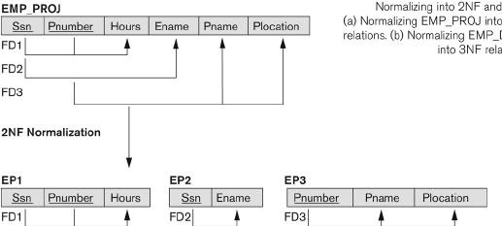

The diagram shows the original EMP_PROJ table being split into three 2NF tables (EP1, EP2, EP3) to eliminate partial dependencies.

Third Normal Form (3NF) 📘
Transitive functional dependency: An FD $X → Z$ that can be derived from $X → Y$ and $Y → Z$ .

3NF: A relation is in 3NF if it is in 2NF and no non‑prime attribute is transitively dependent on any candidate key.

Example: Music Genres
Relation R(MusicId, Title, Singer, GenreId, Genre) with FD GenreId → Genre.
- GenreId is not a key, and Genre (non‑prime) depends on GenreId via a transitive path, violating 3NF.
- Decomposition:
- R₁(MusicId, Title, Singer, GenreId)
- R₂(GenreId, Genre) – both now satisfy 3NF.

Example: Tournament Winners

Tournament | Year | Winner | WinnerDoB
Indiana Invitational | 1998 | Al Fredrickson | 21 July 1975
Cleveland Open | 1999 | Bob Albertson | 28 Sept 1968
… | … | … | …

- Candidate key: {Tournament, Year}.
- FD Winner → WinnerDoB is a transitive dependency (Winner is non‑prime). Decomposition into 3NF:
- WinnersInfo( Winner, WinnerDoB )
- TournamentResults( Tournament, Year, Winner )

Visual Aid

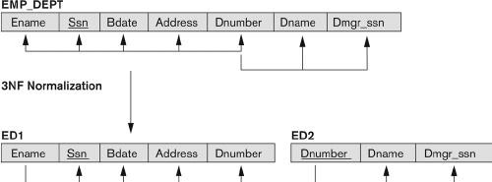

The diagram illustrates how EMP_DEPT is split into ED1 and ED2, removing the transitive dependency between Dnumber and Dmgr_ssn.

Boyce‑Codd Normal Form (BCNF) 🏆
BCNF: A relation R is in BCNF if for every non‑trivial FD $X → Y$ that holds in R, X is a superkey.

Example: favBeer
Relation Drinkers(name, addr, beersLiked, manf) with FDs:
- $name → addr$
- $name → beersLiked$
- $beersLiked → manf$ Only key: {name, beersLiked}.
- Left side of each FD is not a superkey ⇒ violation of BCNF.

BCNF Decomposition Steps
- Pick a violating FD (e.g., $name → addr$).
- Compute $name^{+}$ → {name, addr, beersLiked, manf}.
- Create:
  - R₁(name, addr, manf)
  - R₂(name, beersLiked)
- Check each new relation for BCNF; further decompose if needed (e.g.,
$beersLiked → manf$ in R₂ leads to additional tables).
Resulting schemas:
  - Drinkers1(name, addr, manf) – BCNF.
  - Drinkers3(beersLiked, manf) – BCNF.
  - Drinkers4(name, beersLiked) – BCNF.
Key Insight: Every BCNF relation is automatically in 3NF, but the converse is not true.

Algorithms for Lossless‑Join Decomposition ⚙
- Start with the set ρ = {R}.
- Iteratively select a relation S in ρ that violates BCNF.
- Find a violating FD $X → A$ where $X$ is not a superkey of S.
- Decompose S into:
  - $S₁ = X^{+}$ (attributes reachable from X).
  - $S₂ = S - (X^{+} - X)$ (remaining attributes).
- Replace S by $S₁$ and $S₂$ in ρ.
- Repeat until all schemas are in BCNF.
The decomposition is guaranteed to be lossless, though it may not preserve all original dependencies.

Example of BCNF Decomposition & Dependency Preservation Issue
Relation R( C, T, H, R, S, G ) with FDs:

$C → T$
$CS → G$

$HR → C$
$HS → R$
$TH → R$
- Key computed: HS (only key).

Decomposition steps produce schemas: CHS, CSG, CHR, CT.
- The FD $TH → R$ is not preserved in any of the resulting BCNF relations, illustrating that BCNF decomposition can lose dependency preservation.

3NF Decomposition Procedure 📐
- Canonical cover – eliminate extraneous attributes and redundant FDs.
- First‑cut decomposition – for each FD $X → A$ in the canonical cover, create a relation $R_i = X ∪ {A}$ . Add any attribute that never appears on the right‑hand side as a singleton relation.
- Ensure lossless join – if no relation already contains a key for R, add a relation consisting of a candidate key.
The resulting set of relations is dependency‑preserving, lossless, and each relation is in 3NF.

Additional Remarks 🗒
  - Non‑uniqueness: Different sequences of decomposition steps can yield different sets of relations.
  - Complexity: Deciding BCNF membership is NP‑complete; finding a BCNF decomposition that also preserves dependencies is generally impossible.
  - Practical design: Designers often stop at 3NF or BCNF (occasionally 4NF) and may deliberately denormalize for performance reasons.

Lossless‑Join Test with Added Key 🔎
Lossless‑join property: A decomposition ρ of relation R is lossless if the natural join of the sub‑relations in ρ yields exactly R (no spurious tuples).

  - Original FD set: F = { A → C, BC → D, AD → E }
  - Initial decomposition: ρ = { AC, BCD, ADE } Observation:
  - None of AC, BCD, ADE is a superkey; their closures are
    - $AC^{+} = A C$ (does not contain all attributes)
    - $BCD^{+} = B C D$
    - $ADE^{+} = A D E$
Solution: add the key AB to the decomposition.
  - AB is a key because $AB^{+} = A B C D E$ (using the three FDs in order).
  - New decomposition: ρ′ = { AC, BCD, ADE, AB }. Chase Test (illustrative):
Row | A | B | C | D | E
AC | a | – | c | – | –
BCD | – | b | c | d | –
ADE | a | – | – | – | e
AB | a | b | – | – | –
Apply FDs in the order A → C, BC → D, AD → E:
- From row AB, $A → C$ adds C → row becomes a b c – –.
- From rows AB and BCD, $BC → D$ adds D → a b c d –.
- From rows AB and ADE, $AD → E$ adds E → a b c d e.
All rows converge to the same tuple (a,b,c,d,e), confirming a lossless join for ρ′.

Schema Design Workflow Using Functional Dependencies 🛠
Design process: Choose attributes, specify functional dependencies, then decompose into normal‑form schemas that are lossless‑join and (if possible) dependency‑preserving.

- Select attributes for the target relation R.
- Specify the FD set F (use Armstrong relations to validate that the chosen FDs are exactly those that hold).
- Compute a decomposition that:
  - Is lossless‑join (e.g., via the chase test).
  - Preserves all dependencies (if possible).
  - Places each sub‑relation in a desired normal form:
    - Prefer BCNF when achievable.
    - Otherwise aim for 3NF (still dependency‑preserving).

Attributes vs. Data: Modeling Choices 📊

Design | Layout | Example Row | Typical Queries
Option 1 (single table) | **EmpName | Dept** | `Joe
Option 2 (cross‑tab) | **EmpName | Candy | PCs
Considerations
- Stability of departments: If department list changes often, a separate table (Option 2) may become cumbersome.
- Sparsity vs. density: Option 2 can be sparse (many null/false entries) leading to wasted space.
- Query ease: Simple look‑ups (Option 1) vs. set‑based queries (Option 2).

Armstrong Relations: Verifying Exact FD Sets ✔
Armstrong relation: A relation instance that satisfies exactly the functional dependencies in F⁺ (no more, no fewer).

- FD set: F = { theater → title }
- Armstrong relation instance:
Schedule | theater | title
1 | Paloma | Casablanca
2 | Hillcrest | Casablanca

- Satisfies: theater → title (each theater appears with a single title).
- Violates: title → theater (the same title “Casablanca” appears under two different theaters).
Thus the instance is an Armstrong relation for F.

Beyond Functional Dependencies: Multi‑Valued Dependencies (MVDs) 🌐
Multi‑valued dependency (MVD): $X \twoheadrightarrow Y$ holds when, for a given value of X, the set of Y values is independent of the set of other attributes.

Illustrative Example

Movie | Director | Actor
M1 | D1 | A1
M1 | D2 | A1
M1 | D1 | A2
M1 | D2 | A2
- A movie can have multiple directors and multiple actors.
- No non‑trivial FDs exist (the relation is already in BCNF).
- Redundancy remains because each director‑actor pair is repeated.

Improved Design Using MVDs
Decompose into two separate relations that capture the independent multi‑valued information:
- Directors(Title, Director)
- Actors(Title, Actor)
Both tables are in 4th Normal Form (4NF), which extends BCNF by eliminating non‑trivial MVDs whose left side is not a superkey.

Normal Forms Recap (Reference) 📚

Normal Form | Condition on FDs / MVDs | Key Requirement
BCNF | Every non‑trivial FD $X → Y$ has X as a superkey | —
4NF | Every non‑trivial MVD $X  \twoheadrightarrow Y$ has X as a superkey | —
5NF | Every non‑trivial JD (join dependency) has a superkey left side | —
As discussed earlier, BCNF guarantees lossless join but may sacrifice dependency preservation; 4NF addresses the additional redundancy caused by MVDs.

🚀 Query Planning Overview

Brief Overview
This note covers query planning and was created from 18-page PDF slides. It covers an example SQL query, logical and physical plans, cost estimation, statistics, access paths, and data layout.

Key Points
- Understand how SQL queries translate into logical and physical plans.
- Learn the roles of different physical operators and their cost considerations.
- Explore how statistics drive optimization decisions.
- Get a visual sense of how data is stored in slotted pages.

📊 Example SQL Query
SQL Statement
SELECT M.Year, COUNT(*) AS NumBest FROM Ratings R, Movies M WHERE R.MID = M.MID AND R.Stars = 5 GROUP BY M.Year ORDER BY NumBest DESC;

- Retrieves the number of 5‑star ratings per movie release year.
- Results are sorted by the count (NumBest) in descending order.

🧩 Logical Query Plan
Logical Query Plan – A tree of relational‑algebra operators that describe what must be done, without specifying how.

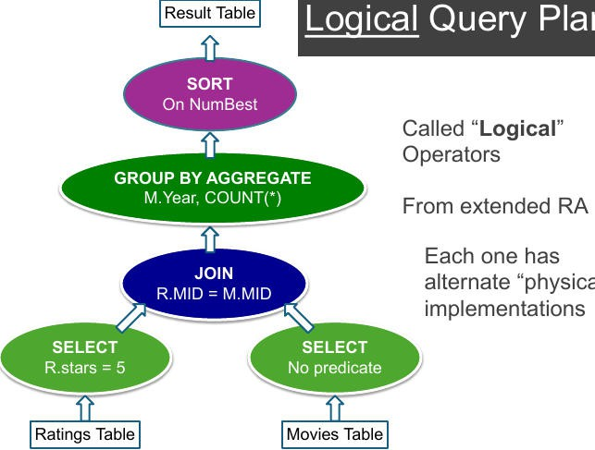

The diagram visualizes each logical step: selecting rows from Ratings and Movies, joining on MID, grouping by Year, aggregating with COUNT(*), and sorting on NumBest.
- SELECT (two green ovals) – filter R.Stars = 5 and pass through Movies rows.
- JOIN – inner join on R.MID = M.MID.
- GROUP BY AGGREGATE – group by M.Year and compute COUNT(*).
- Result Table – final sort on NumBest.

🏎 Physical Query Plan
Physical Query Plan – A tree of concrete operators that specify the exact algorithms the DBMS will execute.

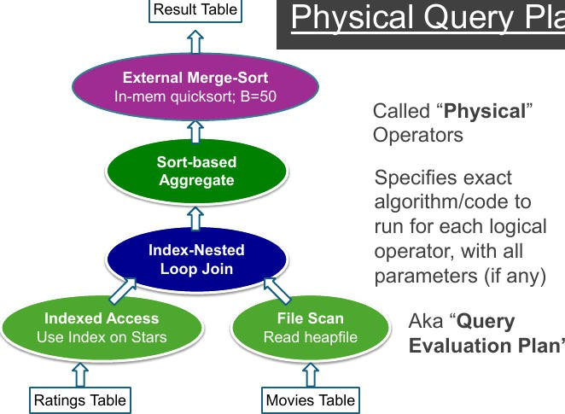

The flowchart annotates each node with the chosen algorithm (e.g., “Index‑Nested Loop Join”) and access method (e.g., “Indexed Access Use Index on Stars”).
Key operators in this plan:

Logical Operator | Physical Implementation | Notes
Select (filter on Stars) | Indexed Access (use index on Stars) | Fast lookup via index leaf pages
Join | Index‑Nested Loop Join | Uses the index on Stars for the outer relation
Aggregate | Sort‑based Aggregate (or Hash‑based in alternative plan) | Groups after sorting
Sort (final ordering) | External Merge‑Sort with in‑memory quicksort (B=50) | Handles large intermediate results
Table Scan | File Scan (heapfile) for Movies | Full sequential read
Alternative physical plan (shown later) replaces the sort‑based aggregate with a Hash‑based Aggregate and uses a Hash Join.

⚙ Components of a Physical Query Plan
Physical Operator – A low‑level database routine (scan, join, sort, etc.) with a concrete algorithm, estimated cost, output cardinality, and physical properties.

- Leaves – Access methods (SeqScan, IndexScan, BitmapScan).
- Internal nodes – Relational operators (Hash Join, Merge Join, Nested Loop Join, Sort, Hash Aggregate, Projection, Filter).
Each operator defines:
- Algorithm (e.g., quicksort, hash partitioning).
- Estimated cost (I/O + CPU + memory).
- Output cardinality (expected number of rows).
- Physical properties (ordering, partitioning, uniqueness, tuple format).

📐 Physical Properties of Operators
Physical Property – Traits of an operator’s output that influence downstream choices.

- Output Ordering – Is the result sorted? (e.g., merge join preserves order, hash join does not).
- Partitioning / Hashing – Does the output consist of hash buckets? Useful for subsequent hash‑based operators.
- Uniqueness – Are duplicate rows retained?
- Tuple Format / Row Layout – Column order, presence of system columns, materialization vs. streaming.
Understanding these properties lets the optimizer chain compatible operators and avoid unnecessary re‑ordering.

📈 Cost Model Overview
Cost Model – Formula that predicts the total execution expense of a plan.

$ \text{Cost} = \text{I/O cost} + \text{CPU cost} + \text{Memory cost} $

- I/O Cost – Page reads/writes, index traversals, sequential scan page counts, spill‑to‑disk for sorts/hashes.
- CPU Cost – Predicate evaluation, hash computations, tuple comparisons, join condition checks.
- Memory Cost – Size of hash tables, sort buffers, and whether spills to disk are required.
The optimizer selects the plan with the lowest estimated total cost.

📏 Cardinality & Selectivity Estimation
Cardinality Estimation – Predicting the number of rows produced by each operator.

- Uses statistics: total rows, NDV (number of distinct values), histograms, most‑common‑value (MCV) lists, null fractions.
- Example: predicate age > 40 → consult histogram of age to estimate percentage.
- For joins, estimate using NDV of the join attribute:
$ \text{Join size} \approx \frac{|R| \times |S|}{\text{NDV}(A)} $
- Accurate estimates reduce memory usage (smaller hash tables, fewer loop iterations) and improve overall plan quality.

📊 Statistics Utilized by the Optimizer

Statistic Type | Example Data | Impact on Planning
Base | Row count, page count, tuple width, dead vs. live rows | Determines scan costs; dead rows inflate cost if not vacuumed.
Column | NDV, histograms, MCVs, null fraction, correlation with physical order | Guides index selection, selectivity of predicates, and ordering benefits.
Index | Tree height, leaf page count, duplicate fraction, correlation with heap order | Influences choice between index scan vs. heap scan; predicts locality.

Multivariate | Multi‑column MCVs, joint histograms, functional dependencies | Helps avoid independence assumptions; improves join size estimates.
Regular VACUUM updates base statistics, keeping cost estimates realistic.

🔍 Access Path Selection
Access Path – The concrete method used to retrieve rows from a table.

Path | Typical Cost Estimate | Best Use Cases
Sequential Scan | O(#pages) | Non‑selective predicates, small tables, no suitable index.
Index Scan | O(log N) + #tuples·random I/O | Equality lookups, small ranges, moderate selectivity.
Index‑Only Scan | O(log N) (no heap reads) | All required columns are in the index.
Bitmap Index Scan | Combines multiple indexes | OR conditions, low‑selectivity ranges.
The optimizer weighs estimated selectivity against these costs to choose the optimal path.

📚 Summary of Physical Planning Steps
- Statistics lookup – Gather table, column, and index metrics.
- Cardinality estimation – Predict output sizes for each predicate and join.
- Access‑path selection – Choose scans or index accesses.
- Join ordering – Dynamic programming / memoization to explore alternatives.
- Operator choice – Pick join (hash, merge, NLJ), aggregation (hash vs. sort), and sorting methods.
- Physical operator tree generation – Assemble a rooted tree of concrete operators.

- Execution – Engine runs the tree.

📁 Data Layout: Slotted Pages
Slotted Page – On‑disk page format that stores variable‑length records with a slot directory.

  - Page Header – Metadata (page ID, free‑space pointers, record count).
  - Data Records – Variable‑length tuples stored from the top downward.
  - Slot Directory – Array of pointers at the bottom upward, each entry containing: offset, length, and optional status flags.

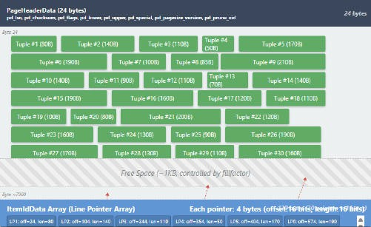

The image visualizes the header, tuple slots, and the ItemIdData array (line‑pointer array) that maps TIDs to physical record locations.

Behavior of Slotted Pages
  - Delete a tuple – Slot entry marked dead; space becomes reclaimable by VACUUM.
  - Update a tuple
    - If space permits, a new version is written in‑place (HOT update).
    - Otherwise, the tuple moves to another page; the old version stays dead, potentially causing bloat.
  - In‑page movement does not break indexes because indexes store TIDs (block number + offset), not absolute byte locations.

📖 Physical Operators Cheat Sheet

Category | Operators | Typical Use
Access Paths | Sequential Scan, Index Scan, Index‑Only Scan, Bitmap Scan | Retrieve rows from base tables.
Join Methods | Nested Loop, Index‑Nested Loop, Hash Join, Merge Join, Grace Hash Join (disk‑based) | Combine rows from two relations.
Aggregation & Sorting | Sort, Hash Aggregate, Sort‑Merge Union | Grouping, ordering, set operations.
Materialization | Materialize, Limit | Cache intermediate results, early stopping.
Parallelism | Parallel Seq Scan, Parallel Index Scan, Parallel Hash Join, Gather Merge, Parallel Append | Exploit multiple CPUs for large workloads.
These operators are combined according to the optimizer’s cost model to form the final execution plan.

📚 Query Optimization Flow

Brief Overview
This note covers SQL query optimization and was created from a 22‑page PDF presentation. It outlines the end‑to‑end flow from parsing to runtime, key logical rewrite rules, physical plan selection, and practical examples of join minimization.

Key Points
  - Understand the six‑stage query lifecycle
  - Master predicate push‑down and join re‑ordering
  - Learn how logical rewrites influence physical plans
  - See concrete examples with semi‑joins and join minimization

📊 Overall Query Processing Flow
The flowchart below visualizes the six stages a SQL query goes through from textual input to result delivery.

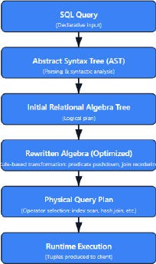
The diagram shows a top‑down progression:
- SQL Query – declarative input.
- Abstract Syntax Tree (AST) – parsing & syntactic analysis.
- Initial Relational Algebra Tree – logical plan.
- Rewritten Algebra (Optimized) – clause‑based transformations (predicate push‑down, join re‑ordering).
- Physical Query Plan – operator selection (index scan, hash‑join, etc.).

- Runtime Execution – tuples produced to the client.

🧩 Parsing & Semantic Analysis
SQL Query example: SELECT name FROM Customer WHERE city = 'Paris';
Parsing → AST

The SQL string is tokenized and parsed into a tree representing grammatical components (SELECT, FROM, WHERE). Syntax errors are caught before semantic analysis.
Semantic Analysis → Initial Relational Algebra

The AST is translated into a logical algebra tree whose nodes are abstract operators (σ = selection, π = projection, ⋈ = join). This captures the query’s meaning independently of physical storage.

📐 Logical Algebra Generation
Logical operators represent what to do, not how:
σ (selection) – filter rows.
π (projection) – keep required columns.
⋈ (join) – combine relations.
The resulting tree is the initial logical plan.

🔄 Logical Rewriting (Optimization)

Principles
Equivalence Preservation – every rewrite must return exactly the same result as the original query.
Relational Algebra as the Internal Language – rewrites are applied at the algebra

level.
Reduce Before You Join – push selections (σ) and projections (π) as early as possible. Local Transformations – most rules modify small sub‑trees.
Iterative Refinement – apply rules repeatedly until a fixpoint is reached.

Heuristic Goals
Push selections down → fewer rows enter joins.
Push projections down → narrower tuples, lower memory use.
Reorder joins using commutativity/associativity for cheaper execution orders.
Replace expensive operators (e.g., nested subqueries → semi‑joins).
Exploit constraints & keys (PK/FK, uniqueness, nullability).
Remove redundant operators (merge cascaded selections, drop unnecessary projections).

Common Rewrites
Predicate push‑down
Join re‑ordering
Eliminate redundant projections/selections
Convert IN / EXISTS subqueries to semi‑joins

📚 Equivalence Rules

Rule Type | Example (Algebra) | Description
Commutativity | σ₁ σ₂ R ≡ σ₂ σ₁ R | Order of selections does not matter.
 | R ⋈ S ≡ S ⋈ R | Join is symmetric.
 | R ∪ S ≡ S ∪ R | Union is symmetric.
Associativity | (R ⋈ S) ⋈ T ≡ R ⋈ (S ⋈  T) | Join grouping can be rearranged.
 | (R ∪ S) ∪ T ≡ R ∪ (S ∪ T) | Union grouping can be rearranged.
Selection Rules | σ_{c₁∧c₂}(R) ≡ σ_{c₁}  (σ_{c₂}(R)) | Cascade of selections.

 | σ_c(π_{L}(R)) ≡ π_{L} (σ_c(R)) if attrs(c)⊆L | Move selection above projection when attributes match.
 | σ_c(R ⋈ S) ≡ σ_c(R) ⋈  S if c references only R | Predicate push‑down through join.
Projection Rules | π_{L₁}(π_{L₂}(R)) ≡ π_{L₁}  (R) if L₁⊆L₂ | Cascade of projections.
 | π_{L₁∪L₂}(R ⋈ S) ≡ π_{L₁}  (R) ⋈ π_{L₂}(S) | Push projection below join (when safe).
Join‑Selection Interaction | R ⋈_{c}(S) ≡ σ_c(R × S) | Theta‑join equals selection over Cartesian product.
Set Operation Rules | σ_c(R ∪ S) ≡ σ_c(R) ∪ σ_c(S) | Selection distributes over union.
 | π_L(R ∪ S) ≡ π_L(R) ∪  π_L(S) | Projection distributes over union.
Rename (ρ) Rules | ρ_{A→B}(σ_c(R)) ≡ σ_{c'} (ρ_{A→B}(R)) | Rename commutes with selection (attributes in c renamed).
 | ρ_{A→B}(π_L(R)) ≡ π_{L'} (ρ_{A→B}(R)) | Rename commutes with projection.

🛠 Physical Plan Selection
Logical operators are mapped to concrete algorithms:

Logical Operator | Physical Alternatives
Scan | Seq Scan (full table) vs. Index Scan (use B‑tree/bitmap index)
Join | Nested Loop Join (row‑by‑row), Hash Join (build hash table), Merge Join (sorted inputs)
Aggregation | Hash‑aggregate, Sort‑based aggregate

Sorting | External merge sort, In‑memory quicksort
The chosen algorithms form the physical query plan, a blueprint for execution.

🚀 Execution Engine (Runtime)
Operators run as iterators, pulling tuples from child nodes.
Intermediate results stream bottom‑up (leaf → root).
Final rows are returned to the client application.

🔗 Logical ↔ Physical Optimization Connection
Logical rewriting shrinks the search space for physical plans by removing unnecessary operators and reducing intermediate cardinalities.
Early selection/projection push‑down → smaller intermediate results → fewer physical join candidates → lower I/O & memory use.
A poor logical plan (e.g., bad join order) forces the physical optimizer to consider expensive join strategies; a good logical plan enables cost‑based choices (hash, merge, index‑nested‑loop) on a simpler tree.

📈 Semi‑Join Concept
A semi‑join R ⋉ S returns all tuples of R that have at least one matching tuple in S; it does not append columns from S.

Key properties
Produces only the left‑hand relation’s attributes.
Implements existence checks (IN, EXISTS).
Reduces tuple width and intermediate result size.
Enables join reordering and selection push‑down across subquery boundaries.

🔧 Join Minimization
Goal: Eliminate joins that do not affect the result.

Redundant join: when the information it supplies is already guaranteed by other joins or constraints (PK/FK, functional dependencies).
Benefits: fewer intermediate results → faster execution.
Typical sources of redundancy
Hand‑written queries or auto‑generated SQL.
Unfolded view definitions.
Schemas with strong constraints.
Pattern folding (homomorphism) – mapping multiple variables to a single one without altering semantics.

📝 End‑to‑End Query Processing Examples

Example 1 – Customer / Order
SQL
SELECT cname FROM Customer c WHERE EXISTS (
SELECT 1
FROM OrderInfo o WHERE o.cid = c.cid
AND o.total_value > (
SELECT AVG(o2.total_value) FROM Customer c2
JOIN OrderInfo o2 ON c2.cid = o2.cid WHERE c2.city = c.city
)
);
Logical Rewrite Highlights
Selection push‑down on OrderInfo (filter by cid).
Projection push‑down (keep only needed columns).
Join re‑ordering to compute city‑wise average before applying the outer filter.
Subquery to semi‑join (EXISTS → semi‑join).
Removal of unused attributes (e.g., columns not needed for final cname).

Resulting logical plan (simplified):
π_cname ( σ_{ o.total_value > AvgCity } ( Customer □ OrderInfo ) )

where Avg City is computed via an aggregation on Customer IZ OrderInfo grouped by city.

Example 2 – Student / Course / Dept
SQL
SELECT s.sname FROM Student s
JOIN Enroll e ON s.sid = e.sid JOIN Course c ON e.cid = c.cid WHERE c.dept IN (
SELECT d.dept FROM Dept d WHERE d.chair LIKE '^Dr\.'
)
AND c.credits > (
SELECT AVG(c2.credits) FROM Course c2 WHERE c2.dept = c.dept
);
Logical Rewrite Highlights
Selection push‑down on Dept (chair LIKE '^Dr\.').
Projection push‑down (retain only dept).
IN → semi‑join: c.dept ⋉ Dept_filtered.
Join minimization – join Course with the filtered Dept first, then with Enroll, and finally with Student.
Aggregation push‑down – compute AVG(credits) per department before applying the credit filter.
Resulting join order (optimal):
((Course ⋉ Dept_filtered) □ Enroll) □ Student

📊 Summary Tables

Logical vs. Physical Optimizations

Aspect | Logical Optimization | Physical Optimization
Focus | Transform algebraic expression while preserving semantics. | Choose concrete algorithms for each operator.
Typical Techniques | Predicate push‑down, projection push‑down, join re‑ordering, semi‑join conversion. | Index scan vs. sequential scan, hash vs. merge join, parallel execution.
Effect on Search Space | Reduces size of algebra tree → fewer physical alternatives. | Explores cost‑based choices on the reduced tree.
Primary Goal | Lower cardinalities & tuple widths. | Minimize I/O, CPU, and memory usage.

📚 🗂 Relational Data & SQL Basics

Brief Overview
This note covers Relational Databases and was created from a 27-page PDF presentation. It includes a quick recap of relational model, Airbnb listings example, SQL query basics, data types, and constraint enforcement.

Key Points
Understand key relational model terminology (attributes, tuples, domains).
Apply basic SELECT queries and learn common constraints (uniqueness, primary keys).
Explore the Airbnb dataset to practice filtering, joining, and type casting.

📊 Quick Recap – Relational Data Model
A relational data model stores data in relations (tables).
Attributes → columns
Tuples → rows (records)
Domain → set of all possible values for an attribute

Attribute | Example Values
CustomerID | 1, 2, 3
CustomerName | “Google”, “Amazon”, “Apple”
Status | “Active”, “Inactive”
❌ Bad Example of Relational Data
Missing clear domain definitions for columns C2, C3, C4 leads to ambiguity.

C1 | C2 | C3 | C4
100 | John | 2022‑01‑04 | 15.3
63.85 | 21.999 | Fred | 2021‑12‑30

🏡 Our First Example – Airbnb Listings (Washington, DC)
Attributes: 62
Records: 867 (each row = one Airbnb listing)
Sample rows (truncated for brevity):

id | listing_url | name | space | room_type | price
1328195 | https://airbnb | .com“F/arbouolmouss/13 Furnished JBR/IBA” | 28195 – | Entire home/apt | $160
1422933 | https://airbnb | .com“F/arbouolmouss/14 furnished Jedcoom St!” | 22933 – | Entire home/apt | $ ?
1449253 | … | “Efficiency Dedroom” | – | Private room | $ ?
(Only a few rows shown; full table contains many listings.)

🗂 Operations in a Relational Model
Retrieve whole table → SELECT * FROM
;
  - Get a specific record → SELECT * FROM WHERE id = 1625869;
  - Project a column → SELECT column_name FROM
;
  - Select rows with condition → e.g., price < $100 and room_type = 'Entire home'
🔒 Constraints in a Relational Model
Constraint: logical rule that restricts permissible data.

Attribute domain constraint – e.g., ID cannot be negative.
Uniqueness constraint – e.g., listing_url must be unique.
Key constraint – combination of attributes uniquely identifies a row.

Example CREATE TABLE (simplified)

CREATE TABLE "Airbnb_listings" (
listing_id listing_url name summary space
description
INTEGER PRIMARY KEY,
TEXT
UNIQUE,
VARCHAR(256) NOT NULL, TEXT,
TEXT,
TEXT,
neighborhood_overview TEXT, host_id INTEGER, host_name VARCHAR(128), host_since TEXT,
city VARCHAR(256),
state CHAR(2) NOT NULL,
zipcode INTEGER,
price TEXT, weekly_price TEXT, monthly_price TEXT,
-- other columns omitted for brevity
);
📚 Standard Data Types

Category | Types
Numeric | INTEGER, NUMERIC (floating‑point)
Textual | VARCHAR(n), TEXT
Temporal | DATE, TIME, DATETIME
Geometric | POINT, LINE, POLYGON, CIRCLE
Binary | BYTEA (binary array)
Note: Operations are type‑specific (e.g., addition works on numbers, not on circles).

🛠 Basic SQL Construct
SELECT FROM WHERE ;

Result of a query is itself a relation (table).
Tuple order in the result is unspecified unless ORDER BY is used.
📋 Example Queries
Find basic listing info
SELECT id, name, space, room_type, price FROM "Airbnb_listings";
Returns columns: id, name, space, room_type, price.

Private rooms only, hide null spaces
SELECT id, name, space, price FROM "Airbnb_listings"
WHERE room_type = 'Private room' AND space IS NOT NULL;
Private rooms in DC or MD, also show city & state
SELECT id, name, space, city, state, price FROM "Airbnb_listings"
WHERE room_type = 'Private room' AND space IS NOT NULL
AND (state = 'MD' OR state = 'DC');

❗ Common mistake (missing parentheses)
Incorrect:
SELECT id, name, space, city, state, price FROM "Airbnb_listings"
WHERE room_type = 'Private room' AND space IS NOT NULL AND (state = 'MD' OR state = 'DC';

Missing closing parenthesis leads to syntax error.

Limit results to 10 rows
SELECT id, name, space, city, price FROM "Airbnb_listings"
WHERE room_type = 'Private room' LIMIT 10;
🧮 Data‑Type Issue – Comparing Text to Number
Attempt:
SELECT id, name, space, city, price FROM "Airbnb_listings"
WHERE room_type = 'Private room' AND space IS NOT NULL AND price <

Error: operator does not exist: text = integer → price is stored as TEXT; must cast:
SELECT id, name, space, city, price FROM "Airbnb_listings"
WHERE room_type = 'Private room' AND space IS NOT NULL
AND ltrim(regexp_replace(price, '[\$,]', '', 'g'))::numeric < 100;
🔤 String Functions & Type Casting

Function | Description
`
bit_length(str) | Number of bits
char_length(str) | Number of characters
lower(str) | Lower‑case conversion
`trim([leading | trailing
substring(str FROM pattern) | Extracts substring matching a POSIX regex
regexp_replace(str, pattern, replace) | Regex‑based replace

ltrim(str, chars) | Remove leading characters
::type | Cast to type (e.g., ::numeric)
📦 Sets, Multisets & Deduplication
Set: collection with no duplicates.
Multiset (Bag): collection that may contain multiple instances of the same element.

Distinct values
SELECT DISTINCT room_type FROM "Airbnb_listings";

Distinct on multiple columns
SELECT DISTINCT room_type, property_type FROM "Airbnb_listings";
🔍 Comparing Strings & Substrings

Equality / Inequality
WHERE room_type = 'Private room' WHERE room_type != 'Private room'

LIKE – pattern matching
% → any sequence of characters
_ → any single character
Example: find listings with “luxury” in the name (case‑insensitive)
SELECT id, name, city, price FROM "Airbnb_listings"

WHERE lower(name) LIKE '%luxury%';
Equivalent using ILIKE (PostgreSQL specific):
WHERE name ILIKE '%luxury%';

Complex LIKE usage
SELECT id, description, notes, city, price FROM "Airbnb_listings"
WHERE (description ILIKE '%bedroom%' OR description ILIKE '%br%') AND (description ILIKE '%smoking%' OR notes ILIKE '%smoking%');

Substring comparison – “walk … museum”
SELECT id, description, notes, city, price FROM "Airbnb_listings"
WHERE description ILIKE '%walk%museum%';

Using LIKE to filter formatted prices (no arithmetic)
SELECT id, description, weekly_price FROM "Airbnb_listings"
WHERE weekly_price LIKE '$%';
🖋 Expressions in the SELECT Clause (Renaming)
Build a custom textual report for listings that have daily, weekly, and monthly prices.
SELECT
'Listing ID ' || id ||
', located at ' || street ||
', has daily rate of ' || price ||
', weekly rate of ' || weekly_price ||

' and monthly rate of ' || monthly_price AS report FROM "Airbnb_listings"
WHERE weekly_price IS NOT NULL AND monthly_price IS NOT NULL;

Result column report contains a human‑readable sentence for each qualifying listing.

📚 Database Fundamentals Overview

Brief Overview
This note covers Database Fundamentals and was created from a PDF presentation, 26 pages. Key concepts include superkeys, primary keys, aggregate functions, set operations, and foreign keys.

Key Points
Definition and distinction between superkeys, candidate keys, and primary keys.
SQL syntax for creating tables with primary key and foreign key constraints.
Aggregate functions and set operations like UNION, INTERSECT, and EXCEPT.
Grouping with GROUP BY, filtering with HAVING, and the role of WHERE clauses.
Referential integrity rules and how foreign keys enforce relationships.

🔑 Superkeys & Keys
📚 Definition

Superkey – a set of attributes S ⊆ R such that no two distinct tuples in any legal state of R have the same values on S (i.e., t₁[S] ≠ t₂[S]).

Key (Candidate Key) – a minimal superkey; removing any attribute from it would break the uniqueness property.

📂 Example 1 – STUDENT(StudentID, Name, Major, Year)

Tuple | StudentID | Name | Major | Year
1 | 101 | Alice | CS | 2024
2 | 102 | Bob | EE | 2023
3 | 103 | Carol | CS | 2024

Superkeys: {StudentID}, {StudentID, Name}, {StudentID, Major, Year} (all guarantee uniqueness).
Keys (minimal): {StudentID} only. {StudentID, Name} is not a key because
{StudentID} alone already suffices.
📂 Example 2 – COURSE(CourseID, Title, Room, Time)

CourseID | Title | Room | Time
C101 | DB Systems | 220 | 9AM
C102 | ??? | 240 | 10AM
C103 | Algorithms | 250 | 9AM
When Room + Time repeats, it is not a key.
With the revised data where each (Room, Time) pair is unique, we have:
- Candidate keys: {CourseID} and {Room, Time}.
- {CourseID, Room} is a superkey but not minimal (since {CourseID} alone works).
📂 Example 3 – ENROLL(StudentID, CourseID, Semester, Grade)

StudentID | CourseID | Semester | Grade
101 | C101 | Fall2024 | A
101 | C102 | Fall2024 | B
102 | C101 | Fall2024 | A
Key: {StudentID, CourseID, Semester} (unique for each enrollment).
{StudentID, CourseID} is not a key because the same course can appear in different semesters.
Adding Grade yields a superkey but not minimal.

🗝 Primary Key & Candidate Keys
📌 Definitions

Candidate key – any minimal superkey of a relation.
Primary key – the candidate key chosen by the designer to uniquely identify tuples.

Prime attribute – an attribute that belongs to some candidate key.
Non‑prime attribute – an attribute that does not belong to any candidate key.

✅ Primary‑Key Properties (presented in a table)

Property | Description
Uniqueness | No two tuples share the same primary‑key value.
Minimality | Removing any attribute destroys uniqueness.
Non‑nullability | Every tuple must contain a non‑NULL primary‑key value.
Stability | Primary‑key values should rarely change; they act as permanent identifiers.
🛠 SQL Example – Creating Tables with Primary Keys
CREATE TABLE student (
studentid BIGSERIAL PRIMARY KEY, name TEXT,
major TEXT, year INT
);

CREATE TABLE enroll (
studentid INT REFERENCES student(studentid), courseid TEXT REFERENCES course(courseid), semester TEXT,
grade CHAR(2),
PRIMARY KEY (studentid, courseid, semester)
);

Alternative syntax to add a primary‑key constraint later:
ALTER TABLE enroll
ADD CONSTRAINT enroll_pk PRIMARY KEY (studentid, courseid, semester);

📊 Aggregate Functions & Set Operations

🧮 Aggregate Functions
Numeric: sqr(), sqrt(), abs(), round().
String: trim(), lower(), upper().
Casting: e.g., ::numeric.
Date: date '2001-09-28', intervals.
User‑defined: e.g., conv_price().
Aggregate (operate on collections): COUNT, SUM, AVG, STDDEV, MAX, MIN.

♾ Set Operations (SQL)

Operation | Symbol | Meaning
Union | UNION | Combines distinct rows from two queries (schemas must be compatible).
Difference | EXCEPT | Rows in the first query that are not in the second.
Intersection | INTERSECT | Rows common to both queries (can be expressed as A − (A − B)).
📈 Example – Price Statistics (using UNION)

The query aggregates price, weekly_price, and monthly_price from the Airbnb_listings table, producing one‑row result sets that are then united.

PriceType | count | avg | stddev | max | min
monthly price | 349 | 3341.5186 | 2436.5140 | 19000 | 495
price | 867 | 198.6148 | 238.7743 | 2822 | 10
weekly price | 408 | 936.2843 | 826.7600 | 8877 | 165

🖼 Visual Aid

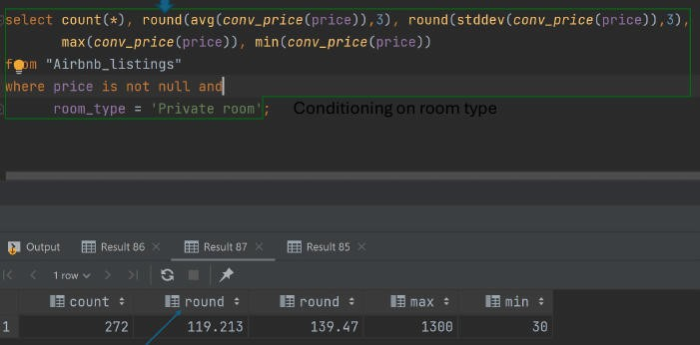

The screenshot shows a SQL query that computes count, average, standard deviation, maximum, and minimum for the price column (filtered by room_type = 'Private room'). The result table below the query illustrates the calculated statistics.

📈 GROUP BY, HAVING, WHERE
📂 GROUP BY
Extracts unique values of the grouping attributes.
Computes aggregate functions independently for each group.
SELECT clause may contain only grouping attributes and aggregates (no other columns).
SELECT city, property_type, room_type, COUNT(*) AS cnt,
ROUND(AVG(conv_price(price)), 3) AS avg_price, ROUND(STDDEV(conv_price(price)), 3) AS std_price, MAX(conv_price(price)) AS max_price, MIN(conv_price(price)) AS min_price
FROM Airbnb_listings WHERE price IS NOT NULL
GROUP BY city, property_type, room_type ORDER BY city ASC, property_type DESC;
🔎 HAVING vs. WHERE

Clause | When it applies | What it can reference
WHERE | Before grouping; filters raw rows. | Any column, even if not in SELECT.
HAVING | After grouping; filters groups. | Only aggregate expressions or grouping columns.
📂 Example – HAVING with Group Count
SELECT city, property_type, room_type, COUNT(*) AS cnt,
ROUND(AVG(conv_price(price)), 3) AS avg_price, ROUND(STDDEV(conv_price(price)), 3) AS std_price, MAX(conv_price(price)) AS max_price, MIN(conv_price(price)) AS min_price
FROM Airbnb_listings WHERE price IS NOT NULL
GROUP BY city, property_type, room_type HAVING COUNT(*) > 5
ORDER BY city ASC, property_type DESC;

Result excerpt:

city | property_ | tryopoem_typ | e cnt | avg_price | std_price | max_pric | e min_price
Washingto | nTownhous | e Entire home/apt | 1 | 338.25 | 202.011 | 720 | 720
Washingto | nTownhous | e Private  room | 1 | 115.22 | 113.053 | 399 | 399
… | … | … | … | … | … | … | …

🔗 Foreign Keys & Referential Integrity
📌 Definitions

Foreign key – a set of attributes in a child table that references the primary key of a
parent table, enforcing a link between the two tables.

Referential integrity – the rule that a foreign‑key value must either be NULL or match an existing primary‑key value in the referenced table.

Child table – contains the foreign‑key column(s).
Parent (referenced) table – contains the primary‑key being referenced.
🛠 SQL Example – Defining Foreign Keys
CREATE TABLE customers (
customer_id INT GENERATED ALWAYS AS IDENTITY PRIMARY KEY,
customer_name VARCHAR(255) NOT NULL
);

CREATE TABLE contacts (
contact_id INT GENERATED ALWAYS AS IDENTITY PRIMARY KEY,
customer_id INT,
contact_name VARCHAR(255) NOT NULL, phone VARCHAR(15),
email VARCHAR(100),
CONSTRAINT fk_customer FOREIGN KEY (customer_id)
REFERENCES customers (customer_id)
);

GENERATED ALWAYS AS IDENTITY creates sequential integer IDs; attempts to insert a manual value raise an error.
GENERATED BY DEFAULT AS IDENTITY would allow manual insertion if needed (not shown in the transcript).
📊 Simple Referential‑Integrity Illustration

Persons
PersonID | LastName | FirstName
1 | Hansen | Ola
2 | Svendson | Tove

3 | Pettersen | Kari
Orders
OrderID | OrderNumber | PersonID
77895 | 44678 | 1
22456 | 24562 | 2
An order cannot exist without a matching PersonID in Persons.

📚 PostgreSQL Integrity & Querying

Brief Overview
This note covering Database Integrity & Querying was created from a PDF presentation with 35 pages. It focuses on how PostgreSQL enforces referential integrity through foreign keys and their various ON DELETE/ON UPDATE actions, practical ways to retrieve schema information, and common query patterns such as joins, nested queries, and EXISTS clauses.

Key Points
Detailed explanation of the five ON DELETE options (NO ACTION, RESTRICT, CASCADE, SET NULL, SET DEFAULT) and how they affect related rows.
PostgreSQL foreign keys and the use of information_schema queries to list schemas, tables, columns, constraints, and indexes.
Overview of JOIN operations (INNER, LEFT, RIGHT, outer‑mixing) and how they shape result sets.
Techniques for nested queries and EXISTS/NOT EXISTS to filter and correlate data across tables.

🔗 Referential Integrity

Definition: A foreign key creates a link between two tables, ensuring that a value in the child table corresponds to an existing value in the parent (referenced) table. PostgreSQL can automatically enforce consistency when the referenced row is updated or deleted.

ON DELETE / ON UPDATE Options

Action | Description
NO ACTION | Rejects the operation if dependent rows exist (default).
RESTRICT | Same as NO ACTION but checked immediately (not deferred).
CASCADE | Propagates the change automatically to dependent rows.
SET NULL | Sets the foreign‑key column to NULL.
SET DEFAULT | Sets the foreign‑key column to its DEFAULT value.
Example: ON DELETE CASCADE
CREATE TABLE enroll (
studentid INT REFERENCES student(studentid) ON DELETE CASCADE,
courseid
semester grade
TEXT REFERENCES course(courseid) TEXT,
CHAR(2),
ON DELETE CASCADE,

PRIMARY KEY (studentid, courseid, semester)
);

Effect: Deleting a student or a course automatically removes the related enrollment rows.

Example: ON DELETE SET NULL
CREATE TABLE teaches (
profid INT REFERENCES professor(profid) ON DELETE SET NULL, courseid TEXT REFERENCES course(courseid),
semester TEXT,
PRIMARY KEY (courseid, semester)
);

Effect: Deleting a professor sets profid to NULL while keeping the course record.

Example: ON DELETE SET DEFAULT
INSERT INTO professor (profid, profname, department) VALUES (999, 'TBD', 'Administration');

CREATE TABLE teaches (
profid INT DEFAULT 999 REFERENCES professor(profid) ON DELETE SET DEFAULT, courseid TEXT REFERENCES course(courseid),
semester TEXT,
PRIMARY KEY (profid, courseid, semester)
);

Effect: Deleting a professor reassigns their courses to the placeholder professor (profid = 999).

Example: ON DELETE RESTRICT
CREATE TABLE enroll (
studentid INT REFERENCES student(studentid),
courseid TEXT REFERENCES course(courseid) ON DELETE RESTRICT, semester TEXT,
grade CHAR(2),
PRIMARY KEY (studentid, courseid, semester)
);

Effect: A course cannot be deleted while enrollments referencing it still exist.

Example: ON DELETE NO ACTION (default, deferred)
CREATE TABLE enroll (
studentid INT REFERENCES student(studentid),
courseid TEXT REFERENCES course(courseid) ON DELETE NO ACTION,

semester TEXT, grade CHAR(2),
PRIMARY KEY (studentid, courseid, semester)
);

Effect: The check is performed at transaction commit; the delete is rejected if dependent rows remain.

📁 Getting Schema Information (PostgreSQL)

List all schemas
SELECT schema_name FROM information_schema.schemata;

List tables in a schema
SELECT table_name FROM information_schema.tables WHERE table_schema = 'public';

List columns for a specific table
SELECT column_name, data_type, is_nullable FROM information_schema.columns
WHERE table_schema = 'public'
AND table_name IN ('airbnb_listings','airbnb_reviews','mutualfunds','usnewspaper');

List primary keys
SELECT kc.column_name
FROM information_schema.table_constraints tc JOIN information_schema.key_column_usage kc
ON kc.constraint_name = tc.constraint_name WHERE tc.constraint_type = 'PRIMARY KEY'
AND tc.table_schema = 'public';

List foreign keys
SELECT tc.constraint_name, kcu.column_name, ccu.table_name AS foreign_table, ccu.column_name AS foreign_column
FROM information_schema.table_constraints tc JOIN information_schema.key_column_usage kcu
ON kcu.constraint_name = tc.constraint_name
JOIN information_schema.constraint_column_usage ccu

ON ccu.constraint_name = tc.constraint_name WHERE tc.constraint_type = 'FOREIGN KEY';
List unique constraints
SELECT constraint_name, column_name
FROM information_schema.table_constraints tc JOIN information_schema.key_column_usage kcu
ON kcu.constraint_name = tc.constraint_name WHERE tc.constraint_type = 'UNIQUE';

List indexes
SELECT indexname, indexdef FROM pg_indexes
WHERE schemaname = 'public';

List check constraints
SELECT conname, pg_get_constraintdef(oid) FROM pg_constraint
WHERE contype = 'c';

✖ Cartesian Product

Definition: The Cartesian product R × S returns every possible concatenated pair where x is a tuple from R and y is a tuple from S.

Illustration:
If R = {John, Fred, Liz} and S = {115 1st St, 823 Main St, 13921 Genesee Ave.}, the product contains 9 rows such as John – 115 1st St, Fred – 823 Main St, etc.

🔄 Join Operations
Inner Join Example (Top 10 Holdings)
SELECT m.fund_symbol, n.top10_holdings FROM mutualfunds m
JOIN mfnews n
ON m.fund_symbol = n.fund_symbol WHERE n.src ILIKE 'marketwatch%';

SPJ (Select‑Project‑Join) Query
SELECT DISTINCT m.fund_symbol, n.management_name, u.src, u.publishdate, u.title
FROM mutualfunds m
JOIN mfnews n ON m.fund_symbol = n.fund_symbol JOIN usnewspaper u ON n.newsid = u.id
WHERE u.collectiondate >= DATE '2021-01-01'
AND u.collectiondate < DATE '2021-01-01' + INTERVAL '10 days' ORDER BY u.publishdate, m.fund_symbol;

Left Outer Join

Definition: Returns all rows from the left table; rows without a match in the right table have NULL for right‑table columns.
SELECT DISTINCT m.fund_symbol, n.newsid FROM mutualfunds m
LEFT JOIN mfnews n ON m.fund_symbol = n.fund_symbol ORDER BY n.newsid NULLS LAST;

Right Outer Join

Definition: Returns all rows from the right table; unmatched left‑table columns become NULL.
SELECT DISTINCT m.fund_symbol, n.newsid FROM mutualfunds m
RIGHT JOIN mfnews n ON m.fund_symbol = n.fund_symbol ORDER BY n.newsid NULLS LAST;

Mixing Outer and Inner Joins (Exercise)
-- Query A
SELECT m.fund_symbol, n.newsid, u.title FROM mfnews n
RIGHT OUTER JOIN mutualfunds m ON m.fund_symbol = n.fund_symbol INNER JOIN usnewspaper u ON n.newsid = u.id;

-- Query B
SELECT m.fund_symbol, n.newsid, u.title FROM usnewspaper u
RIGHT OUTER JOIN mfnews n ON n.newsid = u.id
INNER JOIN mutualfunds m ON m.fund_symbol = n.fund_symbol;

Key difference: The order of joins determines which table’s rows are preserved when no match exists.

📦 Nested Queries
General Pattern
- Break the problem into smaller subqueries.
- Combine them using SELECT, FROM, WHERE, or WITH.
- Use EXISTS, IN, or scalar subqueries as needed.

Example 1 – Highest PE Ratio
-- Find the maximum PE ratio
SELECT MAX(fund_price_earning_ratio) AS max_pe FROM mutualfunds;
-- Retrieve the fund(s) with that ratio
SELECT fund_symbol, fund_long_name, fund_price_earning_ratio FROM mutualfunds
WHERE fund_price_earning_ratio = (
SELECT MAX(fund_price_earning_ratio) FROM mutualfunds
);

Example 2 – Conditional WHERE Placement
SELECT fund_symbol, fund_long_name, fund_price_earning_ratio FROM mutualfunds
WHERE fund_price_earning_ratio > (
SELECT AVG(fund_price_earning_ratio) FROM mutualfunds
) AND total_net_assets >= 50000000;
Example 3 – Family‑Specific PE Comparison
SELECT fund_symbol, fund_long_name, fund_price_earning_ratio FROM mutualfunds
WHERE fund_price_earning_ratio > 1.2 * (
SELECT AVG(fund_price_earning_ratio) FROM mutualfunds
)
AND fund_family ILIKE '%American Century%';

WITH (Common Table Expression)
WITH miniquery AS (
SELECT DISTINCT n.fund_symbol, u.title FROM mfnews n
JOIN usnewspaper u ON n.newsid = u.id
)
SELECT m.fund_symbol, mq.title, m.management_name

FROM mutualfunds m
LEFT JOIN miniquery mq ON m.fund_symbol = mq.fund_symbol;

Finding Median PE Ratio per Family
SELECT fund_family,
PERCENTILE_CONT(0.5) WITHIN GROUP (ORDER BY fund_price_earning_ratio) AS median_pe FROM mutualfunds
GROUP BY fund_family ORDER BY median_pe DESC LIMIT 10;

Nested Subquery in SELECT Clause
SELECT fund_symbol,
fund_price_earning_ratio /
(SELECT AVG(fund_price_earning_ratio) FROM mutualfunds) AS relative_pe FROM mutualfunds
WHERE fund_family = 'Aberdeen'
ORDER BY relative_pe DESC NULLS LAST;

✅ EXISTS & NOT EXISTS
EXISTS – “Is there at least one matching row?”
SELECT DISTINCT name
FROM Airbnb_listings al WHERE EXISTS (
SELECT 1
FROM Airbnb_reviews ar WHERE ar.listing_id = al.id
);

Result: Lists Airbnb listings that have at least one review.

NOT EXISTS – “No matching rows”
SELECT al.*
FROM Airbnb_listings al WHERE NOT EXISTS (
SELECT 1
FROM Airbnb_reviews ar WHERE ar.listing_id = al.id
);

Result: Returns listings without any reviews.

Correlated Subqueries

Definition: A subquery that references columns from the outer query, creating a row‑by‑row evaluation (loop‑inside‑loop).
SELECT DISTINCT al.name
FROM Airbnb_listings al WHERE EXISTS (
SELECT 1
FROM Airbnb_reviews ar WHERE ar.listing_id = al.id
);

The outer query scans Airbnb_listings; for each row it runs the inner query to test for a matching review.

📊 Miscellaneous Queries
Counting Rows in mutualfunds
SELECT COUNT(*) FROM mutualfunds;

Selecting Distinct Fund Symbols and Titles (Joined Tables)
SELECT DISTINCT m.fund_symbol, u.title, m.management_name FROM mutualfunds m
LEFT JOIN mfnews n ON m.fund_symbol = n.fund_symbol JOIN usnewspaper u ON n.newsid = u.id
ORDER BY m.fund_symbol, u.publishdate DESC;

📚 Null Values in SQL

Brief Overview
This note covers NULL values in SQL and was created from a 49-page PDF presentation. It covers the NULL marker, testing with IS NULL, handling unknown data, and query examples.

Key Points
Understanding NULL semantics
Using IS NULL in WHERE clauses
Dealing with NULL in aggregates
Common pitfalls and best practices

Null Values in SQL 🐞
NULL – a special marker used to indicate that a data value does not exist or is unknown.

Testing for NULL
IS NULL

📚 Transaction Basics

Brief Overview
This note covers Transaction Systems and was created from a 21-page PDF presentation. It covers transaction definition, server architecture, concurrency control, and serializability analysis.

Key Points
Definition of a transaction and its lifecycle states (Active, Committed, Aborted, etc.).
Server architecture: server processes, lock manager, log writer, and checkpointing.
Concurrency control concepts: serializability, conflict, and view equivalence.
Locking mechanisms: mutex vs semaphore and the lock table.

📘 What Is a Transaction?
Definition

A transaction is a unit of program execution that accesses and possibly updates various data items.

Example: Transfer $50 from account A to account B
- read(A) → $A$
- $A := A - 50$
- write(A)
- read(B) → $B$
- $B := B + 50$
- write(B)
Key Issues
- Failures (hardware crashes, system errors)
- Concurrent execution of multiple transactions

🏗 Basic Architecture of a Transaction Server

Server Processes – receive user queries (transactions), execute them, and return results.
Often multithreaded so a single process can handle several queries concurrently.
Lock Manager Process – coordinates lock acquisition; used for deadlock detection.
Database Writer Process – continuously writes modified buffer blocks to disk.

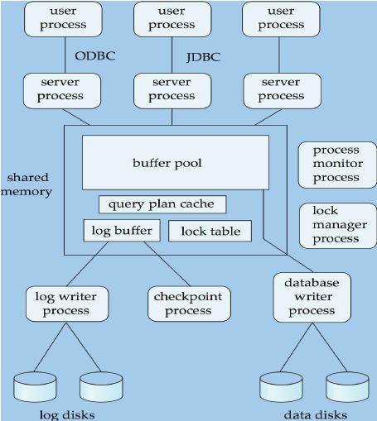

The diagram shows user processes communicating via ODBC/JDBC to server processes, which share a buffer pool containing a query‑plan cache, log buffer, and lock table.
Background processes (lock manager, log writer, checkpoint, etc.) interact with the buffer pool and storage devices.

Additional Server Components

Component | Role

Log Writer Process | Buffers log records and writes them to stable storage
Checkpoint Process | Performs periodic checkpoints to limit recovery time
Process Monitor | Detects failures, aborts/restarts affected transactions

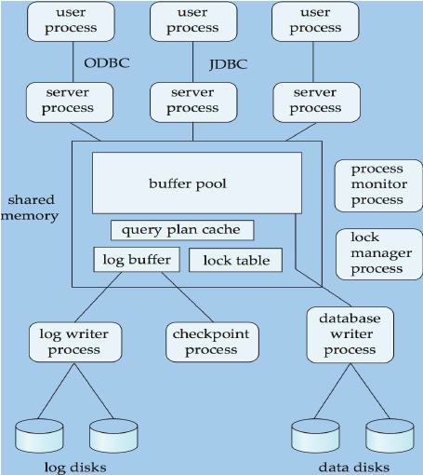

Illustrates shared memory (buffer pool, lock table, log buffer) and background processes that maintain consistency and durability.

🔒 Transaction‑Related Processes & Shared Memory
Shared Memory Structures

Buffer Pool – caches data pages.
Lock Table – records current lock owners.
Log Buffer – holds log records before they are flushed.
Cached Query Plans – reused for identical queries.
- Mutual Exclusion
  - Implemented via OS semaphores or atomic instructions (e.g., test‑and‑set).
  - Each process manipulates the lock table directly to avoid IPC overhead; a separate lock manager handles deadlock detection.

🔐 Mutex vs. Semaphore

A mutex (binary semaphore) provides mutual exclusion for a single thread, while a semaphore allows a preset number of threads to enter a critical region.

- Mutex
  - Only one thread may acquire it at a time.
  - Used for mutual exclusion.
- Semaphore
  - Allows up to N concurrent acquisitions.
  - Used for flow control.
Both must be released after the protected code region finishes.

📂 Transactions Have Their Own Work Areas
- Each transaction maintains a private workspace (e.g., x1, y1 for T1) while reading/writing through the shared buffer.

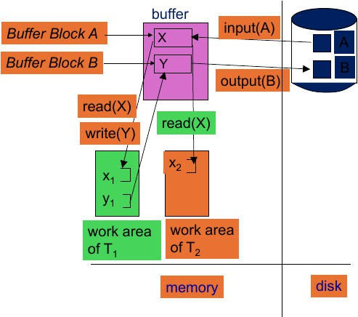

The figure shows two transactions (T1 in green, T2 in orange) interacting with a shared buffer (pink) and underlying disk storage. Each transaction reads from the buffer, updates its private workspace, and later writes back.

🔄 Transaction States
- Active – execution in progress.
- Partially Committed – final statement executed, but not yet durable.
- Failed – cannot continue normal execution.
- Aborted – rolled back to the state before the transaction started; may be restarted or killed.
- Committed – changes are permanent.

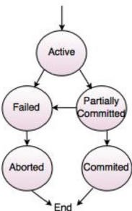

Flowchart visualizing transitions among the five transaction states.

✅ Requirements for Transactions (Why ACID Matters)
- Atomicity – either all operations take effect or none do.
- Consistency – integrity constraints (primary/foreign keys, sum of balances) must hold after commit.
- Isolation – intermediate results are invisible to other concurrent transactions.

- Durability – once committed, changes survive crashes.
  - Example of inconsistency: if step 3 fails after debiting A but before crediting B, the total $A + B$ changes, violating the “sum unchanged” rule.
  - Isolation can be trivially achieved by serial execution, but concurrency yields higher throughput.

🔁 Concurrent Executions & Serializability
  - Benefits: higher CPU/disk utilization, reduced response time, increased throughput.
  - Serializability – a schedule is serializable if its effect equals some serial schedule (transactions run one after another).

Schedule Types

Type | Description
Serial Schedule | Transactions execute consecutively, no interleaving.
Non‑serial Schedule | Operations from different transactions interleave.
Serializable Schedule | Non‑serial but yields the same final state as a serial schedule.
Non‑serializable Schedule | No equivalent serial order; may cause anomalies.
Example Analysis
  - Given Interleaving (A and B are data items):
    - Final A = $2A_0 + 200$ (matches T1→T2 order)
    - Final B = $2B_0 + 100$ (matches T2→T1 order)
    - Since the two results correspond to different serial orders, the schedule is non‑serializable.

⚔ Conflict Serializability

  - Conflict occurs when two operations:
- Access the same data item, and

- At least one is a write.
  - Rules
    - Read‑Read → not a conflict.
    - Read‑Write or Write‑Read → conflict; order cannot be swapped.
    - Write‑Write → conflict but can be ordered arbitrarily (they don’t read each other’s value).
  - Conflict serializability is a sufficient condition for overall serializability.

👁 View Serializability
Two schedules are view‑equivalent if they satisfy:
- Initial Read – each data item is first read by the same transaction in both schedules.
- Final Write – the transaction that performs the last write on each item is the same.
- Update Read – any read of a value written by another transaction occurs after that write in both schedules.

📊 Example Schedules Comparison

Schedule | Operations (simplified) | Serializability
Schedule 1 | T1: R(A), W(A); T2: R(A), W(A) | Conflict‑serializable (non‑conflicting reads can be reordered)
Schedule 2 | T1: R(A), W(B); T2: R(B), W(A) | Non‑serializable (conflicting writes interleaved)

🔄 A Serialization Scheme Example
- Step 1 – T1 updates X to 2000.
- Step 2 – Switch to T2; T2 updates X to 4000, then back to T1.
- Step 3 – T1 finishes; T2 updates Y to 4000 (by multiplying 2000).

Result: $X + Y = 4000$, same as the original total, thus the schedule is equivalent to a serial schedule and maintains consistency.

📈 Concurrency Control Overview
  - Goal: Allow many users to perform operations simultaneously without compromising data integrity.
  - Advantages
    - Improves system throughput.
    - Reduces waiting time for short transactions.
  - Risks Without Control – lost updates, dirty reads, and other anomalies that break consistency.

