CSE 102 HW 1

1. 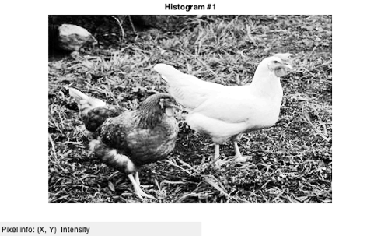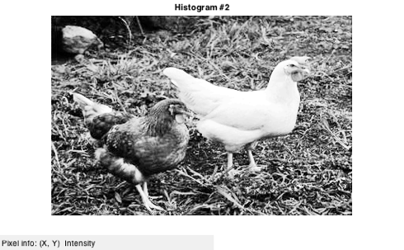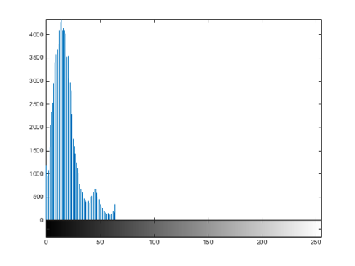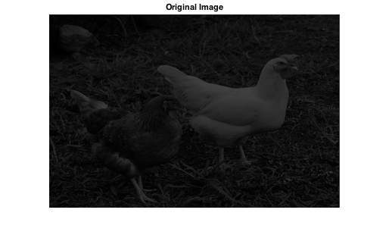The histogram of the chicken image divided by four is a darkened image of the original chicken image. The histogram shows that there are no values above the 126. The histogram equalization of the darkened chicken image is the same on the first and second pass of the histogram equalization.
2. a) If you repeatedly subtract image b from image a, then the result image will slowly get darker and darker, until it is completely black.

b) Reversing the order of the images would yield a different result, but the end product would end up being the same, a black image.

1. a) The negative is the compliment of the image

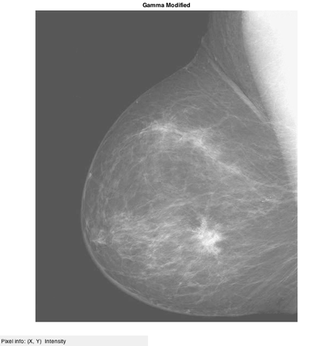b) If the gamma function is < 1, then a black image will look grayer than the original and a white image will look whiter than the original. A gamma function > 1 will do the opposite.

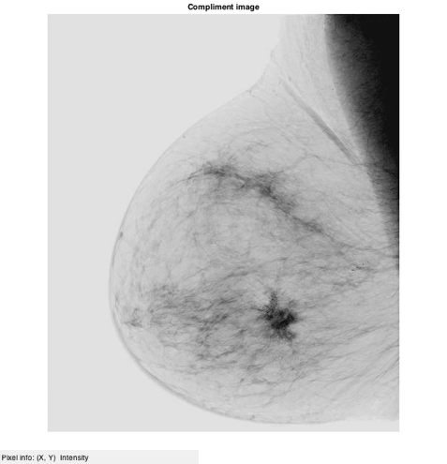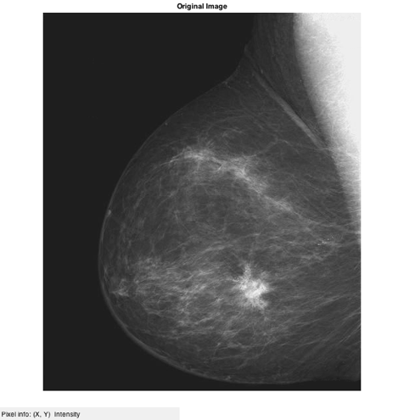

1. A combination of the filters will sometimes be better than using only one filter. The median filter works better on the salt and pepper image, while the average and median filter is better on the Mona Lisa picture.

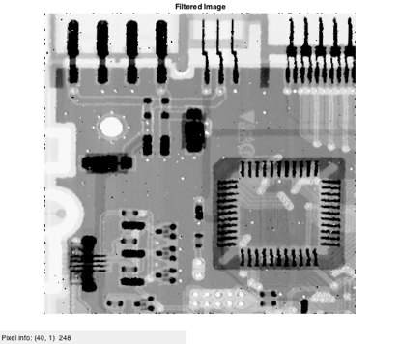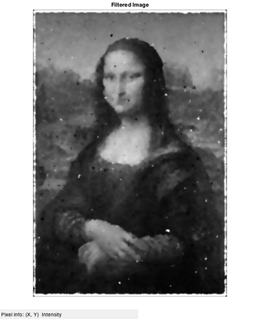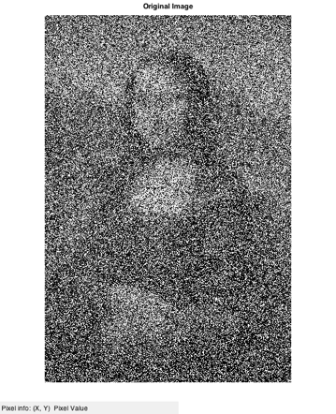

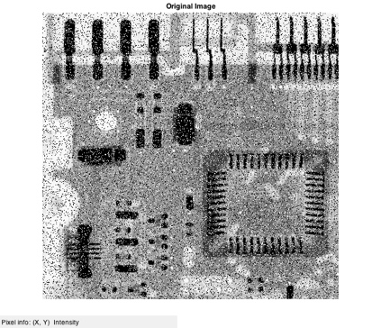

1. The log transformation makes something that looks dark, and enhances the pixels that aren’t completely black so they are more visible in the picture.

