CSE 102 Lab 6

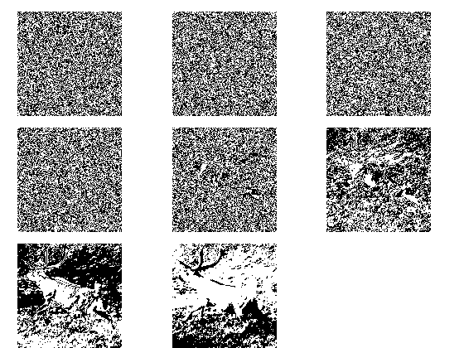

1. 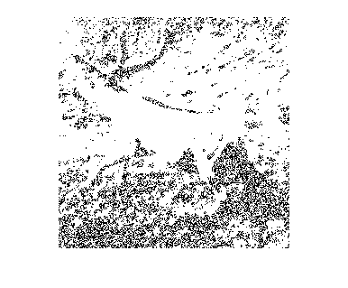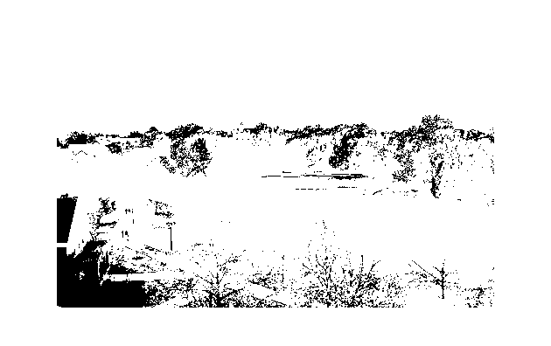This image is the bit subplots for the caribou image and the below image is the first bit plane subtracted from the eighth bit plane. The third picture is the 7th and 6th bit plane of the Miami university’s bit planes added together.

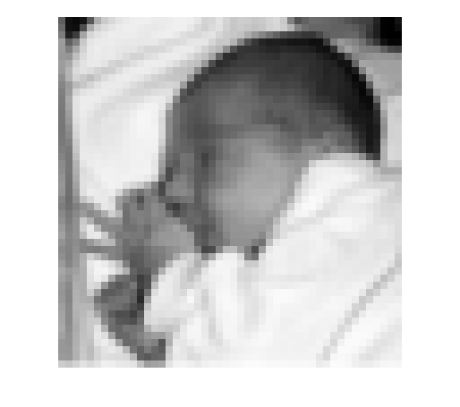

1. This image is the baby image with modified spatial reasoning.
2. 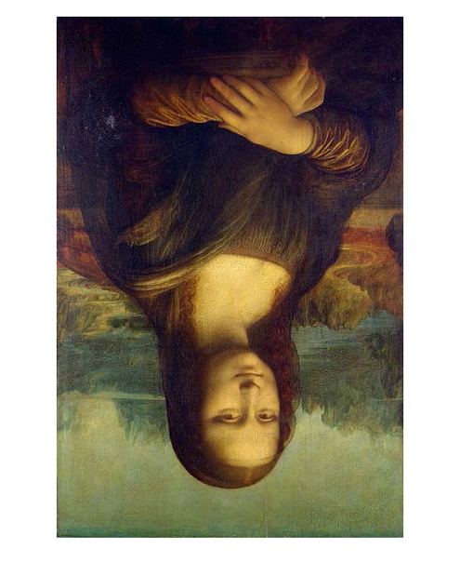The mona lisa image is the mona lisa image rotated 90 degrees.
3. 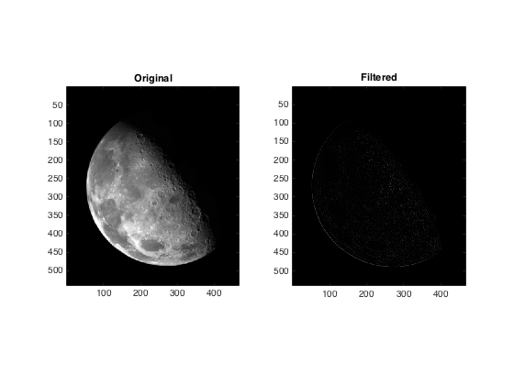Shown below

1. 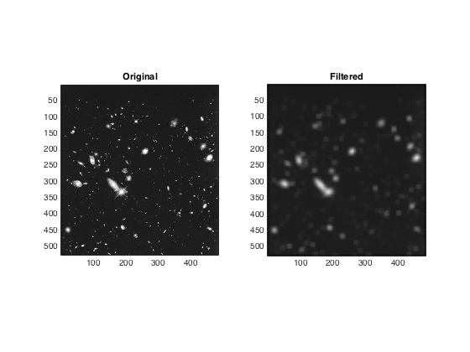Shown below